**Parameters:**

G – graph defining the network to be sized – should be specified in the program by hand for the first iteration (for example Q may be in gpd or m3/hr and Lengths may be in ft or meters.)

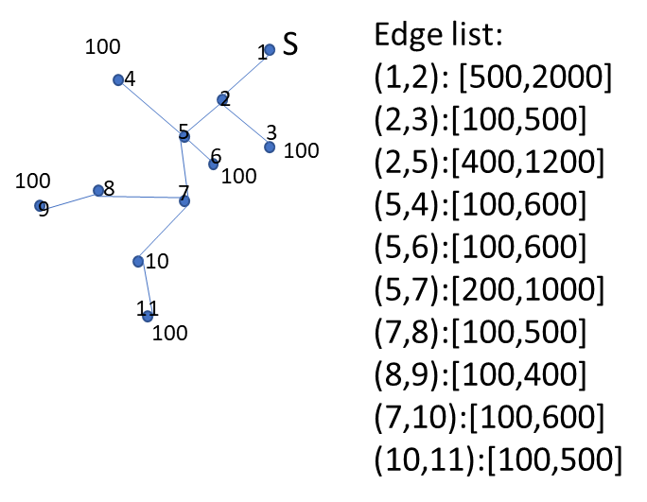

Qij – flow in link ij defined based on the branched network configuration

Lij – length of link ij

CPk – Cost of piping $/m for each pipe size k

**Objectives:**

$$\min{Z=\sum_{ijk}{L_{ij}∙{CP}_{k}{∙x}_{ijk}}}$$

**Decision variable:**

xijk  - {0,1} binary variable to determine pipe size k is selected for link ij

**Constraints:**

${HL}_{ij}=\sum_{k}{x_{ijk}L_{ij}}∙J_{ijk}$ where $J_{ijk}=α∙{\frac{Q_{ij}}{C}}^{-1.852}∙D_{k}$ and C and α are defined by the Hazen Williams equation and units of analysis (See Mays textbook for details and units required for flow, diamater and pipe length)

${H_{min}≤HL}_{ij}≤H_{max}∀ij$ where the bounds are set first to be non-binding (Hmin = 0 and Hmax is calculated as the highest possible head loss in the systems—the smallest pipe size, highest flow and longest edge length) in subsequent model runs incrementally reduce Hmax to observe how the pipes sizes assigned change.

$\sum_{k}{x_{ijk}=1 ∀ ij}$ only select one pipe size k for each link