Quiet Classroom
  - Interactive Web Design Reflection

Idea and design intentions
Quiet Classroom is an interactive website that encourages a quieter study environment through a sleeping fish. Instead of displaying only a warning or a number, the page turns classroom sound into a small story: staying quiet lets the fish rest, while sustained noise wakes it up. The intention is to make self regulation feel gentle, playful, and easy to understand.
The interface pairs an illustrated room and aquarium with a study control panel. Soft gradients, rounded shapes, translucent surfaces, and warm furniture create a calm atmosphere. The window and background change with the local time of day. A live sound meter, quiet time, score, and session summary give feedback. Manual, duration, and scheduled modes support different study routines, while a sensitivity slider lets users adjust the response to their environment.

How I used AI tools
I used ChatGPT and Codex to help develop and revise the website. My requests focused on an interactive Quiet Classroom experience and, in this revision, a more lively fish, clearer visual design, and a review of unreasonable behavior or code bugs. I also asked AI to organize the CSS and JavaScript, prepare this reflection, translate the complete interface into English, and add screenshots with gameplay instructions.
AI provided the HTML interface, CSS room and fish artwork, and JavaScript for microphone input, sound level feedback, timing, scoring, and the result dialog. The original repository stored its CSS and JavaScript inside the HTML rather than as separate files. During this revision, AI extracted them into style.css and script.js and updated the HTML links so the structure, presentation, and behavior are easier to inspect and maintain.
My contribution was to set the concept, choose the quiet study scenario, and direct the next changes: improve the fish character and review the interaction logic. I used AI as an implementation assistant and requested another review rather than treating the generated code as finished. The revision added breathing, fin and tail animation to the fish and improved the panel hierarchy. AI also corrected microphone cleanup, cancellation during startup, repeated noise counting, and simulated sound scoring. I requested these refinements so the visual idea and the session behavior work together.

HTML and CSS work
GitHub repository: https://github.com/yz5099-sys/Quiet-Classroom
Files: index.html for structure, style.css for visual design, and script.js for interaction. The sound percentage is a relative microphone level, not a calibrated decibel measurement.
Live website: https://quiet-classroom.vercel.app/

How to play
Your goal is to protect the fish’s sleep by keeping the room quiet during a study session. Figure 1 shows where to select a mode, adjust the noise threshold, and start.
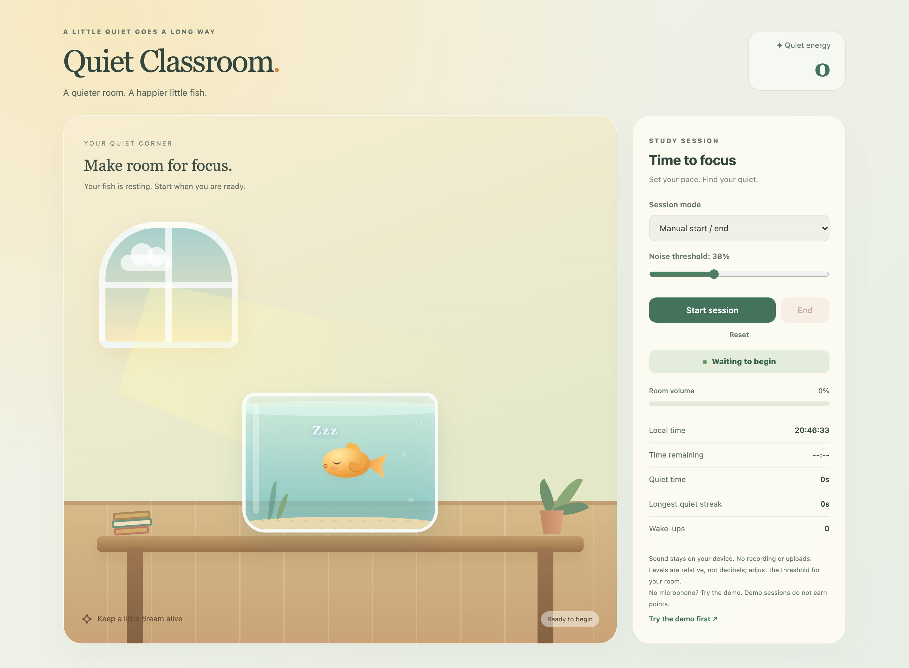
Figure 1 The English interface before a session begins
Choose a session. Select Manual start / end for an open session, Timed session for 1 to 1440 minutes, or Scheduled session for local start and end times. Keep this page open for a scheduled session.
Start and adjust. Select Start session and allow microphone access. Watch Room volume and adjust Noise threshold for the room. This percentage is a relative level, not a decibel reading.
Keep the fish asleep. Quiet time earns points, with a bonus for longer quiet streaks. Sustained sound wakes the fish and subtracts 25 points, without taking the score below zero.
Finish or explore. Select End to see the session summary, or Reset to clear the session. Try the demo first works without a microphone; Simulate a sound demonstrates the response. Demo sessions do not earn points or record quiet time and wake-ups.

Sound response and session results
Sound above the selected threshold for 0.3 seconds wakes the fish. The open eye, faster swimming, alert, and Room volume meter make the change visible together. Continuous noise counts as one wake-up. After 1.4 seconds below 90 percent of the threshold, the fish settles back to sleep.
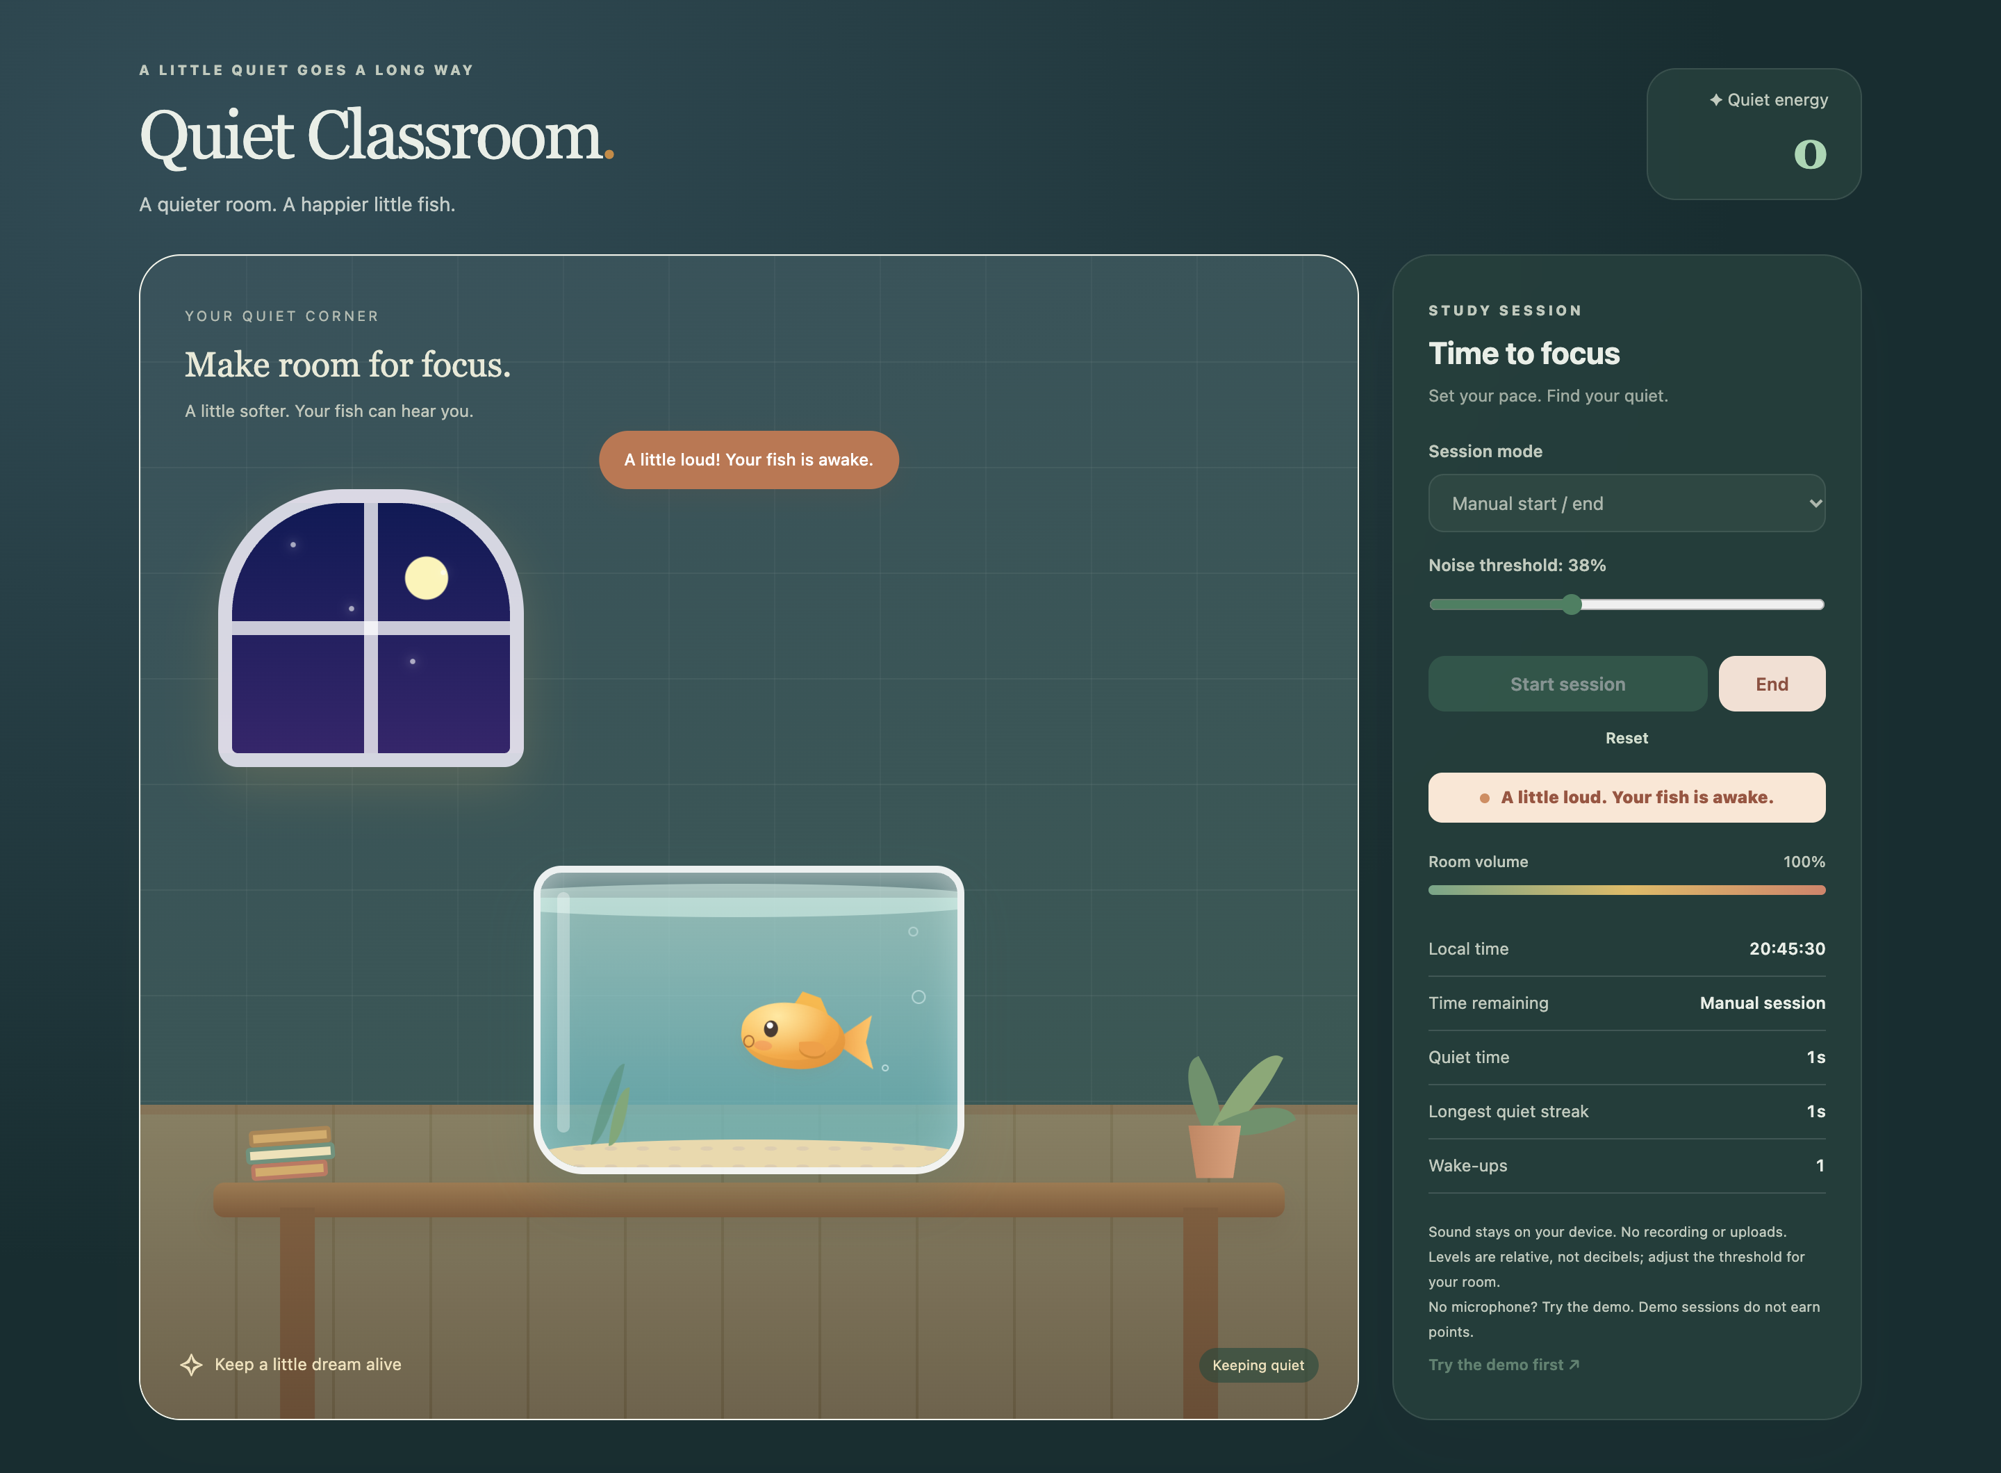
Figure 2 Noise feedback captured using controlled microphone test input
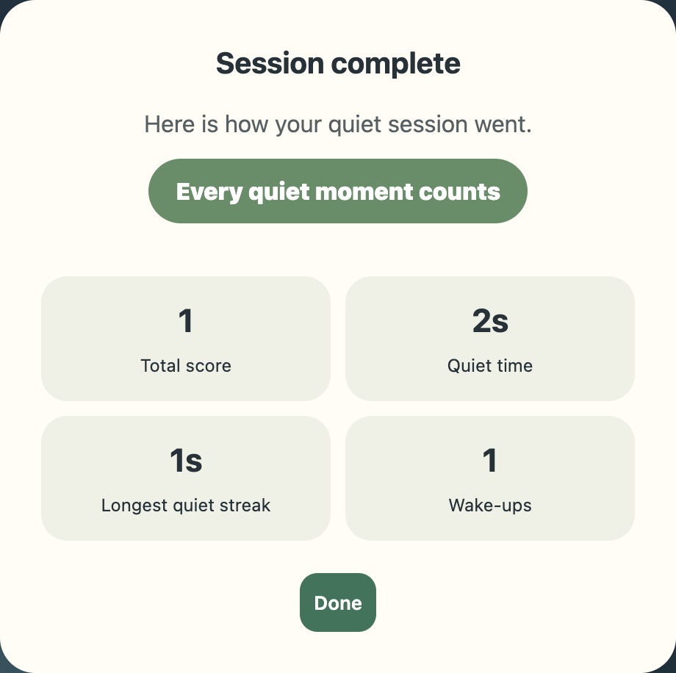
Figure 3 End opens a summary of the completed session
Select Done to close the summary and start again. Screenshots use controlled test sound, without classroom recordings. Mobile and night views are available in design/screenshots.

