A

(1-a)

time dimension, PK: time_key

item dimension, PK: item_key

branch dimension, PK: branch_key

location dimension, PK: location_key

(1-b)

PK: Sales_Fact(time_key, item_key, branch_key, location_key)

(1-c)

Measures: dollars_sold, units_sold

(1-d)

Location dimension: street → city → province_or_state → country

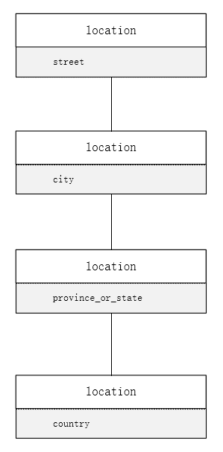

(1-e)

Item dimension: item_name → brand → type → supplier_type

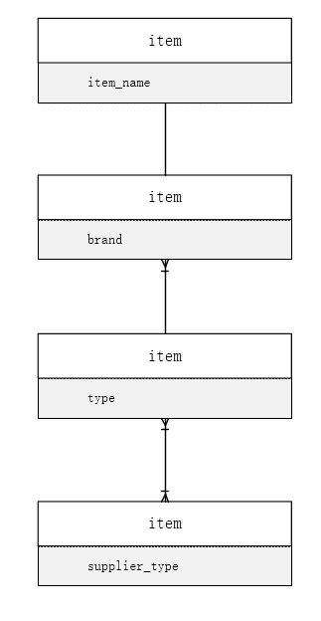

(2-a)

Query: Find the total amount of dollars sold for all the branches for the years between 2014 to 2017.

Rollup operation summarizes data at a higher level by climbing up hierarchy or dimension reduction, in this case I implement dimension reduction by only have 2 dimensions in the query: branch dimension and year dimension..

(2-b)

Query: Find the total amount of dollars sold and the total number of units_sold for all the branches for each city and each brand for the years between 2014 to 2017’s first 6 months.

Drilldown operation summarizes lower-level dimension hierarchy or introduces a new dimension. Since in the initial query, all four dimensions are included, no more new dimensions can be introduced. So the only way to drill-down is to summarize at a lower-level, which is the “first 6 month” because “month” is lower than “year” in time dimension.

(2-c)

Query: Find the total amount of dollars sold and the total number of units_sold for all the branches for Washington DC and each brand for the years between 2014 to 2017.

Slice operation creates a new subcube by selecting a single value of one dimension. In this case, I select “Washington DC” as the single value in the location dimension.

(2-d)

Query: Find the total amount of dollars sold and the total number of units_sold for all the for all the branches for Philadelphia or Washington DC and Coca-Cola or PepsiCo for the years between 2014 to 2017 or 2017 to 2020.

Dice operation creates a new subcube by selecting a range of values of one or more dimensions. In this case, I select “Philadelphia or Washington DC” as multiple values in location dimension, “Coca-Cola or PepsiCo” as multiple values in item dimension and “2014 to 2017 or 2017 to 2020” as multiple values in time dimension.

B.

(1)

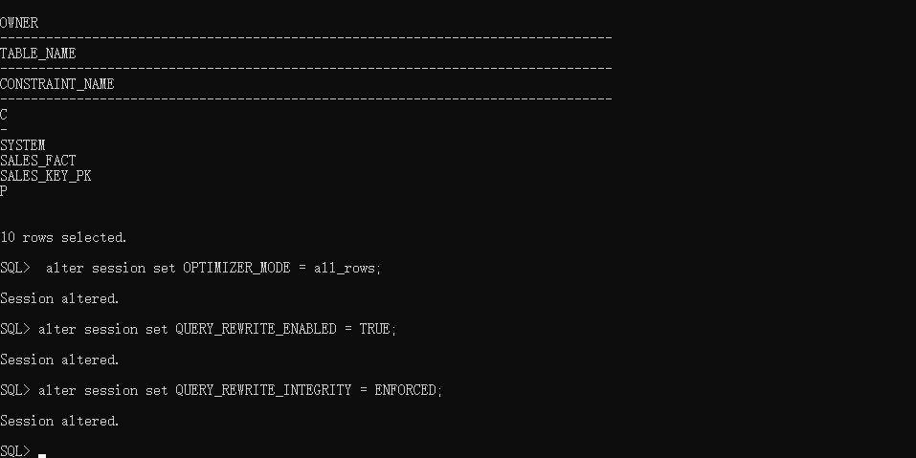

(2-a)

create sequence seq_time start with 1 increment by 1;



(2-b)

create or replace procedure populate_time_dimension(p_start_date in DATE, p_end_date in DATE)

is

v_actualDate date;

v_dayofmonth number(2);

v_month varchar2(9);

v_quarter number(1);

v_year number(4);

Begin

v_actualdate := p_start_date;

LOOP

exit when v_actualDate>p_end_date;

v_dayofmonth:= to_number(to_char(v_actualDate,'DD'));

v_Month := to_char(v_actualDate,'Month');

v_quarter := to_number(to_char(v_actualDate,'Q'));

v_year := to_number(to_char(v_actualdate,'YYYY'));

insert into time_dimension(day_key, actual_date, day_of_month, month, quarter, year)

values(seq_time.nextval, v_actualDate, v_dayofmonth, v_month, v_quarter,v_year);

v_actualDate:= v_ActualDate+1;

End Loop;

end populate_time_dimension;

/

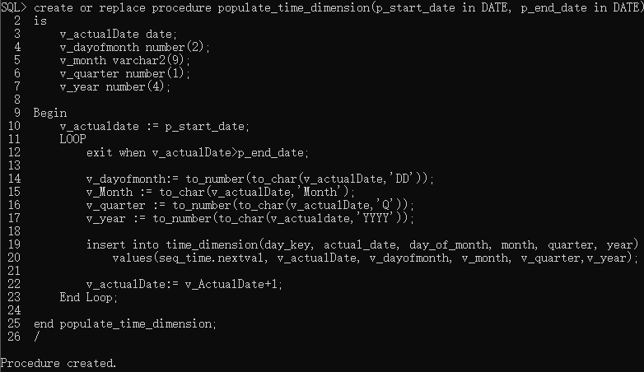

(2-c)

Exec populate_time_dimension ('01-JAN-1999','31-DEC-2001');



(2-d)

select * from time_dimension where rtrim(month) = 'January' and day_of_month <= 10;

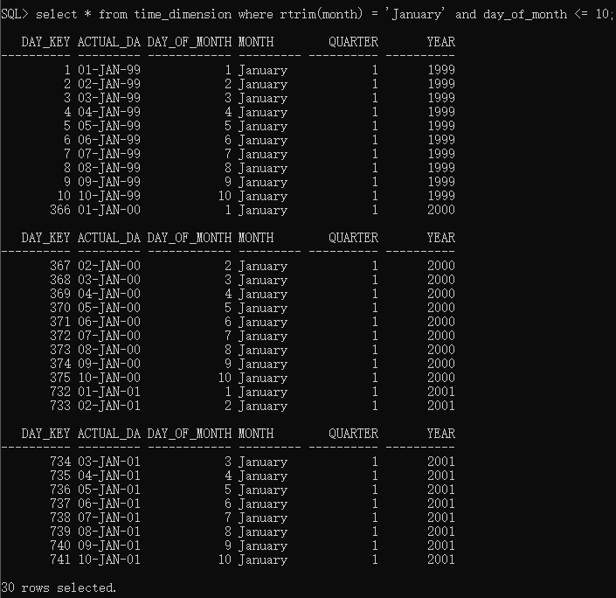

(3)

SET LINESIZE 200

SELECT * FROM product_dimension;

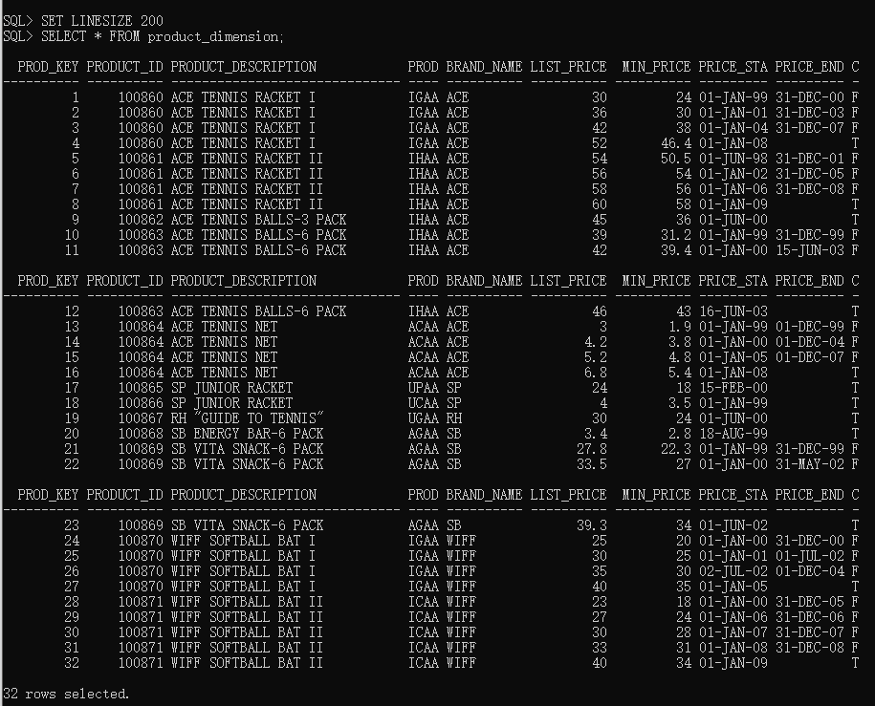

(4-a)

select first_name, last_name, product_code, product_description, year, sum(quantity) as total_units from sales_fact, product_dimension, time_dimension, employee_dimension where sales_fact.orderdate_key = time_dimension.day_key and sales_fact.prod_key = product_dimension.prod_key and sales_fact.emp_key = employee_dimension.emp_key group by first_name, last_name, product_code, product_description, year;

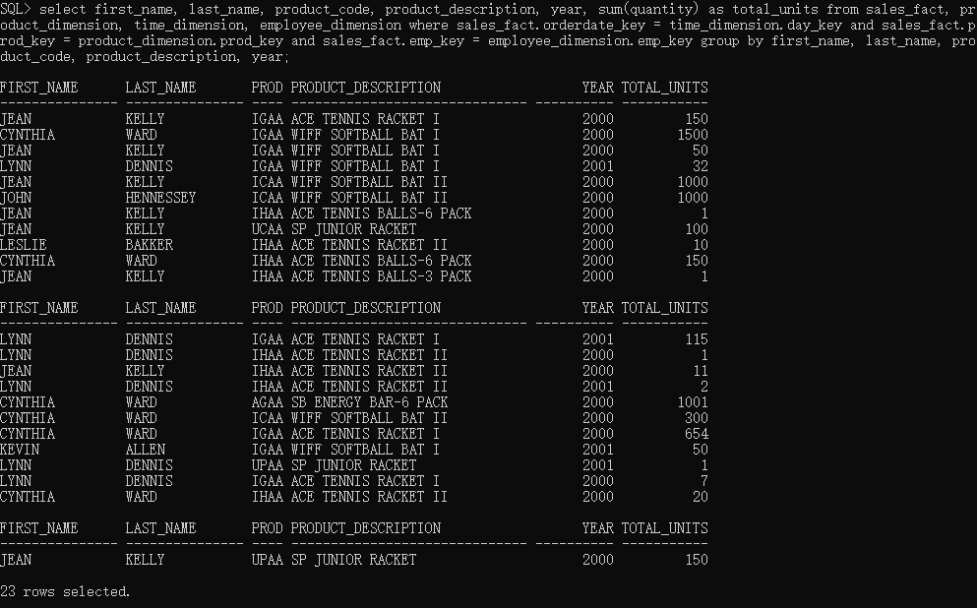

(4-b)

select product_code, product_description, sum(sales_dollar_amount) as total_sales, rank() over (order by sum(sales_dollar_amount) desc) as rank_sales from sales_fact, product_dimension where sales_fact.prod_key = product_dimension.prod_key group by product_code, product_description order by rank_sales asc;

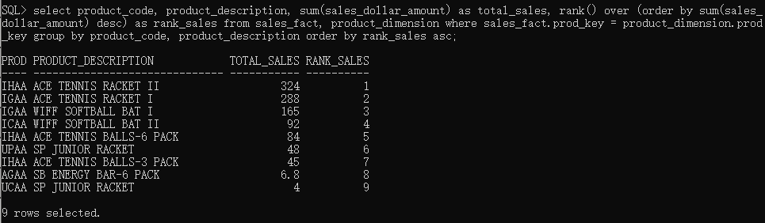

(4-c)

select product_code, product_description, month, year, sum(sales_dollar_amount) as total_sales from sales_fact, product_dimension, time_dimension where sales_fact.orderdate_key = time_dimension.day_key and sales_fact.prod_key = product_dimension.prod_key group by rollup (product_code, product_description, month, year);

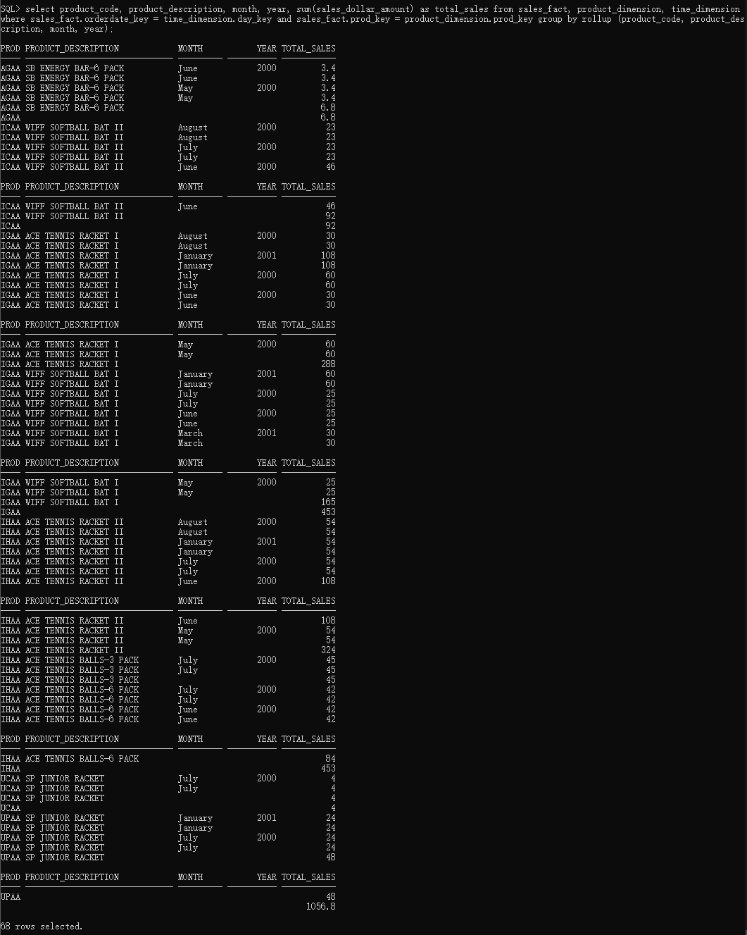

(4-d)

Select name, year, sum(sales_dollar_amount) as total_sales from sales_fact, customer_dimension, time_dimension where sales_fact.orderdate_key = time_dimension.day_key and sales_fact.cust_key = customer_dimension.cust_key group by cube(name, year);

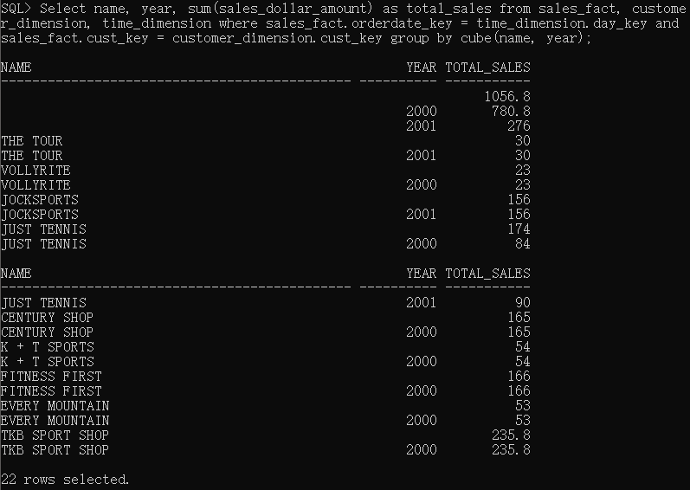

(5-a)

create materialized view customer_monthly_sales enable query rewrite as select sales_fact.cust_key as customer_key, sales_fact.prod_key as product_key, year as sale_year, month as sale_month, sum(sales_dollar_amount) as total_sales from sales_fact, time_dimension, customer_dimension, product_dimension where sales_fact.orderdate_key = time_dimension.day_key and sales_fact.prod_key = product_dimension.prod_key and sales_fact.cust_key = customer_dimension.cust_key group by sales_fact.cust_key, sales_fact.prod_key, year, month;

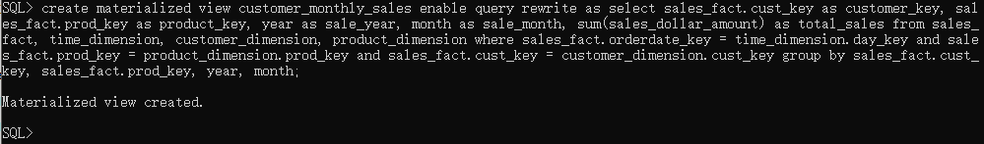

(5-b)

select customer_key, product_key, sale_year, sale_month, total_sales from customer_monthly_sales;

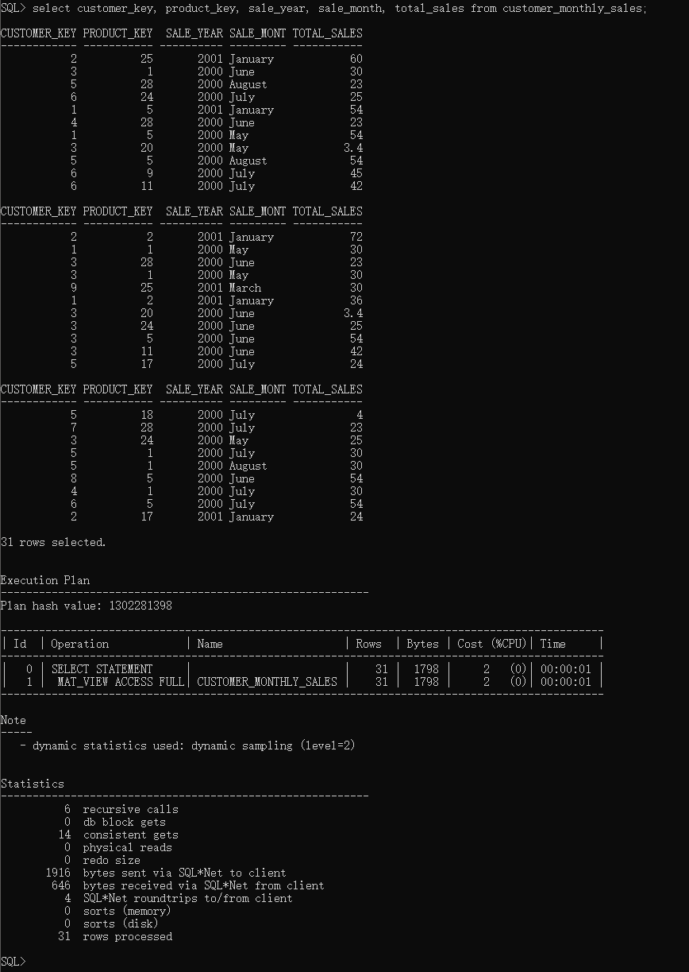

(5-c)

select customer_key, sale_year, sum(total_sales) from customer_monthly_sales group by customer_key, sale_year;

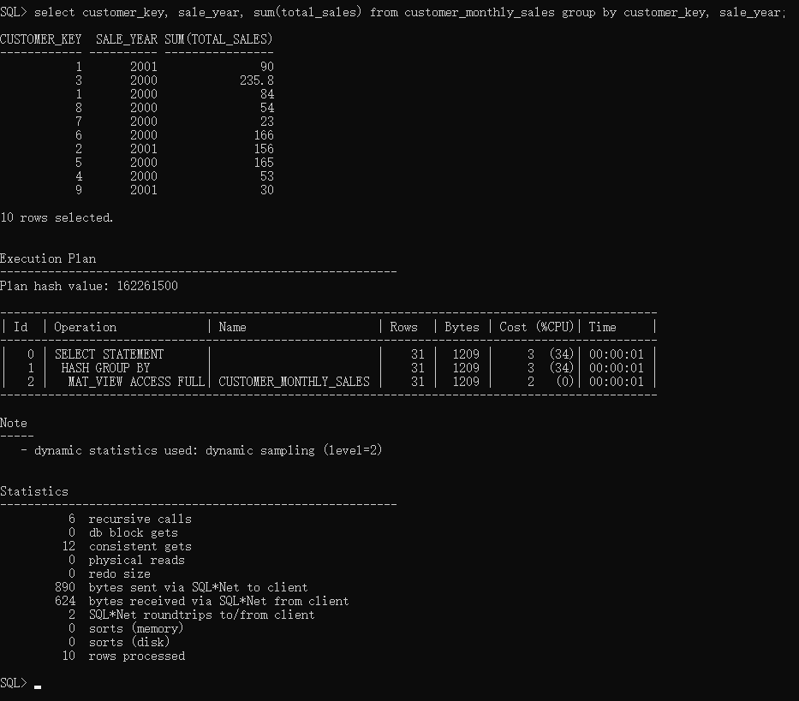

(5-d)

select sales_fact.cust_key as customer_key, year as sale_year, sum(sales_dollar_amount) as total_sales from sales_fact, time_dimension, customer_dimension, product_dimension where sales_fact.orderdate_key = time_dimension.day_key and sales_fact.prod_key = product_dimension.prod_key and sales_fact.cust_key = customer_dimension.cust_key group by sales_fact.cust_key, year;

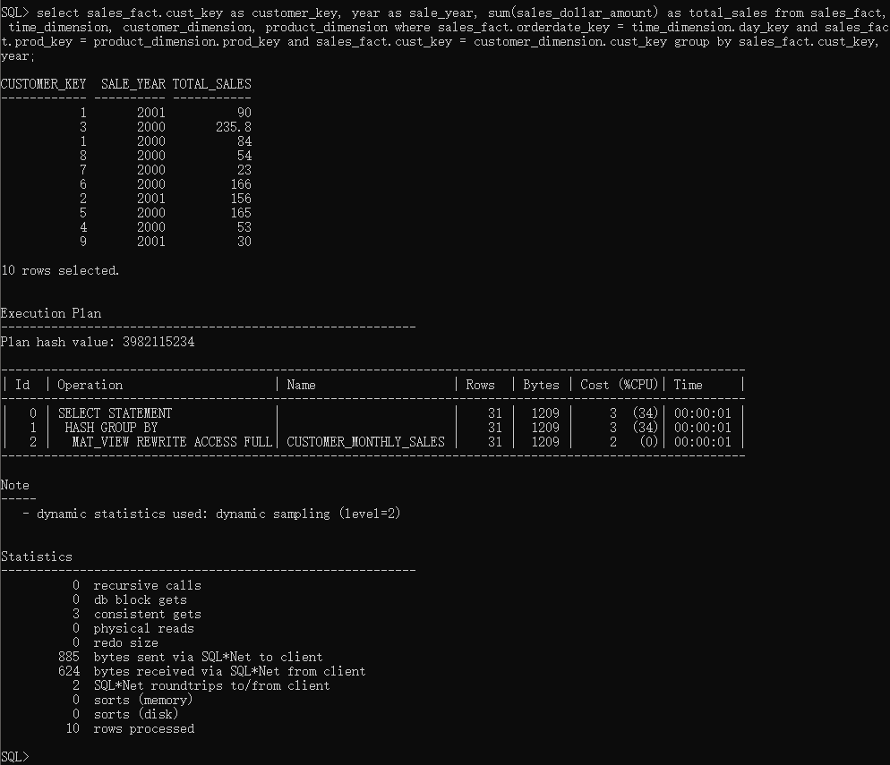

Yes. From the execution plan, we can see the MV Rewrite feature and customer_monthly_sales is used in this query.