Yiyun Zhang

yz523

**Part A**

**(a)**

use hw3



db.createCollection("customers")



db.customers.insert({

"id": "1",

"name": "Bill",

"productId": "1",

"customerId": "1",

"amount": 20.00,

"state": "PA"

});

db.customers.insert({

"id": "2",

"name" : "Hillary",

"productId": "2",

"customerId": "2",

"amount": 30.00,

"state": "DC"

});

db.customers.insert({

"id": "3",

"name" : "brian",

"productId": "1",

"customerId": "3",

"amount": 25.00,

"state": "DC"

});

db.customers.insert({

"id": "4",

"name" : "Donald",

"productId": "2",

"customerId": "4",

"amount": 50.00,

"state": "PA"

});

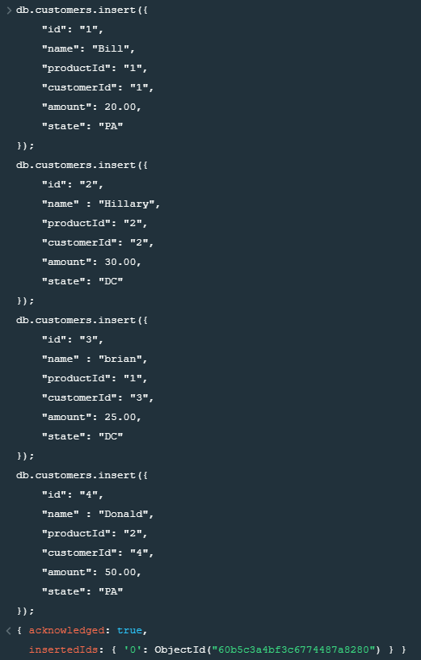

**(b)**

db.customers.find(

{"state" : "PA"},

{

_id: 0,

name: 1,

mount: 1

}

).pretty()

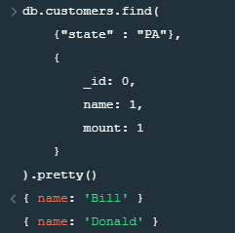

**(c)**

db.customers.find(

{

"name" : {$regex:/b/i}},

{

_id: 0,

name: 1,

state: 1

}

).pretty()

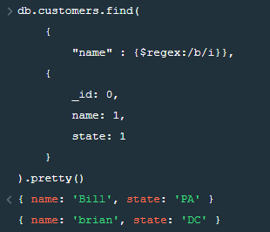

**(d)**

db.customers.find(

{

"amount" : {

$gte: 30, $lt: 40

}

},

{

_id: 0,

name: 1

}

).pretty()

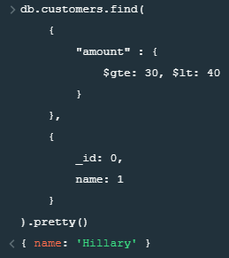

**(e)**

db.customers.aggregate([

{

$group: {

_id: "$state",

customersNumber: {

$sum: 1

},

totalAmount: {

$sum: "$amount"

}

}

}

]).pretty()

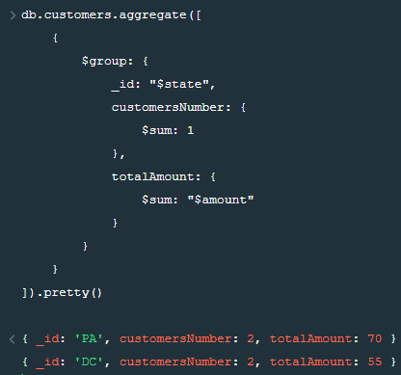

**(f)**

db.customers.updateMany(

{},

{

$inc: {amount: 10}

}

)

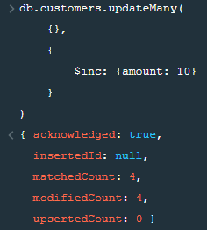

db.customers.find().pretty()

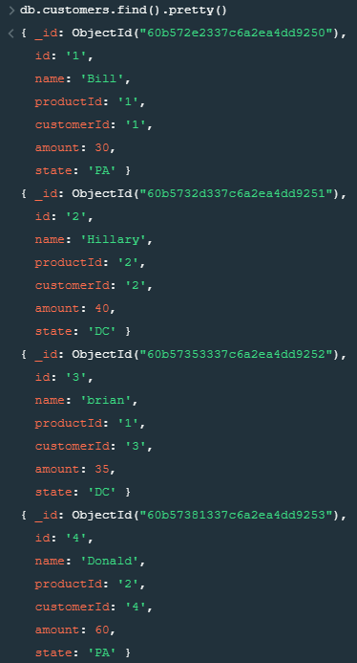

**(g)**

db.customers.aggregate([{

$addFields: {

totalSaleAmount: {

$trunc : [{$multiply: ["$amount", 1.06]} , 2]

}

}

}]).pretty()

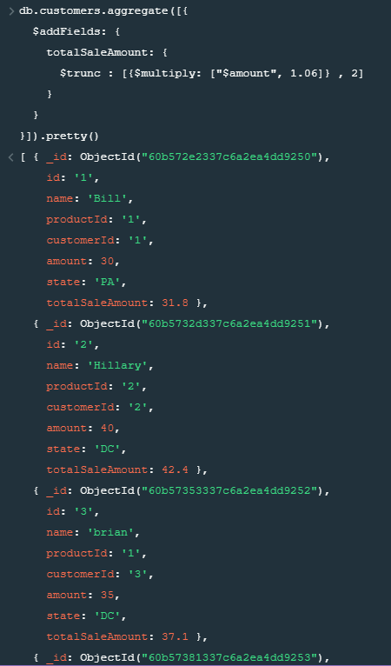

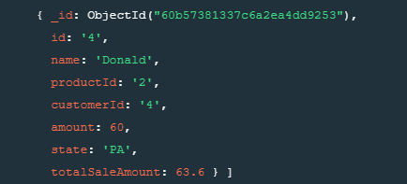

**(h)**

db.customers.aggregate([

{

$match: {state: "PA"}

}, {

$addFields: {

pastPurchase: {

$switch: {

branches: [

{case: {$eq: ["$id" , "1"]}, then: ["chair", "desk"]},

{case: {$eq: ["$id" , "4"]}, then: ["chair", "desk", "usb"]}

],

default: [""]

}

}

}

}

]).pretty()

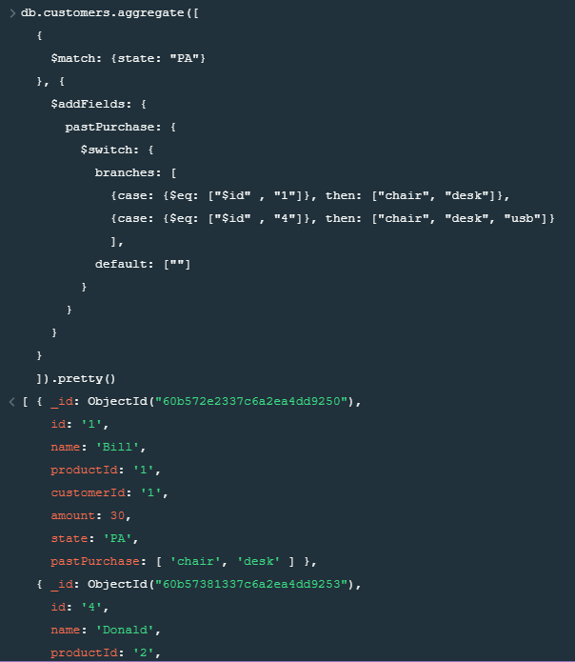

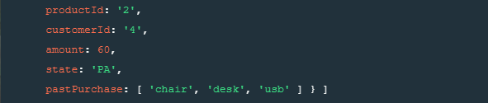

**Part B**

**(1)**

db.createCollection("grocery")



db.grocery.insert({name: "Bob", shoppingCart: "Milk, Corn, Chocolates", discount: 0.75});

db.grocery.insert({name: "Alice", shoppingCart: "Milk, Turkey, Apple", discount: 0});

db.grocery.insert({name: "Trudy", shoppingCart: "Cheese, Corn, Tomatoes, Ginger, Juice, Pork", discount: 1.50});

db.grocery.insert({name: "Jacob", shoppingCart: "Ice Cream, Onions, Tomatoes, Vinegar, Chicken, Fish", discount: 2.60});

db.grocery.insert({name: "Paul", shoppingCart: "Cheese, Chocolates, Fish, Bread"});

db.grocery.insert({name: "Jack", shoppingCart: "Milk, Corn, Fish", discount: 0.25});

db.grocery.insert({name: "Mary", shoppingCart: "Milk, Turkey, Apple", discount: 0});

db.grocery.insert({name: "Kate", shoppingCart: "Cheese, Apple, Corn, Juice, Pork", discount: 3.50});

db.grocery.insert({name: "Chris", shoppingCart: "Ice Cream"});

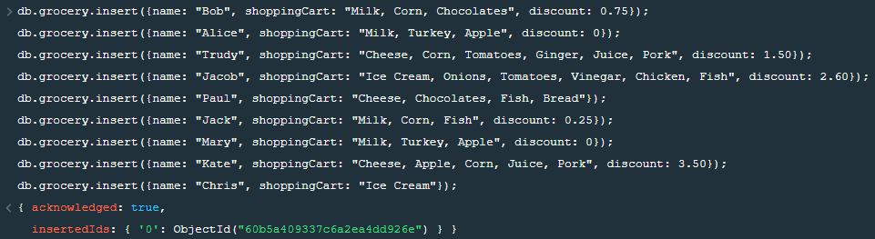

**(2)**

db.grocery.insert({name: "Zhang", shoppingCart: "Apple, Ice Cream, Chocolates", discount: 1.25});



**(3)**

db.grocery.find().pretty()

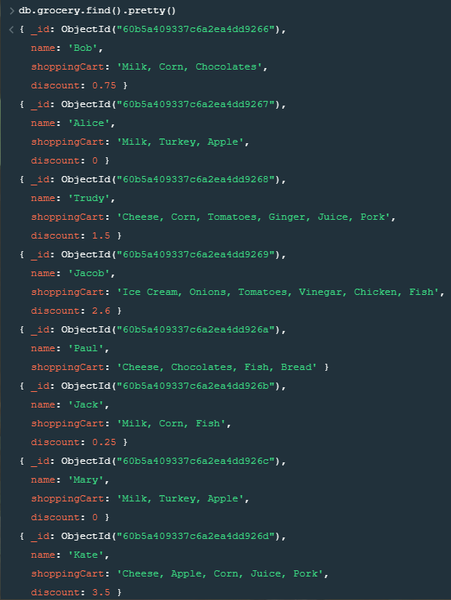

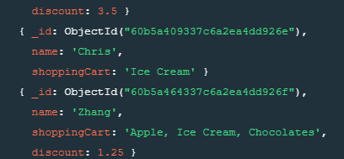

**(4)**

db.grocery.mapReduce(

function() {

if(this.discount > 0) {

emit("totalDiscountPeopleCount", "totalDiscountPeopleCount");

}

},

function(key, values) {

var counter = 0;

for (v in values) {

counter++;

}

return counter;

},

{

out: "totalDiscountPeopleCount"

}

);

db.totalDiscountPeopleCount.find().pretty();

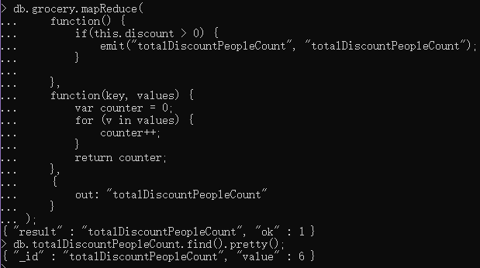

**(5)**

db.grocery.mapReduce(

function() {

if(this.discount != null) {

emit("totalDiscountValue", this.discount);

}

},

function(key, values) {

var counter = 0;

for (v in values) {

counter += values[v];

}

return counter;

},

{

out: "totalDiscountValue"

}

);

db.totalDiscountValue.find().pretty();

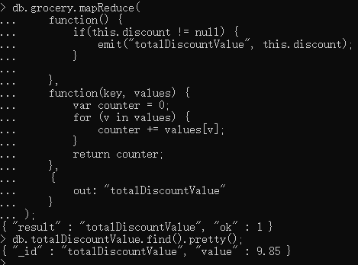

**(6)**

db.grocery.mapReduce(

function() {

var itemList = this.shoppingCart.split(", ");

for(i in itemList){

emit(itemList[i], 1);

}

},

function(key, values) {

return Array.sum(values);

},

{

out: "itemAppearTimes"

}

);

db.itemAppearTimes.find().pretty();

