

《机器学习2》
实验报告

学 院 | 卓越学院
专 业 | 智能科学与技术
学 号 | 20051212
学生姓名 | 龚郝亮

2022年 10 月14 日

一、实验内容（题目）
用贝叶斯实现西瓜数据集v3分类
二、实验过程（程序）
自定义函数贝叶斯.py:
from math import *
import pandas as pd
import numpy as np
from sklearn.preprocessing import LabelEncoder
def calculate1(i, label):
fea_num = 0
label_num = 0
for k in range(xigua.shape[0]):
if xigua[k][-1] == label:
label_num += 1
if xigua[k][i] == data_predict[i - 1]:
fea_num += 1
p = round(fea_num / label_num, 3)
return p
def laplacian_calculate1(i, label):
fea_num = 0
label_num = 0
num = 0
for k in range(xigua.shape[0]):
if xigua[k][i] > num:
num = xigua[k][i]
if xigua[k][-1] == label:
label_num += 1
if xigua[k][i] == data_predict[i - 1]:
fea_num += 1
p = round((fea_num + 1) / (label_num + num + 1), 3)
return p
def calculate2(i, label):
x = data_predict[i - 1]
num = 0 # 个数
miu = 0 # 中位数
var = 0 # 方差
for k in range(xigua.shape[0]):
if xigua[k][-1] == label:
miu += xigua[k][i]
num += 1
miu /= num
for k in range(xigua.shape[0]):
if xigua[k][-1] == label:
var += pow(xigua[k][i] - miu, 2)
var /= num - 1
return 1 / ((sqrt(2 * pi)) * sqrt(var)) * exp(-(x - miu) * (x - miu) / (2 * var))
def predict(list_a, list_b):
sum_a = 0.0
sum_b = 0.0
for i in range(len(list_a)):
sum_a = sum_a * list_a[i]
for j in range(len(list_b)):
sum_b = sum_b * list_b[j]
if sum_a >= sum_b:
result = "好瓜"
else:
result = "坏瓜"
print(result)
if __name__ == "__main__":
# 使用Pandas导入数据
filename = "西瓜数据集3.0.xls"
names = ["编号", "色泽", "根蒂", "敲声", "纹理", "脐部", "触感", "密度", "含糖量", "好瓜"]
data = pd.read_excel(filename, names=names)
# print(data)
data_predict = [2, 2, 1, 1, 0, 0, 0.697, 0.460]
for i in data.columns[1:7]:
le = LabelEncoder()
le.fit(data[i])
data[i] = le.transform(data[i])
# print(data)
xigua = np.array(data)
# print(xigua)
P_good1 = []
P_bad1 = []
P_good1.append(round(8 / 17, 3))
P_bad1.append(round(9 / 17, 3))
for i in range(1, 7):
P_good1.append(calculate1(i, '是'))
P_bad1.append(calculate1(i, '否'))
for i in range(7, 9):
P_good1.append(calculate2(i, '是'))
P_bad1.append(calculate2(i, '否'))
print(P_good1)
print(P_bad1)
predict(P_good1, P_bad1)
#添加拉普拉斯修正
P_good2 = []
P_bad2 = []
P_good2.append(round(9 / 19, 3))
P_bad2.append(round(10 / 19, 3))
for i in range(1, 7):
P_good2.append(laplacian_calculate1(i, '是'))
P_bad2.append(laplacian_calculate1(i, '否'))
for i in range(7, 9):
P_good2.append(calculate2(i, '是'))
P_bad2.append(calculate2(i, '否'))
print(P_good2)
print(P_bad2)
predict(P_good2, P_bad2)

sklearn贝叶斯.py：
import numpy as np
import pandas as pd
from sklearn.naive_bayes import GaussianNB
from sklearn.model_selection import train_test_split
from sklearn.preprocessing import LabelEncoder
# 导入数据集
df1 = pd.read_excel('西瓜数据集3.0.xls')
np1 = np.array(df1)
for i in range(np1.shape[1]):
if i != 7 and i != 8:
enc = LabelEncoder()
np1[:, i] = enc.fit_transform(np1[:, i])
np1[:, i] = np1[:, i].astype('int')
X = np1[:, 1:9]
y = np1[:, 9]
y = y.astype('int')
xtrain, xtest, ytrain, ytest = train_test_split(X, y, test_size=0.3, random_state=0)
gnb = GaussianNB().fit(X, y)
acc_score = gnb.score(X, y)
print(acc_score)
y_pred = gnb.predict(X)
yprob = gnb.predict_proba(X)

三、实验结果与分析
自定义函数贝叶斯.py：
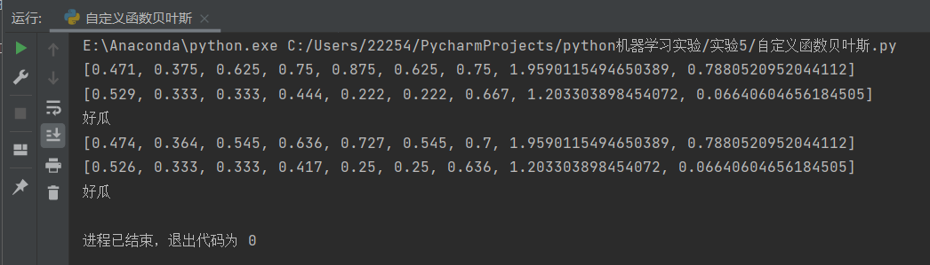
Sklearn贝叶斯.py：
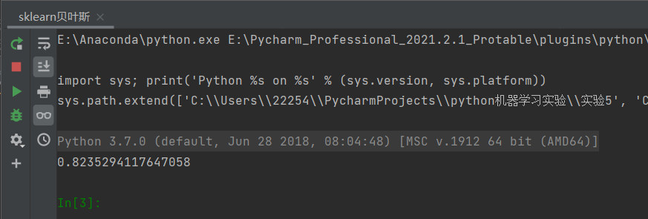
可以看到，自定义函数贝叶斯.py成功实现了朴素贝叶斯算法和添加拉普拉斯修正的朴素贝叶斯算法并计算正确了类先验概率和每个属性的条件概率（与西瓜书上一致），成功实现了对样本的预测，是通过自定义函数实现的。
而sklearn贝叶斯.py则使用sklean库的高斯朴素贝叶斯模型GaussianNB拟合了样本数据，模型在全体数据集上的得分也比较高。

