RESEARCH SUMMARY | PHASE 7B
Reliable Robotic Manipulation Through Evidence-Grounded Control
Across identical simulation protocols, optimized PID produced the strongest aggregate reliability while no controller dominated every condition.

Problem and research question
Reliable manipulation requires more than nominal trajectory tracking: controllers must remain interpretable under payload, configuration, disturbance, noise, and actuator changes.

Method
A 2-link arm compares manual PID, Mamdani Fuzzy-PID, and bounded optimization-assisted PID under identical 0.001 s simulation, trajectory, torque-limit, threshold, and paired-seed protocols.

Key results
Evidence snapshot: 7.283% nominal objective reduction; 10/13 optimized PID deterministic scenarios passed; 30/30 vs 0/30 per controller-scenario cell: isolated-noise cell vs full-combined-stress cell
7.283%  nominal objective reduction | 10/13  optimized PID deterministic scenarios passed | 30/30 vs 0/30  per controller-scenario cell: isolated-noise cell vs full-combined-stress cell
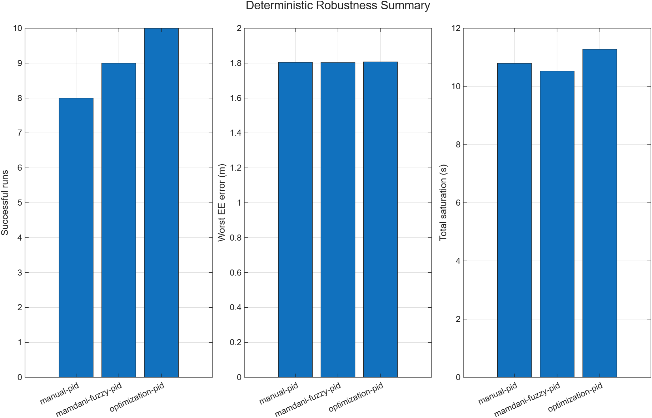
Figure. Deterministic stress testing separates aggregate controller reliability while preserving failed cases.

Why this matters
The project supplies a transparent low-level execution layer that can sit beneath future perception, language, and task-planning systems.

Simulation scope
Simulation only; no hardware fidelity, collision avoidance, perception, online safety supervisor, or end-to-end embodied-AI implementation is claimed.

Limitations and next steps
Validate on hardware, add calibrated sensing uncertainty, and introduce runtime safety monitoring before deployment claims.
Sources: docs/report/technical_report.md | results/report/report_evidence.json | docs/report/build_manifest.json

