**My Pantry**

# Project Requirement Capture

**Revision History**

|  |  |  |  |
| --- | --- | --- | --- |
|  |  |  |  |
| **0.0.1** | **Change Date** | **Initials of teammates involved** | **Initial revision** |
|  |  |  |  |

**Table of Contents**

Project Requirements Capture Deliverables/Schedule….…………………………….. 4 Current Situation……………………...……………………………………………………. 4 Statement of Work....………………………………………………………………………. 4 Scenarios…….……………………………………………………………………………... 5

Functional Requirements..………………………………………………………………... 5

Nonfunctional Requirements..……………………………………………………………. 5

Use Cases………………….……………………………………………………………….. 5

Project Schedule....………………………………………………………………………… 5

**Project Requirements Capture Deliverables/Schedule**

|  |  |
| --- | --- |
| **Description** | **Complete Date** |
| Requirement Capture Document | Date |
| Powerpoint Presentation |  |
| Team Review (during team meeting) |  |
| Assign Presenter (during team meeting) |  |
| Upload Document/Presentation to Repository |  |
| Project Requirement Capture Review/Presentation (during class) |  |

**Deliverables**

* Problem Description
  + The current situation
  + Statement of Work
  + Functional Requirement
  + Nonfunctional Requirement (usability, reliability, performance,supportability)
* Scenarios
* Use Case
* Project Schedule
* Powerpoint Presentation

**Notes**

Problem description is a simple statement of what the product should do and not how to do it. Scenarios to Use Cases ratio is 2 to 1.

30­40% of functional requirements should have scenarios and use cases

# Current Situation

What problem are you trying to solve? Paragraph description

# Statement of Work

The project entails the development of an application to expand

This project will require a team of # developers. The time required to complete the project is approximately **time**. The team will deliver a completed and tested stand­alone application by **date**.

In order to reach decisions to support program timing and to identify issues and tasks, the development team will **what?**

Each team member will require a **hardware/software requirements?**

# Scenarios

Put your scenarios here.

# Functional Requirements Nonfunctional Requirements

**Use Cases**

EXAMPLE

**Use Case Name:** Search Participant Actors:

Child (Charlie in the Scenarios) Client (E­Guard Client)

WebDB (Subsystem) Flow of Events

1. Child initiates a search containing an inappropriate word in the search criteria
2. The inappropriate words are matched to a list of blacklisted words
3. As Child types the search, the screenshot is taken
4. The search string typed by Child initially is modified to exclude the bad words
5. The screenshot is sent to the WebDB

### Project Schedule

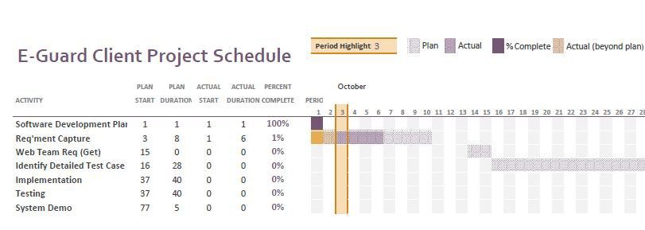

**Example Project Schedule**