Exemplar Small Group Setup.
Pre-requisites:
You must have completed the base workbench setup instructions which includes the setup of Maven, Tortoise and eclipse with the Maven and Subclipse plugin.
Exemplar/trunk uses java 1.5.
Make sure that your system JAVA_HOME and PATH is correclty set.
Make all the necessary version changes for eclipse compilations and runtime.

Step 1 : Download the source
1) Create folder c:\riverwood\exemplar-trunk.
Let the folder name reflect the svn branch you’ll be working on.
2) Click on this folder.
3) Go to File/SVN Checkout.....

URL of repository : http://source.wks.ct.com/repos/exemplar/trunk
Checkout directory : C:\riverwood\exemplar-trunk
Revision : HEAD Revision

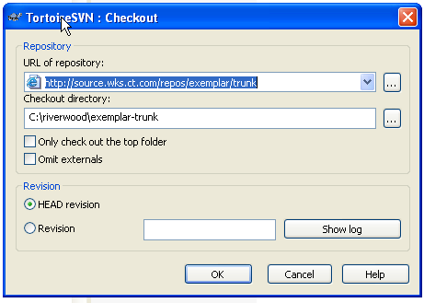

4) Type in your windows username and password.

Step 2 : eclipse setup
1) Start eclipse
2) Create a new workspace C:\workspaces\exemplar-trunk
3) Click File....New.....Project
4) Select Java Project

Project name : exemplar
Click “Create project from existing source” and browse to C:\riverwood\exemplar-trunk
Click FINISH

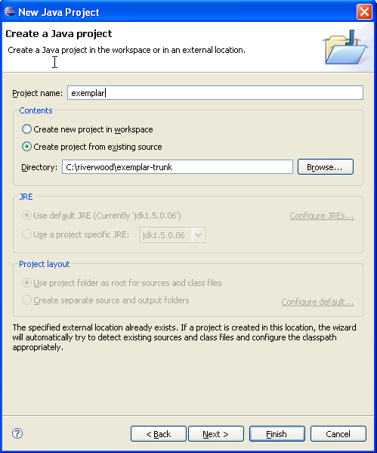

Set the Source Folders on build path:
Go to Java Build Path. (Highlight the project. Right click, properties, Java Build Path)
Choose the source tab
You should see

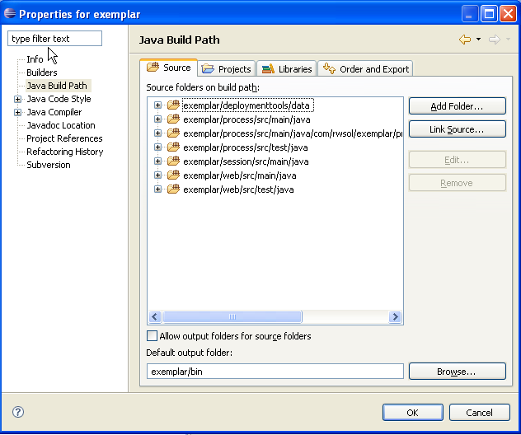

Set the “Default output folder” to exemplar/bin
Remove all the exemplar source folders. You should now no entries.
We now add the source folders as needed.
Select the source folder as in the attached screen shot

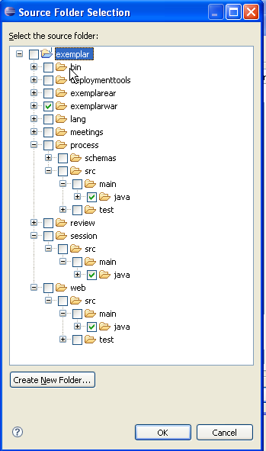

Click OK
You should see

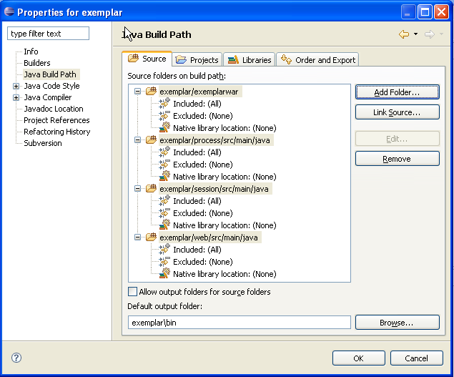

Click OK

Add view filters.
In the “Package Explorer” view there’s a dropdown on the far right side.

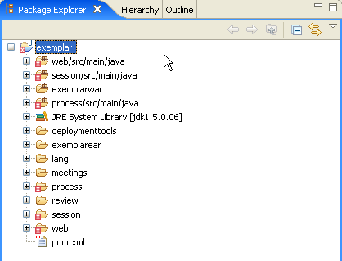

Click the dopdown and select “Filters...”
Enter the filter criteria as in the snap below.
Filter out the deploymenttools, meetings, process, review, session, web, exemplarear, lang from display

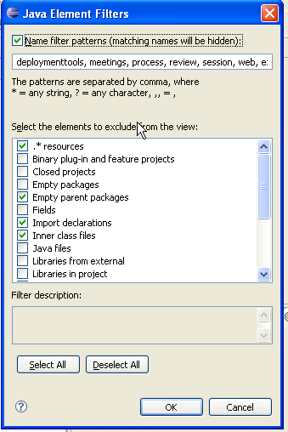

You should end up as in snap below

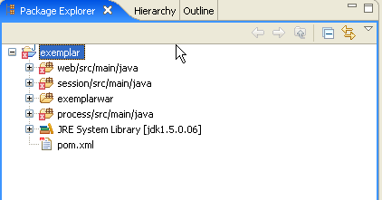

exemplar/session/src/main/java
exemplar/process/src/main/java
exemplar/exemplarwar
exemplar/web/src/main/java

5) We now need to resolve all dependencies. We use Maven for this.

Bring up the command prompt.
Change directory to C:\riverwood\exemplar-trunk.
Type “MVN clean”. This cleans out the Maven repositories for us. Because this is a initial installation, this should not be necessary.
Type “MVN install”. This builds a new Maven repository for us in C:\Documents and Settings\user name\.m2\repository
You will see lots of warnings. Ignore them.
You should see as below once the install completes

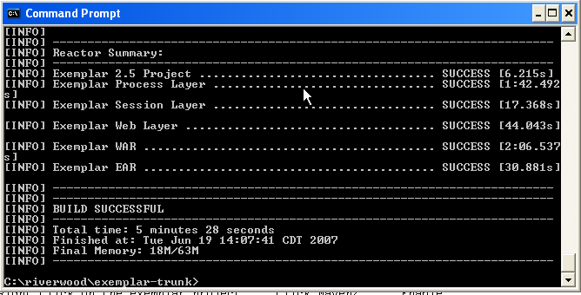

Go back to eclipse
Right Click on the exemplar project.....Click Maven2......Enable
This will resolve all dependencies.
You should not see any red X’s in your project at this point.

Step 3 : JBOSS config

Copy (1) and (2) below from P:\Office\Documents\Training\Java\Software\eXemplar\JBOSS
1) Copy files exemplar.properties and go.bat to the C:\jboss-4.0.3SP1 directory
2) Copy the ms-sql-ds.xml file to C:\jboss-4.0.3SP1\server\default\deploy Change the username and password to your own. ATL developers will also need to change the url to be ATL specific.
You will need to get this from a colleague who has exemplar running.
3) Ensure that you have the SQL Server drivers in C:\jboss-4.0.3SP1\server\default\lib
Copy from P:\Office\Documents\Training\Java\Software\DBDrivers\SQLServer if necessary.

Step 4 : Test a build

Make a small change
Save the change

Bring up the command prompt.
Change directory to C:\riverwood\exemplar-trunk.
Type “MVN install”.
If you get a build failed message, then you’ll need to resolve the error messages.
If you get a BUILD SUCCESSFUL message the go to C:\riverwood\exemplar-trunk\exemplarear\target to find the ear file.
Copy the ear file to JBOSS C:\jboss-4.0.3SP1\server\default\deploy.
Start JOSS; double click C:\jboss-4.0.3SP1\go.bat
Bring up the browser and enter url http://localhost:8080/exemplar/version.html

