WEEK 05 | FLEET FORECAST & BATTERY HEALTH
Service demand forecasting · Battery degradation · Operational planning
inGen Dynamics | Data Scientist Internship • Simulation cutoff: 30 June 2026 • Synthetic fleet: 50 robots / 7 sites

Executive summary
This analysis uses synthetic fleet telemetry and maintenance history to evaluate 12-week maintenance-demand forecasts, battery-capacity degradation, and illustrative staffing and procurement decisions. The Last Value baseline achieved the best rolling-origin service-demand MAE (1.02 events/week), while per-unit linear battery modeling achieved the lowest capacity MAE (0.4107 percentage points). These are simulated-data findings, not live operational forecasts.
Key planning output | Result
12-week expected demand | 12 service events / 96 technician-hours
Staffing sensitivity | 32 hours in 5 weeks vs 30 hours/technician/week
Battery scenarios | 50 first crossings per threshold (80% or 90%)
Interval check | 70.8% empirical coverage vs 80% nominal
Historical risk–capacity association | Pearson r = −0.1783 (weak)

1 | Weekly service-demand forecasting
Service events were aggregated by calendar week from the synthetic maintenance log (131 events; 79 calendar weeks, including incomplete boundary weeks). Model evaluation used seven rolling forecast origins and 12 horizons (84 forecasts per model); the future planning period begins 6 July 2026, avoiding the incomplete week of 29 June.
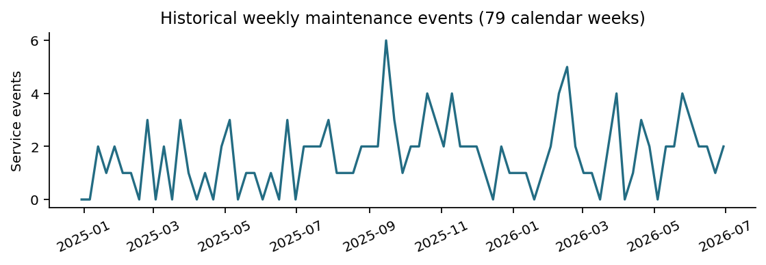
Figure 1. Historical synthetic weekly service events; boundary weeks are partial.
Model | MAE | WAPE
Last Value | 1.02 | 57.33%
Exponential Smoothing | 1.15 | 64.40%
Prophet | 1.33 | 74.52%
Moving Average (4) | 1.45 | 81.33%
Seasonal Naive (4) | 1.65 | 92.67%
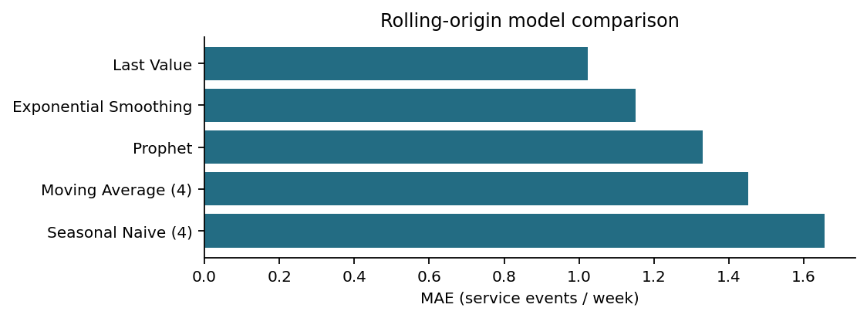
Figure 2. Rolling-origin MAE; lower is better. All models share the same 84 forecast targets.
Last Value is retained as the planning baseline. Its WAPE of 57.33% indicates substantial uncertainty despite the lowest comparative MAE; a constant one-event/week projection should not be interpreted as precise demand.

2 | Forecast intervals and uncertainty
A horizon-dependent residual approach was evaluated using earlier origins for calibration and later origins for checking. After removing overlapping evaluation target weeks, coverage was 17/24 = 70.8% against nominal 80%, with mean interval width ≈3.12 events. The small sample, neighboring-horizon pooling, and residual dependence mean these ranges are exploratory rather than statistically guaranteed 80% prediction intervals.
Weekly upper planning counts were conservatively rounded outward to whole service events. These upper scenarios are useful for capacity sensitivity, but should be re-estimated as additional independent weeks become available.

3 | Battery degradation and replacement dates
The lifecycle dataset contains 109,126 deduplicated telemetry records across 50 robots, with battery-repair segmentation to account for partial resets. Per-unit linear, per-unit exponential, and pooled linear models were evaluated using chronological train/test splits.
Model | Capacity MAE (percentage points) | Predictions
Per-Unit Linear | 0.4107 | 21,848
Per-Unit Exponential | 0.4152 | 21,848
Pooled Linear | 0.4299 | 21,848
The per-unit linear model performed best (MAE 0.4107 percentage points); a pooled-slope fallback was used where recent post-repair history was too sparse. Replacement dates are first projected crossings of 80% capacity (primary) or 90% (sensitivity), not observed failures or repeated replacement cycles. Crossing-date bootstrap bands are not independently calibrated.

4 | Technician staffing and battery procurement
Across 12 weeks, expected demand is 12 service events, or 96 hours assuming 8 hours/event. At 30 productive hours per technician/week, one technician covers the expected workload. In five August weeks, the exploratory upper case is 32 hours/week: only 2 hours above one technician's weekly capacity, so flexible overtime or cross-coverage is preferable to assuming a second full-time hire is necessary.
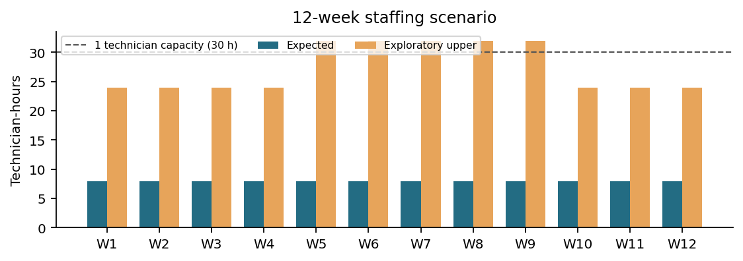
Figure 3. Forecast-driven technician workload; the upper case is an exploratory sensitivity scenario.
Procurement assumes 30 days of supplier lead time plus 14 days of planning buffer (44 days before predicted crossing). Under the 90% sensitivity threshold, 31 first-crossing battery orders fall in September–November 2026; the 80% scenario first requires orders in June 2028. These are alternative policies: do not add their counts, and do not sum point and early-crossing scenarios.
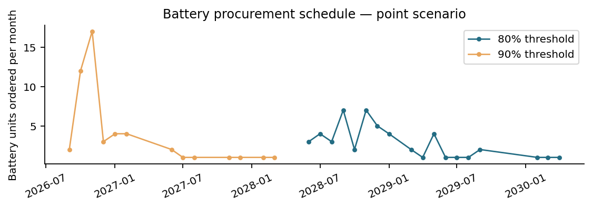
Figure 4. Monthly point-scenario order quantities by alternative threshold; months with no orders are omitted.

5 | Week 4 historical risk cross-check
Week 4 validation scores cover 8 November 2025–28 February 2026, while the battery capacity snapshot is June 2026. All 50 robot IDs matched. Historical mean raw Gradient Boosting risk score and later capacity show a weak negative Pearson association (r = −0.1783). The top risk quintile averaged 92.19% capacity versus 93.50% for other robots (1.30 percentage points lower). This is a cross-period descriptive comparison, not contemporaneous validation or evidence of causality.
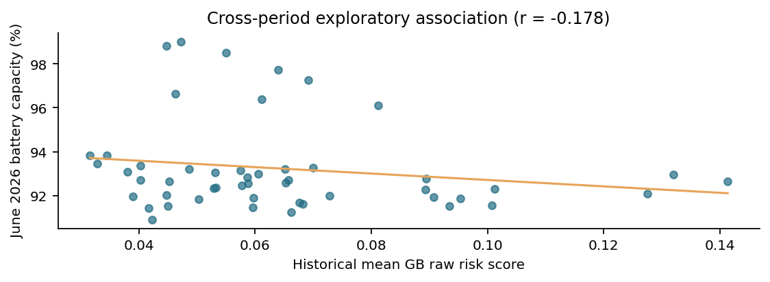
Figure 5. Historical Week 4 risk scores compared with later observed synthetic battery capacity.
Week 4 validation AP for the raw Gradient Boosting model was approximately 0.053 versus a 0.041 event prevalence; its ranking performance was modest. Robot-day failure labels and threshold alerts cannot be treated as independent service tickets. No future service queue was available, so risk-driven queue validation remains outstanding.

6 | Limitations and next actions
- Synthetic causal generator and sparse event counts limit external validity; all dates are relative to the June 2026 simulation cutoff.
- Rolling-origin forecasts share target weeks; interval calibration requires more independent periods and ideally prospective validation.
- Battery crossing dates extrapolate degradation and charge-cycle trends; replacements, operating changes, and supplier stock may alter timing.
- Staffing hours (8 per event; 30 productive per technician/week) and 44-day procurement advance are illustrative, not vendor or workforce commitments.
- Connect future risk scores to actual dated work orders, technician rosters, battery inventory and supplier lead times before operational deployment.

Supporting deliverables
W05_Planning_Outputs.xlsx (staffing, replacements, monthly/unit procurement, summary, assumptions); CSVs for model comparisons, interval evaluation, battery lifecycle and crossing dates, and historical risk cross-check. All figures in this report are generated from the supplied Week 5 CSV files.

