W02 | Data Profile
Predictive Maintenance & Fleet Forecasting • Aido Rover synthetic fleet
Week 2 deliverable | October 2026 | Prepared by Yang Zhao

Executive summary
This report profiles the reproducible synthetic fleet used for the Week 2 predictive-maintenance workflow. The source covers 50 robots across seven sites from 1 January 2025 through 30 June 2026 (546 calendar days). Six relational-style tables were cleaned and audited. The final chronological robot-day modelling frame contains 26,135 eligible observations, including 1,231 positive labels (4.71%). The target is at least one severity ≥3 fault within the next seven calendar days.
Cleaning removed 200 exact duplicate telemetry rows; fixed clock offsets on eight robots; identified 82 missing expected readings across 30 telemetry gaps; and flagged rather than deleted 2,906 telemetry records with one or more IQR outliers. The strongest descriptive pre-fault contrast among the four explored telemetry means was motor current (+0.237 A, approximately +5.89%). These exploratory differences are not estimates of predictive performance.

1. Dataset inventory and coverage
Table | Records | Purpose
Sites | 7 | Site metadata
Robots | 50 | Fleet units and commissioning
Telemetry (raw) | 109,318 | 6-hour sensor readings, including duplicates
Telemetry (clean) | 109,118 | Deduplicated and timestamp-corrected readings
Missions | 46,579 | Operating intervals
Faults | 289 | Fault occurrence, severity and type
Maintenance | 161 | Service intervals

Expected telemetry: 50 robots × 546 days × 4 readings/day = 109,200. Observed unique cleaned readings: 109,118, yielding 99.925% grid coverage. Counts for non-telemetry tables are based on the Week 2 profiling runs; telemetry counts and derived coverage were cross-checked against the supplied analysis outputs.

2. Cleaning pipeline and data quality

2.1 Type standardisation, duplicates and clock drift
The cleaning script parses declared timestamp columns as UTC, drops exact duplicate rows, sorts each table deterministically, and exports cleaned CSVs. Telemetry timestamps are adjusted using each robot’s median signed offset from the nearest six-hour UTC grid; original_timestamp is retained for traceability. The independent clock-drift audit compares raw and cleaned streams: eight robots initially showed median offsets (−9 to +20 minutes); no residual median drift was detected after correction.
Unit | Raw offset (min) | Clean offset (min)
R004 | +8 | 0
R006 | +20 | 0
R009 | +20 | 0
R010 | +12 | 0
R030 | +19 | 0
R033 | -9 | 0
R043 | +10 | 0
R047 | -2 | 0

Important reproducibility note: clock_drift_audit.csv is the current raw-versus-clean audit. The separately uploaded clock_drift_summary.csv was produced by an earlier analysis step and should not be interpreted as the authoritative post-clean correction audit without checking its input provenance.

2.2 Missing readings and telemetry gaps
Measure | Result
Missing expected readings | 82
Detected gaps > 6 hours | 30
Possible connectivity gap (mission overlap) | 38
Unknown cause | 44
Maintenance overlap | 0

Missing readings coinciding with a mission are classified as possible connectivity gaps, not proven network outages. Unknown gaps cannot reliably be labelled robot-off periods. No missing telemetry values were imputed during Week 2.

2.3 Outlier treatment
Sensor | IQR outliers | Share of cleaned telemetry
battery_capacity_pct | 0 | 0.000%
charge_cycles | 0 | 0.000%
motor_current_a | 2197 | 2.013%
wheel_wear_pct | 726 | 0.665%
temperature_c | 15 | 0.014%

The IQR rule (Q1 − 1.5×IQR, Q3 + 1.5×IQR) is applied per sensor to flag unusual values. There are 2,906 distinct telemetry rows with at least one flag; the sum of individual sensor flags can be higher because rows may have multiple flags. Values are retained to avoid erasing possible pre-failure signatures. Physical-range checks in the Week 2 analysis found no violations of the specified basic bounds.

3. Fault and maintenance profile
The fleet has 289 recorded fault events, of which 185 are severity ≥3. These are event counts, not robot-day labels: one event can make several consecutive robot-days positive because the prediction horizon spans seven days. The source contains 161 maintenance intervals; the earlier maintenance profiling found a median duration of approximately 24.91 hours.
Site | All faults | Severe faults
SITE_06 | 64 | 46
SITE_04 | 67 | 38
SITE_07 | 44 | 28
SITE_05 | 28 | 21
SITE_01 | 43 | 20
SITE_02 | 25 | 18
SITE_03 | 18 | 14

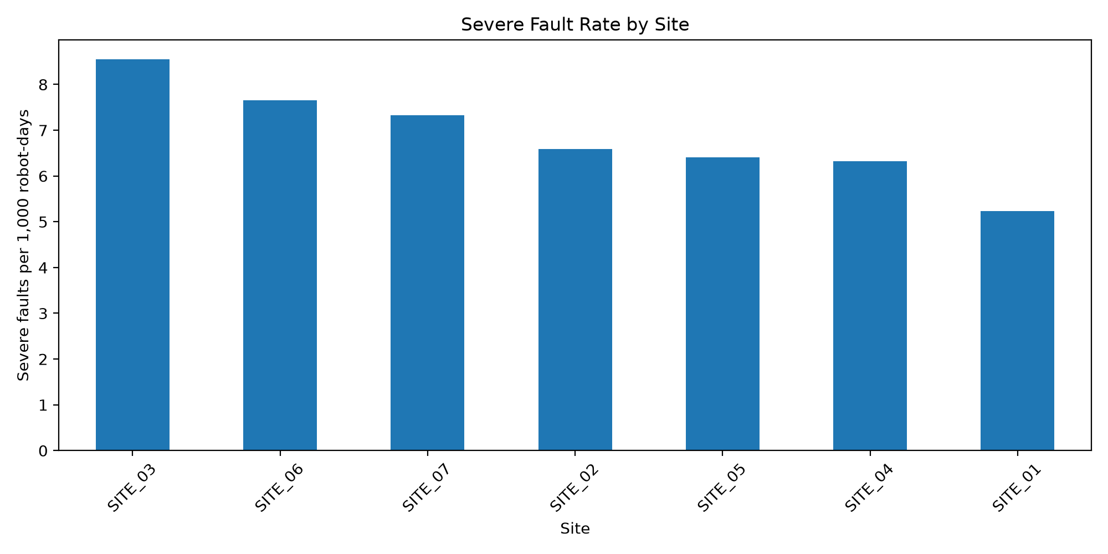
Figure 1. Severe fault events per 1,000 calendar robot-days by site (not a model positive-label rate).
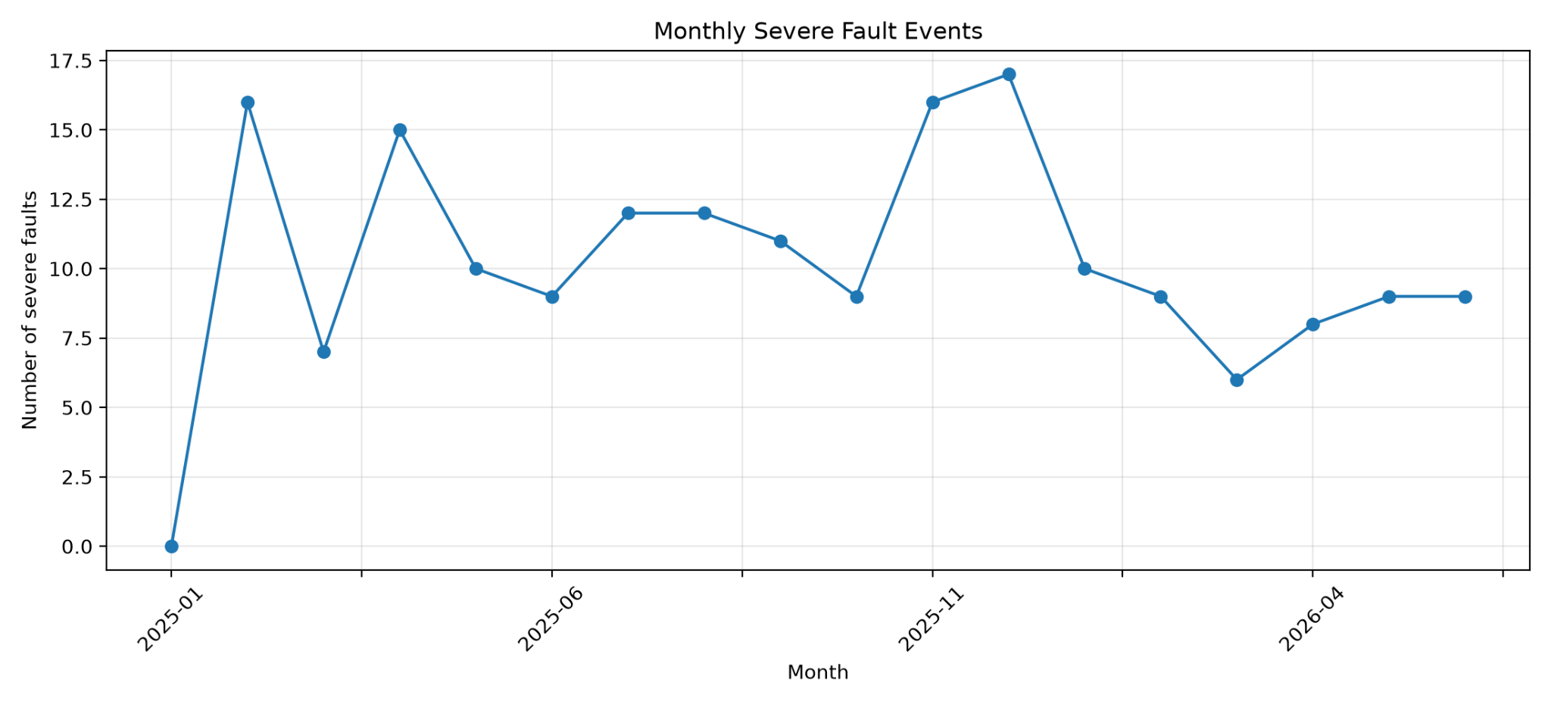
Figure 2. Monthly severity ≥3 fault event counts. Variation is descriptive; no seasonal effect is established.

4. Robot-day modelling frame
Each sample is a (unit_id, prediction date) pair scored at 00:00 UTC. Eligible rows exclude a robot only if a maintenance interval is active at the prediction instant; this removes 168 initial robot-days. Labels equal 1 when at least one severity ≥3 fault occurs in [T, T+7 days). Prediction dates after 24 June 2026 are excluded because their full outcome windows are unavailable. Seven-day gaps separate chronological splits.
Split | Eligible robot-days | Positive labels | Positive rate
Train | 15,104 | 700 | 4.63%
Validation | 5,609 | 314 | 5.60%
Test | 5,422 | 217 | 4.00%
Total | 26,135 | 1,231 | 4.71%

The pre-split frame had 1,255 positive robot-day labels; 1,231 remain after outcome-window and split-gap exclusions. These are repeated horizon labels, not independent failure events. Final checks reported zero duplicate robot-days, label mismatches, maintenance-at-prediction overlaps, unknown robot IDs, invalid split assignments, and missing critical fields.

5. Pre-fault telemetry EDA
For each eligible robot-day, the exploratory analysis calculates mean telemetry over the previous seven days, using timestamps strictly before prediction time. At least 21 of 28 expected readings are required for sufficient history. Coverage: 25,835 of 26,135 robot-days (98.85%); 300 have insufficient history.
Seven-day mean | Negative | Positive | Difference
motor_current_a_mean_7d | 4.029 | 4.266 | +0.237
battery_capacity_pct_mean_7d | 95.085 | 95.202 | +0.116
wheel_wear_pct_mean_7d | 8.922 | 8.960 | +0.039
temperature_c_mean_7d | 22.249 | 21.606 | -0.643

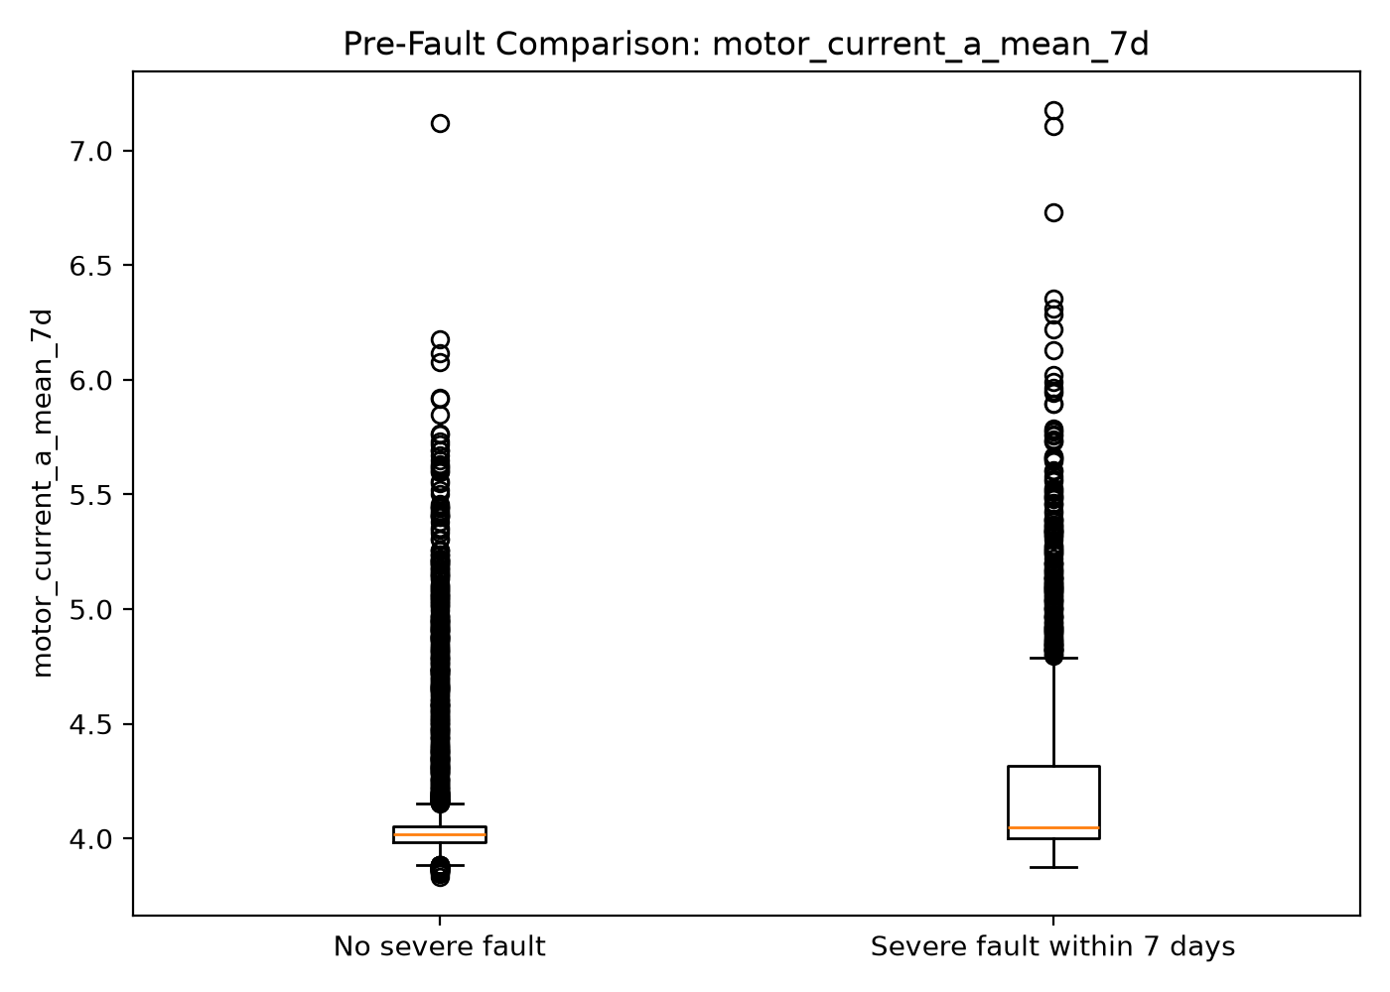
Figure 3. Motor-current distributions; higher mean current is associated descriptively with positive robot-days.
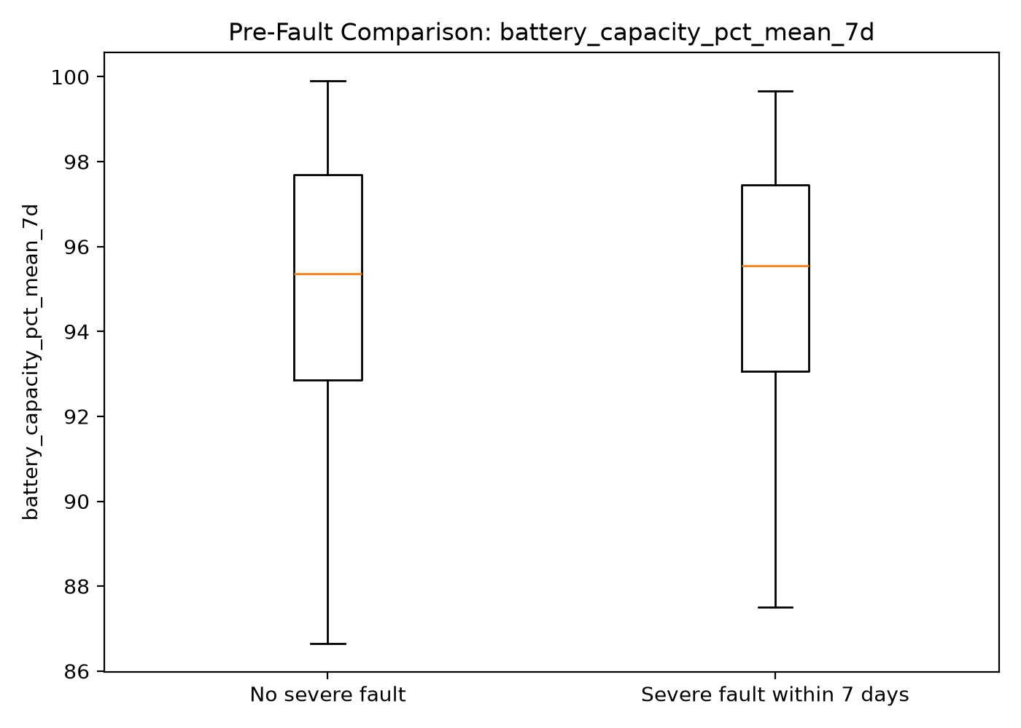
Figure 4. Battery-capacity distributions overlap substantially.
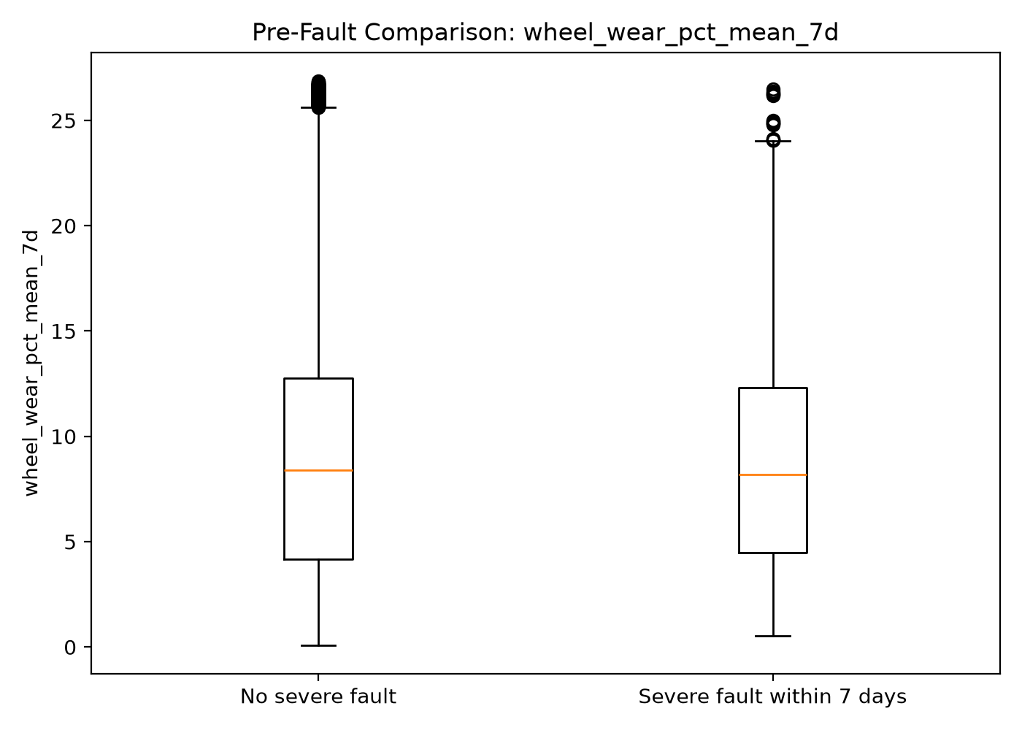
Figure 5. Wheel-wear distributions overlap substantially.
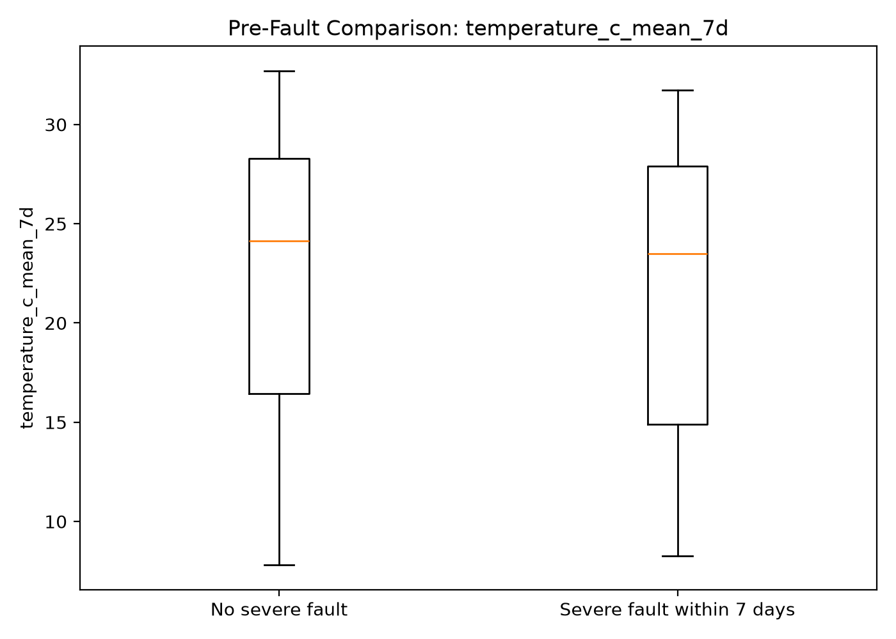
Figure 6. Temperature distributions overlap; the group mean differs modestly.
Interpretation: motor current is a plausible candidate for Week 3 trend and rolling-window features, but the distributions overlap and many positive robot-days share an underlying fault event. This pooled EDA includes train, validation and test periods and is descriptive only; feature selection and threshold tuning should be based on training/validation data, preserving the test period for final evaluation.

6. Leakage controls, limitations and next steps
The Week 1 problem specification defines a one-day blackout in calendar-day terms: features may use observations through T−1, while the outcome covers T through T+6. The implemented [T−7 days, T) telemetry window at 00:00 UTC does not include any same-day readings and is consistent with that convention. Fault occurrence timestamps, rather than logging timestamps, define outcomes.
Limitations: (1) synthetic failure mechanisms and site distributions may not generalise to live deployments; (2) telemetry gap causes remain partly unknown; (3) IQR flags are descriptive, not definitive sensor faults; (4) site rates use calendar robot-days rather than adjusted operational exposure; (5) pooled EDA is not causal and should not be treated as held-out predictive evidence; and (6) time-dependent label windows create correlated robot-day positives.
Week 3 should engineer leakage-tested trailing-window and trend features, document missing-history handling, train baseline models using chronological splits, evaluate PR-AUC and inspection-budget metrics, and preserve the held-out test set for final model assessment.
Evidence base: W02_clean_fleet.py, W02_build_modeling_frame.py, uploaded profiling CSVs and EDA figures, plus Week 2 validation logs.

