run 2D_Erosion case as it is
A
Agent
Starting simulation workflow…
A
Agent
SIMULATION PLAN
Reasoning
Using the existing 2D_Erosion case as-is. I preserved the original geometry, resolution (dp=0.0064), 2D domain convention (pointmin.y = pointmax.y = 0), and the first listed non-Newtonian phase parameters from the provided case. Execution parameters match the supplied XML defaults.
Geometry XML
<geometry>
<definition dp="0.0064">
<pointmin x="-4" y="0" z="-1" />
<pointmax x="4" y="0" z="4" />
</definition>
<commands>
<mainlist>
<setshapemode>dp | bound</setshapemode>
<setdrawmode mode="full" />
<!-- Phase 1 -->
<rotateline ang="23">
<point x="0" y="1" z="0" />
<point x="0" y="-1" z="0" />
</rotateline>
<setmkfluid mk="0" />
<drawbox>
<boxfill>solid</boxfill>
<point x="-3" y="-0.15" z="0" />
<size x="1.5" y="0.3" z="0.2"/>
</drawbox>
<!-- wall boundaries -->
<setmkbound mk="1" />
<drawbox>
<boxfill>bottom | front | back</boxfill>
<point x="-3.84" y="-0.15" z="0.0" />
<size x="3.84" y="0.3" z="0.4" />
<layers vdp="0,1,2" />
</drawbox>
<matrixreset />
<!-- Phase 2 -->
<setmkfluid mk="1" />
<drawbox>
<boxfill>solid</boxfill>
<point x="0" y="-1.5" z="-0.2" />
<size x="3" y="3" z="0.2" />
</drawbox>
<setmkbound mk="2" />
<drawbox>
<boxfill>front | back | bottom | left</boxfill>
<point x="0" y="-1.5" z="-0.2" />
<size x="3" y="3" z="0.2" />
<layers vdp="0,1,2" />
</drawbox>
<drawbox>
<boxfill>right</boxfill>
<point x="0" y="-1.5" z="-0.2" />
<size x="3" y="3" z="0.4" />
<layers vdp="0,1,2" />
</drawbox>
<shapeout file="Box"/>
</mainlist>
</commands>
</geometry>
Physics Parameters
gravity_z = -9.81 rhop0 = 1600.0 coefh = 1.0 cflnumber = 0.2 phase_rhop = 1600.0 visco_nn = 0.007 tau_yield = 0.1 HBP_m = 10.0 HBP_n = 1.5 Visco = 0.1 DensityDT = 3 DensityDTvalue = 0.1 TimeMax = 8.0 TimeOut = 0.2
U
You
run
U
You
yes
A
Agent
SIMULATION RESULTS
Default post-processing complete:
- Script: /home/yzhao52/DualSPHysics/DualSPHysics_NN_v5.0.1-danrong-mcp-simulation-agent/dualsphysics-maf/runs/run_20260329_015519/postprocess.sh
- Fluid VTK files: out/particles/PartFluid_*.vtk
- Boundary VTK files: out/particles/PartBound_*.vtk
Post-processing script: /home/yzhao52/DualSPHysics/DualSPHysics_NN_v5.0.1-danrong-mcp-simulation-agent/dualsphysics-maf/runs/run_20260329_015519/postprocess.sh
Generated files:
- /home/yzhao52/DualSPHysics/DualSPHysics_NN_v5.0.1-danrong-mcp-simulation-agent/dualsphysics-maf/runs/run_20260329_015519/out/particles/PartFluid_0000.vtk
- /home/yzhao52/DualSPHysics/DualSPHysics_NN_v5.0.1-danrong-mcp-simulation-agent/dualsphysics-maf/runs/run_20260329_015519/out/particles/PartFluid_0001.vtk
- /home/yzhao52/DualSPHysics/DualSPHysics_NN_v5.0.1-danrong-mcp-simulation-agent/dualsphysics-maf/runs/run_20260329_015519/out/particles/PartFluid_0002.vtk
- /home/yzhao52/DualSPHysics/DualSPHysics_NN_v5.0.1-danrong-mcp-simulation-agent/dualsphysics-maf/runs/run_20260329_015519/out/particles/PartFluid_0003.vtk
- /home/yzhao52/DualSPHysics/DualSPHysics_NN_v5.0.1-danrong-mcp-simulation-agent/dualsphysics-maf/runs/run_20260329_015519/out/particles/PartFluid_0004.vtk
- /home/yzhao52/DualSPHysics/DualSPHysics_NN_v5.0.1-danrong-mcp-simulation-agent/dualsphysics-maf/runs/run_20260329_015519/out/particles/PartFluid_0005.vtk
- /home/yzhao52/DualSPHysics/DualSPHysics_NN_v5.0.1-danrong-mcp-simulation-agent/dualsphysics-maf/runs/run_20260329_015519/out/particles/PartFluid_0006.vtk
- /home/yzhao52/DualSPHysics/DualSPHysics_NN_v5.0.1-danrong-mcp-simulation-agent/dualsphysics-maf/runs/run_20260329_015519/out/particles/PartFluid_0007.vtk
- /home/yzhao52/DualSPHysics/DualSPHysics_NN_v5.0.1-danrong-mcp-simulation-agent/dualsphysics-maf/runs/run_20260329_015519/out/particles/PartFluid_0008.vtk
- /home/yzhao52/DualSPHysics/DualSPHysics_NN_v5.0.1-danrong-mcp-simulation-agent/dualsphysics-maf/runs/run_20260329_015519/out/particles/PartFluid_0009.vtk
- /home/yzhao52/DualSPHysics/DualSPHysics_NN_v5.0.1-danrong-mcp-simulation-agent/dualsphysics-maf/runs/run_20260329_015519/out/particles/PartFluid_0010.vtk
- /home/yzhao52/DualSPHysics/DualSPHysics_NN_v5.0.1-danrong-mcp-simulation-agent/dualsphysics-maf/runs/run_20260329_015519/out/particles/PartFluid_0011.vtk
- /home/yzhao52/DualSPHysics/DualSPHysics_NN_v5.0.1-danrong-mcp-simulation-agent/dualsphysics-maf/runs/run_20260329_015519/out/particles/PartFluid_0012.vtk
- /home/yzhao52/DualSPHysics/DualSPHysics_NN_v5.0.1-danrong-mcp-simulation-agent/dualsphysics-maf/runs/run_20260329_015519/out/particles/PartFluid_0013.vtk
- /home/yzhao52/DualSPHysics/DualSPHysics_NN_v5.0.1-danrong-mcp-simulation-agent/dualsphysics-maf/runs/run_20260329_015519/out/particles/PartFluid_0014.vtk
- /home/yzhao52/DualSPHysics/DualSPHysics_NN_v5.0.1-danrong-mcp-simulation-agent/dualsphysics-maf/runs/run_20260329_015519/out/particles/PartFluid_0015.vtk
- /home/yzhao52/DualSPHysics/DualSPHysics_NN_v5.0.1-danrong-mcp-simulation-agent/dualsphysics-maf/runs/run_20260329_015519/out/particles/PartFluid_0016.vtk
- /home/yzhao52/DualSPHysics/DualSPHysics_NN_v5.0.1-danrong-mcp-simulation-agent/dualsphysics-maf/runs/run_20260329_015519/out/particles/PartFluid_0017.vtk
- /home/yzhao52/DualSPHysics/DualSPHysics_NN_v5.0.1-danrong-mcp-simulation-agent/dualsphysics-maf/runs/run_20260329_015519/out/particles/PartFluid_0018.vtk
- /home/yzhao52/DualSPHysics/DualSPHysics_NN_v5.0.1-danrong-mcp-simulation-agent/dualsphysics-maf/runs/run_20260329_015519/out/particles/PartFluid_0019.vtk ... and 62 more
U
You
plot sinking depth of the top phase against time. Sinking depth means the deepest point of the top phase compared to the original top of the bottom phase
A
Agent
Done.
I generated the plot and data for top-phase sinking depth vs time.
Results:
- Bottom phase mk: 2
- Top phase mk: 1
- Reference level = original top of bottom phase = z = -0.0016 m
- Maximum sinking depth = 0.03907 m at t = 8.0 s
Files saved in:
- out/analysis/top_phase_sinking_depth.png
- out/analysis/top_phase_sinking_depth.csv
- out/analysis/top_phase_sinking_depth_summary.txt
Definition used:
- The top phase was identified as the fluid phase with the higher initial mean elevation.
- Sinking depth = (initial top elevation of bottom phase) - (deepest z of top-phase particles at each time).
If you want, I can also:
- plot the deepest top-phase elevation directly,
- smooth the curve,
- compute average penetration depth instead of deepest-point depth,
- or overlay snapshots showing where that deepest point occurs.
U
Good
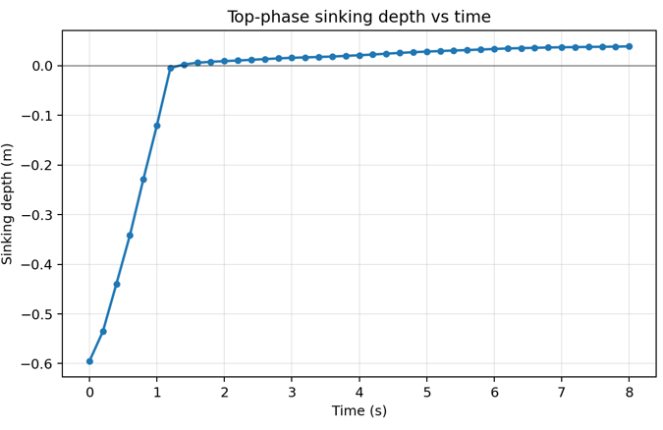
You
plot the runoff distance of the top phase against time and the deepest point of the top phase against time, both in its x direction, starting from when the two phases meet. Plot together.
A
Agent
Done — I plotted both curves together, starting from when the two phases first meet.
Files:
- out/analysis/top_phase_runoff_and_deepest_x_from_meeting.png
- out/analysis/top_phase_x_metrics_from_meeting.csv
- out/analysis/top_phase_x_metrics_from_meeting_summary.txt
Key results:
- Meeting time: 1.4 s
- Final runoff distance of top phase: 0.9229 m
- Final deepest-point x progress: 0.1051 m
Definitions used:
- Top phase runoff distance = change in the maximum x-position of top-phase particles after the meeting instant.
- Deepest-point x = change in the x-position of the deepest top-phase particle after the meeting instant.
- Meeting instant = first output where the deepest top-phase particle reaches or goes below the initial top elevation of the bottom phase.
If you want, I can also make a second version using:
- absolute x positions instead of x-change from meeting,
- runout of the centroid of the top phase,
- or a smoothed/interpolated curve.
Good, although the x axis value is not what I expected but is consistent with what is explained below and logically sound.
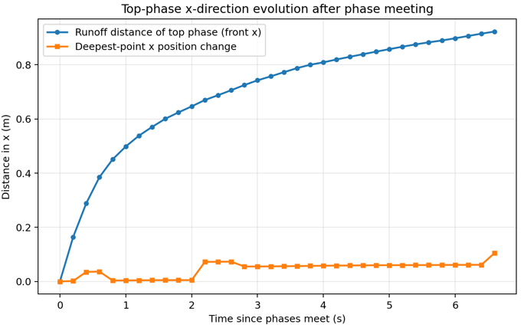
U
You
what is the x you used upon meeting
A
Agent
At the meeting instant (t = 1.4 s), I used two different x reference values:
- Front x of the top phase at meeting: this is the reference for the runoff distance
- Deepest-point x of the top phase at meeting: this is the reference for the deepest-point x progress
I haven’t printed those numbers in the chat yet, but they are stored in:
- out/analysis/top_phase_x_metrics_from_meeting_summary.txt
If you want, I can extract and report the exact two x values here.
U
You
plot volume per thickness against time of the top phase sinking to bottom and the volume per thickness of the bottom phase bulge to top. They are defined as the area crosses the initial interface height.
A
Agent
Done — I plotted both quantities together versus time.
Files:
- out/analysis/cross_interface_volume_per_thickness.png
- out/analysis/cross_interface_volume_per_thickness.csv
- out/analysis/cross_interface_volume_per_thickness_summary.txt
Definitions used:
- Top-phase sinking volume per thickness: total 2D area of top-phase particles below the initial interface height
- Bottom-phase bulge volume per thickness: total 2D area of bottom-phase particles above the initial interface height
Reference/interface:
- Initial interface height: z = -0.0016 m
How volume per thickness was computed:
- This is a 2D simulation measure, so I used
volume per thickness = area
- Estimated from particle count: [ V/\text{thickness} \approx N \cdot dp^2 ]
- Inferred particle spacing:
  - dp = 0.0064 m
  - particle area = 4.096e-5 m²
Key results:
- Max top-phase sunk volume/thickness: 0.01573 m² at t = 8.0 s
- Max bottom-phase bulged volume/thickness: 0.01147 m² at t = 8.0 s
If you want, I can also produce a more geometric version using:
- binned cross-interface area by x,
- signed net exchange area, or
- only the connected intrusion/bulge region instead of all particles crossing the interface.
Good. Although this is a simplified calculation. And it did mention what more accurate calculation should be.
