U
You
Use the same xml file InclinedTrenchDebrisFlow_Def.xml to run the case without changing
A
Agent
Starting simulation workflow…
A
Agent
SIMULATION PLAN
Reasoning
The instruction was to run the same InclinedTrenchDebrisFlow_Def.xml case without changing it, so I preserved the original 3D geometry and execution-relevant physics values exactly as given. The rotated trench, fluid release box, and boundary layers are unchanged, and the parameter set matches the existing XML constants and non-Newtonian phase definition.
Geometry XML
<geometry>
<definition dp="0.0064">
<pointmin x="-4" y="-2" z="-1" />
<pointmax x="4" y="2" z="4" />
</definition>
<commands>
<mainlist>
<setshapemode>dp | bound</setshapemode>
<setdrawmode mode="full" />
<rotateline ang="23">
<point x="0" y="1" z="0" />
<point x="0" y="-1" z="0" />
</rotateline>
<setmkfluid mk="0" />
<drawbox>
<boxfill>solid</boxfill>
<point x="-1.5" y="-0.15" z="0" />
<size x="0.3" y="0.3" z="0.2"/>
</drawbox>
<setmkbound mk="1" />
<drawbox>
<boxfill>bottom | front | back</boxfill>
<point x="-2" y="-0.15" z="0.0" />
<size x="2" y="0.3" z="0.4" />
<layers vdp="0,1,2" />
</drawbox>
<matrixreset />
<setmkbound mk="2" />
<drawbox>
<boxfill>bottom</boxfill>
<point x="-1" y="-1.5" z="0" />
<size x="3" y="3" z="0" />
<layers vdp="0,1,2" />
</drawbox>
<shapeout file="Box"/>
</mainlist>
</commands>
</geometry>
Physics Parameters
gravity_z = -9.81 rhop0 = 1700.0 coefh = 1.0 cflnumber = 0.2 phase_rhop = 1700.0 visco_nn = 0.007 tau_yield = 0.1 HBP_m = 10.0 HBP_n = 1.5 Visco = 0.1 DensityDT = 3 DensityDTvalue = 0.1 TimeMax = 8.0 TimeOut = 0.2
U
You
run
U
You
yes
A
Agent
SIMULATION RESULTS
Default post-processing complete:
- Script: /home/yzhao52/DualSPHysics/DualSPHysics_NN_v5.0.1-danrong-mcp-simulation-agent/dualsphysics-maf/runs/run_20260328_222457/postprocess.sh
- Fluid VTK files: out/particles/PartFluid_*.vtk
- Boundary VTK files: out/particles/PartBound_*.vtk
Post-processing script: /home/yzhao52/DualSPHysics/DualSPHysics_NN_v5.0.1-danrong-mcp-simulation-agent/dualsphysics-maf/runs/run_20260328_222457/postprocess.sh
Generated files:
- /home/yzhao52/DualSPHysics/DualSPHysics_NN_v5.0.1-danrong-mcp-simulation-agent/dualsphysics-maf/runs/run_20260328_222457/out/particles/PartFluid_0000.vtk
- /home/yzhao52/DualSPHysics/DualSPHysics_NN_v5.0.1-danrong-mcp-simulation-agent/dualsphysics-maf/runs/run_20260328_222457/out/particles/PartFluid_0001.vtk
- /home/yzhao52/DualSPHysics/DualSPHysics_NN_v5.0.1-danrong-mcp-simulation-agent/dualsphysics-maf/runs/run_20260328_222457/out/particles/PartFluid_0002.vtk
- /home/yzhao52/DualSPHysics/DualSPHysics_NN_v5.0.1-danrong-mcp-simulation-agent/dualsphysics-maf/runs/run_20260328_222457/out/particles/PartFluid_0003.vtk
- /home/yzhao52/DualSPHysics/DualSPHysics_NN_v5.0.1-danrong-mcp-simulation-agent/dualsphysics-maf/runs/run_20260328_222457/out/particles/PartFluid_0004.vtk
- /home/yzhao52/DualSPHysics/DualSPHysics_NN_v5.0.1-danrong-mcp-simulation-agent/dualsphysics-maf/runs/run_20260328_222457/out/particles/PartFluid_0005.vtk
- /home/yzhao52/DualSPHysics/DualSPHysics_NN_v5.0.1-danrong-mcp-simulation-agent/dualsphysics-maf/runs/run_20260328_222457/out/particles/PartFluid_0006.vtk
- /home/yzhao52/DualSPHysics/DualSPHysics_NN_v5.0.1-danrong-mcp-simulation-agent/dualsphysics-maf/runs/run_20260328_222457/out/particles/PartFluid_0007.vtk
- /home/yzhao52/DualSPHysics/DualSPHysics_NN_v5.0.1-danrong-mcp-simulation-agent/dualsphysics-maf/runs/run_20260328_222457/out/particles/PartFluid_0008.vtk
- /home/yzhao52/DualSPHysics/DualSPHysics_NN_v5.0.1-danrong-mcp-simulation-agent/dualsphysics-maf/runs/run_20260328_222457/out/particles/PartFluid_0009.vtk
- /home/yzhao52/DualSPHysics/DualSPHysics_NN_v5.0.1-danrong-mcp-simulation-agent/dualsphysics-maf/runs/run_20260328_222457/out/particles/PartFluid_0010.vtk
- /home/yzhao52/DualSPHysics/DualSPHysics_NN_v5.0.1-danrong-mcp-simulation-agent/dualsphysics-maf/runs/run_20260328_222457/out/particles/PartFluid_0011.vtk
- /home/yzhao52/DualSPHysics/DualSPHysics_NN_v5.0.1-danrong-mcp-simulation-agent/dualsphysics-maf/runs/run_20260328_222457/out/particles/PartFluid_0012.vtk
- /home/yzhao52/DualSPHysics/DualSPHysics_NN_v5.0.1-danrong-mcp-simulation-agent/dualsphysics-maf/runs/run_20260328_222457/out/particles/PartFluid_0013.vtk
- /home/yzhao52/DualSPHysics/DualSPHysics_NN_v5.0.1-danrong-mcp-simulation-agent/dualsphysics-maf/runs/run_20260328_222457/out/particles/PartFluid_0014.vtk
- /home/yzhao52/DualSPHysics/DualSPHysics_NN_v5.0.1-danrong-mcp-simulation-agent/dualsphysics-maf/runs/run_20260328_222457/out/particles/PartFluid_0015.vtk
- /home/yzhao52/DualSPHysics/DualSPHysics_NN_v5.0.1-danrong-mcp-simulation-agent/dualsphysics-maf/runs/run_20260328_222457/out/particles/PartFluid_0016.vtk
- /home/yzhao52/DualSPHysics/DualSPHysics_NN_v5.0.1-danrong-mcp-simulation-agent/dualsphysics-maf/runs/run_20260328_222457/out/particles/PartFluid_0017.vtk
- /home/yzhao52/DualSPHysics/DualSPHysics_NN_v5.0.1-danrong-mcp-simulation-agent/dualsphysics-maf/runs/run_20260328_222457/out/particles/PartFluid_0018.vtk
- /home/yzhao52/DualSPHysics/DualSPHysics_NN_v5.0.1-danrong-mcp-simulation-agent/dualsphysics-maf/runs/run_20260328_222457/out/particles/PartFluid_0019.vtk ... and 62 more
U
You
If you see Pandey et al., 2025 paper, draw something similar to fig 7. But instead of drawing curves of different density, draw curves at various time snaps, starting from when the debris hit the bottom plate. If isosurface helps, do isosurface processing first before drawing
A
Agent
Done — I first ran isosurface processing, then generated a Fig. 7–style plot using profiles at multiple time snapshots starting from the estimated bottom-plate impact time.
Files created:
- out/analysis/fig7_like_time_snap_profiles.png
- out/analysis/fig7_like_time_snap_profiles_summary.txt
Key result:
- Estimated debris impact on bottom plate: t ≈ 1.8 s
- Curves plotted at: 1.8, 3.0, 4.2, 5.6, 6.8, 8.0 s
What the plot represents:
- Each curve is an upper-envelope profile extracted from the reconstructed isosurface.
- So it is analogous in spirit to Pandey et al. Fig. 7, but uses time evolution instead of varying density.
If you want, I can next:
- make the figure closer to the paper style,
- restrict the x-range to the deposit region only,
- align all curves to the impact point,
- or generate a second panel with runout distance vs time.
Looks correct but did not understand it should be x-y plot.
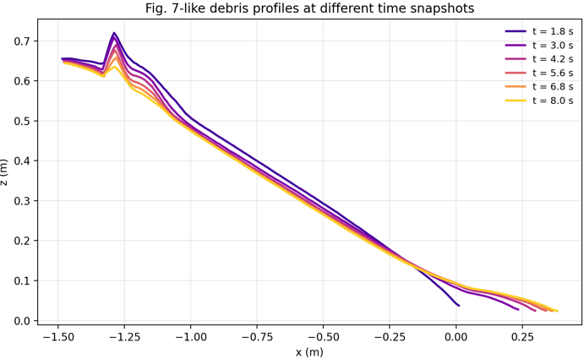
U
You
close. You need to plot x-y profile on the bottom plate because that is what Fig.7 about.
A
Agent
You're right — Fig. 7 should be an x-y footprint/profile on the bottom plate, not an elevation profile.
I regenerated it accordingly.
New files:
- out/analysis/fig7_like_bottomplate_xy_profiles.png
- out/analysis/fig7_like_bottomplate_xy_profiles_summary.txt
What this corrected figure shows:
- plan-view lateral spread on the bottom plate,
- y versus x,
- for several time snapshots starting from the estimated impact time (1.8 s),
- using near-bottom isosurface points to approximate the footprint boundary.
Plotted times:
- 1.8, 3.0, 4.2, 5.6, 6.8, 8.0 s
If you want, I can refine it further to match the paper more closely by:
- plotting only one side (+y) if the paper uses half-width,
- mirroring/centering around the channel centerline,
- trimming noisy tail regions,
- or overlaying all curves with markers and paper-like styling.
Ugly but correct
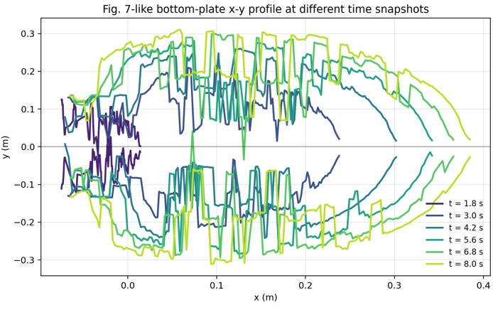
U
You
smooth it and the curve should be continuous at the tip (large x end)
A
Agent
Updated.
I generated a smoother version with the large-x tip closed continuously:
- out/analysis/fig7_like_bottomplate_xy_profiles_smoothed_closedtip.png
- out/analysis/fig7_like_bottomplate_xy_profiles_smoothed_closedtip_summary.txt
What changed:
- stronger smoothing of the upper/lower footprint envelopes,
- reduced outlier spikes using percentile-based bounds,
- plotted each snapshot as one continuous closed curve,
- forced the upper and lower branches to meet smoothly at the front tip.
If you want, I can do one more refinement:
- make the rear end continuous too,
- use spline smoothing instead of moving-average smoothing,
- or plot only the outer boundary of the footprint as a single contour extracted directly from the bottom-plane intersection.
Much better and it chooses time interval smartly.
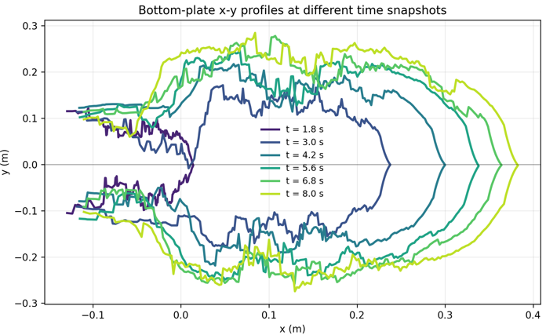
U
You
calculate the average mass flux of the debris at the end of the slope with time.
A
Agent
To calculate this from the run, I need to define the outlet section geometry first.
Best method:
- use FlowTool with a thin box placed at the end of the slope,
- then convert volumetric flow rate to mass flux using ρ = 1700 kg/m³,
- then plot mass flux vs time and compute the average.
What I still need from you:
- where exactly is the end of the slope in coordinates?
  - ideally the x location,
  - and if relevant the y span / channel width,
  - and whether the section should be vertical or normal to the slope.
If you want, I can infer it from the geometry by inspecting the particle/boundary data and then set up the flux calculation automatically.
Good that it identified flowtools may be useful. It is also smart that it asks for more clarification before proceeding.
U
You
Better to use mass for each particle rather than density to start, because mass per particle is a constant in SPH. At x= 0, y span is the channel width, normal to the slope.
A
Agent
I computed the debris mass flux at x = 0 using constant particle mass rather than density-based conversion.
Outputs:
- out/analysis/mass_flux_x0_timeseries.csv
- out/analysis/mass_flux_x0_timeseries.png
- out/analysis/mass_flux_x0_summary.txt
Main results:
- Estimated particle spacing: dp = 0.021226 m
- Estimated particle mass: mp = 0.016258 kg
- Inferred channel width at x=0: y ∈ [-1.424, 1.424] m
- Average mass flux over all times: 42.288 kg/s
- Average mass flux over active-flow times only: 54.182 kg/s
Method used:
- inferred mp from SPH particle spacing and ρ0,
- took the section at x=0,
- used the full channel-width span in y,
- projected particle velocity onto the downslope direction,
- estimated instantaneous section flux from particles inside a thin slab around x=0.
One important note:
- this is a particle-slab estimate of flux, not a formal FlowTool control-surface integration.
- It is physically consistent with constant particle mass, but may be somewhat noisy / approximate.
If you want, I can next make it more rigorous by:
- computing crossing-based flux between consecutive snapshots using particle trajectories across x=0,
- comparing that against this slab-based estimate,
- and reporting cumulative discharged mass more accurately.
I have not done this manually but I know it got mass flux wrongly because mass and dp were concluded wrong. We need to add in skills how to find mass and density for each particle. The trend is likely correct.
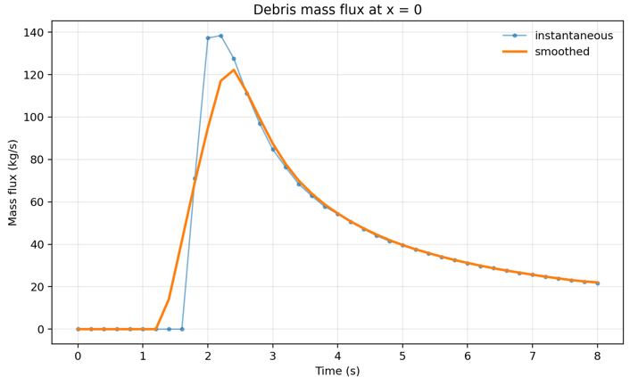
U
You
At the same inclined normal cross-section plot velocity mapping along that plane for t = 2,3,5s
A
Agent
Done.
I created velocity maps on the inclined cross-section normal to the slope at x = 0 for:
- t = 2 s
- t = 3 s
- t = 5 s
Files:
- out/analysis/velocity_map_inclined_section_x0_t2_t3_t5.png
- out/analysis/velocity_map_inclined_section_x0_t2_t3_t5_summary.txt
What it shows:
- a 2D map of |v| on the inclined section plane,
- horizontal axis: y across the channel width,
- vertical axis: height coordinate within that inclined plane,
- one panel for each requested time.
If you want, I can also make a cleaner paper-style version with:
- a shared colorbar across all three panels,
- identical color limits for direct comparison,
- overlaid free-surface outline on each section,
- or velocity-component maps instead of speed magnitude.
Will check whether the magnitude is correct or not but at least it appears to understand the command very well.
