SQL and Relational Algebra Exercise 4

I University Schema Relational Algebra
Assume the standard university schema: student(ID, name, dept_name, tot_cred), takes(ID, course_id, sec_id, semester, year, grade), course(course_id, title, dept_name, credits), and instructor(ID, name, dept_name, salary).
1. Find the names of all students who have taken at least one Comp. Sci. course.
Answer:
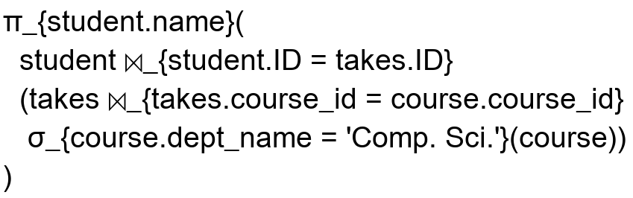

2. Find the IDs and names of all students who have not taken any course offering before Spring 2009.
Answer:
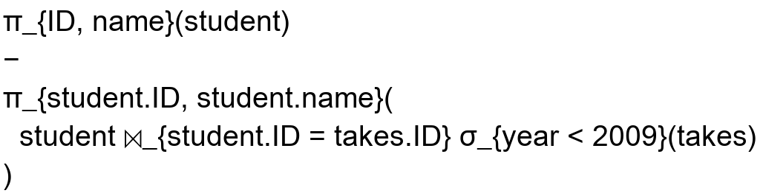

Note: under the standard university data, the semesters are Spring, Summer, and Fall, so “before Spring 2009” is represented by year < 2009.
3. For each department, find the maximum salary of instructors in that department. You may assume that every department has at least one instructor.
Answer:

4. Find the lowest, across all departments, of the per-department maximum salary computed by the preceding query 3.
Answer:
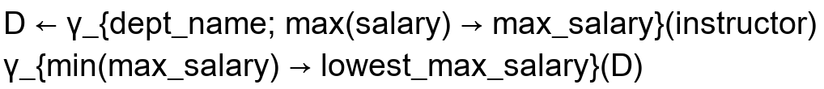

II Library Schema Relational Algebra
Consider the following relational schema for a library:
Schema:


For the following queries, let:
Definition:

1. Find the names of members who have borrowed any book published by "McGraw-Hill".
Answer:
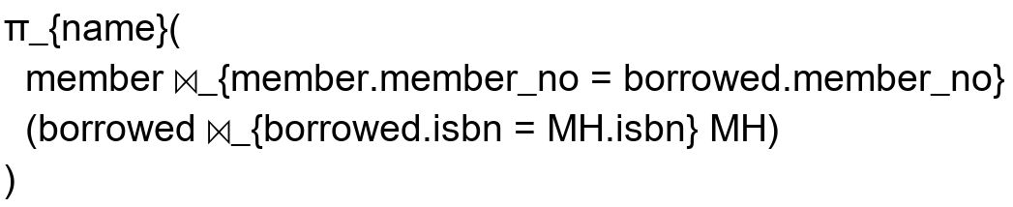

2. Find the names of members who have borrowed all books published by "McGraw-Hill".
Answer:
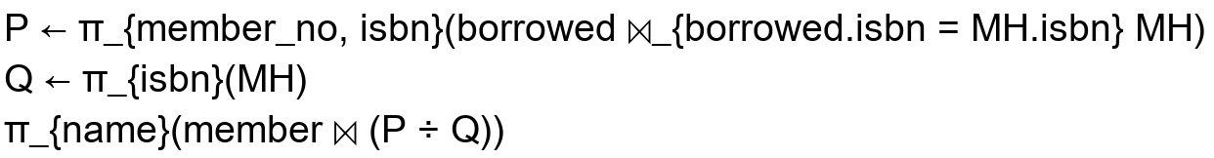

3. Find the name and membership number of members who have borrowed more than five different books published by "McGraw-Hill".
Answer:
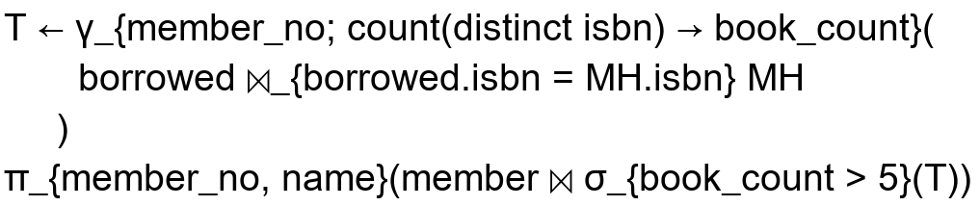

III Software Company Management System
Schema:


A Relational Algebra
Answer:

Answer:
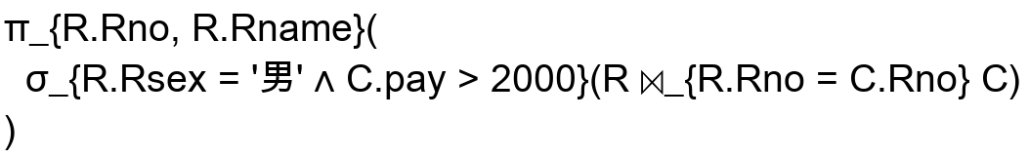

Answer:
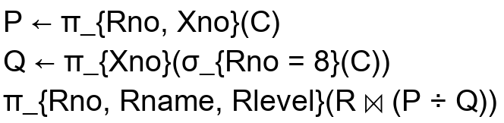

B SQL
Answer:


Answer:


Answer:
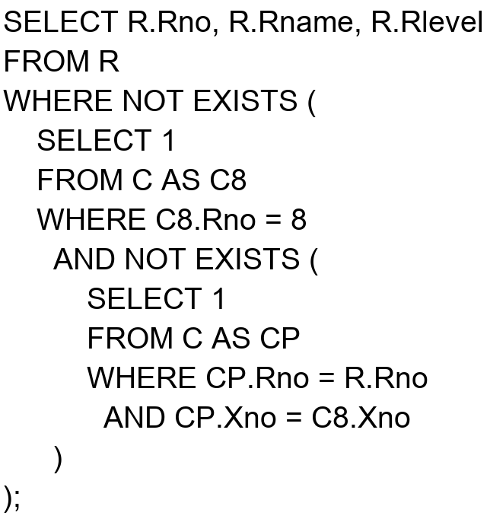

Answer:
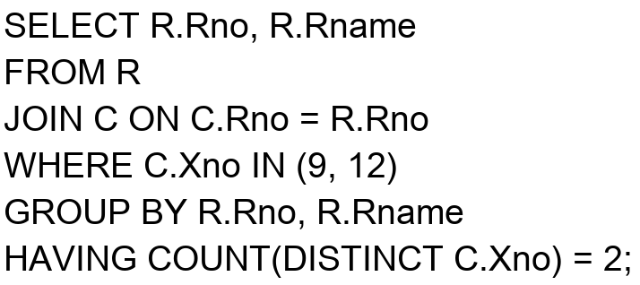

Answer:


