Database Design Exercise 5

I Automobile Company Database
Problem statement
Design a database for an automobile company to provide to its dealers to assist them in maintaining customer records and dealer inventory and to assist sales staff in ordering cars.
Each vehicle is identified by a vehicle identification number (VIN). Each individual vehicle is a particular model of a particular brand offered by the company. Each model can be offered with a variety of options, but an individual car may have only some or none of the available options. The database needs to store information about models, brands, options, dealers, customers, and cars.
The design includes an ER diagram, relation schemas, and primary-key, foreign-key, and semantic constraints.

Answer

1 ER Diagram
The ER model separates available options for a model from options actually installed on a vehicle. It also connects dealer inventory and customer orders to individual vehicles.
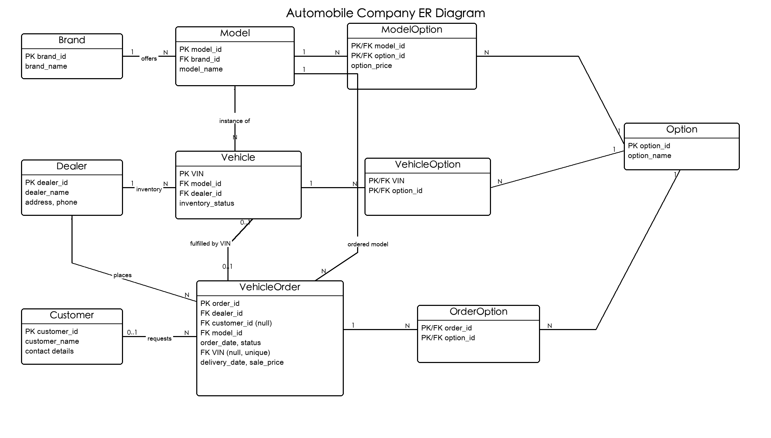
Figure 1 Automobile company ER diagram

2 Relation Schemas
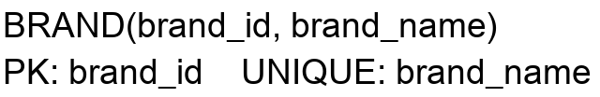
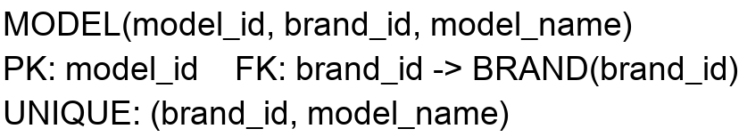
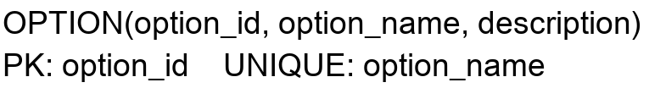
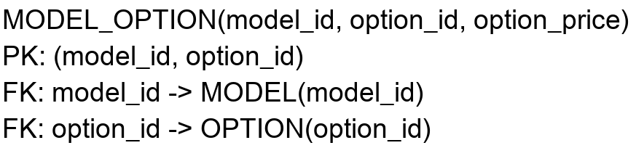

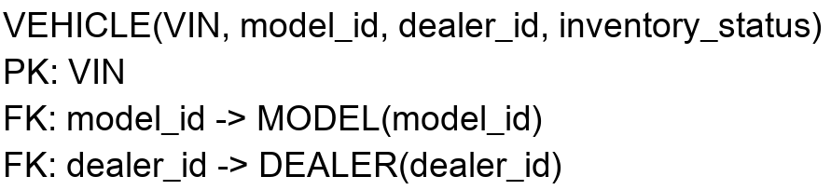
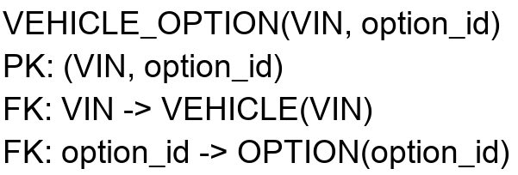
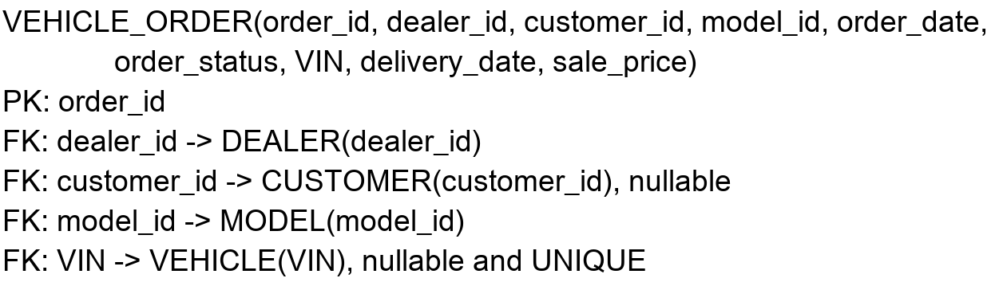
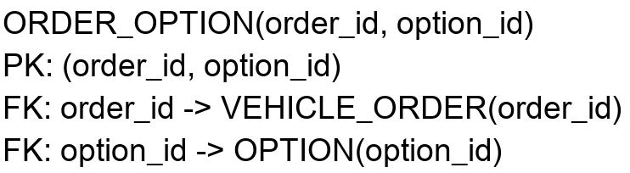

3 Constraints
1. VIN and all primary-key values are unique and not null.
2. Each model belongs to exactly one brand; model names are unique within a brand.
3. option_price and sale_price must be greater than or equal to zero.
4. inventory_status is restricted to ORDERED, IN_STOCK, RESERVED, or SOLD.
5. order_status is restricted to PLACED, CONFIRMED, BUILT, DELIVERED, or CANCELLED.
6. A VEHICLE_OPTION must be listed in MODEL_OPTION for that vehicle's model.
7. An ORDER_OPTION must be listed in MODEL_OPTION for the order's model.
8. A fulfillment VIN must refer to the same model and dealer as the order.
9. A delivered customer order has non-null VIN, delivery_date, and sale_price; delivery_date is not earlier than order_date, and the vehicle status is SOLD.




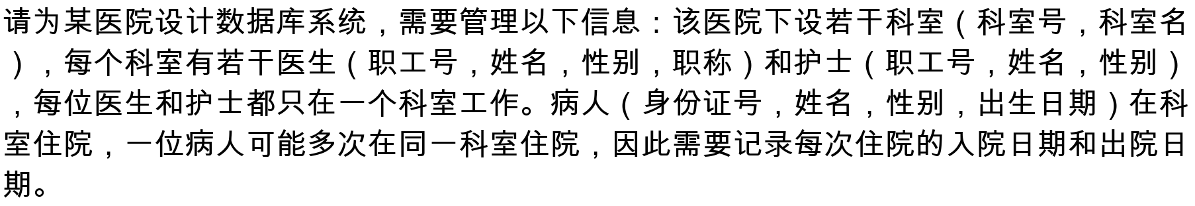





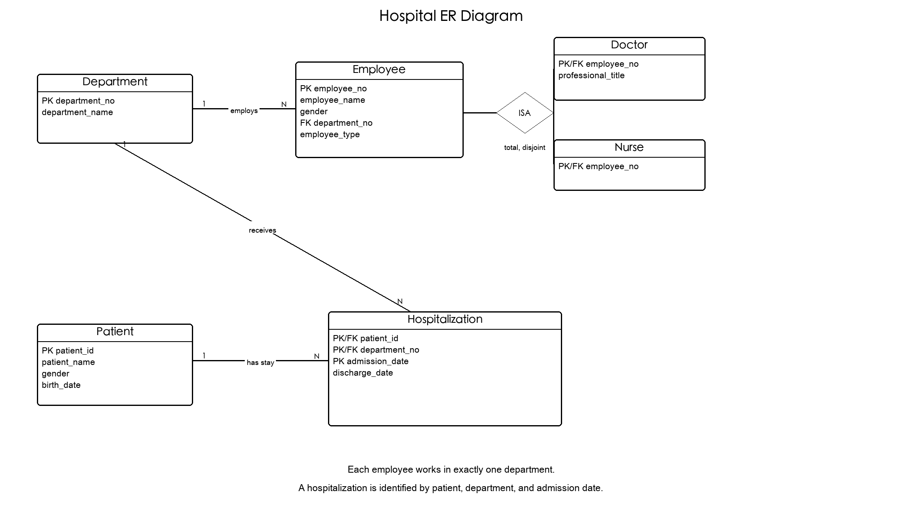
Figure 2 Hospital ER diagram






