Jobing – Design Plan

## **Page Load**

**Current Job List** (<asp:ListView>)



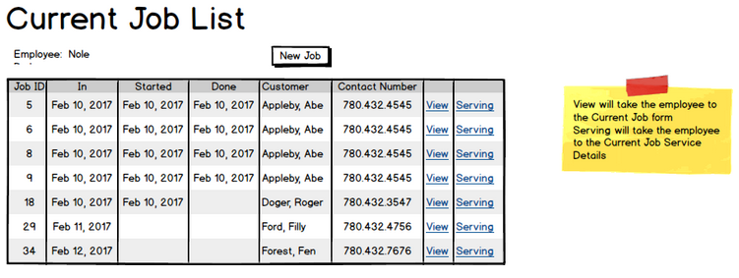

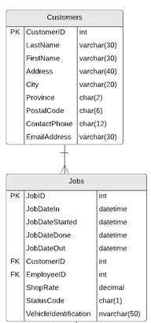

## **Manage Services**

**Coupon List** (<asp:DropDownList>)



**Service Details List** (<asp:ListView>)







**Description** (<asp:TextBox>)



**Hours** (<asp:TextBox>)



**Hours** (<asp:TextBox>)



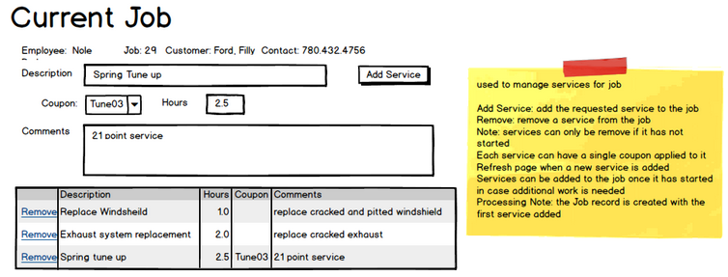

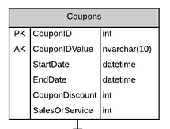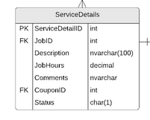

## **Manage Service Details**

**Service Details List** (<asp:ListView>)





**Comment** (<asp:TextBox>)



**Service Details Parts List** (<asp:ListView>)









