eBikes Purchasing Design Document

By: Madison Kendall

*Note: Fields highlighted in yellow are used for queries and fields highlighted in blue are used for commands

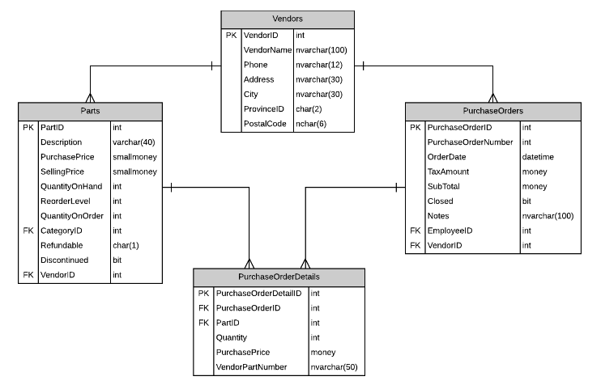

Page Load

* Drop-down has [Select a Vendor] as the first item. Labels are empty until button is pressed

Selecting Vendor (<asp:DropDownList>)

Displaying Vendor Information (<asp:Label>)

Controller: VendorController

POCO:

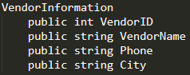

Method:

* To populate drop down list



* Get-CreatePO_OnClick button



* To get and display vendor information



* This button will cause either:
  + A
    - A new order to be generated in the database



* + - A display of vendor stock items not on the suggested order
    - A part item is considered a candidate for ordering when

ReorderLevel – (QuantityOn Hand + QuantityOnOrder) > 0

* Generate PurchaseOrder and PurchaseOrderDetail records for this suggested order list
* B
  + The current open order to be retrieved and displayed
  + Display of vendor stock items not on the current open order
  + Current order is open until place order is clicked

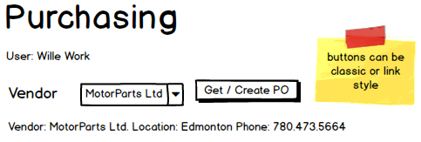

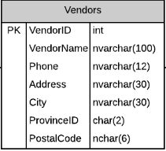

Current Purchase Order Display

* Will hold the current purchase order detail items

Current Purchase Order (<asp:GridView>)

Subtotal, GST and Total (<asp:Label>)

Controller: PurchaseOrderDetailsController

POCOs:

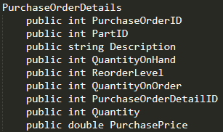

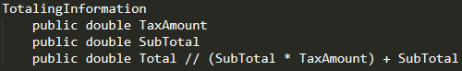

Methods:

* GetCurrentActiveOrder



* Remove
  + Will remove the line item from the Purchase Order
  + Will refresh the page





* Update
  + Will do a bulk update processing of the currently displayed purchase order





* Place
  + Will set the OrderDate and a new PurchaseOrderNumber for the current order and update the QuantityOnOrder for each part on the purchase order





* Delete
  + Will delete the current open purchase order and purchase order details from the system.
  + A placed order cannot be deleted





* Clear
  + Will clear the web page of the current purchase order and reset the vendor list to the vendor prompt line





* Populate Subtotal, GST and Total
  + Totaling update on each page refresh



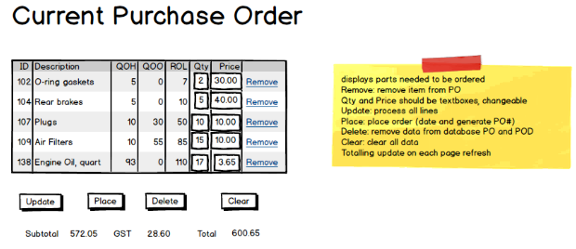

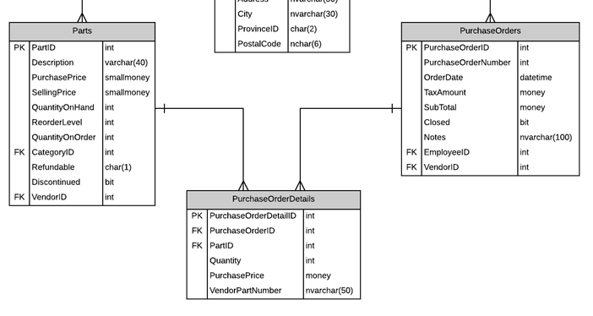

Current Inventory

* Will hold the stock items of the vendor selected from the dropdown list that are NOT on the displayed order

Current Inventory (<asp:GridView>)

Controller: InventoryController

POCO:

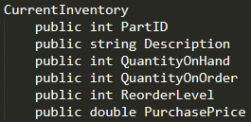

Method:

* Display



* Add
  + Add the line item to the PurchaseOrder
  + Refresh the page





