Customer Orders – Design Plan

Page Load

Catalories/Products Section(<asp:ListView>)

// CategoryController class

[DataObjectMethod(DataObjectMethodType.Select)]

public List<Category> ListAllCategories()

//Selecting a Category

[DataObjectMethod(DataObjectMethodType.Select)]

public List<Part> ListPartsByCategory(int categoryId)

//Adding Parts

public void AddToCart(String userId, int productId, int quantity)

? public List<Part> getPartsInCart(IPrincipal user)

Do we consider if customers already have parts in the cart, we will display which parts or how many parts?

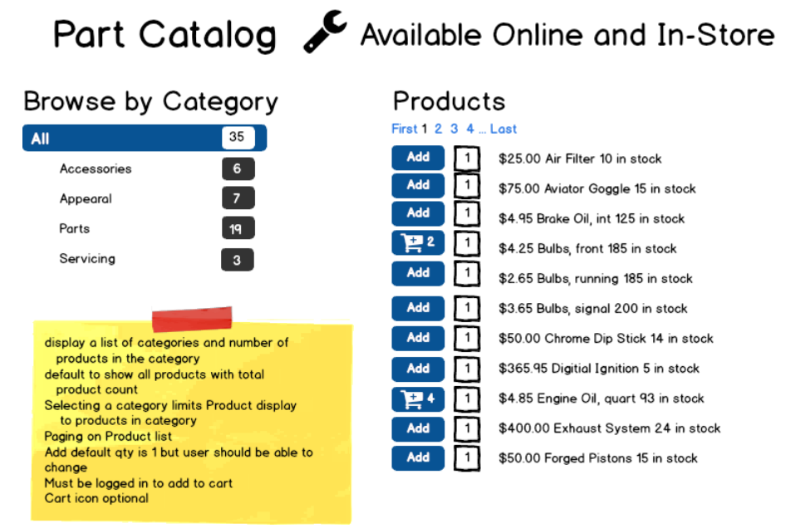

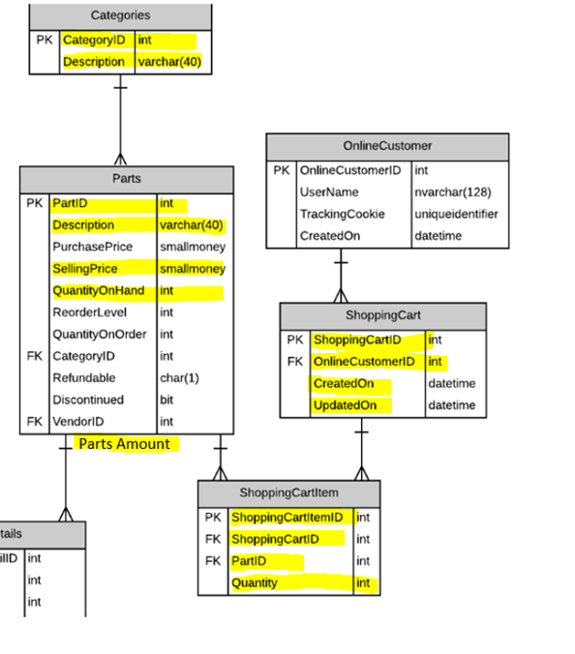

QUESTION:

Why does customerId is string?

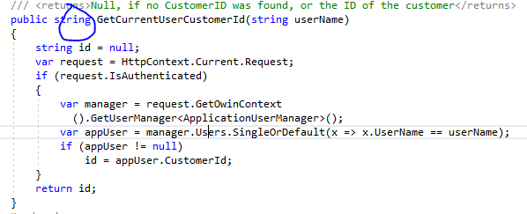

**Viewing Cart**

Page Load

Navigation(<asp:BulletedList>)

Sale cart details section(<asp:GridView>)

[DataObjectMethod(DataObjectMethodType.Select)]

public List<CartInfo> ListPartsInCart(int shoppingCartId)

[DataObjectMethod(DataObjectMethodType.Update)]

public Void UpdateItemQuantity(int shoppingCartItemId, int quantity)

[DataObjectMethod(DataObjectMethodType.Update)]

Public Void UpdateDate(int shoppingCartId, DateTime date)

[DataObjectMethod(DataObjectMethodType.Delete)]

public Void DeleteItemInCart(int shoppingCartItemId)

public decimal calculate(int shoppingCartItemId)

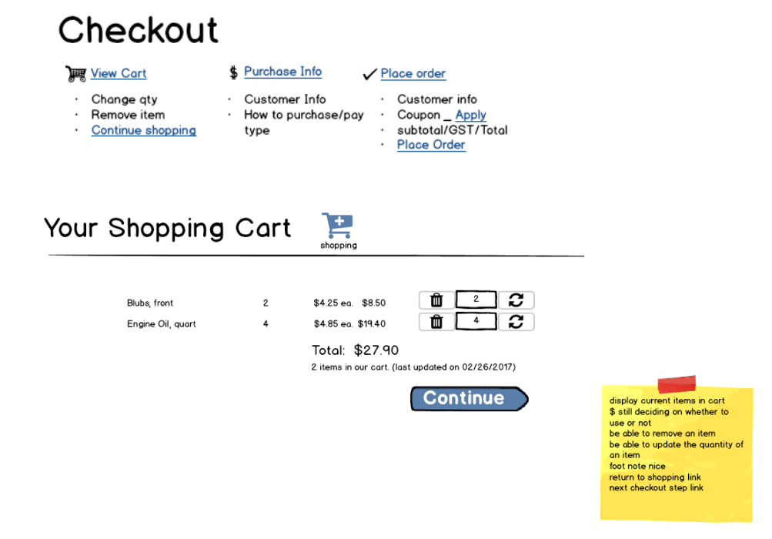

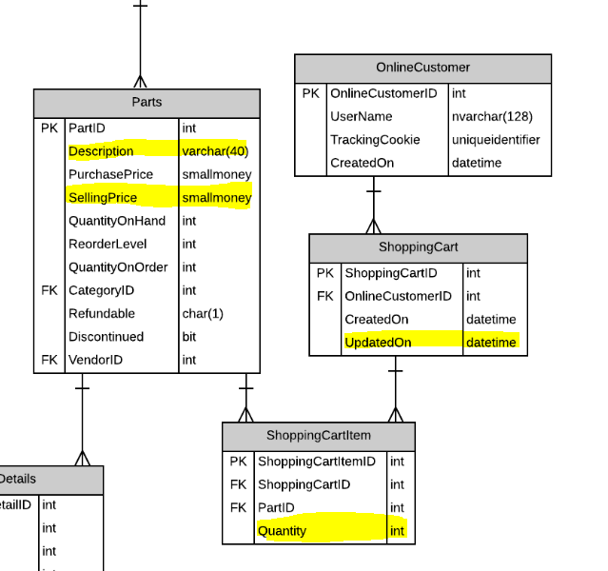

Saving Purchase Details

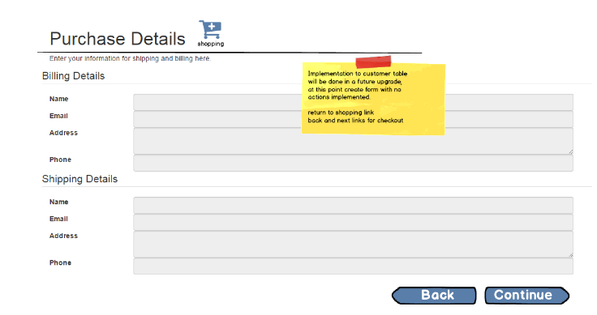

Saving Order/Placing Order

Page Load

checkout Section(<asp:ListView>)

total sale cart (<asp:FormView>)

coupon (<asp:DropDownList>)

[DataObjectMethod(DataObjectMethodType.Select)]

public List<CartInfo> ListPartsInCart(int shoppingCartId)

public decimal calculate(int shoppingCartItemId)

<asp:DropDownList>

[DataObjectMethod(DataObjectMethodType.Select)]

Public List<Coupon> ListCouponCode()

[DataObjectMethod(DataObjectMethodType.Insert)]

public void AddOrder(order)

public void ClearCart(cartId)

