Collection View

collectionViewController

subClass: UICollectionViewController, UICollectionViewDelegateFlowLayout

1. Import UIKit
2. Add viewDidLoad
3. Header/Footer
   1. In viewDidLoad:
      1. collectionView.register([UICollectionViewCell.self], forCellWith..:cellId)



* 1. Override method: “collectionView viewForSupplementryElementOfKind”
     1. let header = collectionView.dequeueReusableSupplementary



* 1. for size “refsizeheader” or “refsizefooter” (import UICollectionViewDelegateFlowLayout subClass)
     1. return CGSize



* 1. init(frame: CGRect)
     1. super.init(frame: frame)
     2. +required init?....

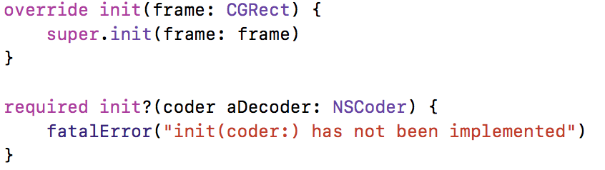

1. Main cell
   1. In viewDidLoad:
      1. collectionView.register([UICollectionViewCell.self]…) //UICollectionViewCell.self is for test
      2. collectionView.backgroundColor = .black //for test

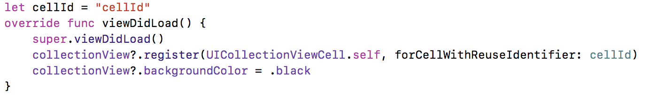

* 1. override method:
     1. “numberOfItem”



* + 1. “cellForItemAt”

//default cell background color is transparency

* + - 1. let cell = collectionView.dequeueReuseableCell(…)
      2. cell.backgroundColor = .red //for test



* 1. method for size “sizeForItemAt”
     1. return CGSize



* 1. init(frame: CGRect)
     1. super.init(frame: frame)
     2. +required init?....



* 1. Optional method
     1. “miniLineSpacing”



* + 1. “miniInteritem”



* + 1. “insetForSection”