Import firebase cocoPod

1. Login google email account
2. Go to console

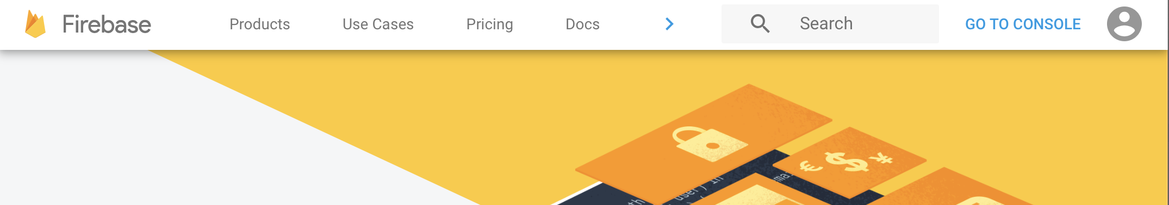

1. Add project(create new project

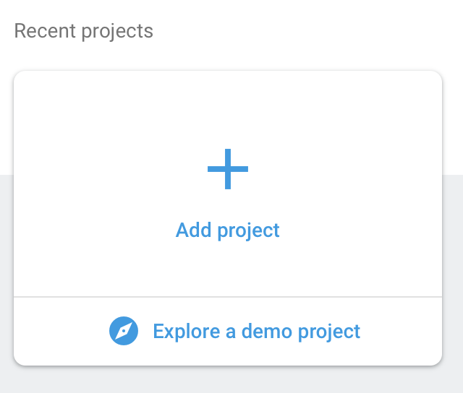

1. Add an app to get started

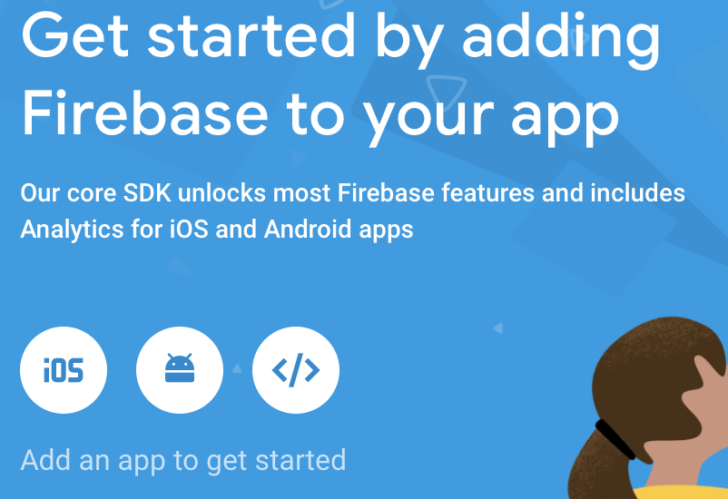

1. Fill out iOS bundle ID

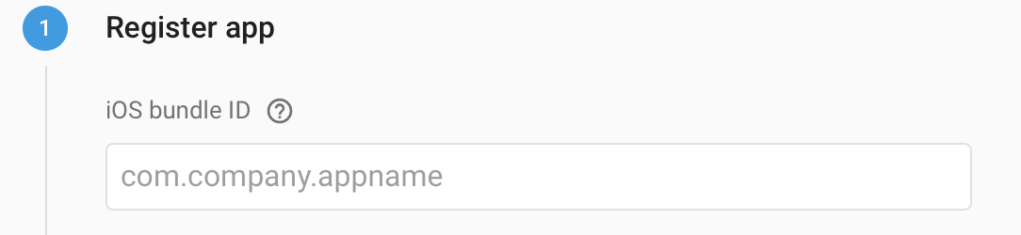

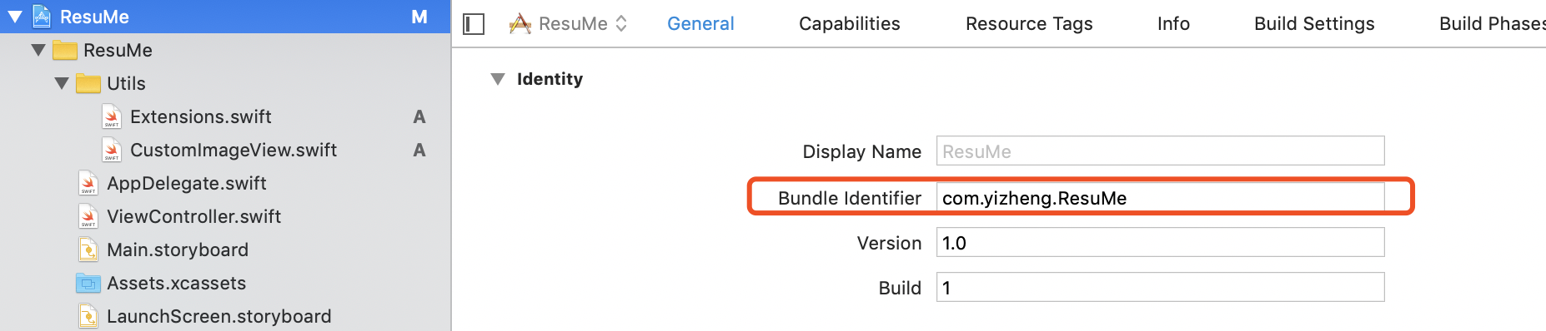

1. Download GoogleService-Info.plist

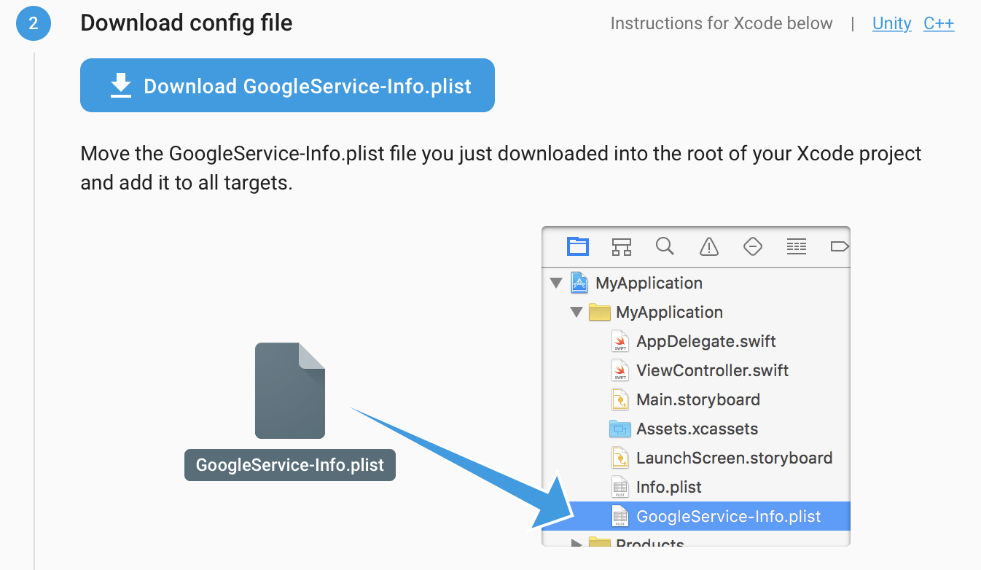

1. Drag the file to your project

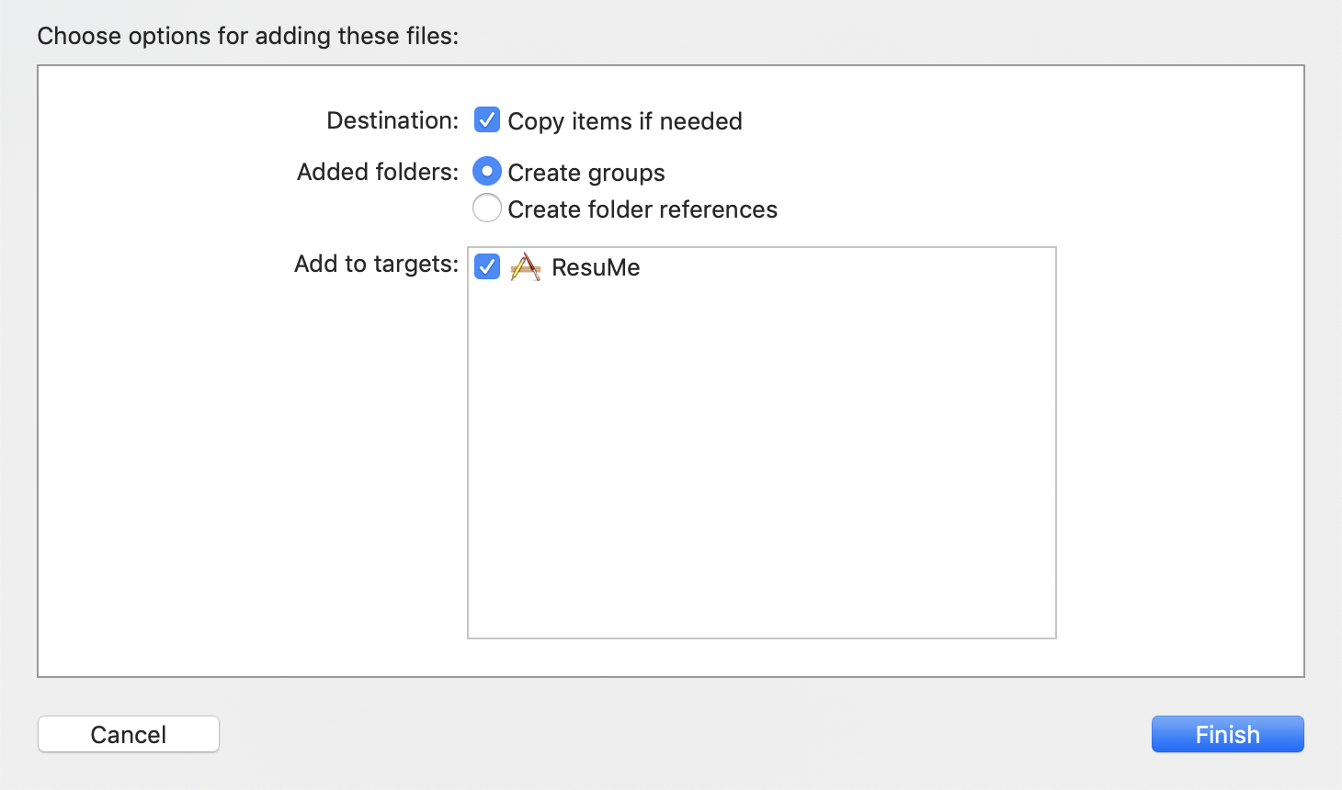

1. Add Firebase SDK
   1. Open terminal
   2. Go to the directory

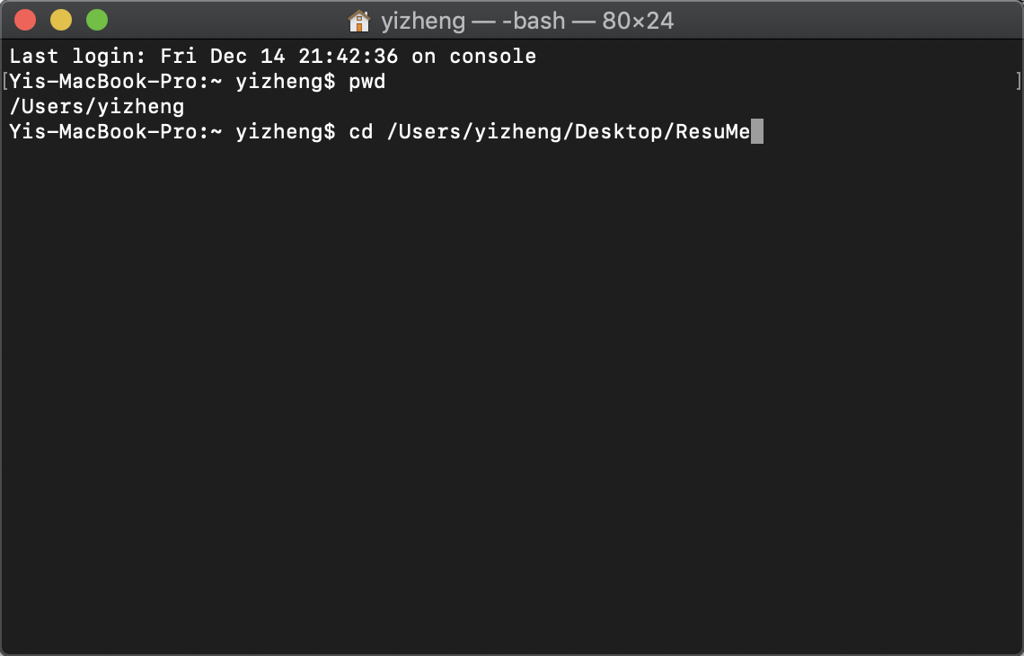

* 1. Input “pod init” (if you don’t have CocoPod install input “sudo gem install cocoapods” [https://cocoapods.org])

1. Open Podfile. Input “open Podfile”
2. Input some statements. And then close it.
   1. **pod 'Firebase/Core' pod 'Firebase/Auth' pod 'Firebase/Database' pod 'Firebase/Storage'**
3. Make sure file is correct

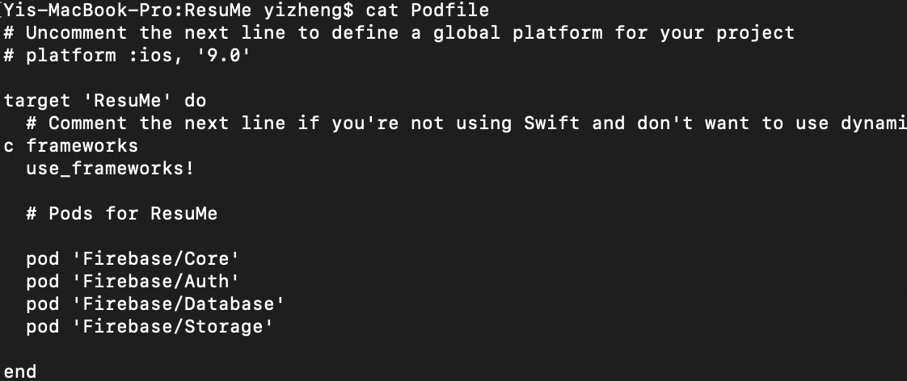

1. Input “pod install” in the terminal

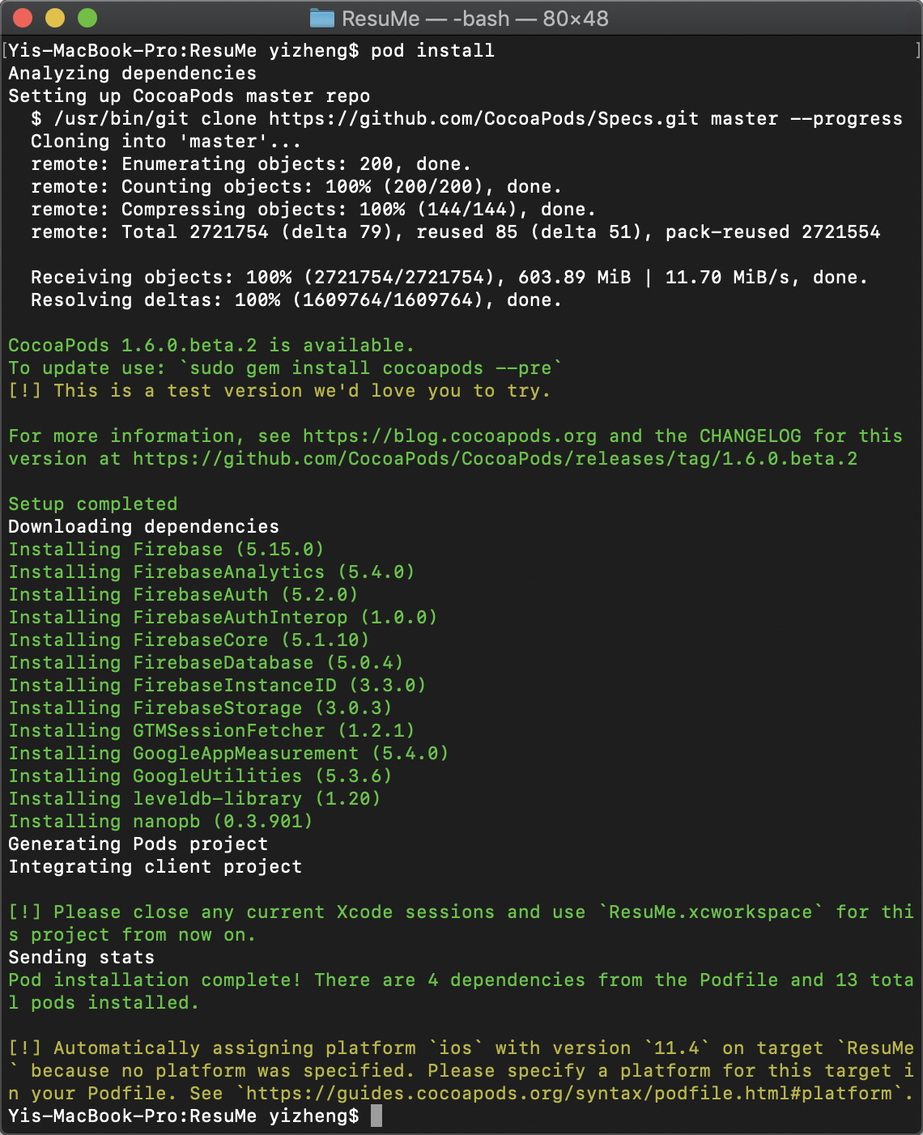

1. Close Xcode and open with white icon
2. Add initialization code

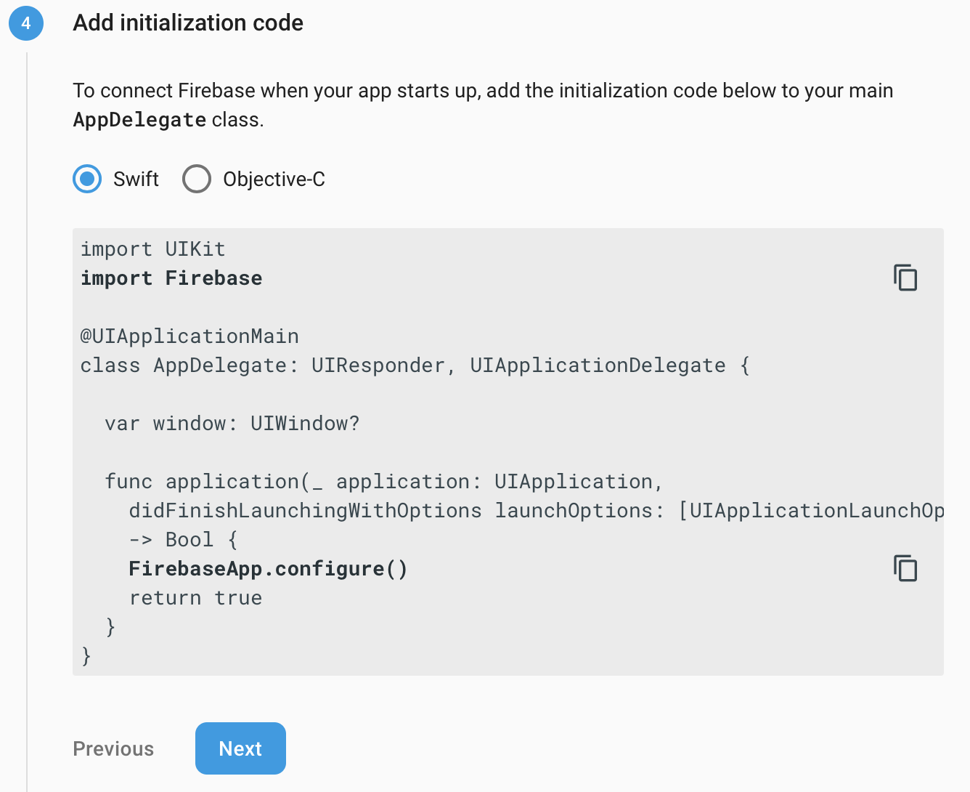

1. Disable some console output

