TabBar

MainTabBarController

supperClass: UITabBarController, UITabBarControllerDelegate

1. viewDidLoad //override func
   1. view.backgroundColor = .red
   2. delegate = self
   3. setupTabBarViewController()

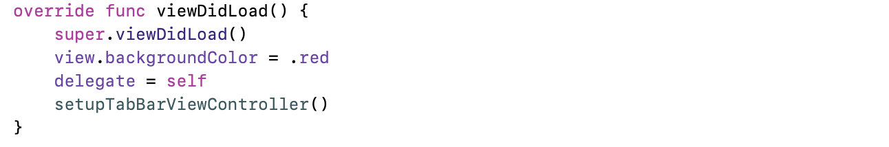

1. setupTabBarViewController //func
   1. tabBar.tintColor = .black
   2. let xxNavController = templateNavController() //custom func
   3. viewControllers = [xxNavController, …, xxNavController]
   4. adjust icons position

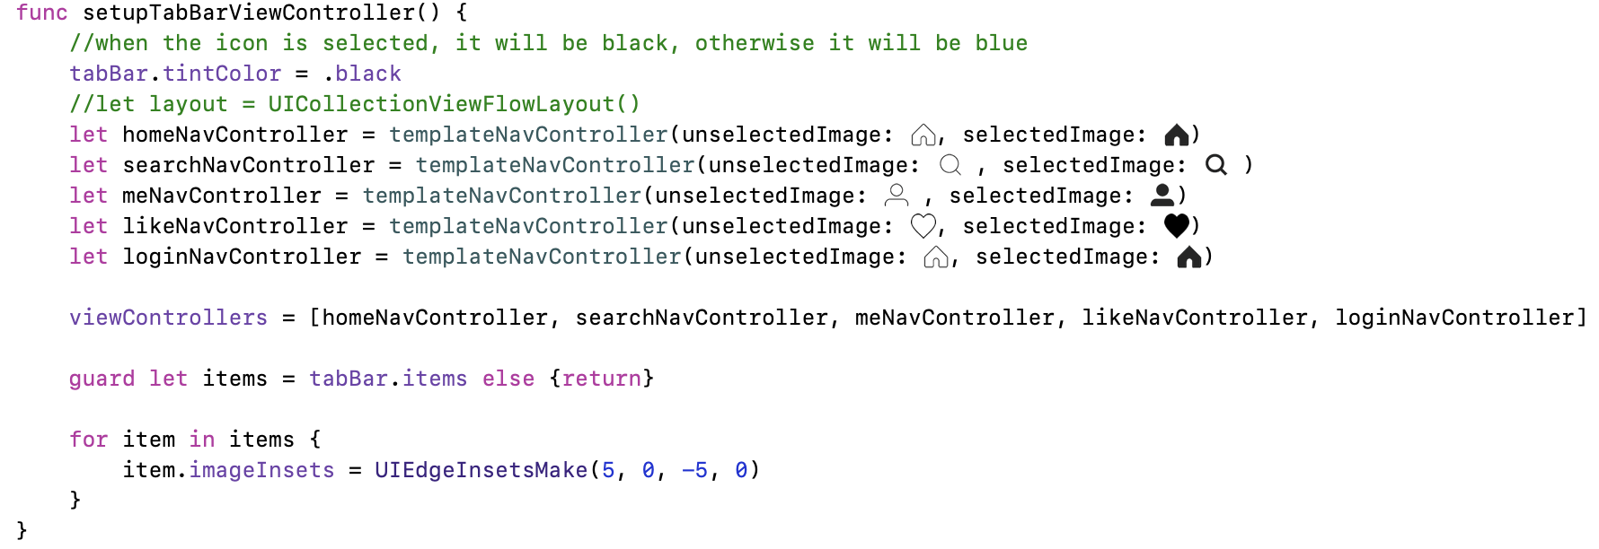

1. templateNavController(unselectedImage: UIImage, selectedImage: UIImage, rootViewController: UIViewController = UIViewController()) -> UINavigationController

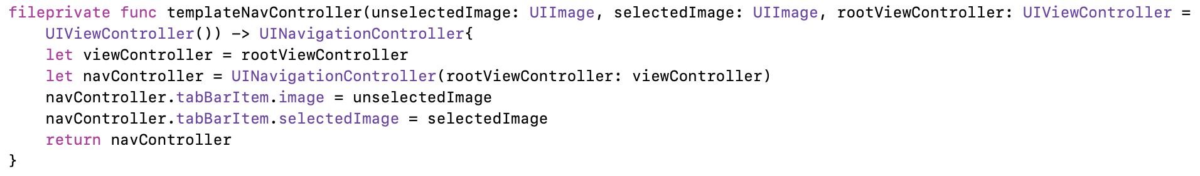

Overall

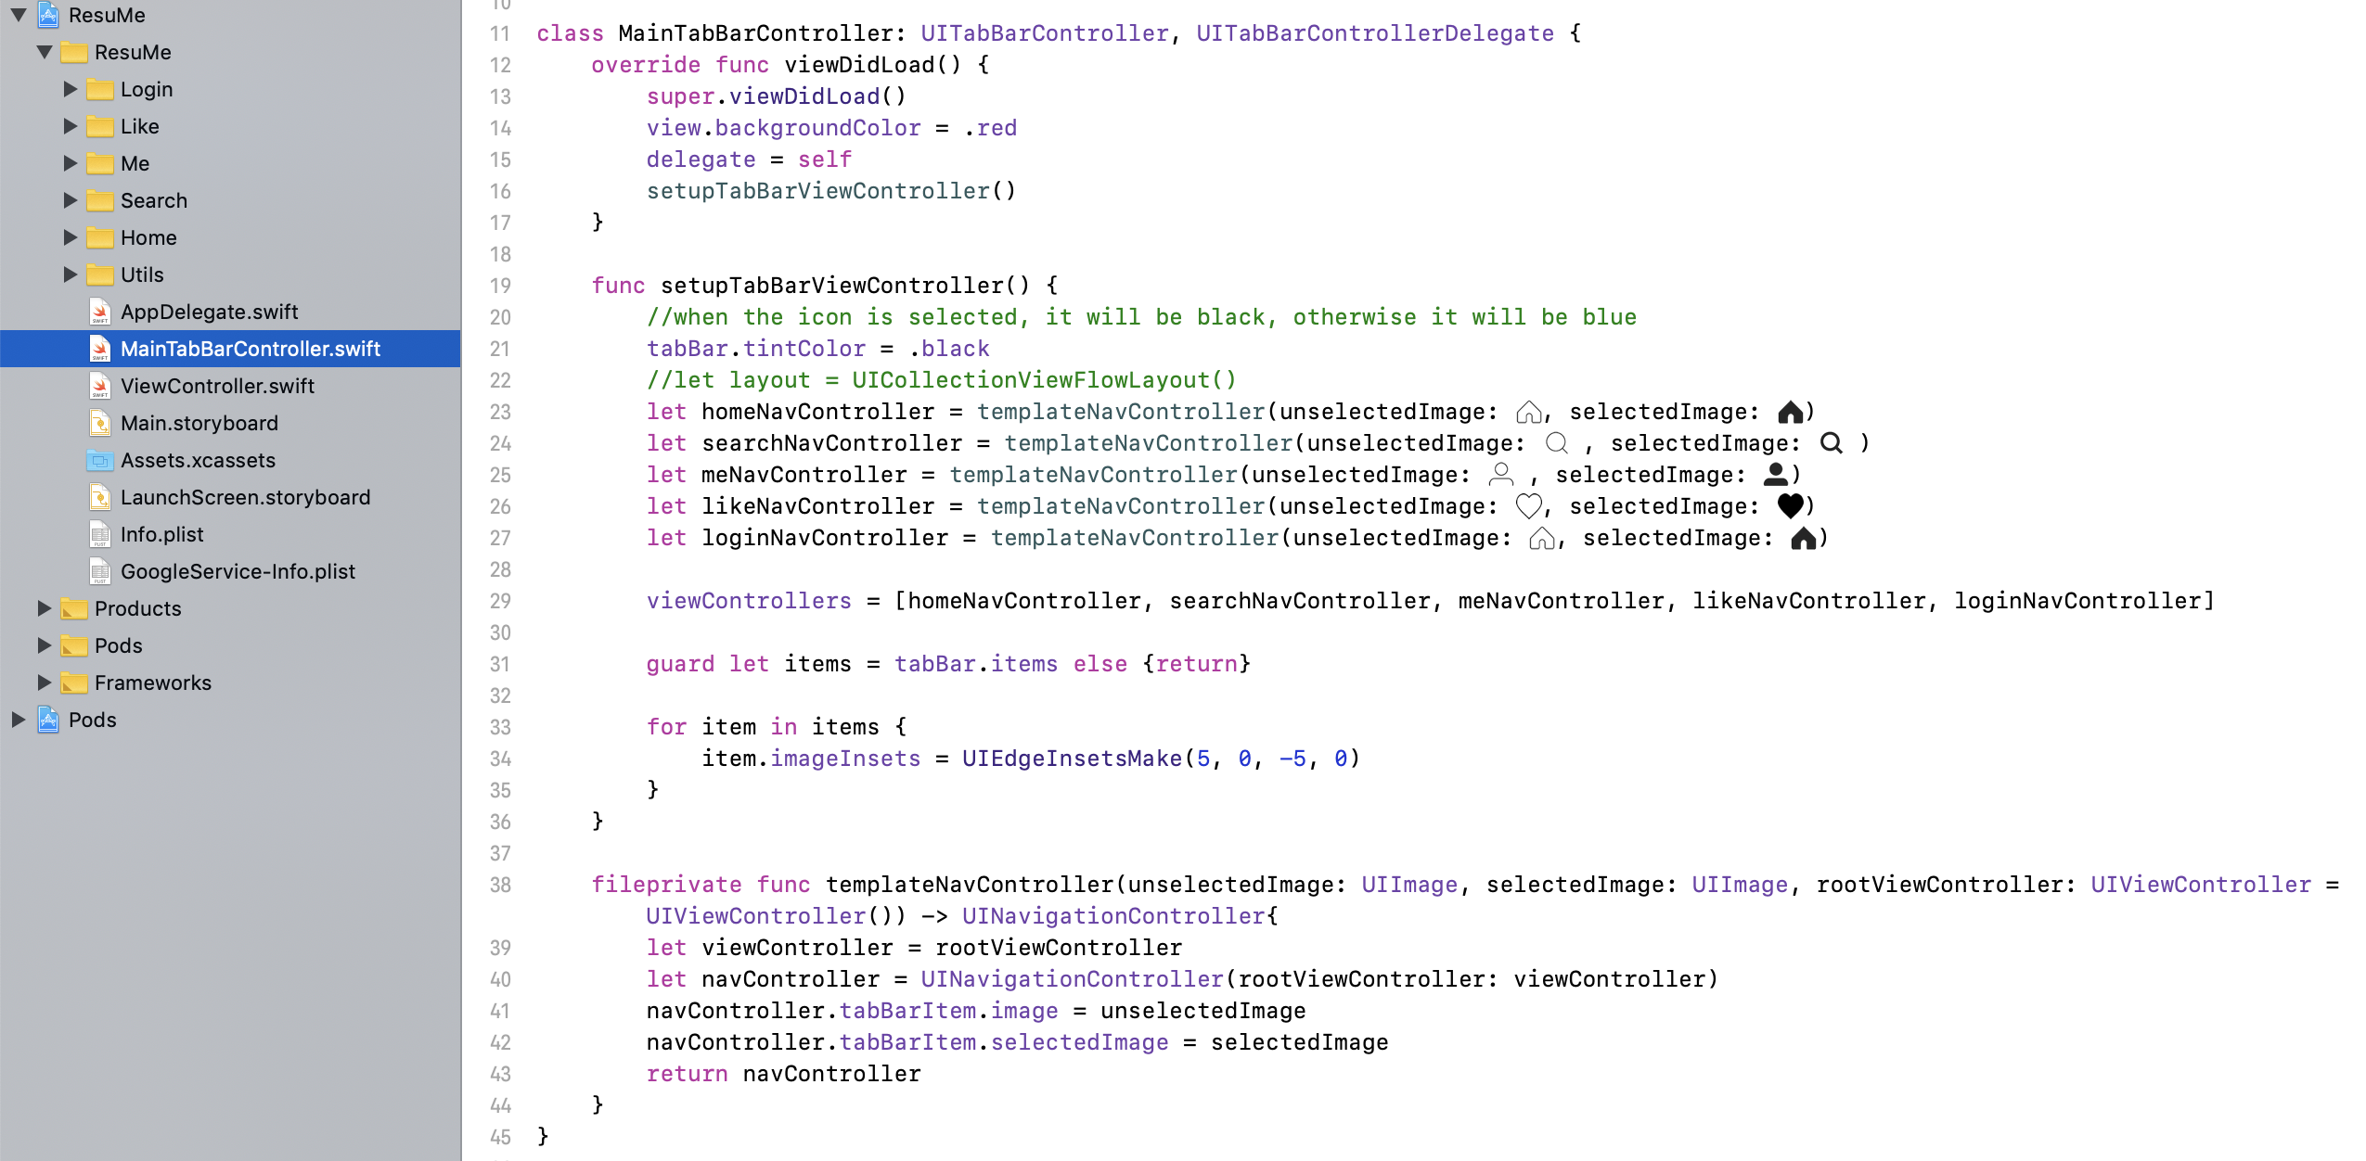

AppDelegate

1. window = UIWindow()
2. window?.rootViewController = MainTabBarController()

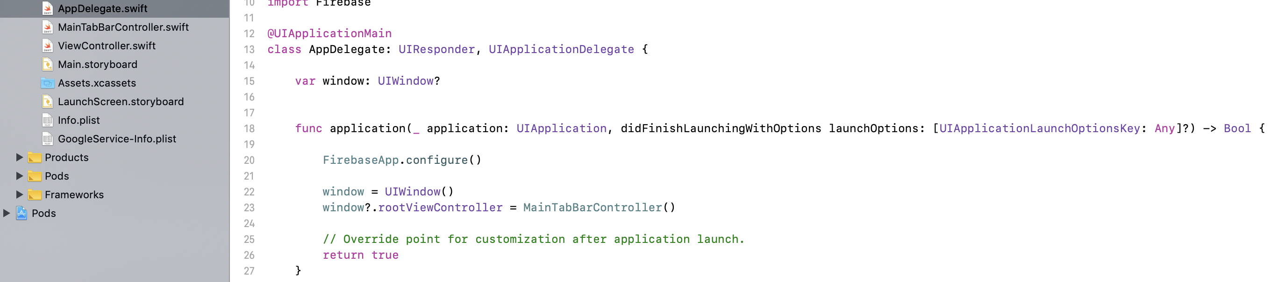

1. Go to AppDelegate.swift file

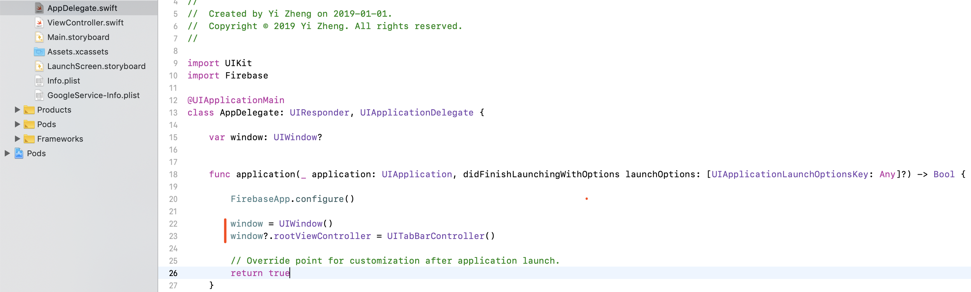

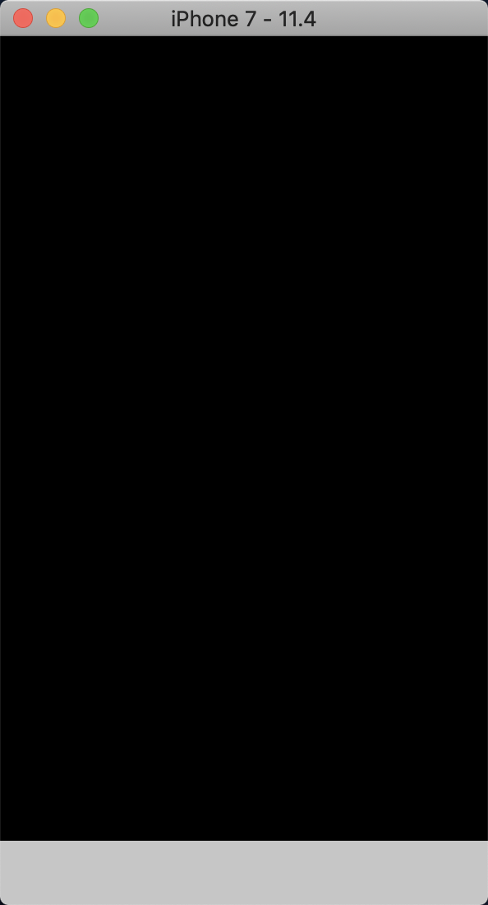

1. Create MainTabBarController.swift file

subclass: UITabBarController, UITabBarControllerDelegate

* 1. Import UIKit
  2. Add viewDidLoad
  3. In AppDelegate.swift:
     1. Add “window = UIWindow()/ window?.rootViewController = MainTableBarController()”

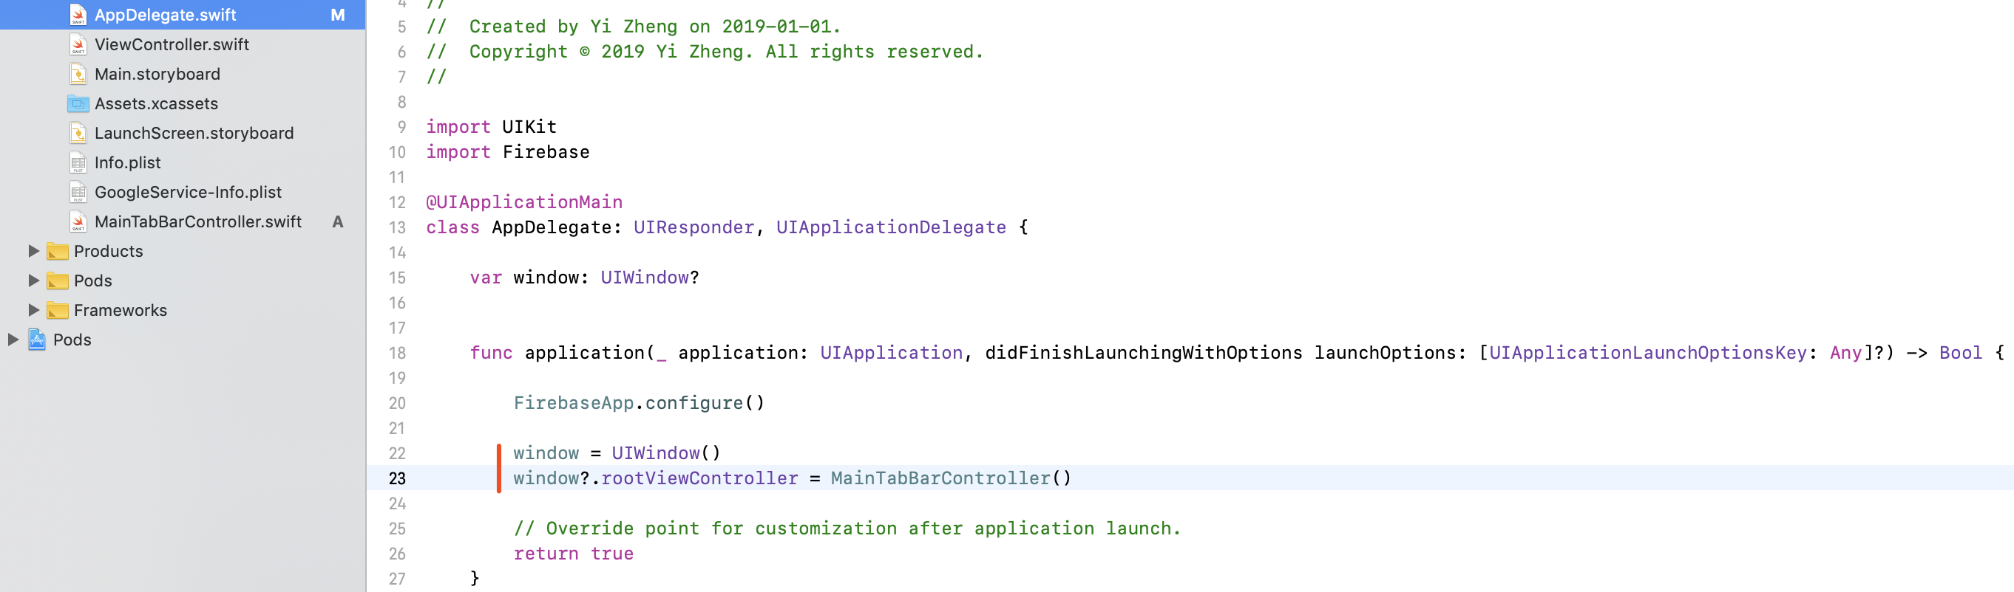

Short cuts

1. Create a file -> command + n
2. Run app -> command + r
3. Build app -> command + b