# In-Class Programming 3 (Section 2)

Create the following program to determine whether an entered year is a leap year or not:

* User enters a 4-digit year (integer number), store the entered number into a variable named year
* First test this variable whether it is divisible by 100
  + If it is, then test this variable whether it divisible by 400
    - If it is, display a message ‘Year [2000] is a leap year’ (where [2000] is the value of the variable)
    - If it is not divisible by 400, display a message ‘Number [1900] is not a leap year’ (where [1900] is the value of the variable)
* If the variable is not divisible by 100
  + Test whether this variable is divisible by 4
    - If it is, display message ‘Year [2016] is a leap year’ (where [2016] is the value of the variable)
* Number is not divisible by 100 or 4, display a message ‘‘Number [2021] is not a leap year’ (where [2021] is the value of the variable)

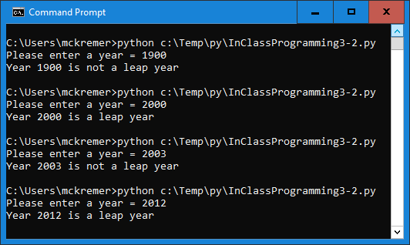

Test this program with the following values:   
1900, 2000, 2003, 2012

The output window should look like this:

Upload the following files to Canvas:

* Screenshot of the executed code in command line/terminal window (either pasted into a Word document or as an image)
* Text file of your code named InClassProgramming3-2.py (put your name and section as comments at the top of file)

**Notes:**

* Upload the files (screenshot(s) and Python code as text file(s) )
* Your code should contain some meaningful comments
* Your code should be well organized and formatted