# In-Class Programming 7 (Section 2)

Create the following program: Calculate the net pay of an employee by deducting federal, state, and social security taxes

* Create a file named paydeductions.py which will store the following functions and its parameters:
  + fFedTax with parameter gross pay, return the federal tax deduction by multiplying the gross pay with 0.1725
  + fStateTax with parameter gross pay, return the state tax deduction by multiplying the gross pay with 0.0585
  + fOASDI with parameter gross pay, return the social security tax deduction by multiplying the gross pay with 0.0765
* Create the main program file (InClassProgramming7-2.py), import the paydeductions file and create the following functions:
  + Function main with no parameters:
    - Display a message ‘Welcome to the net paycheck calculator’
    - Get user input of gross pay and store it into a variable named meaningfully
    - Call the function fDeductNetpay (see below) and store the return result into variables deductions and netPay
    - Display the gross pay, deductions and net pay (see output below)
  + Function fDeductNetpay with parameter gross pay:
    - Calculate the total deductions by calling the 3 functions in paydeductions and adding them up, storing it in variable deductions
    - Calculate the net pay by subtracting the deductions from gross pay, storing it in variable netPay
    - 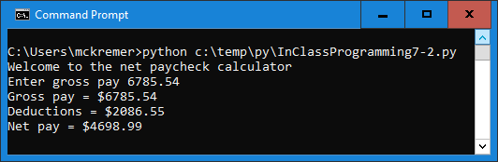Return both variables

Upload the following files to Canvas:

* Screenshot of the executed code in command line/terminal window (either pasted into a Word document or as an image)
* Text files of your code named InClassProgramming7-2.py and paydeductions.py (put your name and section as comments at the top of file)

**Notes:**

* Upload the files (screenshot(s) and Python code as text file(s) )
* Your code should contain some meaningful comments
* Your code should be well organized and formatted