# In-Class Programming 8 (Section 2)

Create the following program: Read a data file (data.csv download from Canvas) in a try, except, else, finally structure and calculate the sum of numbers on a per line basis contained in the file.

**Part 1:**

* Create variables sum initialized with 0 and strLine initialized with empty string
* Open the file data.csv storing the object into variable file
* Create a for loop to loop over the lines of the file
* Within the data file loop, create another for loop to loop over each character in each line
* Test for each character:
  + When it is a comma, skip the character
  + Otherwise calculate the sum of all numbers in a line and accumulate it into variable sum
* For each line, store the line concatenated with the sum into a variable (make sure to remove the line break from the original line and add it back after the sum)
* Reset the variable sum to zero for the next iteration

**Part 2:**

* Create two global variables named file and err. Initialize file with an empty string and err with a Boolean false
* Create a try, except, else, finally structure
* Wrap the part 1 code into the try part:
* The except part:
  + Test for a file not found exception
  + Set the err variable to a Boolean true
* The else part:
  + Display the sum for each line as shown below
* The finally part:
  + Test the file variable, when it is not equal to an empty string, then close the file
  + Test the err variable:
  + If it is true, display a message "Program completed with errors" (see output below)
  + If it is false, display a message "Program completed successfully without errors" (see output below)

Test your program in two ways and provide two screenshots or both runs in one screenshot as shown below:

* Execute the program, it should complete with no errors and display the sum
* 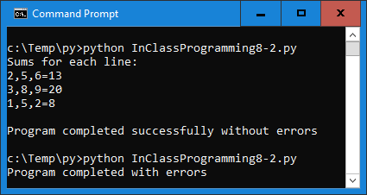Change the file name to data1.csv in your program and execute the program, it should now display the error message

Upload the following files to Canvas:

* Screenshot of the executed code in command line/terminal window (either pasted into a Word document or as an image)
* Text files of your code named InClassProgramming8-2.py (put your name and section as comments at the top of file)

**Notes:**

* Upload the files (screenshot(s) and Python code as text file(s) )
* Your code should contain some meaningful comments
* Your code should be well organized and formatted