# In-Class Programming 9 (Section 2)

Create the following program: Calculate incremental values from a list of cumulative values (Covid cases) and then calculate the moving average.

* Create a list using variable lstCumCovid storing the following data:  
  2, 5, 9, 22, 67, 123, 345, 654, 845, 1234, 3050, 6453
* Create a list object stored in variable lstDailyCases and initialize the first element with the first element of lstCumCovid.
* Create a for loop and loop over lstCumCovid starting at 1 (since the first value of lstDailyCases equals the first value of lstCumCovid)
* Within the loop, subtract the current cumulative value from the previous one and append it to list lstDailyCases
* After the loop, print out the lists lstCumCovid and lstDailyCases as shown below
* Create a list variable lstMovAvg and initialize it with the first element of lstDailyCases
* To calculate the moving average, create the same for loop as above
* Within the loop, calculate the sum of all previous values in lstDailyCases, divided by the number of elements up to the current iteration, then append it to list lstMovAvg
* 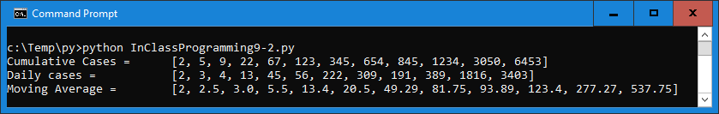After the loop, print out the lstMovAvg as shown below

**Note:** Tab keys were used to align the lists (not required)

Upload the following files to Canvas:

* Screenshot of the executed code in command line/terminal window (either pasted into a Word document or as an image)
* Text files of your code named InClassProgramming9-2.py (put your name and section as comments at the top of file)

**Notes:**

* Upload the files (screenshot(s) and Python code as text file(s) )
* Your code should contain some meaningful comments
* Your code should be well organized and formatted