# Lab 3

Objectives

* Practice with functions
* Learn about function parameters
* Use random numbers

Problems

1. Payroll calculator (25 points)

Write a Python program (payroll.py) that consists of two functions:

* main
* fPayroll

In function main do the following:

* Print a message that says "Welcome to the Payroll Manager!"
* Perform five calls to the fPayroll function with various names, hours worked, and pay rates (see output below)
* Aggregate the regular pay and overtime pay over the five function calls and display them below the previous output (see output below)

In function fPayroll do the following:

* Define three parameters: employee name, hours worked that week, and pay rate in dollars per hour
* Calculate the employee's salary as the number of hours worked multiplied by the pay rate
* If the employee has worked more than 40 hours, then calculate overtime as 1.5 times the regular pay rate and add that to the salary (total salary)
* Print the name, hours worked, pay rate and the total salary as shown below in the output
* Return the regular pay and the overtime pay

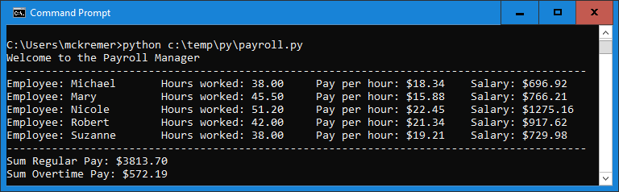Use the test data as shown in the following output:

1. Rock, Paper, Scissors Game (25 points)

The Rock, Paper, Scissors game rules are as follows:

* If both the computer and the player pick the same (rock/paper/scissors), it is a tie
* Rock beats scissors
* Paper beats rock
* Scissors beat paper

Write a Python program (rockpaperscissors.py) that consist of three functions:

* Main
* fComputerRPS (RPS = Rock Paper Scissors)
* fDetermineWinner

Import the random module into your program

In function fComputerRPS do the following:

* Use the random number generator to return one of "rock", "paper", or "scissors"

In function main() do the following:

* Print a welcome message to the user
* Ask the user for their choice - rock/paper/scissors
* Perform input validation and only accept valid input, if validation fails, display input again (loop)
* Call the fComputeRPS() function and save the returned "computer's choice" value in a variable
* Display the user's choice and the computer's choice (see output below)
* Display the winner by calling function fDetermineWinner (see output below)
* Ask the user whether they want to play again, accept lowercase and uppercase y as acceptable input
  + If yes, then call function main again

In function fDetermineWinner do the following:

* Define two input parameters, the user’s choice and the computer’s choice (Rock, Paper, or Scissors)
* Based on the rules mentioned above, determine whether it is a tie, or whether the computer won or whether the player won
* Return a string summarizing the outcome of the game (this string will be displayed in function main), for example:
  + Computer wins (Paper beats Rock) or User wins (Rock beats Scissors)

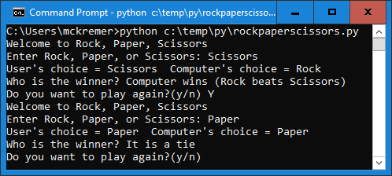

Upload the following files to Canvas:

* 1 screenshot of executed code in command line/terminal window for the payroll.py file (either paste into Word document or as an image)
* 1 screenshot of executed code in command line/terminal window for the rockpaperscissors.py file with at least 2 plays (either paste into Word document or as an image)
* Text files of your code named payroll.py and rockpaperscissors.py (put your name and section as comments at the top of files)
* README.txt file - A description of your lab with your name and your student ID. Please include any problems you faced, any resources you used, names of friends/tutors you received help from

**Notes:**

* Do not use phantom numbers in your code, use meaningful constants instead
* Your code should contain some meaningful comments
* Your code should be well organized and formatted