**Game-theoretic Modeling of Pre-disaster Relocation**

by

Vicki M. Bier

Professor

Department of Industrial and Systems Engineering

University of Wisconsin-Madison

3234 Mechanical Engineering Bldg., 1513 University Ave., Madison, WI 53706, US

Tel: (608)-262-2064 Email: [vmbier@wisc.edu](mailto:vmbier@wisc.edu)

Yuqun Zhou, Hongru Du

Graduate Student

Department of Industrial and Systems Engineering

University of Wisconsin-Madison

**Abstract**

Sea-level rise due to climate change is clearly an important problem. This paper uses game theory in conjunction with discounting to explore strategies by which governments might encourage pre-disaster relocation by residents living in areas at high risk of flooding due to sea-level rise. We find that offering a subsidy (e.g., a partial buyout) can be effective if government has a significantly lower discount rate than residents. We also present extensions to our model, exploring the use of a fixed annual benefit after relocation (instead of a one-time subsidy), and hyperbolic instead of standard exponential discounting. Numerical sensitivity analysis elucidates many important factors affecting the timing of anticipatory relocation, since for example relocating too soon may be costly to both residents and government if flooding risk is increasing only gradually. This conceptual model also provides a foundation for future studies that quantify the model with more realistic parameter values (e.g., realistic estimates of flooding probabilities), and alternative behavioral models of resident decision making.

**Keywords**: Decision analysis, Games/group decisions, Environment, Flood Relocation

1. **Introduction**

**1.1 Background and Motivation**

Many types of disasters can cause population displacement, including nuclear accidents (Pascucci-Cahen, 2014; Silva et al., 2014; Bier et al., 2014), terrorism (e.g., Buddemeier et al., 2011), natural disasters such as earthquakes (Schulz, 2015) and hurricanes (Richardson et al., 2008; Goldman and Coussens, 2007), and coastal flooding due to climate change (Busby, 2007; Melillo et al., 2014; Udvardy and Winkelman, 2014). However, coastal flooding due to sea-level rise is almost unique among these causes, since it is possible to know with some certainty well in advance which cities are most likely to be affected—e.g., Tampa, Miami, New Orleans, Boston, and New York within the U.S. (Hallegatte et al., 2013; Environment News Service, 2013), and those areas may be affected permanently. Thus, even though the effects of climate change can be expected to be intermittent and uneven, making it unclear to what extent an observed flood is a one-time event or a signal of a worsening trend (Trenberth et al., 2015), knowledge of which cities are most likely to be affected can facilitate proactive planning such as anticipatory relocation.

In anticipation of climate change, discussion and preparations have recently begun for relocation of entire coastal villages—e.g., Isle de Jean Charles, Louisiana (Davenport and Robertson, 2016); Kivalina, Koyukuk, Newtok, and Shishmaref in Alaska (U.S. Government Accountability Office, 2003; Mele and Victor, 2016). However, these efforts generally affect only small communities, and are extremely costly (on the order of up to $1 million per person). Huntington et al. (2012) emphasize that “Spending up to US $1 million per person to respond to one manifestation of climate change is clearly a major commitment…, and may be politically untenable,” and more cost-effective solutions must be found.

Specifically, the Risky Business Project (2014) estimates that climate change will cost the U.S. hundreds of billions of dollars by the middle of the 21st century in “lost productivity, inundated housing and infrastructure along coasts, and plunging crop yields in key farming regions” (Spotts, 2014). The Risky Business Project predicts that $66 to $106 billion of property will be below sea level by 2050, and $238 billion to $507 billion by 2100, with more than half of the U.S. population living in coastal counties. Similarly, Melillo et al. (2014) estimate that “more than $1 trillion of property and structures are at risk of inundation from sea level” between 2050 and 2070. Thus, Haer et al. (2013) estimate that coastal flooding could result in the need to relocate several million people, with impacts on U.S. GDP on the order of $100 billion. More dramatically, taking anticipated population growth into account, Hauer et al. (2016) estimate that up to 13 million people may eventually need to relocate away from coastal areas due to climate-related flooding; in fact, they observe that “the absence of protective measures could lead to US population movements of a magnitude similar to the twentieth century Great Migration of southern African-Americans.” Hallegatte et al. (2013) identify New Orleans, Miami, and Tampa as among the hardest-hit U.S. cities; New York and Boston are also sometimes cited among cities at great risk (Environment News Service, 2013). Therefore, given the likelihood of permanent sea-level arise affecting major urban areas, we need to be prepared to relocate large numbers of people in a cost-effective manner that also minimizes the social disruption and personal hardship experienced in the aftermath of Hurricanes Katrina and Sandy.

However, most efforts to date focus primarily on seawalls or flood-proofing of buildings in at-risk areas (Kirshen et al., 2008) and/or more resilient infrastructure systems such as backup generators or distributed generation (Udvardy and Winkelman, 2014), even though Freudenberg et al. (2016) note that “Managed retreat is the strategy that most effectively eliminates risk.” Where retreat is considered, it tends to be only after flooding has occurred (Kirshen et al., 2008). Note, however, that retreating from affected areas only after significant flooding does not prevent the loss of personal property and personal, economic, and societal disruption that accompanies a disaster. For example, Eyer et al. (2016) note that evacuees in the near aftermath of Hurricane Katrina tended to settle near New Orleans (“with little consideration for destination…characteristics” such as “wage rates, unemployment, and the cost of living”), while those who left New Orleans at other times (e.g., for economic reasons) chose destinations with more favorable economic conditions. Therefore, it makes sense to explore mechanisms for encouraging relocation prior to a disaster (or after floods but before catastrophic levels of sea-level rise), such as zoning, buyouts, tax incentives, and public-private partnerships (Meyer and Kunreuther, 2017).

Not surprisingly, Kirshen et al. (2008) finds retreat to be cost-effective in less densely developed areas, with options such as seawalls more desirable in highly populated areas (since the cost of the seawall can be amortized over a larger amount of property to be protected). However, seawalls can be expected to provide only temporary protection in the face of continued increases in sea levels, and are not effective in places with porous geology, such as Florida. In addition, the apparent safety provided by seawalls tends to attract more development to flood-prone areas, thus increasing long-term vulnerability while decreasing short-term damage (Hino et al., 2017). Not surprisingly, Turner et al. (2007) find that the optimal choice of strategies is crucially dependent on the time horizon and discount rate assumed in the analysis, with managed retreat viewed more favorably over longer time horizons. Thus, engineering strategies focused on keeping water out of populated areas may be ineffective against long-term continuing sea-level rise.

Preparing for managed relocation is a long-term process that will unfold over a period of years. The required planning is complex, and may involve numerous stakeholders, suitable timing, and appropriate relocation assistance. Moreover, barriers to the adoption of managed retreat are important and numerous (Bierbaum et al., 2013; Biesbroek et al., 2011, 2013, 2014; Eisenack et al., 2014; Ekstrom and Moser, 2014; Freudenberg et al., 2016; Treuer, 2017). However, one significant barrier mentioned by many researchers is the problem of “conflicting timescales” (see for example Biesbroek et al., 2011, 2013; Treuer, 2017)—in particular, the need to address climate change over a timescale of decades in the face of shorter-term priorities. One aspect of conflicting timescales is that government typically has a lower “social discount rate” than most private companies or individuals/households. This suggests that investment in preparedness may require coordination between public and private decision makers in order to achieve desirable social goals. Since government may want to take action much earlier than many private decision makers would, this suggests that government could create incentives or “nudges” (e.g., subsidies for relocation, or tax breaks for inland areas) to encourage private individuals and companies to start moving away from vulnerable coastal areas before they otherwise would. This paper investigates the conditions under which government can incentivize populations at risk to relocate earlier.

Our model is also predicated on the greater desirability of voluntary migration rather than “forced displacement” after a disaster. In particular, forced displacement has been found to result in significant health risks, including risks to mental health (“fragmented social networks and separation from family, loss of familiar social contexts, poor social connections, diminished sense of belonging, economic deprivation, inadequate housing, little educational and job security”; McMichael et al., 2012). Likewise, Ingram et al. (2006) noted the problems created by “hastily devised post-disaster policies” after the tsunami of 2004, which relocated people to regions where they did not have desirable “livelihood opportunities” due to a perceived need to “act quickly.” Okada et al. (2014) similarly noted that “Living standards are low” in the near-term aftermath of forcible resettlement, and that “This stage can last many years or indefinitely if poorly managed” (see also Oliver-Smith 1991, Partridge 1989). Less amenable to quantification, but potentially important, forced relocation can also lead to noneconomic hardship—e.g., elderly residents leaving their longtime homes and neighborhoods for low-income apartment complexes in other towns (Lieb and Salter, 2011). Encouraging voluntary anticipatory migration by individuals or households may thus be a means of reducing not only cost but also social vulnerability, by maximizing the opportunities for self-determination—i.e., allowing people to choose both the time of their moves, and their new locations (to best suit their personal needs, resources, and economic opportunities).

Numerous mechanisms exist to encourage proactive relocation. Examples include:

* Reducing or eliminating subsidies under the National Flood Insurance Program.
* Imposing special hazard-district fees for coastal properties.
* Tax incentives to encourage inland development.
* Buyouts of flood-damaged properties.
* Modifications to make the Stafford Disaster Relief and Emergency Assistance Act less generous.

Changes that are perceived as overly onerous for residents could be phased in gradually over time, to allow residents who cannot accommodate increased property taxes or actuarially fair insurance costs to relocate in a planned manner; in fact, this was done for second homes and commercial properties as part of recent flood-insurance reforms (Hayat and Moore, 2015).

Note that even government may not want to encourage relocation *too* soon. First, that would entail loss of the substantial economic benefits of agglomeration (e.g., Ellison et al., 2010). For example, there are sizable benefits to having musicians living in the French Quarter (rather than living outside New Orleans and commuting into town), or for companies that service the shipping industry to be located near the ports in Norfolk. Such concentrations of expertise and capital are valuable economically, so it is desirable to maintain critical expertise, capital, and efficiencies as long as possible. Moreover, even if the benefits of agglomeration are not significant on a societal scale, local considerations such as loss of tax base, tourism, or other revenues can also lead government not to favor early relocation.

We are also of course aware that government is not a unitary actor. For example, in some cases, the Federal Emergency Management Agency may pay both the cost of buyouts and the costs of post-disaster assistance—but in other cases, local tax districts may bear the cost of encouraging relocation while other agencies benefit from reduced post-disaster costs. Similarly, even a jurisdiction that wishes to incentivize inland relocation may find itself susceptible to political pressure from local constituencies over short-term goals (e.g., a school district may build new schools in coastal areas to satisfy the needs of the current population, at the same time as city planners or “chief resilience officers” may be working to encourage migration away from the coasts). Likewise, residents are not homogeneous, and may for example have different discount rates and different relocation costs. However, we believe that even our simplistic model still provides useful insights into the barriers created by conflicting timescales, and strategies for overcoming those barriers.

The paper models the process of inland relocation as a “game” between government and residents. In this game, the government is the first mover, and determines what subsidy (if any) to offer to coastal residents who relocate to lower-risk inland areas, in order to minimize the expected net present value of both the expected flood losses and the size of the subsidy. The residents then respond to the subsidy, and decide when to move, by determining the time at which the cost of moving (minus any subsidy) becomes less than the expected net present value of future flood losses. Note that in addition to the direct economic effects of incentives to encourage relocation, announcing such incentives might also serve an informational purpose, making flood risk more salient to residents in their decision making and “raising risk awareness” (Aerts and Botzen, 2011); however, we do not propose to quantify this informational effect.

**1.2 Modeling of Incentives for Proactive Relocation**

As noted above, high individual and/or corporate discount rates create a barrier to anticipatory relocation. In particular, if the rate of increase of the probability or expected damage of flooding is less than the decision maker’s discount rate, the perceived net present value of future flooding may diminish over long time horizons, effectively shortening the decision maker’s time frame, even if the actual expected damage from flooding is increasing over time. Thus, future flooding may loom larger for government decision makers (with low social discount rates) than for many private decision makers, and governments may wish to take action sooner than private decision makers would (to avoid even a modest risk of severe flooding). This can be modeled through a system of incentives whereby government subsidizes or otherwise facilitates anticipatory relocation through proactive measures (e.g., incentives for relocating inland), attempting to influence the voluntary relocation decisions of private parties.

If successful, such a system of incentives and other proactive measures would reduce costs in multiple ways. First, homeowners and companies would avoid the property loss and disruption of severe floods. Those choosing anticipatory relocation would have time to identify economically desirable new locations (Eyer et al., 2016). Moreover, through suitable incentives to influence behavior at the “tipping point,” governments would be able to transfer some of the costs of relocation to the individuals themselves and may be able therefore to incentivize relocation at a cost significantly less than a total buyout.

**2 Notation, Assumptions, and Basic Model**

The notation used in this paper is defined below:

* $P_{k}$: Probability of flood in year $k$ (given by a cumulative Rayleigh distribution), implicitly assuming only one flood per year (which may be reasonable for the most severe floods)
* $λ$: Scale parameter for the Rayleigh distribution
* $μ$: Location parameter for the Rayleigh distribution
* *LG*: Loss experienced by government in the event of a flood
* *LR*: Loss experienced by residents in the event of a flood
* $L$: Loss in the event of a flood when *LR* = *LG*
* : Expected loss due to flooding in year $k$
* $E_{a}^{b}(r)$: Cumulative expected flood loss from years $a$ to $b$ (inclusive), discounted to year *a* at rate *r*
* $r_{G}$: Discount rate for government
* $r_{R}$: Discount rate for residents
* $M$: One-time cost of relocation
* $k^{°}$: Year in which residents would choose to relocate in the absence of incentives
* $k^{*}$: Year in which residents would relocate in the face of optimal incentives from the government

* $S_{k}$: Magnitude of subsidy required to induce residents to relocate in year $k$

* $I_{k }$: Binary decision variable indicating whether residents relocate in year $k$ (1 if yes, 0 if no)
* $obj$: Objective function for government

Consider a game between the government and a coastal resident (or a homogeneous group of residents), when the probability of flooding is increasing. Each player incurs a loss if severe flooding occurs in a given year. Let *LR* be the loss experienced by the resident(s), and *LG* be the loss experienced by the government. Of course, the assumption of a single loss value is somewhat unrealistic given the range of flood severities, but Zhu et al. (2007) also use this approach. We will further assume here that the two losses are equal, *LR = LG = L* (e.g., if the government sees its role as minimizing the total social cost experienced by residents), but that need not be the case. (Alternatively, for example, residents may incur the full value of all property loss, and the government only the expenses involved in emergency response; or the government could reimburse residents for all property losses, in which case residents would incur only the additional monetary and intangible costs associated with disruption.) Note also that losses as conceptualized here need not be limited to direct economic costs but could include social or intangible costs borne by those relocated (e.g., hardship due to forced relocation). To simplify, we set *L* to 1 in our model; this is without loss of generality, since other costs (e.g., *M*, *Sk*) can be scaled appropriately.

We assume that the probability of flooding in a given year is given by a two-parameter cumulative Rayleigh distribution (Dey et al., 2017). In other words, the probability of flooding in year $k$ is given by equation (1) below:

$P_{k}=1-e^{{-λ\left(k-μ\right)}^{2}}, k>μ$ (1)

where $P_{k}$ ≥ $P_{k-1}$ due to climate-related rise in sea levels. For example, Figure 1 displays this function for values of (λ, μ) equal to (0.005, 0.5), (0.05, 0.5), (0.05, 10), and (0.001, 10).

As can be seen from that figure, large values of μ mean that severe flooding does not start for some time (although sea-level rise may already be occurring), while large values of λ imply that the risk of flooding increases sharply. The choice of the Rayleigh distribution is primarily one of convenience, and more complex models incorporating volatility could also be used (e.g., Gersonius et al., 2013). However, the Rayleigh is one of the few two-parameter distributions for which the cumulative can be expressed in closed form, and the use of a two-parameter distribution allows us to vary both the timing and the speed of sea-level rise. In the following discussion, we use λ = 0.005, μ = 0.5, corresponding to the upper left plot in Figure 1. The expected loss due to flooding in year $k$ is then given by equation (2) below:

$E\left(L_{k}\right)=\left\{\begin{aligned}L P_{k}=L\left[1-e^{{-λ\left(k-μ\right)}^{2}}\right] if k≥μ \\ 0 if k<μ\end{aligned}\right.$ (2)

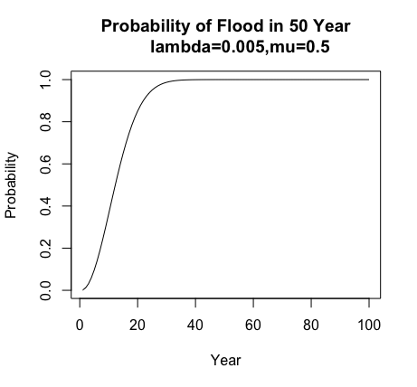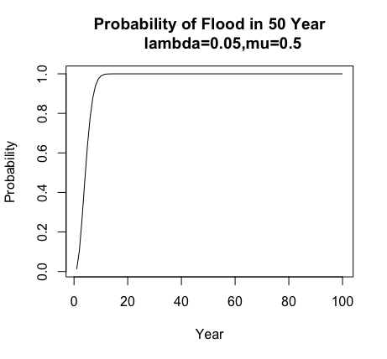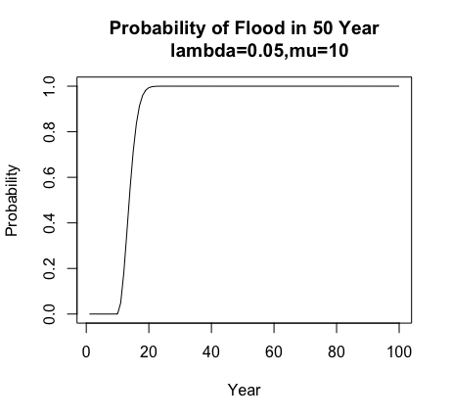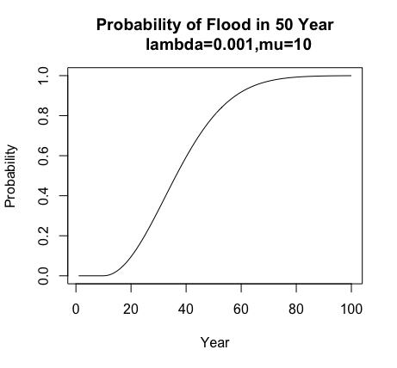

Figure 1 Probability of flood by year

We model the decision of when residents relocate as a game between the government and the residents. In this game, the government moves first, by choosing how much subsidy to offer (if any). The residents move second, by making a binary decision in any given year about whether to relocate out of the flood-prone area (assuming that they have not yet relocated). Moreover, we let each player have a discount rate, $r_{R}$ for the resident(s) and $r_{G}$ for the government, where by assumption $r_{R}$ ≥ $r_{G}$. In the following discussion, we set $r_{R}$ = 12% and $r_{G}$ = 5% as our base case, but these values are varied in our sensitivity analysis.

A resident deciding whether to relocate in year *k* is assumed to compare the cost of relocation, *M*, with the expected net present value (NPV) of future flood losses from not relocating, $E_{k}^{∞}$ (*rR*), as given by

$E_{k}^{∞}(r_{R})=\sum_{i=k}^{∞}{\frac{E(L_{k})}{{(1+r_{R})}^{i-k}}}$ (3)

(For now, $M$ is assumed to be a one-time cost in the year when the relocation occurs, but the model could be extended to allow for costs in subsequent years; e.g., to reflect the ongoing loss of coastal amenities and/or reduced benefits of agglomeration.) Equation (3) is essentially just the NPV of the loss avoided by relocating in year *k*, discounted to year *k* (the time at which the residents are making their decision) at the residents’ discount rate of *rR*. Figure 2 shows how this increases over time, due to the increasing probability of flooding.

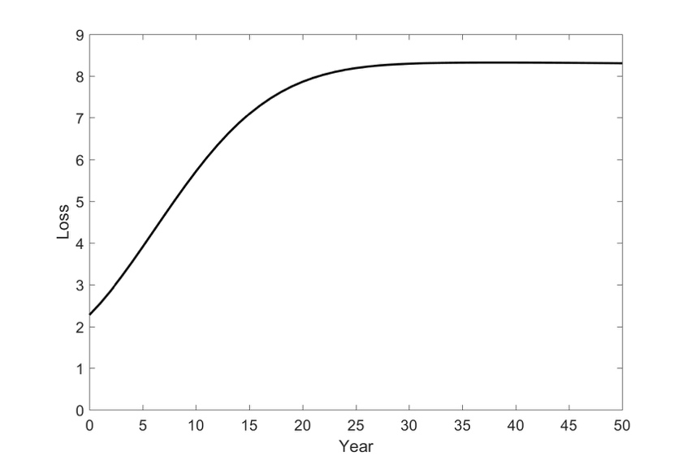

Figure 2 Cumulative NPV of future flood losses by year

Thus, in any given year *k*, if residents have not yet relocated and a subsidy $S^{*}$ is available from the government to offset moving costs, the residents’ optimization problem is given by

$\min_{I_{k}}\left\{I_{k}\left(M-S^{*}\right)+(1-I_{k})\sum_{i=k}^{∞}{\frac{E(L_{i})}{{(1+r_{R})}^{i-k}}}\right\}$ (4)

where

$$I_{k}= \left\{\begin{aligned} 1 if residents move in year k \\ 0 otherwise \end{aligned}\right.$$

Government in turn makes its decision at the start of year 0. In particular, it chooses the amount of subsidy to offer in order to minimize the discounted value of the subsidy (paid in the year when residents relocate, *k*) plus the expected discounted flood losses until year *k*, as given by

$E_{0}^{k}(r_{G})= \sum_{i=0}^{k-1}{\frac{E(L_{k})}{{(1+r_{G})}^{i}}}$ (5)

and shown in Figure 3.

The minimum value of *S* that will induce residents to move in year *k* is the value that satisfies

${S+E}_{k}^{∞}=S+ \sum_{i=k}^{∞}{\frac{E(L_{i})}{{(1+r_{R})}^{i-k}}=M}$ (6)

At equality, the value of the subsidy *S* plus the NPV of the avoided flood losses is just enough to justify residents’ incurring the relocation cost *M*. Solving for *S*, and taking into account the constraint that the subsidy cannot be negative, we find

$S_{k}=Max\{M-\sum_{i=k}^{∞}{\frac{E\left(L_{i}\right)}{{\left(1+r_{R}\right)}^{i-k}}},0\}$ (7)

(In cases where *Sk* is 0, the government need not offer any subsidy, since residents will move at or before year *k* even in the absence of a subsidy.) Figure 4 shows that large subsidies would be required to encourage residents to relocate in the early years, when flooding risk is small. However, as the probability of flooding increases over time, the NPV of the flood losses avoided by relocating may (for some parameter values) eventually become large enough that people are willing to relocate even in the absence of a subsidy; i.e., for $S_{k}=0$.

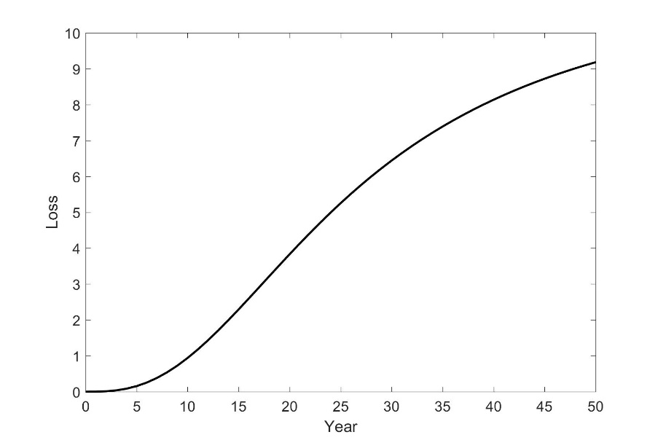

Figure 3 Cumulative NPV of past flood losses by year

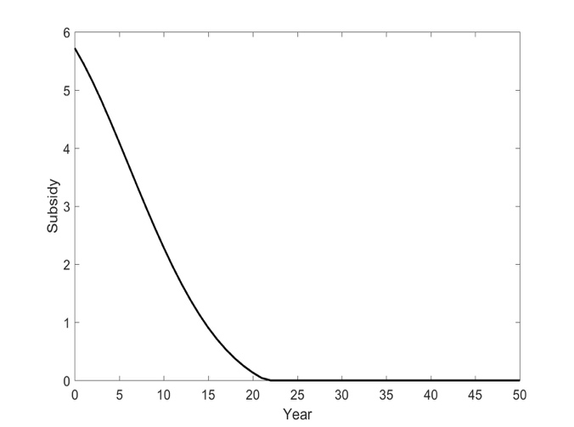

Figure 4 Minimum subsidy needed to incentivize residents to relocate in a given year

As shown in Figure 4, the earlier the government wants people to move, the larger the subsidy must be offered. So, the government needs to trade off a large benefit from early relocation against a large subsidy needed to achieve early relocation. Figure 5 shows that choosing the optimal timing of relocation allows the government to minimize its total losses. That minimization is expressed mathematically by the following optimization problem:

$obj(S)= \min_{k}{\{\frac{S_{k}}{{\left(1+r_{G}\right)}^{k}}+\sum_{i=0}^{k-1}{\frac{E\left(L_{i}\right)}{{\left(1+r_{G}\right)}^{i}} }\}}$ (8)

subject to

$E\left(L_{i}\right)=\left\{\begin{aligned}L\left(1-e^{-λ\left(i-μ\right)}\right) if k≥ μ \\ 0 if k< μ\end{aligned}\right.$

$S_{k}=\max_{}{[M-\sum_{i=k}^{∞}{\frac{E(L_{i})}{{(1+r_{R})}^{i-k}},0]}}$

$$k≥0 integer$$

For comparison purposes, the year $k^{o}$ in which residents would choose to relocate in the absence of incentives is the smallest value of $k^{o}$ for which the following inequality is satisfied:

$\sum_{i=k^{°}}^{∞}{\frac{E\left(L_{i}\right)}{{\left(1+r_{R}\right)}^{i-k^{°}}}≥M}$ (9)

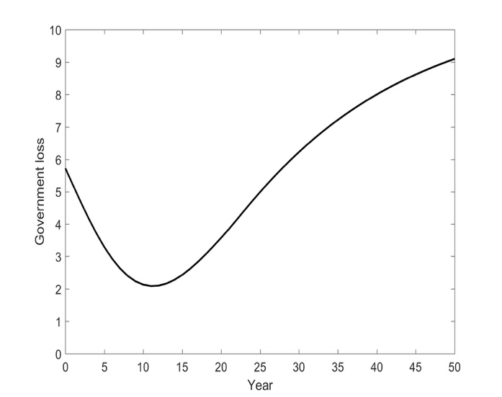

Figure 5 Government loss as a function of the year in which residents relocate

The relatively high discount rate of the resident(s) means that future flooding will pale in comparison to the relocation cost $M$ until the flooding probability $P_{k}$ has become sufficiently large. By contrast, with its lower social discount rate, the government may well find relocation to be worthwhile much earlier (since relocation would avoid both a small risk of flooding in the near future, and a larger but only slightly discounted risk of flooding in the more distant future). Thus, from a game-theoretic perspective, the government could offer a subsidy $S_{k}$ (e.g., a partial buyout) to induce residents to undertake voluntary relocation earlier than they otherwise would. Note in particular that our model allows the government to offer a subsidy substantially less than the value if the damage due to flooding (when that is effective at motivating relocation), in contrast to the full buyouts that are commonly offered after floods.

1. **Sensitivity Analysis of the Basic Model**

We now illustrate the behavior of this model for notional parameter values. The base-case parameters used in our analysis are as follows: $\left\{M=8;L=1;r_{R}=12\%;r_{G}=5\%;μ=0.5;λ=0.005\right\}$. While these parameter values are not intended to be realistic, we deliberately chose the moving cost *M* to be significantly larger than the flood loss *L*, to model the situation where residents will not readily relocate on their own.

For these parameter values, the solution to the government’s optimization problem in equation (7) is $k^{*}$ =11, whereas $k^{°}$ = 22 in the absence of a subsidy. Moreover, the optimal objective-function value $obj$ is 2.09 (including both the NPV flooding losses in years 0 through 10 and the discounted value of the subsidy), compared to an equivalent value of $E_{0}^{21}(r_{G})=$ 4.13 in the absence of a subsidy (including flooding losses in years 0 through 21). Thus, this simple numerical example shows that providing a partial subsidy of relocation expenses (*Sk* = 1.96, much less than *M* = 8) can be preferable from the government’s perspective to doing nothing, while still allowing residents to relocate voluntarily.

The sensitivity analysis in the remainder of this section shows the effects of the various parameters on the optimal subsidy $S_{k}$, the discounted expected flooding loss experienced by the government ($E_{0}^{k^{*}-1})$, and the equilibrium objective-function value $obj$. We also explore the effects of the model parameters on the relocation times $k^{°}$ (with no subsidy) and $k^{*}$ (with an optimal subsidy).

Table 1 shows how the various results depend on the government’s discount rate *rG*. We can see that in the absence of a subsidy, residents wait 22 years to relocate for the base-case parameter values. The government is willing to give the greatest subsidy (nearly double the flood loss *L*=1) when its discount rate is small (5-7%), reducing the time until relocation to only 11 years. As its discount rate increases, the government offers a smaller subsidy and accepts a slightly longer time until relocation (up to 16 years). The same results are shown graphically in Figure 6.

|  |  |  |  |  |  |  |  |  |
| --- | --- | --- | --- | --- | --- | --- | --- | --- |
| $$r_{G}$$ | $S_{k}$ | | $$E_{0}^{k^{*}-1}$$ | $obj$*(S)* |  | $$k^{*}$$ | | $$k^{°}$$ |
| 5% | 1.96 |  | 0.94 | 2.09 |  | 11 |  | 22 |
| 6% | 1.66 |  | 1.08 | 2.00 |  | 12 |  | 22 |
| 7% | 1.66 |  | 0.99 | 1.91 |  | 12 |  | 22 |
| 8% | 1.38 |  | 1.08 | 1.82 |  | 13 |  | 22 |
| 9% | 1.38 |  | 0.99 | 1.73 |  | 13 |  | 22 |
| 10% | 1.13 |  | 1.05 | 1.62 |  | 14 |  | 22 |
| 11% | 0.91 |  | 1.08 | 1.52 |  | 15 |  | 22 |
| 12% | 0.71 |  | 1.09 | 1.41 |  | 16 |  | 22 |

Table 1 Sensitivity analysis with respect to $r_{G}$ in the basic model

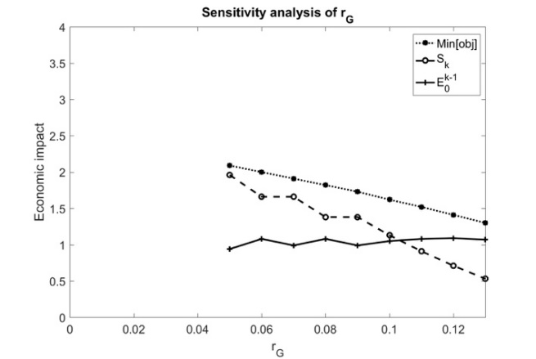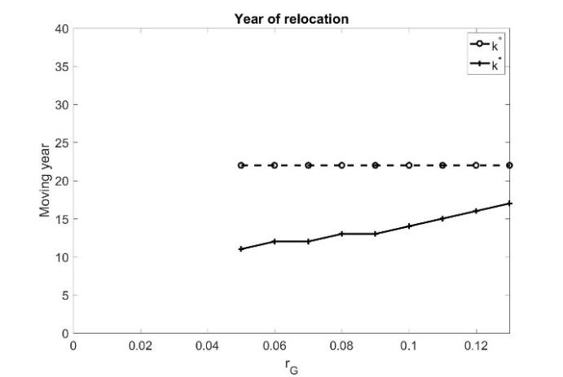Figure 6 Sensitivity analysis with respect to the government’s discount rate, $r_{G}$

Table 2 and Figure 7 show similar results for the residents’ discount rate *rR*. We can see from this table that in the absence of any subsidy, the time until relocation is increasing steeply in the residents’ discount rate, from only four years at a discount rate of 7%, to extremely large values (more than 100 years) for discount rates of 13-15% (which are not unreasonably high in practice; see for example Warner and Pleeter, 2011). For extremely low resident discount rates, the government (with a base-case discount rate of 5%) is willing to accept the relocation time preferred by residents in the absence of a subsidy and offers no subsidy to incentivize earlier relocation. (If the time of relocation were treated as continuous rather than integer, a small subsidy might be optimal in these cases.) At moderate resident discount rates, the government offers a subsidy smaller than the flood loss of L=1 (equivalent to a partial buyout). As the residents’ discount rate increases (resulting in a longer time to relocation in the absence of a subsidy), the government is willing to give greater subsidies (to a maximum of more than three times the flood loss *L*=1 when *rR*=15%), and ensures that the time until relocation does not exceed 12 years (despite some extremely long relocation times in the absence of a subsidy). 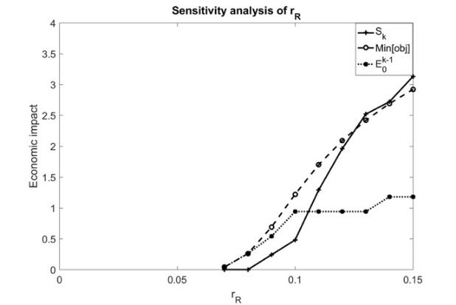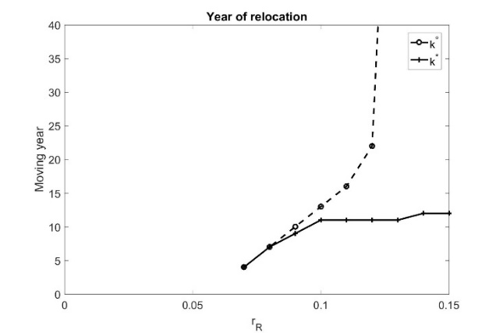

Figure 7 Sensitivity analysis with respect to the residents’ discount rate, $r_{R}$

|  |  |  |  |  |  |  |  |  |
| --- | --- | --- | --- | --- | --- | --- | --- | --- |
| $$r_{R}$$ | $S_{k}$ | | $$E_{0}^{k^{*}-1}$$ | $$obj(S)$$ |  | $$k^{*}$$ | | $$k^{°}$$ |
| 7% | 0 |  | 0.04 | 0.04 |  | 4 |  | 4 |
| 8% | 0 |  | 0.26 | 0.26 |  | 7 |  | 7 |
| 9% | 0.24 |  | 0.54 | 0.69 |  | 9 |  | 10 |
| 10% | 0.48 |  | 0.94 | 1.22 |  | 11 |  | 13 |
| 11% | 1.29 |  | 0.94 | 1.70 |  | 11 |  | 16 |
| 12% | 1.96 |  | 0.94 | 2.09 |  | 11 |  | 22 |
| 13% | 2.52 |  | 0.94 | 2.42 |  | 11 |  | >100 |
| 14% | 2.72 |  | 1.18 | 2.69 |  | 12 |  | >100 |
| 15% | 3.13 |  | 1.18 | 2.92 |  | 12 |  | >100 |

Table 2 Sensitivity analysis with respect to $r_{R}$ in the basic model

Figures 8 through 10 show similar results for $μ$, $λ$, and *M*. Results show that increases in *M* lead to increased (worse) values of *obj(S)* for the government, since larger subsidies are needed to encourage relocation. By contrast, increases in $λ$, $μ$ cause $obj$ to decrease. In the case of increasing *μ*, the reduced cost to government is simply because of early years with no flooding risk, while increasing *λ* effectively shifts costs from the government to residents (since residents relocate sooner, with or without a subsidy). Conversely, increases in $μ$ and *M* cause residents to move later (and increases in *M* also lead to increases in the optimal subsidy *Sk*).

Figure 8 Sensitivity analysis with respect to the time at which flood risk begins, μ

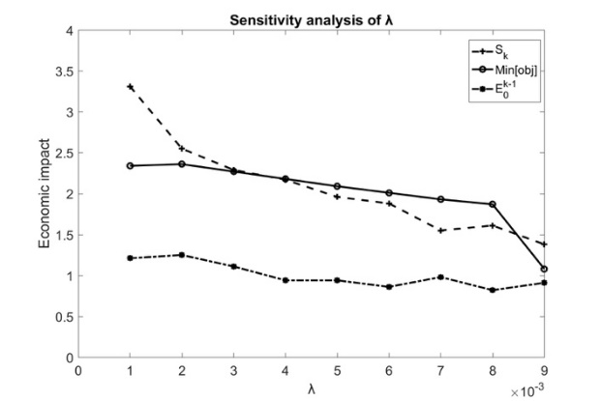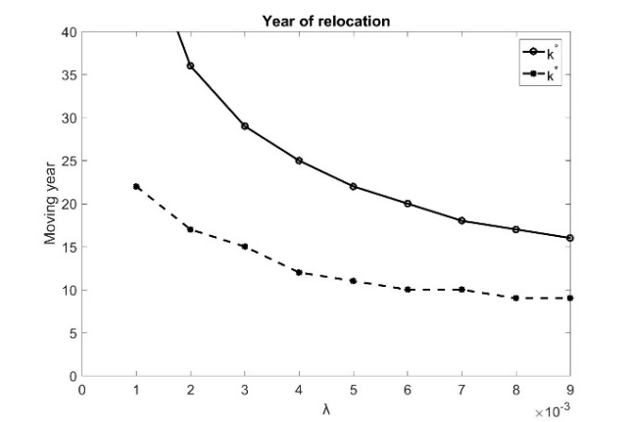Figure 9 Sensitivity analysis with respect to the rate of increase in flood risk, λ

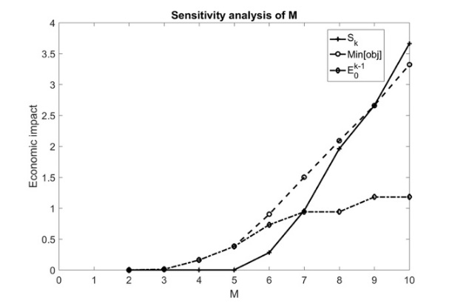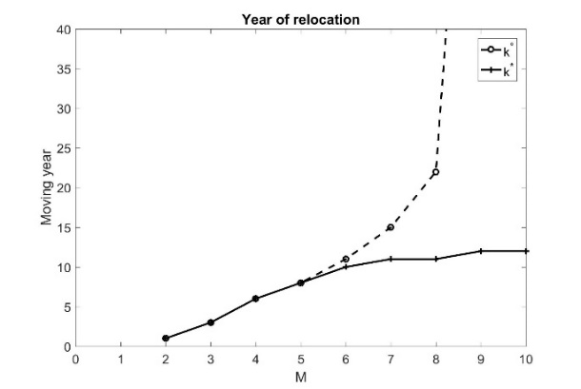

Figure 10 Sensitivity analysis with respect to the relocation cost, *M*

1. **Annual Benefits vs. One-Time Subsidies**

Numerous variants of this model could be explored. For example, tax incentives or reduced subsidies under the National Flood Insurance Program (Michel-Kerjan, 2010) could be modeled by a fixed annual benefit to residents in every year after relocation, independent of whether flooding occurred in that year. Alternatively, modifications to the Stafford Act (Bea, 2010) could increase the loss born by residents in the event of a flood, by reducing both emergency relief and subsidies for infrastructure restoration. Modeling of these various policy options would make it possible to identify those that are relatively effective economically. For now, we consider only the provision of annual benefits after relocation, as an alternative to a one-time subsidy. (For example, this could take the form of a reduced tax rate for residents who relocate to an inland area at low flood risk, similar to the special economic zones used to encourage development.)

We assume here that the government will offer residents a fixed annual benefit $B_{k}$ after relocation. By similar logic to that presented above in Equation (7), the optimal annual benefit *Bk*for the government to offer in order to motivate residents to move in year *k* should satisfy:

$B_{k}=Max\{\sum_{i=k}^{∞}{{(1+r_{R})}^{k-i}}[M-\sum_{i=k}^{∞}{\frac{{E(L}_{i})}{{\left(1+r_{R}\right)}^{i-k}}]}, 0\}$ (10)

In other words, the relocation cost *M* will be justified if it is no greater than the NPV of flood losses avoided by relocating, plus the NPV of the additional annual benefit. (Of course, the benefit $B_{k}$ may not actually remain in place in perpetuity, but at typical discount rates, benefit paid more than a few decades into the future would have negligible NPV in any case.) Likewise, the government’s objective function changes to

$\underset{ k}{obj(B)= Min\{}{\sum_{i=k}^{∞}{\frac{B_{k}}{{(1+r_{G})}^{i}}}+\sum_{i=0}^{k-1}{\frac{E\left(L_{i}\right)}{{\left(1+r_{G}\right)}^{i}} }}\}$ (11)

Table 3 compares the results for a one-time subsidy *Sk* vs. a fixed annual benefit *Bk* in every year after relocation, as a function of the government’s discount rate *rG*. As can be seen from that table, a one-time subsidy is preferable for the government (resulting in a smaller objective-function value and earlier relocation) for small values of the government’s discount rate (5-8%). If the government is more time-sensitive (corresponding to a higher discount rate), paying a one-time subsidy becomes more costly, and the government prefers to offer a fixed annual benefit for every year after relocation. In that case, the fixed annual benefit also results in relocation times at least as early as those for a one-time subsidy (since the government’s time sensitivity prevents it from offering a large enough subsidy to encourage extremely early relocation). The same results are shown graphically in Figure 11.

|  |  |  |  |  |  |
| --- | --- | --- | --- | --- | --- |
| $$r_{G}$$ | $$obj(S)$$ | $$obj(B)$$ | $$k^{*}(S)$$ | $$k^{*}(B)$$ | $$k^{°}$$ |
| 5% | 2.09 | 3.02 | 11 | 15 | 22 |
| 6% | 2 | 2.5 4 | 12 | 14 | 22 |
| 7% | 1.91 | 2.15 | 12 | 14 | 22 |
| 8% | 1.82 | 1.85 | 13 | 13 | 22 |
| 9% | 1.73 | 1.59 | 13 | 13 | 22 |
| 10% | 1.62 | 1.39 | 14 | 13 | 22 |
| 11% | 1.52 | 1.22 | 15 | 13 | 22 |
| 12% | 1.41 | 1.08 | 16 | 12 | 22 |

Table 3 Sensitivity analysis with respect to $r_{G}$ in annual-benefit model vs. basic model

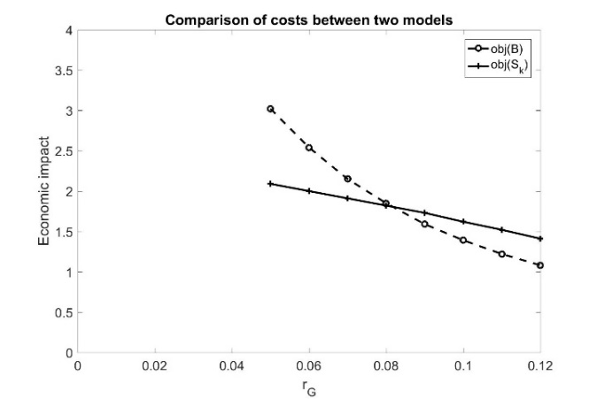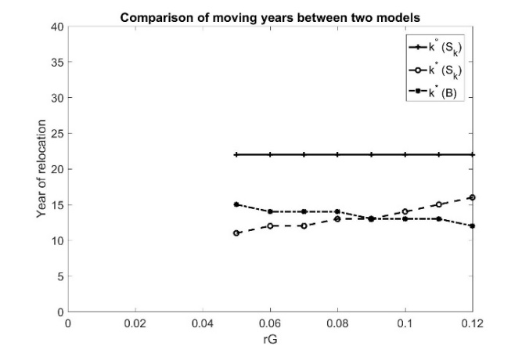

Figure 11 Comparison of one-time subsidy *Sk* and annual benefit *Bk* as a function of *rG*

Table 4 and Figure 12 show similar results (comparing a one-time subsidy *Sk* vs. a fixed annual benefit *Bk*) as a function of the residents’ discount rate *rR*. As can be seen from that table, for a government discount rate of 5%, a one-time subsidy is preferable for all resident discount rates from 9-15%. (At lower resident discount rates, people relocate even without a subsidy, so the two strategies do not differ.) The desirability of the one-time subsidy is because at a discount rate of 5%, the government is not unduly sensitive to paying the one-time subsidy, while the residents’ relatively high discount rate means that they are not as responsive to a benefit that is received only gradually over time. From the comparison between the annual-benefit model and the one-time subsidy, we can see that a one-time subsidy is the optimal strategy for the government unless the discount rates of the government and the residents are fairly close.

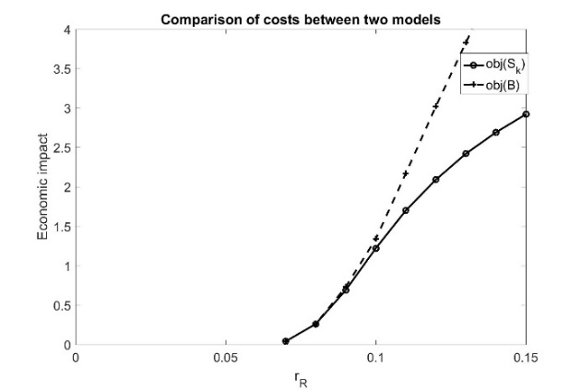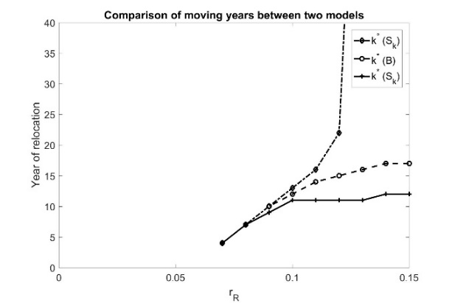

Figure 12 Comparison of one-time subsidy *Sk* and annual benefit *Bk* as a function of *rR*

|  |  |  |  |  |  |
| --- | --- | --- | --- | --- | --- |
|  |  |  |  |  |  |
| 7%  8%  9%  10% | 0.04  0.26  0.69  1.22 | 0.04  0.26  0.73  1.34 | 4  7  9  11 | 4  7  10  12 | 4  7  10  13 |
| 11% | 1.7 | 2.17 | 11 | 14 | 16 |
| 12% | 2.09 | 3.02 | 11 | 15 | 22 |
| 13% | 2.42 | 3.83 | 11 | 16 | >100 |
| 14% | 2.69 | 4.60 | 12 | 17 | >100 |
| 15% | 2.92 | 5.32 | 12 | 17 | >100 |

Table 4 Sensitivity analysis with respect to $r_{R}$ in annual benefit model vs. basic model

1. **Hyperbolic vs. Exponential Discounting**

Several researchers have pointed out that many individuals do not obey exponential discounting, but instead use a significantly higher discount rate for distant future benefits than for near-term benefits. For example, Kunreuther et al. (2013) note that individuals frequently make myopic (near-term) decisions regarding the purchase of flood insurance (e.g., buying insurance only after experiencing a flood, and then canceling it within a few years thereafter). This suggests considering hyperbolic discounting (e.g., Kirby, 1997; Rachlin, 1989; Green and Myerson, 1996; Laibson, 1997) may be more behaviorally realistic than exponential discounting.

Our previous sensitivity analysis showed that the discount rate $r_{R}$ of residents has a large impact on both the time of relocation and the subsidy needed to incentivize residents to relocate at the optimal time. This suggests that a hyperbolic discount rate may have even a greater impact on residents’ decisions, making them less likely to relocate in the absence of government incentives, and potentially calling into question the effectiveness of incentives. To test this, we introduce a hyperbolic discount rate α into residents’ decision making, in which case the optimal one-time subsidy *Sk* for the government to offer in order to induce residents to relocate in year *k* should satisfy

$S_{k}=Max\{M-\sum_{i=k}^{∞}{\frac{{E(L}_{i})}{{(1+r_{R}+α (i-k))}^{i-k}}, 0\}}$ (12)

Table 5 shows the results for our model with hyperbolic discounting, as a function of the parameter α representing the extent of hyperbolic discounting. As can be seen there, hyperbolic discounting in the absence of a subsidy rapidly results in extremely long times until relocation. Despite that, subsidies can still result in reasonable times until relocation (11 or 12 years, for our base-case parameter values), with subsidies not dramatically different than in the case of ordinary exponential discounting (roughly two to three times the amount of the flooding loss *L*). Thus, rather than rendering subsidies ineffective, hyperbolic discounting on the part of residents may simply increase the size of the optimal government subsidy required to motivate relocation.

|  |  |  |  |
| --- | --- | --- | --- |
| $$α$$ | $$obj(S)$$ | $$k^{*}$$ | $$k^{°}$$ |
| 0.1% | 2.40 | 11 | 21 |
| 0.15% | 2.57 | 11 | 26 |
| 0.2% | 2.71 | 11 | >100 |
| 0.25% | 2.84 | 11 | >100 |
| 0.3% | 2.94 | 12 | >100 |
| 0.35% | 3.03 | 12 | >100 |
| 0.4% | 3.11 | 12 | >100 |

Table 5 Results of hyperbolic-discounting model

1. **Future Research Directions**

The work presented here is, in our view, a novel use of game theory and engineering economic analysis (i.e., the mathematics of discounting) to study incentives for relocation in the face of sea-level rise and increasing flood risk. However, this work barely scratches the surface of the analyses that could be done. A first step would be to quantify this model with more than nominal parameter values (e.g., realistic estimates of flooding probabilities, rather than the simple Rayleigh model used here, and realistic flood losses and moving costs). Future work could also address the uncertainty regarding future flooding scenarios (Gersonius et al., 2013; Giuliani and Castelletti, 2016; Hui et al., 2018).

It is also clearly important to have a behaviorally realistic model of resident decision making; for example, alternative functional forms for hyperbolic discounting could be explored. Read et al. (2012) have also suggested that failure to undertake actions that would be desirable in the long term could arise from causes other than excessive discounting. For example, myopic behavior could be the result of *unrealistic optimism* (Shepperd et al., 2013), resulting in underestimation of flooding probabilities, or the result of *normalization of deviance* (Vaughan, 1996), in which residents come to experience repeated flooding as “normal.” Finally, reluctance to relocate could result in some cases not from hyperbolic discounting or biased risk perceptions, but from social pressures (e.g., reluctance to abandon one’s neighbors, pressure to preserve community unity in the face of hazards), as noted by Binder et al. (2015) in the case of Rockaway Park in New York. Each of these phenomena could give rise to quite different models than the ones presented here.

Another important extension to the models presented here would be to allow for resident heterogeneity, especially in discount rates. In particular, low-income people may tend to have higher discount rates, in which case they may respond differently to economic incentives than residents with low discount rates. This would be consistent with the results of Smith et al. (2006), who found that some heavily damaged neighborhoods actually grew in population after Hurricane Andrew, with low-income households moving into damaged middle-class areas. This also suggests the importance of mechanisms to ensure that coastal properties are removed from the market altogether (e.g., through zoning, buyouts, deed restrictions). Otherwise, if coastal properties remain in the market but real-estate prices drop, that could make coastal areas more affordable to low-income residents, potentially raising rather than lowering population density.

It is also important to understand the actual human impact of relocation (rather than only the financial impact). For example, Binder and Greer (2016) find that relocation may involve “losses in homeownership, social networks, access to healthcare, employment, income, and physical and mental health,” not just economic costs. Similarly, de Vries and Fraser (2012) found that supposedly “voluntary” relocation or buyout programs may not always be perceived as truly voluntary, since for example the officials responsible for implementing such programs may face strong incentives to achieve high compliance rates, and thus impose pressure on residents.

Extensions to this work could also explore numerous other types of incentives to encourage relocation, rather than only one-time subsidies and fixed annual benefits after relocation. For example, one could imagine increased costs in advance of relocation, instead of benefits after relocation; such costs could be either fixed per year (e.g., surcharges on residents in high-risk zones), or contingent on the occurrence of flooding (e.g., reduced government assistance in the aftermath of floods). Our limited results so far have suggested that different mechanisms may be preferable in different situations (e.g., for residents with different discount rates). This suggests that further mechanisms should be explored, to help in identifying those that may be the most cost-effective for governments to implement.

There are also numerous barriers to achieving proactive relocation, not limited to conflicting timescales or high discount rates ((Bierbaum et al., 2013; Biesbroek et al., 2011, 2013, 2014; Eisenack et al., 2014; Ekstrom and Moser, 2014; Freudenberg et al., 2016; Treuer, 2017). For example, Slovic (2007) notes that people are insensitive to disasters with large numbers of casualties (not in proportion to the actual number of casualties), in part because the fraction of damage avoided may carry more weight in people’s minds than the actual magnitude of damage avoided (see also Slovic et al., 2013; Wiener, 2016). Thus, communities may be reluctant to invest in incentives to encourage relocation if the uptake is likely to be modest and significant numbers of people will still be living in at-risk areas.

**7. Conclusion**

The novel feature of our work is to view incentives for relocation away from areas at risk for increased flooding due to sea-level rise as a game between residents and the government. We argue that in the face of high discount rates or hyperbolic discounting by residents, government can offer either a one-time subsidy (e.g., a partial buyout) or a fixed annual benefit to “nudge” people to consider relocating (Sunstein and Thaler, 2008). In theory, this can create a win-win situation for both sides: government can reduce the burden of future disasters by encouraging residents to leave the most at-risk areas; while residents may benefit from the incentive to adopt a more farsighted view and relocate before experiencing extensive and repeated flood damage.

Specifically, we argue that in the face of high discount rates or hyperbolic discounting by residents, government can offer either a one-time subsidy or a fixed annual benefit to “nudge” people to consider relocating (Sunstein and Thaler, 2008). Importantly, this subsidy can sometimes represent only a partial buyout (i.e., less than the loss that would be experienced from a single severe flood), while in other cases (when resident discount rates are high), the subsidy may need to be several times greater than a typical flood loss to motivate proactive relocation.

One key factor affecting the ability of the government to encourage proactive relocation is the difference between government’s discount rate and residents’ discount rate. In theory, if government makes decisions using a low “social discount rate,” it should be able to incentivize proactive relocation through the provision of economic incentives. However, government may not always be so farsighted; for example, local governments may face short-term pressures from residents to improve infrastructure in heavily populated coastal areas (even if the ideal long-term strategy would be to disinvest from such areas), and/or political pressures not to acknowledge climate change (Harish, 2012). Moreover, residents may not make their relocation decisions as “rational economic agents” (if subject to myopia, peer pressure, etc.), and some costs of relocation (e.g., worse mental health, loss of social connections, and reduced economic security) may not be easily monetized.

Nonetheless, given the substantial benefits of proactive relocation rather than forced relocation in the aftermath of a flood (loss of personal property, significant disruption, and inability to plan where and when to relocate), we would argue that it is worth considering economic subsidies or other incentives to motivate proactive relocation.

**References**

Aerts JCJH, Botzen WJW (2011) Flood-resilient waterfront development in New York City: Bridging flood insurance, building codes, and flood zoning. Ann. N. Y. Acad. Sci. 1227(1):1-82.

Bea K (2010) Federal Stafford Act disaster assistance: Presidential declarations, eligible activities, and funding. Congressional Research Service,

<https://biotech.law.lsu.edu/blaw/crs/RL33053_20100316.pdf>

Bier V, Corradini M, Roh C, Liu S, Youngblood R (2014) Development of an updated societal-risk goal for nuclear-power safety.

http://psam12.org/proceedings/paper/paper_199_1.pdf

Bierbaum R, Smith JB, Lee A, Blair M, Carter L, Chapin FS III, Fleming P, Ruffo S, Stults M, McNeeley S, Wasley E, Verduzco L (2013) A comprehensive review of climate adaptation in the United States: More than before, but less than needed. Mitig. Adapt. Strat. Gl. 18(3):361-406.

Biesbroek GR, Klostermann JEM, Termeer CJAM, Kabat P (2011) Barriers to climate change adaptation in the Netherlands. Climate Law 2(2):181-199.

Biesbroek GR, Klostermann JEM, Termeer CJAM, Kabat P (2013) On the nature of barriers to climate change adaptation. Reg. Environ. Change 13(5):1119-1129.

Biesbroek GR, Termeer CJAM, Klostermann JEM, Kabat P (2014) Rethinking barriers to adaptation: Mechanism-based explanation of impasses in the governance of an innovative adaptation measure. Global Environ. Chang. 6:108-118.

Binder SB, Greer A (2016) The devil is in the details: Linking home buyout policy, practice, and experience after Hurricane Sandy. Politics and Governance 4(4):97-106.

Binder SB, Baker C, Barile JP (2015) Rebuild or relocate? Resilience and postdisaster decision-making after Hurricane Sandy. Am. J. Community Psychol. 56(1-2):180-196.

Buddemeier BR, Valentine JE, Millage KK, Brandt LD (2011) National Capital Region: Key response planning factors for the aftermath of nuclear terrorism. Lawrence Livermore National Laboratory, LLNL-TR-512111,

https://fas.org/irp/agency/dhs/fema/ncr.pdf

Busby JW (2007) Climate change and national security: An agenda for action. Council on Foreign Relations, Special Report No. 32,

http://www.atlanticcoastconservancy.org/National%20Publications/climate-change-and-national-security.pdf

Davenport C, Robertson C (2016) Resettling the first American ‘climate refugees.’ New York Times.

de Vries DH, Fraser JC (2012) Citizenship rights and voluntary decision making in post-disaster U.S. floodplain buyout mitigation programs. IJMED 30(1):1-33).

Dey S, Dey T, Luckett DJ (2017) Statistical inference for the generalized Rayleigh distribution based on upper record values. MASA 12(1):15-29.

Eisenack K, Moser SC, Hoffmann E, Klein RJT, Oberlack C, Pechan A, Rotter M, Termeer CJAM (2014) Explaining and overcoming barriers to climate change adaptation. Nat. Clim. Change 4:867-872.

Ekstrom J, Moser SC (2014) Identifying and overcoming barriers in urban climate adaptation: Case study findings from the San Francisco Bay Area, California, USA. Urban Clim. 9:54-74.

Ellison G, Glaeser EL, and Kerr WR (2010) What causes industry agglomeration? Evidence from coagglomeration patterns. Am. Econ. Rev. 100(3):1195-1213.

Environment News Service (2013) 10 coastal cities at greatest flood risk as sea levels rise. http://ens-newswire.com/2013/09/03/10-coastal-cities-at-greatest-flood-risk-as-sea-levels-rise/

Eyer J, Rose A, Miller N, Dinterman R (2016) What influences the destination of disaster migrants? Evidence from Hurricane Katrina. Center for Risk and Economic Analysis of Terrorism Events, University of Southern California.

Freudenberg R, Calvin E, Tolkoff L, Brawley D (2016) Buy-in for buyouts: The case for managed retreat from flood zones. Lincoln Institute of Land Policy, Regional Plan Association, https://www.lincolninst.edu/sites/default/files/pubfiles/buy-in-for-buyouts-full.pdf

Gersonius B, Ashley R, Pathirana A, Zevenbergen C (2013) Climate change uncertainty: Building flexibility into water and flood risk infrastructure. Clim. Change 116(2):411-423.

Giuliani M, Castelletii A (2016) Is robustness really robust? How different definitions of robustness impact decision-making under climate change. Clim. Change 135(3-4):409-424.

Goldman L, Coussens C (2007) Environmental Public Health Impacts of Disasters: Hurricane Katrina, Workshop Summary, National Academies Press,

https://www.nap.edu/read/11840/chapter/1

Green L, Myerson J (1996) Exponential versus hyperbolic discounting of delayed outcomes: Risk and waiting time. Am. Zool. 36(4):496-505.

Haer T, Kalnay E, Kearney M, Moll H (2013) Relative sea-level rise and the conterminous United States: Consequences of potential land inundation in terms of population at risk and GDP loss. Global Environ. Chang. 23(6):1627-1636.

Hallegatte S, Green C, Nicholls RJ, Corfee-Morlot J (2013) Future flood losses in major coastal cities. Nat. Clim. Change 3:802-806.

Harish A (2012) New law in North Carolina bans latest scientific predictions of sea-level rise. ABC News.

Hauer ME, Evans JM, Mishra DR (2016) Millions projected to be at risk from sea-level rise in the continental United States. Nat. Clim. Change 6: 691-695, 2016,

http://www.nature.com/nclimate/journal/vaop/ncurrent/full/nclimate2961.html

Hausken K (2002) Probabilistic risk analysis and game theory. Risk Anal. 22(1):17-27.

Hayat B, Moore R (2015) Addressing affordability and long-term resiliency through the National Flood Insurance Program. Envtl. L. Rep. 45: 10338-10349.

Hecht J (2017) Making multi-stakeholder water resources decisions with limited streamflow information. Unpublished doctoral dissertation, Tufts University, Medford.

Hino M, Field CB, Mach KJ (2017) Managed retreat as a response to natural hazard risk. Nat. Clim. Change 7: 64-370,

https://www.nature.com/nclimate/journal/v7/n5/full/nclimate3252.html

Hui R, Herman J, Lund J, Madani K (2018) Adaptive water infrastructure planning for nonstationary hydrology. Adv. Water Resour.

https://www.sciencedirect.com/science/article/pii/S0309170817309739

Huntington HP, Goodstein E, Euskirchen E (2012) Towards a tipping point in responding to change: Rising costs, fewer options for Arctic and global societies. AMBIO 41(1):66-7

Ingram JC, Franco G, Rumbaitis-del Rio C, Khazai B (2006) Post-disaster recovery dilemmas: Challenges in balancing short-term and long-term needs for vulnerability reduction. Environ. Sci. Policy 9(7-8):607-613.

Jeong H, Ha S, Kim H (2018) Flood protection cost allocation using cooperative game theory for adapting infrastructure to climate change. J. Water Res. Pl. 144(4).

Kirby KN (1997) Bidding on the future: Evidence against normative discounting of delayed rewards. JEP: General 126(1):54-70.

Kirshen P, Knee K, Ruth M (2008) Climate change and coastal flooding in Metro Boston: Impacts and adaptation strategies. Clim. Change 90(4):453-473.

Kunreuther HC, Pauly MV, McMorrow S (2013) Insurance and Behavioral Economics: Improving Decisions in the Most Misunderstood Industry (Cambridge University Press, New York).

Kusnetz, N (2017) Sea level rise is creeping into coastal cities. Saving them won’t be cheap. Inside Climate News, https://insideclimatenews.org/news/28122017/sea-level-rise-coastal-cities-flooding-2017-year- review-miami-norfolk-seawall-cost

Laibson D (1997) Golden eggs and hyperbolic discounting. Q. J. Econ. 112(2):443-477.

Lieb DA, Salter J (2011) FEMA flood buyouts top $2B since 1993,

<http://archive.boston.com/news/nation/articles/2011/07/12/apnewsbreak_fema_flood_buyouts_top_2b_since_1993/>

McMichael C, Barnett J, McMichael AJ (2012) An ill wind? Climate change, migration and health. Environ. Health Perspect. 120(5): 646-654.

Mele C, Victor D (2016) Reeling from effects of climate change, Alaskan village votes to relocate. New York Times, https://www.nytimes.com/2016/08/20/us/shishmaref-alaska-elocate-vote-climate- change.html?_r=0

Melillo JM, Richmond TC, Yohe GW, eds. (2014) Climate change impacts in the United States: The Third National Climate Assessment. U.S. Global Change Research Program, http://s3.amazonaws.com/nca2014/low/NCA3_Full_Report_0a_Front_Matter_LowRes.pdf?down load=1

Meyer R, Kunreuther H (2017) The Ostrich Paradox: Why We Underprepare for Disasters (Wharton Digital Press, Philadelphia, PA).

Michel-Kerjan EO (2010) Catastrophe economics: The National Flood Insurance Program. JEP 24(4):165-86.

Okada T, Haynes K, Bird D, van den Honert R, King D (2014) Recovery and resettlement following the 2011 flash flooding in the Lockyer Valley. IJDRR 8:20-31.

Oliver-Smith A (1991) Success and failures in post-disaster resettlement. Disasters 15(1):12-23.

Olsen JR, Beling PA, Lambert JH (2000) Dynamic models for floodplain management. J. Water Res. Pl. 126(3):167-175.

Partridge W. (1989) Involuntary resettlement in development projects. J. Refug. Stud. 2(3):373-384.

Pascucci-Cahen L (2014) Nuclear refugees after large early radioactive releases.

http://psam12.org/proceedings/paper/paper_4_1.pdf.

Rachlin H (1989) Judgment, Decision, and Choice: A Cognitive/Behavioral Synthesis (Freeman, New York).

Read D, Frederick S, Airoldi M (2012) Four days later in Cincinnati: Longitudinal tests of hyperbolic discounting. Acta Psychol. 140(2):177-185.

Read LK, Vogel RM (2015) Reliability, return periods, and risk under nonstationarity. Water Resour. Res. 51(8):6381-6398.

Richardson HW, Gordon P, Moore JE, eds. (2008) Natural Disaster Analysis after Hurricane Katrina: Risk Assessment, Economic Impacts and Social Implications (Edward Elgar, Cheltenham, UK).

Risky Business Project (2014) Risky business: The economic risks of climate change in the United States.

<https://riskybusiness.org/site/assets/uploads/2015/09/RiskyBusiness_Report_WEB_09_08_14.pdf>

Schulz K. (2015) The really big one. New Yorker,

http://www.newyorker.com/magazine/2015/07/20/the-really-big-one

Shepperd JA, Klein WMP, Waters EA, Weinstein ND (2013) Taking stock of unrealistic optimism. Perspect. Psychol. Sci. 8(4):395-411.

Silva K, Ishiwatari Y, Takahara S (2014) Cost per severe accident as an index for severe accident consequence assessment and its applications. Reliab. Eng. Syst. Safe. 123:110-122.

Slovic P (2007) ‘If I look at the mass I will never act’: Psychic numbing and genocide. Judgm. Deci. Mak. 2(2):79-95.

Slovic P, Zionts D, Woods AK, Goodman R, Jinks D (2013) Psychic numbing and mass atrocity.

Shafir E, ed. The Behavioral Foundations of Policy (Princeton University Press, Princeton, NJ).

Smith VK, Carbone JC, Pope JC, Hallstrom DG, Darden ME (2006) Adjusting to natural disasters. J. Risk Uncertain. 33(1-2):37-54.

Spotts P (2014) Global warming to disrupt US economy by mid-century, report finds. Christian Science Monitor, http://www.csmonitor.com/USA/2014/0624/Global-warming-to-disrupt-US-economy-by-mid-century-report-finds-video

Tate E, Strong A, Kraus T, Xiong H (2016) Flood recovery and property acquisition in Cedar Rapids, Iowa. Nat. Hazards 80(3):2055–2079.

Trenberth KE, Fasullo JT, Shepherd TG (2015) Attribution of climate extreme events. Nat. Clim. Change 5:725-730.

Treuer G (2017) Risk and the response to sea level rise in South Florida. Unpublished doctoral dissertation, University of Miami, Miami.

Turner RK, Burgess D, Hadley D, Coombes E, Jackson N (2007) A cost-benefit appraisal of coastal managed realignment policy. Global Environ. Chang. 17(3-4):397-407.

Udvardy S, Winkelman S (2014) Green resilience: Climate adaptation + mitigation synergies. Center for Clean Air Policy, <http://ccap.org/assets/CCAP-Green-Resilience-Climate-Adaptation-Mitigation-Synergies_April-2014.pdf>

U.S. Government Accountability Office (2003) Alaska native villages: Most are affected by flooding and erosion, but few qualify for federal assistance. GAO-04-142,

http://www.gao.gov/products/GAO-04-142

Warner JT, Pleeter S (2001) The personal discount rate: Evidence from military downsizing programs. Am. Econ. Rev. 91(1):33-53.

Wiener JB (2016) The tragedy of the uncommons: On the politics of apocalypse. Global Politics 7(1):67- 80.

Vaughan D. (1996) The Challenger Launch Decision: Risky Technology, Culture, and Deviance at NASA (University of Chicago Press, Chicago, IL).

Zhu T, Lund JR, Jenkins MW, Marques GF, Ritzema RS (2007) Climate change, urbanization, and optimal long-term floodplain protection. Water Resour. Res. 43(6)