

**Can the continued growth of AI Tools eventually undermine Computing as a Profession?**

**Prepared by**

J110585

**TABLE OF CONTENTS**

|  |  |
| --- | --- |
| Introduction |  |
| **Discussion**  1.1 Growth of AI Applications |  |
| 1.2Ethics in Computing  1.3 Computer Law, Copyright and Intellectual Property Rights  1.4Changing Skills Profile and CPD in Computing  1.5 Customer Requirements and Expectations  1.6 Security Issues  1.7 The Changing Nature of Work  **Conclusion** |  |
| **Reference List** |  |

**Introduction**

Rapid progress in artificial intelligence (AI) over the past decades has opened new horizons for technological development around the world. This huge amount of functionality with a noticeable increase in user interest made an argument whether its’ continuing growth can eventually undermine computing as a profession. This report examines the growth of AI applications, the role of professional bodies in it, which ethics issues it has caused and how it can be regulated, computer law, copyrighting, and intellectual property problems, what skills should be improved and gained in continue professional development, what needs and expectations customer requires and how it could be implemented, security issues and what changes in nature of work it has made.

**Discussion**

1.1 Growth of AI Applications

In the last 3 years, AI applications such as ChatGPT, Dall-E 2, and Stable Diffusion 2 have made a huge step in development. According to a chart, it is obvious that with the growth of the functionality of AI, the interest of users is rapidly growing at the same time, meaning that AI is becoming an essential multitool in daily life, that solves complex problems of different levels. It provides a wide range of abilities for people across the world and helps to reduce human errors as its decisions are based on information previously gathered by a set of algorithms, to increase efficiency it performs a summary of outcomes from plenty of sources which saves time on research for users. (Simplilearn, 2023). However, to create a machine that can implement human intelligence and keep the software updated requires money (at least 50,000$) and time resources. (ITRex Group, 2023). The main difference between AI and humans is the lack of creativity and emotions because programs can’t think outside the box. AI can only provide solutions based on previous experience, but you will not notice a human touch in it.

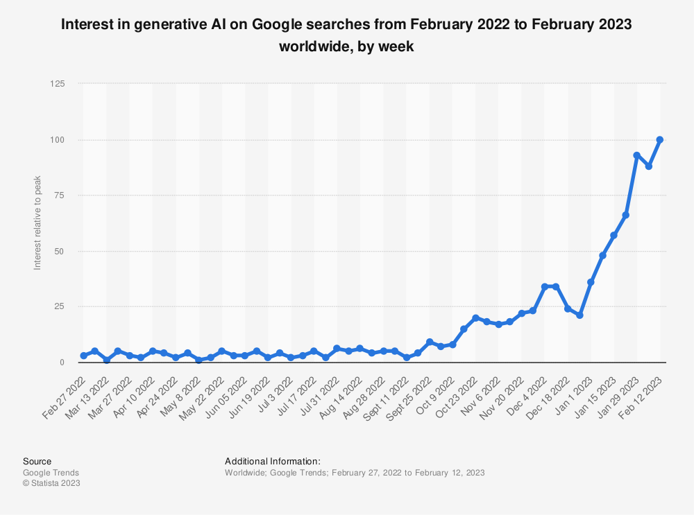

Figure 1: Global weekly interest in generative AI on Google searches 2022-2023. Retrieved from <https://www.statista.com/statistics/1367868/generative-ai-google-searches-worldwide/>

|  |
| --- |
|  |

**1.2 Ethics in computing**

With the development of AI and the increase in the amount of data processing, there are some ethical issues. It raises some concerns in privacy and data protection, exclusively in personal data, so AI developers as professionals need to make sure that a high level of privacy protection is achieved. Job undertaking is another issue raised by an AI. There is a strong capability of automatization of job processes such as office support, customer service and food service, which can lead to a 30% displacement of those jobs (McKinsey & Company, 2023). AI can be also used to create fake content which looks realistic but is a deep fake, contributing to the spread of misinformation. Also, users usually don’t fully understand how data collection of AI-driven applications works and could be unfamiliar with using their sensitive information, which is another ethical problem. However, there are international organisations that have led efforts to ensure that IT is developing with strong ethical guardrails. (UNESCO, 2023)

**1.3 Computer Law, Copyright, and Intellectual Property Rights**

Generally, computer law is flexible, because IT is annually developing science and with new technologies, it is hard to keep all laws up to date in every country. Copyright and intellectual property rights, as part of the Universal Declaration of Human Rights (n.d.), are states for intellectual property protection. It allows you to display and perform work and to be a fundamental person of your creation and have your own rights according to it, so unauthorized use of IP can be detected. As the outcome produced by generative AI is not a product of human authorship it is hard to define who has rights for it, as copyright law extends only to creations made by humans. Produced content also does not fall under copyright protection because created by an abstract machine that uses algorithms. That is why behind created content must be a human individual on whom people can rely on and know who has responsibility for work.

**1.4 Changing Skills Profile and CPD in Computing**

Computer Science is rapidly developing every year and all professionals must develop their skills when a new technology appears and adapt to all changes. It is important that world-leading IT organizations force their employees to continuously reinforce their knowledge as it helps to keep businesses up to date. Due to a growing demand for AI, most enterprises adjust it in their work, for example even GOV.UK (2023) is using it for Q&A purposes which improves time management and reduces the workforce of an organisation. The UK government also provided guidance for businesses to increase the knowledge of workers in the AI sphere. They invested more than “290 million pounds in a broad package of AI skills and talent initiatives since 2018”. This guidance will help to make sure that businesses in the UK are doing “practical, functional and successful steps”. Using AI is also increasing the productivity and competitiveness of the economy, leading to growth in cooperation, so firms will help each other to maximize their profit and gain benefits from work. It shows that CPD is a valuable thing, especially in computing and skills improvement is also an essential part of changing professional profile.

**1.5 Customer Requirements and Expectations**

Approximately 80% of businesses are using AI since 2020. Because of this innovation consumers' expectations and requirements are changing towards new technology. It is important to include all needs so the product will have greater success. Firstly, communication covers a big part, and all enterprises must pay attention to it. According to an AI, it is vital that customer receives good service and businesses need a reliable platform to improve their work. As generative AI cannot replace a true human response, companies potentially can struggle with providing perfect customer service, as communication is the most valuable part of user experience. It means that team members of a business need to make sure they are also accessible to people. Secondly, the speed of response in the communication process is valuable, because existing competition could provide better outcome and consumer tends to be flexible in their choice. So, improvement of algorithms and general monitoring should be required too. Due to big data being used in AI, consumers also expect it to be hidden from third parties, that should not be involved in a process because they are worried about personal data that is unlikely to be shared. (PPCexpo, 2023).

**1.6 Security Issues**

AI security has become one of the biggest issues in cybersecurity. As AI systems are based on huge databases it is obvious that this information is a target for hackers meaning that there are many risks. Generative artificial intelligence uses different personal data of users and poor protection can cause a significant risk of this information being stolen. Also, badly developed system algorithms could lead to unauthorized access to sensible or potentially dangerous data that can be used for illegal purposes. Limited access to information should also be under consideration, so only a certain number of users and developers can access specific information not more than needed. (Malwarebytes, 2023) That is a place for real professionalism because accessed data must not be abused and must stay confidential. There is also a risk of data manipulation and data poisoning as advanced artificial intelligence applications can create fake audio or video recordings to influence a specific group of people. A training dataset could be poisoned by an attacker with malicious data to change the results of the model. Bios injection also can be used as a more subtle manipulation form. (Tarlogic, 2023) These attacks pose a significant risk, especially in industries as healthcare (LogRhythm, 2023) and transportation.

**1.7 The Changing Nature of Work**

With a significant change in technologies, the world changes too. In the last 4 years COVID pandemic has happened and because of the lockdown, all businesses had digital transformation. This crisis accelerated the adoption of AI. This changes the nature of work towards the creation of new job roles, adopting to technological-drive profession landscape in general and automatization of routine tasks, allowing workers to focus on complex, creative and decision-making aspects. It helps to hold a balance in employment. (Harvard Business Review, 2021)

**Conclusion**

In conclusion, the rapid integration of artificial intelligence in modern life has influenced everyone. AI is a great multitool as it can do code optimization testing and generate basic code, however, it cannot replace the human creativity and critical thinking skills that are required to solve complex software development challenges. It also causes many issues that must be regulated by humans, especially in content generation and data security. In crisis situations, quick thinking and adaptability are essential. These experts make decisions on the fly based on complex and ever-changing situations. AI does not have the ability to make such reliable, context-driven decisions. Therefore, the best way of using such a technology is with a real professional alongside maximizing its benefits while reducing all risks.

**Reference List**

Statista. (2023). Global weekly interest in generative AI on Google searches 2022-2023. Retrieved from <https://www.statista.com/statistics/1367868/generative-ai-google-searches-worldwide/>

ITRex Group. (2023). AI Costs. Retrieved from <https://itrexgroup.com/blog/how-much-does-artificial-intelligence-cost/>

Simplilearn. (2023). Advantages and Disadvantages of Artificial Intelligence. Retrieved from <https://www.simplilearn.com/advantages-and-disadvantages-of-artificial-intelligence-article>

UNESCO. (2023). AI Ethical Safety. Retrieved from <https://www.unesco.org/en/artificial-intelligence/recommendation-ethics?hub=32618>

McKinsey & Company. (2023). Generative AI and the Future of Work in America. Retrieved from <https://www.mckinsey.com/mgi/our-research/generative-ai-and-the-future-of-work-in-america>

United Nations. (n.d.). Universal Declaration of Human Rights. Retrieved from <https://www.un.org/en/about-us/universal-declaration-of-human-rights>

GOV.UK. (2023). New business guidance to boost skills and unlock benefits of AI. Retrieved from <https://www.gov.uk/government/news/new-business-guidance-to-boost-skills-and-unlock-benefits-of-ai>

PPCexpo. (2023). Artificial Intelligence in Marketing. Retrieved from <https://ppcexpo.com/blog/artificial-intelligence-in-marketing>

Malwarebytes. (2023). Risks of AI in Cybersecurity. Retrieved from <https://www.malwarebytes.com/cybersecurity/basics/risks-of-ai-in-cyber-security>

LogRhythm. (2023). Risks of Artificial Intelligence in Healthcare. Retrieved from <https://logrhythm.com/blog/risks-of-artificial-intelligence-in-healthcare/>

Tarlogic. (2023). AI Security Risks. Retrieved from <https://www.tarlogic.com/blog/ai-security-risks/>

Harvard Business Review. (2021). AI Adoption Skyrocketed Over the Last 18 Months. Retrieved from <https://hbr.org/2021/09/ai-adoption-skyrocketed-over-the-last-18-months>