Report
Assess Learners ML4T 2017
yzhu319
Yuanzheng Zhu (yzhu319@gatech.edu, 902974603)

1.
Method:
using DTLearner, record the RMSE for both in-sample and out-of-sample data for a given leaf_size ranging from 1 to 100.
Conclusion:
Yes. Overfitting occur with respect to leaf_size. As leaf_size decreases from 100 to 1, the RMSE for in-sample data (orange line) decreases, but RMSE for out-of-sample data (blue line) first decreases then increases.
At about leaf_size = 6, overfitting occurs.

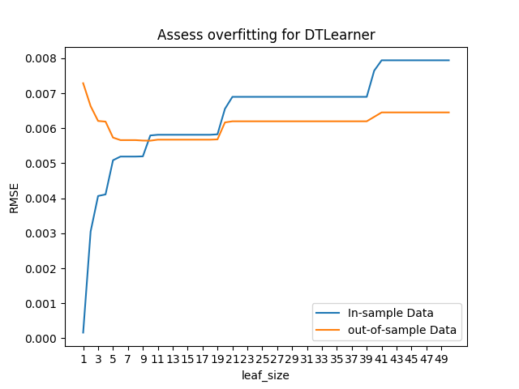

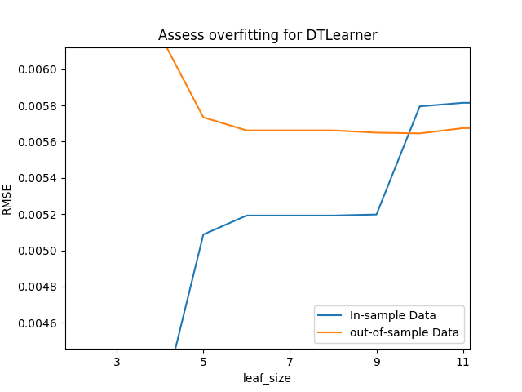
Assess overfitting for DTLearner by testing in-sample and out-of-sample data

Assess overfitting for DTLearner, zoom-in for the range when overfitting occurs

2.
Method:
using BagLearner constructed with 200 bags of DTLearner, record the RMSE for both in-sample and out-of-sample data for a given leaf_size ranging from 1 to 100.
Conclusion:
Yes. Bagging can greatly reduce overfitting as leaf_size decreases.
Around leaf_size = 6 (where overfitting occurs in the problem 1), as leaf_size decreases, there is negligible increase in RMSE of out-of-sample data test. This shows bagging can reduce/eliminate overfitting.

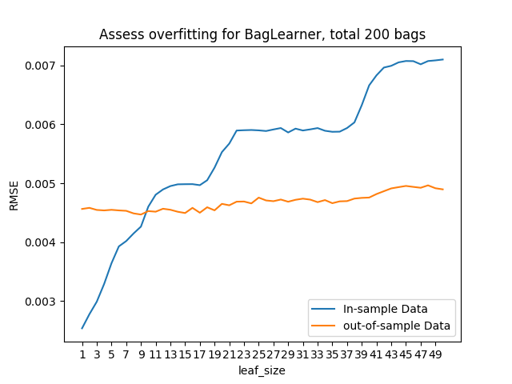
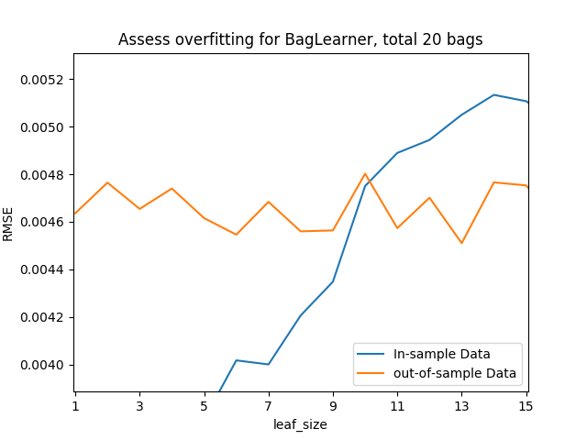
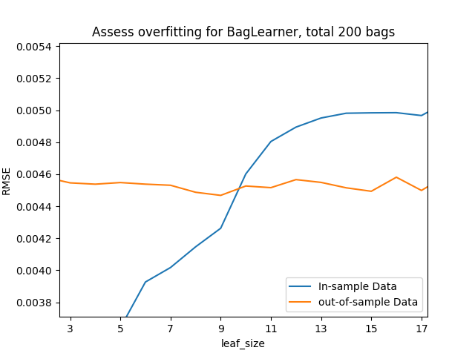
3.

Performance:
single random tree perform very poorly compared with a single decision tree with information gain

decision tree: select features to split on with information gain, it is an expensive process
random tree: select features to split on randomly, it is a cheap operation

