Report: Manual Strategy

ML4T 2017 Fall

Yuanzheng Zhu (yzhu319)

**Part 1.** Indicators

SMA: simple moving averages

For instance, if we use 20 days moving average

SMA[today] is the mean of last 20 days’ price

SMA_indicator = price/ SMA -1

For instance choose threshold = 0.1

If SMA_indicator > 0.1, sell signal

If SMA_indicator < -0.1, buy signal

Otherwise, no signal

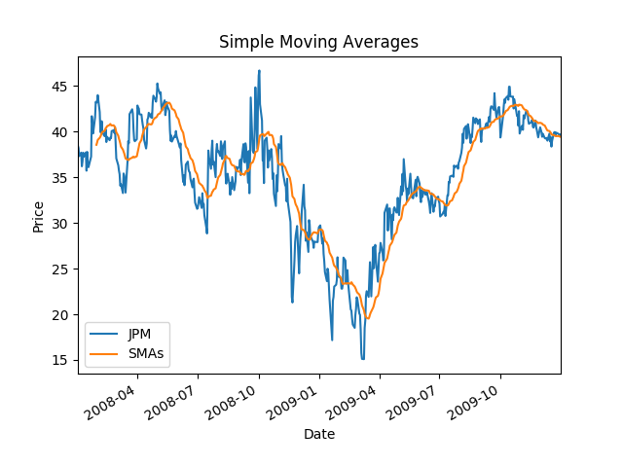

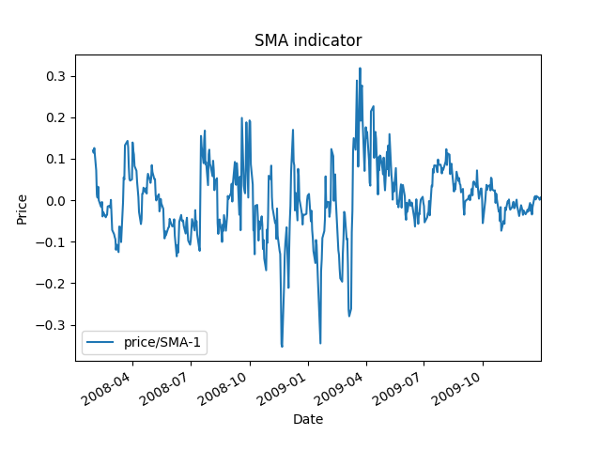

EMA: Exponential moving average

Exponential moving average (EMA) reduce the lag by applying more weight to recent prices.

EMA [today] = (Price [today] x K) + (EMA [yesterday] x (1 – K))

Where:

* K is multiplier, K = 2.0/(N+1)
* N = Lentgh of EMA, usually take 10~20

The very first EMA value is calculated by the average of the first N days’ data.

EMA_indicator = price/ EMA -1

For instance choose threshold = 0.1

If EMA_indicator > 0.1, sell signal

If EMA_indicator < -0.1, buy signal

Otherwise, no signal

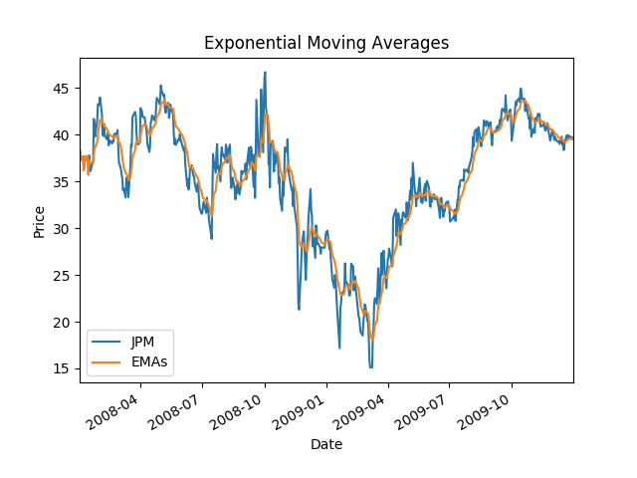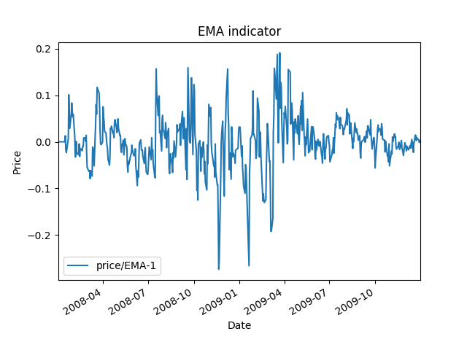

Bollinger Bands

For instance, choose parameters: 20 days window size, threshold bandwidth is 2 times standard deviation.

Based on simple moving average, add 2*sigma (rolling standard deviations of past 20 days) above and below rolling mean curve, we obtain upper band and lower band.

Bolinger_Bands_Index = (price – moving_average) / (2*moving_std)

If Bolinger_Bands_Index > 1, sell signal

If Bolinger_Bands_Index < -1, buy signal

Otherwise, no signal

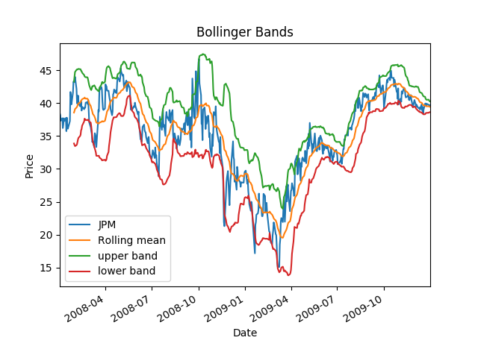

**Part 2.** BestPossibleStrategy

Assume we can peak into tomorrow’s price, the best possible strategy is as follows:

if JPM_price_tomorrow- JPM_price_today > 0, today’s position = long 1000 JPM

if JPM_price_tomorrow- JPM_price_today < 0, today’s position = short 1000 JPM

otherwise, today’s position = 0 JPM (Here ‘Fund’ means portfolio)

Best Possible strategy statistics:

Sharpe Ratio of Fund: 13.3227698482

Sharpe Ratio of Benchmark : 0.156918406424

**Cumulative Return of Fund: 5.7861**

Cumulative Return of Benchmark : 0.0123

Standard Deviation of Fund: 0.00454782319791

Standard Deviation of Benchmark : 0.0170043662712

Average Daily Return of Fund: 0.00381678615086

Average Daily Return of Benchmark : 0.000168086978191

Final Portfolio Value: 678610.0

Final Portfolio Value of Benchmark : 101230.0

Best Possible strategy chart

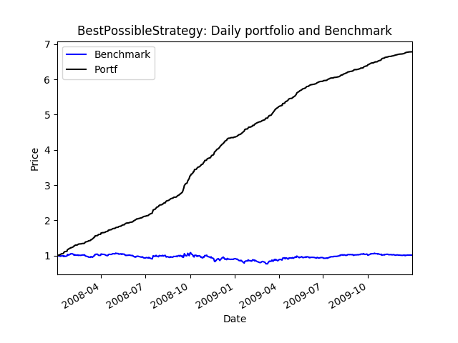

**Part 3.** Manual Rule-Based Traders

SMA

In-sample data: after tests, best cumulative return: window size N = 21 days, threshold = 0.1

Date Range: 2008-01-02 00:00:00 to 2009-12-31 00:00:00

Sharpe Ratio of Fund: 1.86674376346

Sharpe Ratio of Benchmark : 0.156918406424

Cumulative Return of Fund: 0.5103215

Cumulative Return of Benchmark : 0.0123

Standard Deviation of Fund: 0.00717570814121

Standard Deviation of Benchmark : 0.0170043662712

Average Daily Return of Fund: 0.000843818815283

Average Daily Return of Benchmark : 0.000168086978191

Final Portfolio Value: 151032.15

Final Portfolio Value of Benchmark : 101230.0

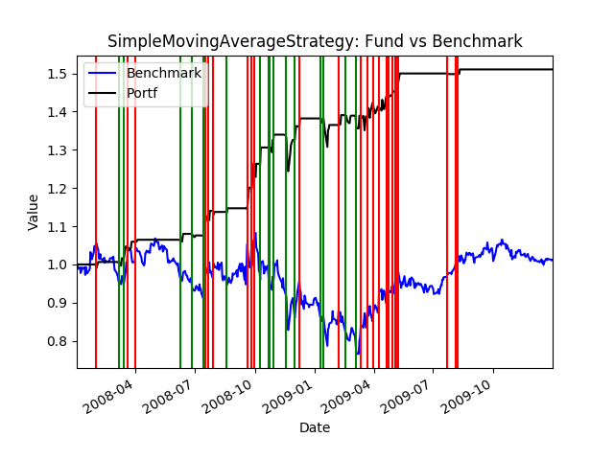

Out-of-sample data with N = 21 days

Date Range: 2010-01-04 00:00:00 to 2011-12-30 00:00:00

Sharpe Ratio of Fund: 1.39052453657

Sharpe Ratio of Benchmark : -0.256812960738

Cumulative Return of Fund: 0.100853

Cumulative Return of Benchmark : -0.0834

Standard Deviation of Fund: 0.00220848283805

Standard Deviation of Benchmark : 0.0084810074988

Average Daily Return of Fund: 0.000193451639619

Average Daily Return of Benchmark : -0.000137203160195

Final Portfolio Value: 110085.3

Final Portfolio Value of Benchmark : 91660.0

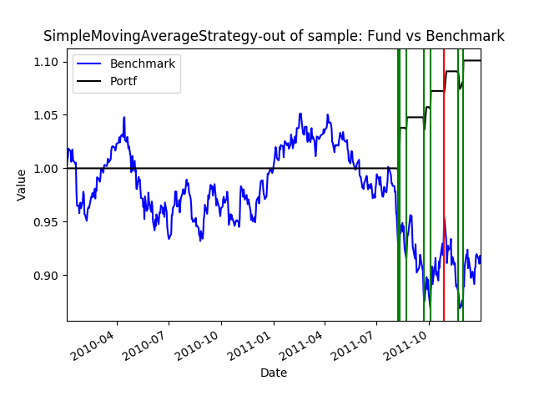

EMA

In-sample data: after tests, best cumulative return: window size N = 20 days, threshold = 0.08

Date Range: 2008-01-02 00:00:00 to 2009-12-31 00:00:00

Sharpe Ratio of Fund: 1.72011731903

Sharpe Ratio of Benchmark : 0.156918406424

Cumulative Return of Fund: 0.480659

Cumulative Return of Benchmark : 0.0123

Standard Deviation of Fund: 0.00744157693209

Standard Deviation of Benchmark : 0.0170043662712

Average Daily Return of Fund: 0.000806348484596

Average Daily Return of Benchmark : 0.000168086978191

Final Portfolio Value: 148065.9

Final Portfolio Value of Benchmark : 101230.0

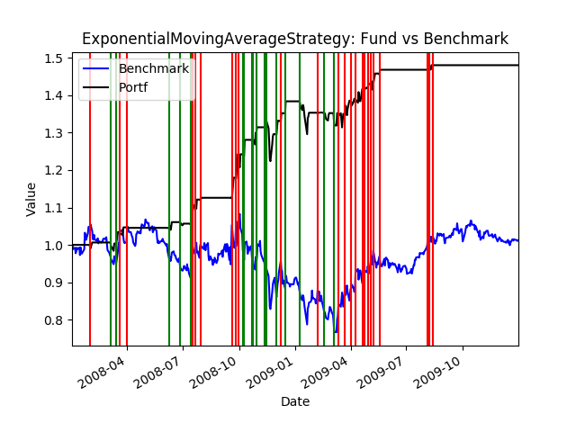

Out-of-sample data with N = 20 days, threshold = 0.08

date Range: 2010-01-04 00:00:00 to 2011-12-30 00:00:00

Sharpe Ratio of Fund: 1.44971663062

Sharpe Ratio of Benchmark : -0.256812960738

Cumulative Return of Fund: 0.102544

Cumulative Return of Benchmark : -0.0834

Standard Deviation of Fund: 0.00215036601702

Standard Deviation of Benchmark : 0.0084810074988

Average Daily Return of Fund: 0.000196379087971

Average Daily Return of Benchmark : -0.000137203160195

Final Portfolio Value: 110254.4

Final Portfolio Value of Benchmark : 91660.0

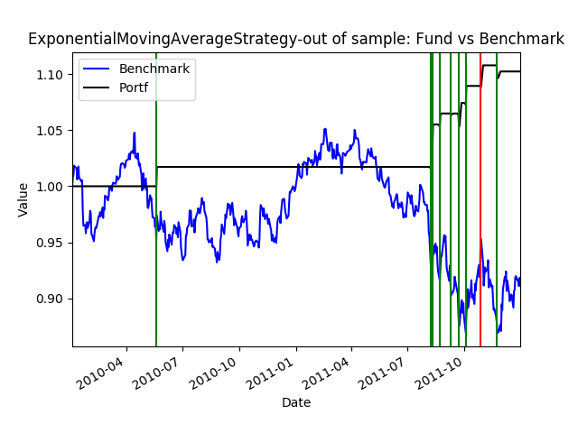

Bollinger Band

In-sample data: after tests, best cumulative return: window size N = 20 days, band width = 1.2 (1.2 times rolling_std)

Date Range: 2008-01-02 00:00:00 to 2009-12-31 00:00:00

Sharpe Ratio of Fund: 1.61177601524

Sharpe Ratio of Benchmark : 0.156918406424

Cumulative Return of Fund: 0.5083125

Cumulative Return of Benchmark : 0.0123

Standard Deviation of Fund: 0.00837625558429

Standard Deviation of Benchmark : 0.0170043662712

Average Daily Return of Fund: 0.000850460874878

Average Daily Return of Benchmark : 0.000168086978191

Final Portfolio Value: 150831.25

Final Portfolio Value of Benchmark : 101230.0

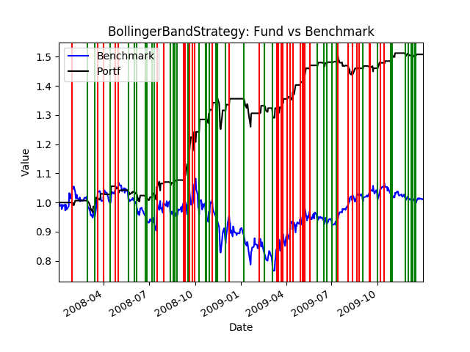

Out-of-sample data with N = 20 days, band width = 1.2 (1.2 times rolling_std)

Date Range: 2010-01-04 00:00:00 to 2011-12-30 00:00:00

Sharpe Ratio of Fund: -0.408424723943

Sharpe Ratio of Benchmark : -0.256812960738

Cumulative Return of Fund: -0.0741755

Cumulative Return of Benchmark : -0.0834

Standard Deviation of Fund: 0.00539089673571

Standard Deviation of Benchmark : 0.0084810074988

Average Daily Return of Fund: -0.000138698820122

Average Daily Return of Benchmark : -0.000137203160195

Final Portfolio Value: 92582.45

Final Portfolio Value of Benchmark : 91660.0

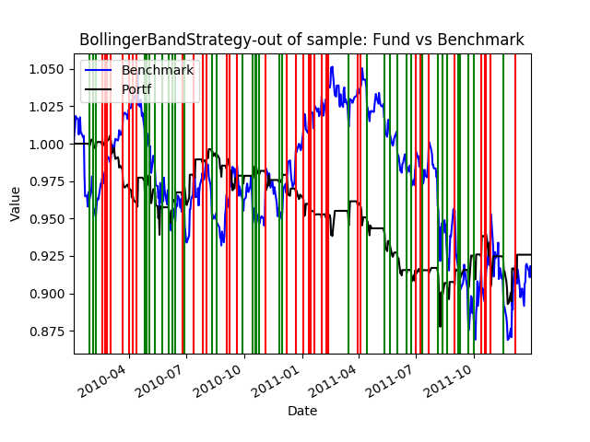

**Part 4.** Comparative Analysis

The three charts for out-of-sample test results are shown in Part 3. (Chart title includes “out-of-sample”).

In summary, the performances of the stock, and the manual strategies for both in sample and out of sample periods are shown below

|  |  |  |
| --- | --- | --- |
| Cummulative Return | In-sample data | Out-of-sample data |
| SMA | 0.5103215 | 0.100853 |
| EMA | 0.480659 | 0.102544 |
| Bollinger Band | 0.5083125 | -0.0741755 |
| Benchmark | 0.0123 | -0.0834 |

All three indicators used in manual strategies perform much better in in-sample data, cumulative return better than benchmark by over 47%. However, in the out-of-sample tests, the advantage decreases to ~15%~18%. Also, the SMA and EMA perform better than Bollinger Band in Out-of-sample data, explanation could be: when Bollinger Band used in the high-volatility period, if the band width is small, the signal is not strong enough. Also small band width will generate more signals, we are “over-trading”; the market impact and fees eat our profit. So, if we set the band width higher in out-of-sample data, the profit will be better. Compare EMA to SMA, EMA essembles more to the price, so the signal will be more accurate, if we can bet more when signal is stronger, it is expected that EMA is better than SMA. But here holding is limited to +1000 or -1000, so there is not much difference between SMA and EMA in this study.