**Policy utility and empirical study of coupling development of biopharmaceutical industry and emerging companies based on NB statistical model and Bayesian probability**

**Author**

**Abstract.**

**Keywords:**Bayesian model; biomedical industry; policy effectiveness; NB statistical model

**1. Introduction**

Currently, biotechnology has become the most promising high-tech industry, and the biotechnology industry is the most promising strategic emerging industry in the world. Data show that worldwide, the sales of biotechnology industry doubles every 5 years, and the sales of biopharmaceuticals grows 30% per year, which is much higher than the average annual growth rate of 10% for the whole pharmaceutical industry [1]. With the rapid development of life sciences and biotechnology, the biopharmaceutical industry has ushered in its golden age [2]. Christopher Meyer, a famous American management consultant and head of Ernst & Young's Center for Business Innovation, has predicted that the 21st century is not only the era of life sciences, but also the era of "bioeconomy" [3]. The application of new technologies such as human genome project, post-genome project, proteomics research, biochip research, nano drug technology, stem cell technology, computer-aided drug design, high-throughput screening technology, etc. has brought the technology and industrial development of biopharmaceuticals into a brand new transition period. However, China's biopharmaceutical industry is still lacking in global competitiveness, independent R&D and innovation capability, integrity of drug approval mechanism, and industrial concentration. Meanwhile, the outbreak of a new global coronavirus epidemic in 2020 has posed a major challenge to the technological innovation and development, structural adjustment and industrial transformation of biopharmaceutical companies. Under the joint influence of new technologies, new policies and new background of biopharmaceutical industry, the development trend of integration and innovation between pharmaceutical industry and emerging enterprises has been strengthened. From the formulation of upstream industrial policies to the development of downstream industries, China's biopharmaceutical industry has experienced unprecedented changes. Major technological advances and industrial transformation are often rare opportunities. After the government introduced a series of new industrial policies based on the new situation, whether the pharmaceutical industry's R&D and innovation capabilities have been improved; whether new enterprises have transformed their innovations into actual production; and whether the pharmaceutical industry and new enterprises have integrated and innovated to promote industrial upgrading. The effectiveness of industrial policies can provide a realistic basis for policy makers to amend policies in a timely manner, adjust policy efforts, and promote industrial development. Therefore, it is necessary to establish a model to study the policy effectiveness of the coupled development of pharmaceutical industry and new enterprises.

**1.1 Definition and description of related concepts**

(1) Biotechnology Industry

Biotechnology is a science and technology that applies the basic principles of biology and other disciplines to produce useful materials to meet human needs through the use of living organisms.In 1982, the Organization for International Cooperation and Development proposed that biotechnology is the application of natural science and engineering principles to process biological raw materials using animals, plants or microorganisms as reactors and then produce biotechnology-related products to serve human society. It is a science and technology. The main contents of biotechnology include: genetic engineering, cell engineering, fermentation engineering, enzyme engineering, biochip technology, gene sequencing technology, tissue engineering technology, bioinformatics technology, etc. Biotechnology can be divided into traditional biotechnology and modern biotechnology according to the development time. Traditional biotechnology has an early origin and has been used in various aspects of production and life since ancient times, mainly using microbial fermentation to produce products. Traditional biotechnology is usually people in the practice of life, through the summary of experience developed, the lack of scientific theory to support, did not form a systematic science. With the continuous development of life science theories and methods, biotechnology has flourished after the twentieth century and entered the stage of "modern biotechnology". Modern biotechnology is based on molecular biology, with recombinant gene technology as the core, integrating modern biological science and a variety of disciplines developed from the practical technology. Modern biotechnology involves many fields and a wide range of applications, mainly including gene recombination, cell fusion and culture, enzyme utilization and fermentation, etc. Modern biotechnology is a systematic science based on multidisciplinary scientific theories, from experiment to practice. Since the mid-1970s, biotechnology has been more and more widely used in medicine, food, agriculture, chemical industry, machinery, energy, environmental protection and other sectors. In the process of development, modern biotechnology science and technology have been continuously cross-developed with other disciplines and further applied to traditional fields, thus giving birth to modern biotechnology industry. Biotechnology industry refers to the application of biological science and technology in traditional industries, based on modern life science theories, using living organisms and their cellular, subcellular and molecular components, combined with engineering, informatics and other means to research and manufacture products, or transform animals, plants, microorganisms, etc., and make them with the required quality and characteristics, and then provide goods and services to society in a comprehensive technical means. System. The biotechnology industry can be divided into two parts. One part is mainly biological experiments and research by researchers [ii], such as enzyme engineering, biochip technology, gene sequencing technology, etc. The other part is mainly technology applications [iii]. The other part is mainly technology application [iii], which is developed by researchers through research and features, and then mass production after repeated validation and subsequently entering the market. The biotechnology industry is characterized by the following features: technological dependence and product diversification. The raw materials used are mainly renewable resources and are less restricted by resources; lower energy consumption; and less pollution to the environment. The biotechnology industry mentioned in this paper refers to the sum of segmented industries based on modern biotechnology, which have been maturely applied in various fields, entered industrial production, and have a certain market scale, forming a relatively complete industrial chain.

1. Pharmaceutical Industry

The pharmaceutical industry is an industry in which multidisciplinary theories and advanced engineering techniques are interwoven. As an integrated industry, it covers primary, secondary and tertiary industries. Its industrial chain is long and involves various production and service fields related to pharmaceuticals and medical devices. At present, the definition of pharmaceutical industry is not uniform at home and abroad. The National Bureau of Statistics does not give a specific definition and classification in the National Economic Classification of Industries. From the existing studies, the pharmaceutical industry in a broad sense is considered to be all for-profit and non-profit organizations that apply biotechnology for production. The pharmaceutical industry in a narrow sense is considered to include the collection of pharmaceutical enterprises that apply biotechnology in relation to people. Domestic scholars, based on the new development of the pharmaceutical industry, define it as the collection of all enterprises and organizations involved in the production, distribution and use of pharmaceuticals in national economic activities. The biopharmaceutical industry studied in this paper refers to the pharmaceutical industry in a narrow sense. Pharmaceutical industry and biomedical engineering industry are the two pillars of modern pharmaceutical industry. Pharmaceuticals are an organic combination of multidisciplinary theories and cutting-edge technologies, using a scientific and modern model to research, develop and produce drugs. In the pharmaceutical industry, in addition to biopharmaceuticals, chemical and traditional Chinese medicines also occupy a certain proportion in the pharmaceutical industry. Biomedical engineering is a comprehensive use of life sciences and engineering science principles and methods, from the perspective of engineering in molecules, cells, tissues, organs and even the entire human body system in multi-level understanding of human structure, function and other life phenomena, research for disease prevention, treatment, human functional aids and health care of artificial materials, products, devices and systems technology in general. Biomedical engineering industry mainly includes: biomedical material products, (biological) artificial organs, medical imaging diagnostic equipment, electronic instruments and monitoring equipment, modern medical equipment, information technology, rehabilitation engineering technology and devices, tissue engineering, etc.

1. The relationship between the biotechnology industry and the pharmaceutical industry

The pharmaceutical industry is one of the strategic emerging industries in China, which we define as the sum of industries covering various fields involved in the process from initial biomedical cultivation to terminal sales services, according to the Strategic Emerging Industry Classification 2018 (National Bureau of Statistics, 2018) published by the National Bureau of Statistics. [View] The pharmaceutical industry mainly involves the biochemical drug industry, Chinese medicine production, medical devices and other fields. Remuneration] The biotechnology industry is based on certain scientific principles and technologies and uses new biological processes to develop products that are widely used in the field of prevention and medical treatment. Biotechnology industry mainly includes pharmaceutical biotechnology industry, industrial biotechnology industry, agricultural biotechnology industry and marine biotechnology industry. The pharmaceutical biotechnology industry is the most important part of the biotechnology industry, accounting for more than 60% of the biotechnology industry, and is the most mature application of biotechnology in pharmaceutical technology. Based on life science and biological science and technology, the biopharmaceutical industry integrates modern medical concepts and technologies to develop, design, manufacture and market health services in the areas of protection, medical treatment and diagnosis. Therefore, the biotechnology industry and the pharmaceutical industry together constitute the most important part of the biopharmaceutical industry, and the two are closely related, interconnected, developing and promoting each other. Since its establishment in the 1970s, the biopharmaceutical industry has made great strides in the past few decades. These achievements are mainly reflected in the shift in production from traditional chemical drugs to innovative biological and macromolecular drugs. Many previously non-existent or incurable diseases can now be effectively diagnosed and prevented or treated through the use of innovative diagnostics and biologics, respectively. The pharmaceutical industry is poised for unprecedented change as research and development costs and technologies rise, and biotechnology development now dominates the various programs of large pharmaceutical companies. The share of the biotechnology industry in the pharmaceutical industry will gradually increase, and the joint development of the two industries will increase the efficiency of the use of common technology platforms and drive further development of both industries.

**1.2 Foundations of Bayesian Theory**

The English mathematician Thomas Bayes created Bayesian statistical theory after years of generalization and published a book "Theory of Probability" in 1763, in which Bayes' theorem was proposed to solve an "inverse probability" problem, which played an important role in the development of probability theory and mathematical statistics. The Bayesian school is one of the two main schools of probabilistic statistical theory. The Bayesian theory proposed by this school is to obtain the posterior information of the parameters based on Bayesian formulas when the sample information and the prior information of the unknown parameters are known, and to infer the unknown parameters from the posterior information. [kinda] Bayesian theory usually refers to Bayesian decision theory, which is an important part of subjective Bayesian induction theory. Bayesian decision making is to estimate a partially unknown state with subjective probability under incomplete intelligence, then correct the occurrence probability with Bayesian formula, and finally make an optimal decision with the expected value and the corrected probability. The process of Bayes' theorem can be summarized as "past experience" plus "new evidence" to obtain "corrected judgment". It provides an objective way to combine newly observed evidence with existing experience to make inferences. Suppose there are random events A and B. Their conditional probability relationship can be expressed by the following mathematical formula.

$P(A|B)=\frac{P(B|A)P(A)}{P(B)}$ (1)

where P(A) represents the prior information and is the likelihood function.

The above formulas are based on probability statistics, taking A and B as examples, P(∙) is the probability of the event, AB is the occurrence of the event, A is A,B is the event B. P(AB) in formula (2) can be calculated by formula (1).

 (2)

Bayesian theory assumes that the parameters are similar to the sample (denoted by θ). Bayesian algorithm uses a new approach to estimate the unknown parameter: the unknown parameter is considered as a random variable; secondly, a learning method is used to obtain the prior distribution of π(θ); then the uncertain parameter is obtained by calculating the density of the posterior distribution.

Bayes' theorem is extended to C = (c1, c2, ... , ck), representing the examples to be discriminated (containing

m attributes) for example, where X = (X1, X2, ... , Xm) represents a set of feature term variables and Xi is the Xi (i 1, 2, ... , m). Then the posterior probabilities of I belonging to different categories can be derived from the above equation.

 (3)

Bayes' theorem studies conditional probability, which is the problem of probability of occurrence under specific conditions. Although Bayes' theorem is just a mathematical formula, it goes far beyond that. Bayes' theorem provides a new way of looking at things. In an uncertain environment, where every piece of information affects the original probability assumptions, decisions need to be updated and improved based on the latest information. Although decision makers cannot control the changes of objective factors, they grasp the possible conditions of their changes and the probability of distribution of various conditions, and use the expectation, i.e. the average conditions that may occur in the future, as a criterion for decision making until the decision maker goes from a state where everything is uncertain to a state where he or she can be firmly confident. Based on this mathematical idea, an algorithm called plain Bayes has been proposed. Commonly used to solve classification problems, the purpose of plain Bayes is to assign samples with certain characteristics to the category to which they most likely belong. That is, the sample is considered to belong to the class to which it has the highest probability. The use of the plain Bayesian algorithm satisfies a basic assumption: each feature for a given target value is assumed to be independent of each other, i.e., conditionally independent. This "plain" assumption greatly simplifies the computational process, and in practice, the conclusions are usually not unduly biased. This is the "plain" idea of plain Bayes, which gives a very strong artificial assumption. Due to this assumption, the number of conditional probabilities included in the model is greatly reduced, and the prediction process of the plain Bayesian algorithm is greatly simplified, but the classification accuracy is reduced.

**1.3 Theory of industrial technological progress**

Technological progress in a narrow sense mainly refers to the changes and development of working methods, labor objects, production processes, operation methods as well as workers' professional knowledge and technology in the field of production; while technological progress in a broad sense includes not only the above connotations, but also the improvement and upgrading of organizational and management capabilities, technological development and perfection at both micro and macro technical levels. in 1999, Li Yixue scholars pointed out that industrial technology In 1912, Austrian economist Joseph Schumpeter put forward the "innovation theory" for the first time in his book "Theory of Economic Development". He believed that technological innovation is not a scientific discovery or invention, but the process of entrepreneurs using new ideas to create new products to increase profits. According to Schumpeter's classification, technological progress consists of three stages: invention, innovation and diffusion. Technological progress can be divided into national and regional level, industry level and enterprise level according to the level of study, i.e. macro level, meso level and micro level technological progress. Macro level refers to the process of inputting multiple factors to promote research and invention, technological innovation, technology diffusion, and industrial structure improvement under a certain economic and political policy environment, which becomes the direct productivity to promote industrial progress. At the meso level, industrial technological progress refers to the process of promoting industrial economic development through scientific and technological innovation and technological progress, which manifests itself in the progress of overall industrial technology, the improvement of total factor productivity and the sustainable development of industrial economy. Technology development refers to the innovation of transforming specific technological achievements into new materials, new products, new designs, new processes and new methods. In this stage, it can be reflected at the micro level as experimental development and transitional experimentation. Experimental development refers to the development of technical documents such as design structures in the laboratory, or intermediate experiments of principle prototypes, in order to test whether the design scheme, process flow is advanced, economical and reasonable, and production is coordinated, so as to transition to final production. Intermediate experiments are the product of the combination of scientific research and production, and are an important part of the overall technological progress. Product commercialization refers to the transformation of new technological achievements into new products and new processes under ordinary process conditions. At this stage, the new products and processes must be tested by actual production to determine the cost, profit, labor productivity, material consumption and other technical indicators of the products. The diffusion of new technology refers to the diffusion of new technology in a certain industry and other industries. From the perspective of society as a whole, the results of technological innovation can only play an important role in the process of promoting technological progress, innovation development and economic development. A case study of innovation in the United States shows that the average rate of return for companies that develop and transfer innovative technologies is 22%, while the average rate of return for companies using new technologies and processes is 55%.

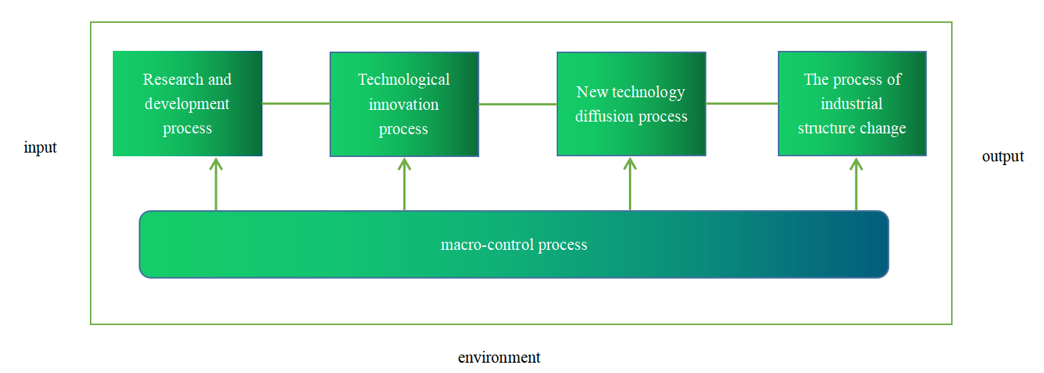

Figure 1. Cycle of technological progress

**1.4 Comparison of research content**

Currently, global scholars are highly concerned about the policy impact of the biopharmaceutical industry in the context of the new Crowne Plaza epidemic, and have explored the impact of policies on the pharmaceutical industry from different perspectives and using different methods. Some scholars have selected companies in a certain area of the pharmaceutical industry from industry segments and conducted empirical analysis of policy effects based on certain indicators. Zhang Ji and Shi Zhanzhong used the event study method to examine the effectiveness of the policy through an empirical study of the return on investment of listed companies in the medical device industry; Chu Shuzhen and Zhu Xuan used the DEA-Malmquist index decomposition method to examine the policy innovation performance of the pharmaceutical industry and its segments through input-output analysis; Yang Hui examined the policy innovation performance from three "innovation input-innovation output-innovation benefit" perspectives explored the policy innovation performance. Yang Hui analyzed the implementation and impact of new policies on pharmaceutical companies from three dimensions." Innovation Input-Innovation Output-Innovation Benefit" ; Yihan Wu studied the development of the biopharmaceutical industry at the firm level, examined the impact of stock liquidity on the value of companies in the biopharmaceutical industry using linear regression, and finally proposed countermeasures at the government and firm levels; and Suhyang Cui [E] studied the development of the biopharmaceutical industry at the firm level. A ten-year review of listed pharmaceutical companies revealed a moderating effect of all drug-related policies ; um, Seung In and Sohn, Uy Dong et al. used interrupted series analysis to examine the extent to which policy implementation stimulated innovation in the pharmaceutical industry and whether it had an impact on long-term innovation in the industry. In addition, some scholars have further investigated the issue of policy formulation based on policy effectiveness. For example, Zhengdong Li introduced a simulation model and found that corporate profits yielded different results depending on the intensity of regulation and policy direction, providing tools for policy makers and strategic decisions in the pharmaceutical industry. lee, Hyonik and Jun, Kim, Young found that policy support had a significant positive impact on the innovation performance of pharmaceutical companies, [oh] and suggested that in developing innovation support in the pharmaceutical industry When formulating policies , government financial support should be rationally allocated according to the diversity of R&D collaborations and firms' own innovation capabilities; Jakhar Suresh and Kumar Mangla conducted a hybrid study using Bayesian worst-case method and multiple imputation boundary approximation regional comparison method. A comprehensive socio-technical framework was provided for brand owners and distributors to select drug suppliers based on eight criteria such as brand technology identification, vehicle sterilization, and logistics distribution network of essential products to improve policy effectiveness in the context of an epidemic; Wenxi Gao developed a supplier evaluation model for biopharmaceutical companies using Bayesian networks. He quantified the evidence-based reasoning based on the construction of a supplier evaluation index system for biopharmaceutical companies, considering the causal relationships among the indicators. Most of the current domestic and international literature on the effectiveness of pharmaceutical industry policies in the context of the Crown pneumonia epidemic focuses on a single perspective of new policies, without considering the effectiveness of new policies under the coupled development of the biopharmaceutical industry with innovation, R&D, and new development-oriented new enterprises. Meanwhile, most of the previous literature ignored the impact of new crown epidemic on the biopharmaceutical industry. Based on a single policy analysis utility, the policy utility analysis mostly focuses on comparing firm value, R&D inputs and outputs. It ignores how to establish a decision-making framework in the context of the epidemic and effectively select new enterprises in various fields of the industry for cooperative development, so as to improve the policy utility and help decision makers to adjust the decision-making framework in a timely manner; the methods of policy utility evaluation are mostly primitive mathematical models, literature research methods, case study methods and other methods for research and analysis, which lack innovation. Therefore, in this paper, we will innovate both the research direction and research methods, and use NB statistical model and Bayesian probability to study and empirically analyze the policy effectiveness of coupled development of biomedical enterprises and new enterprises.

**2. Technology Status**

**2.1 Basic theory of biomedical industry**

Biomedicine broadly refers to drugs produced by biological or other biological processes, including certain small molecular weight drugs; narrowly refers to medical devices manufactured with modern technology, including new vaccines, genetically engineered vaccines, diagnostic reagents, genetically engineered drugs, probiotic drugs, blood products, etc. Biomedicine is a discipline that applies modern biotechnology to pharmaceutical research and development. Modern biotechnology in a broad sense includes genetic engineering, cell engineering, fermentation engineering and enzyme engineering, the core of which is genetic engineering technology. Biomedical industry is composed of biotechnology industry and pharmaceutical industry together, is the national focus on the development of the seven strategic emerging industries. Yao Wenbing pointed out that the biopharmaceutical industry is a technology industry generated by recombinant technology, cloning technology, cell culture technology, monoclonal antibodies, stem cells, bioinformatics, bioreactors, protein engineering, high-throughput genetic engineering and other technologies. The biopharmaceutical industry has the characteristics of policy-oriented, high-tech, high-investment, high-risk, high-return, and high-cycle, in addition to the commonalities of high-tech industries (e.g., knowledge and technology). Along with the innovation of genetic engineering technology, the biopharmaceutical industry is developing rapidly and can promote major technological innovation in the fields of oncology, diabetes, and immune system. At present, the industry is mainly engaged in genetic drugs, recombinant hormone drugs, recombinant cytokines, genetically engineered vaccines, antibodies, etc.

**2.2 Biomedical industry development trend**

Along with the innovation of genetic engineering technology, the biopharmaceutical industry has developed rapidly. The modernization of biopharmaceutical technology was marked by the completion of the research and testing of artificial insulin and its release to the market in 1982. Since the implementation of the "863" program in 1986, biopharmaceutical research and industrialization in China have developed rapidly. Over the next 20 years, more than 56 biotechnology-driven drugs have been marketed and sold, and more than 80 million patients have benefited from their mass-produced properties. By 1998, 65 biotech drugs were on the market worldwide, accounting for 6% of all drugs and 14% of all newly produced drugs. in 2001, the U.S. Food and Drug Administration officially approved 117 biopharmaceuticals for marketing, with a total market value of $330 billion and more than 1,000 drugs in the clinical research phase. The biopharmaceutical industry is rapidly developing into a high-tech pillar industry and will become a leading industry in the world economy in the future. According to Evaluate Pharma's forecast, by 2026, global biopharmaceutical sales will reach $505 billion, and a worldwide revolution in the biopharmaceutical industry is being bred.

Economic development, along with technological advances, the development of biopharmaceutical technology has matured, the biopharmaceutical industry market supply and demand, and will continue to be the fastest growing economic sector. Currently, the global biopharmaceutical industry shows a pattern of agglomeration and development, with developed countries such as the United States, Europe, and Japan occupying a dominant position. According to "Pharmaceutical Manager" published in 2021, the top 50 global pharmaceutical companies in Europe, the United States and Japan on the list of companies accounted for up to 80%. Companies in the region also have an absolute advantage in new drug development. In terms of patent applications, the US has 48 companies among the top 100 worldwide, with a total of 12,059 patents, accounting for 45.92% of the total, followed by Switzerland with 3,687 patents, accounting for 14.04%. Developed countries occupy the high-end position in the division of labor by virtue of capital and technology, while developing countries are mainly in the middle and low-end position by producing generic drugs. In the process of internationalization of the industry, large pharmaceutical companies in developed countries, based on their own development needs and interests and considering the lower clinical trial fees and production costs in developing countries, have gradually shifted their mid- and low-end industries to developing countries to seek broader markets and high profits. In addition, China, India, Singapore and other countries of biopharmaceutical enterprises in recent years under the support of policy development rapidly, Asia has become another major biopharmaceutical industry center in addition to North America, Europe, the pharmaceutical industry center showing a multi-polar trend.

The biopharmaceutical industry to obtain high returns, essential have brought higher risks, but also need a lot of capital continued to invest as a condition to enter the industry and continued development. 2020 new crown epidemic to the biopharmaceutical sector to bring new opportunities for industrial development, 2020 biopharmaceutical sector financing 39.946 billion yuan, compared with 14.139 billion yuan in 2019, an increase of 1.8 times. Capital entry in this field is expected to continue to remain hot. In terms of financing stage, the flow of funds is mainly for start-up financing. According to data released by Artery Orange, since 2021, the number of global biopharmaceutical early round events accounted for more than 50%, and the Pre-A round-A+ round accounted for 28% from January to August 2022, especially CXO, AI + pharmaceutical-driven A round investment, the total number of investment and financing up to 262, from seed to B round investment and financing are more than 100 times. In addition, pharmaceutical giants are frequently acquiring SMEs to layout new tracks while also carrying out cooperation to attack new technologies.

To cope with the increasing competition and achieve sustainable development, innovation is another important trend in the development of biopharmaceutical industry. Many countries have included the biopharmaceutical industry as a strategic industry, giving policy support and financial support. For example, in September 2022, the U.S. launched the National Biotechnology and Biomanufacturing Initiative to invest more than $2 billion to support the development of the biopharmaceutical industry; in 2021, the U.K. government released the Life Sciences Vision policy document; France released the Healthcare Innovation Strategy 2021-2030, while proposing an investment of no less than 2.2 In 2021, the U.K. government released the " Life Sciences Vision" policy document; France released "Healthcare Innovation Strategy 2021-2030", while proposing to invest no less than 2.2 billion euros in key areas of the biomedical industry. According to the third quarter 2022 results report released by Hengrui Pharma, the data show that its R&D expenses reached 3.498 billion yuan in the first three quarters of 2022, thus providing material security for innovation development. Industrial clusters such as the Northwest Swiss Industrial Park, Zurich Biotechnology Park, and China's "Torch Plan" Development Technology Industrial Park have begun to bear fruit, and the trend of biopharmaceutical industry clustering will become more and more obvious in the future, with the biopharmaceutical industry showing rapid growth.

At present, China's biopharmaceutical industry consists of eight sub-industries, they are chemical raw materials manufacturing, chemical pharmaceutical preparation manufacturing, biological and biochemical drug manufacturing, pharmaceutical machinery manufacturing, proprietary Chinese medicine manufacturing, medical equipment and equipment manufacturing, sanitary materials and medical supplies manufacturing and Chinese medicine processing and manufacturing. This figure, chemical products (chemical raw materials, chemical preparations) has more than 50%, is an important pillar of China's pharmaceutical industry.

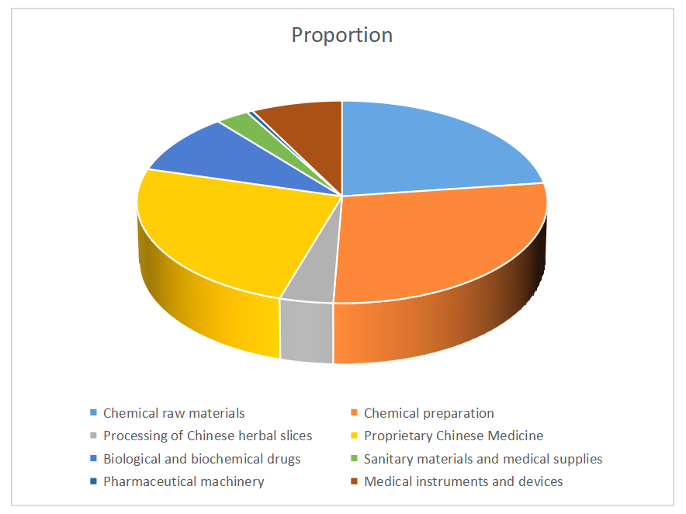

In 2020, the development of China's biopharmaceutical industry continues to accelerate, with an average annual growth rate of 14%, of which, only the Chinese patent medicine industry annual growth rate of less than 10%, pharmaceutical machinery industry and Chinese medicine tablet processing industry annual growth rate of less than 15%. Chemical raw materials industry, chemical drug preparation industry, biological and biochemical drug industry and medical instruments and equipment industry annual growth rate of more than 15%.

|  |  |  |  |
| --- | --- | --- | --- |
| Industry Name | Total assets of $100 million in 2020 | Annual growth rate | Proportion |
| Pharmaceutical Industry | 8716.0 | 14.0% | 100% |
| Chemical raw materials | 1992.9 | 15.0% | 22.9% |
| Chemical preparation | 2410.8 | 16.1% | 27.8% |
| Processing of Chinese medicine tablets | 350.6 | 14.5% | 4.0% |
| Prepared Chinese Medicine | 2156.2 | 8.8% | 24.8% |
| Biochemical drugs | 841.5 | 17.6% | 9.7% |
| Pharmaceutical Machinery | 45.2 | 10.9% | 0.5% |
| Medical equipment and devices | 661.5 | 19.0% | 7.6% |

**2.3 The main problems and analysis of the industry**

First, the impact of the global financial turmoil, drug exports fluctuate sharply

In November 2021, the single-month drug exports plummeted to 5.4% from 32.9% in October last year. China's drug export orders fell significantly. The main reason for the decrease in orders, one is affected by factors such as environmental protection governance on the eve of the Olympic Games, production restrictions on hazardous materials, the market is expected to tight supply of APIs, a large number of customers hoarding, orders continued to decline after the end of the Olympic Games; secondly, the first half of the year, the price of raw materials rose sharply, labor and energy costs rose sharply, resulting in a rapid increase in product export prices. In the second half of the year, due to the significant downward adjustment of crude oil and other raw material prices, the market is in a strong wait-and-see mood, waiting for product export prices to fall back; thirdly, due to the financial crisis, currency devaluation has limited the purchasing power of some customers, and also caused a decline in short-term orders.

Second, the rising cost of Chinese herbal medicines has increased the pressure on the profitability of proprietary Chinese medicines

Since 2015, several rounds of price increases of domestic raw materials of Chinese herbal medicines have made pharmaceutical enterprises at the low end of the industry chain face huge financing difficulties, while the domestic production of proprietary Chinese medicines has lagged relatively behind in terms of profitability due to the improvement of production efficiency. 2020, although the market of Chinese herbal medicines has fallen back, bringing some financial pressure to pharmaceutical enterprises, with the overall price of domestic agricultural products, in the future, as the price of Chinese herbal medicines fall back, the Chinese herbal medicine market will be hit to some extent.

Third, the unbalanced development of biomedical industry, China's biomedical industry needs to be strengthened

Since 1971, when the world's first biopharmaceutical company was founded in the United States and began trial production of biological drugs, more than 3,000 biotechnology companies have been established worldwide. Currently, there is a serious imbalance in the development of the biopharmaceutical industry, with developed countries occupying 80% of the market and having an absolute advantage in many aspects. Data released by the China Biotechnology Development Center shows that the U.S., Europe and Japan hold 94% of the world's biopharmaceutical patents. in 2020, the top 10 pharmaceutical companies spent 71.6% of the overall R&D investment, which is expected to rise to 92.8% by 2026, while the proportion of R&D investment in developing countries is low. The international average investment in R&D expenses accounts for 13% of business income, and the U.S. R&D investment accounts for nearly 18% of business income, while China's R&D investment accounts for only about 4% of business investment, which is relatively insufficient, and the transformation ability of innovation investment needs to be improved. Insufficient capital investment in biopharmaceutical industry, there is also the problem of unreasonable financing structure. According to the national science and technology report, the overall financing efficiency level of China's biopharmaceutical industry is low, and the proportion of the number of enterprises with the optimal level of comprehensive technical financing efficiency is between 4.2% and 13%, indicating that the financing efficiency of enterprises in the biopharmaceutical industry is not high. At present, there is an obvious convergence phenomenon among Chinese biopharmaceutical companies, which urgently need to develop new products and high value-added products. The entire industry lacks core competitiveness and sustainable development momentum, and there are also structural problems such as higher environmental protection costs and high energy consumption. On the other hand, China's pharmaceutical industry industrialization, scale, intensive level is still very low, the number of enterprises, small scale, industrial fragmentation, industrial structure to be further strengthened and improved. At present, the scale of domestic pharmaceutical enterprises is only 1.83%, of which 80% are foreign-funded enterprises, while the profit is only 61.86%, which shows that the gap between China's pharmaceutical enterprises and developed countries is large.

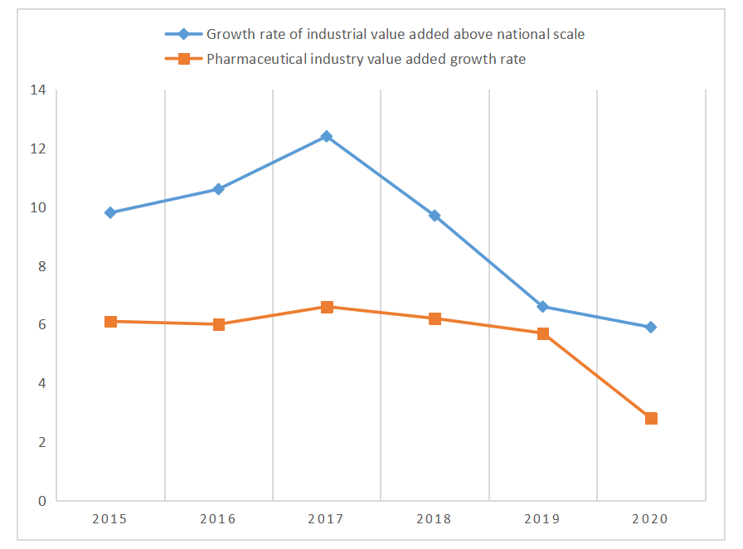

Compared with other industries, the most important characteristics of the biopharmaceutical industry are high technology content, large investment, high risk and long cycle time. In order to promote sustainable development and fair competition in the industry, it is necessary to promote the cross-border flow of talent, technology and other innovative elements, and the state actively improves the institutional norms in various fields of the industry to create a favorable environment for the development of the industry and promote the reform and upgrading of the industry in the context of the epidemic.

**2.4 Biomedical industry policy analysis framework construction**

Policies are constructed from basic policy tool units, which are tools for the government to carry out macroeconomic regulation. Combined with the literature research, this paper adopts Roswell and Zifford's classical classification to classify the sustainable innovation policy tools of biopharmaceutical industry into 17 subcategories and constructs a preliminary framework model for sustainable innovation policy analysis of biopharmaceutical industry in China (the following table).

|  |  |  |
| --- | --- | --- |
| **Biomedical industry policy analysis framework is constructed (Table).** | | |
| **Demand side** | **Supply side** | **Environmental** |
| Public Demand | Capital investment | Financial Support |
| Business Needs | Talent Development | Financial Support |
| Social Needs | Technical help | Tax Deductions |
| Quality and Standards | Information Support | Government Support |
| Overseas Markets |  | Intellectual Property |
| Third Party Outsourcing Services |  | Sustainable Innovation and Development |

Demand-based policies are policies that act as a direct pulling force for biopharmaceutical innovation activities and are a pulling force for the industry. Local government departments use demand-based policy tools to stabilize industry development and expand the development space in biopharmaceuticals. For example, domestic society, enterprises, public demand and overseas market, third-party outsourcing demand, product iteration quality and standardized production efficiency demand, etc., to build framework conditions conducive to innovation diffusion and actively develop and stabilize the market for new applications or products of biopharmaceutical technology. Reduce market uncertainty and alleviate market oversupply of a particular product

Supply-based policies are policies that directly promote biomedical research and innovation, which are the driving force of industry development, mainly through financial investment from government departments, professional talent training, industry technical assistance, and professional information support to expand the supply of the biomedical industry, improve the supply of innovation and research-related elements, and directly promote industry development. This approach can effectively enhance the status of enterprise research, improve the enthusiasm of enterprise innovation, enhance the level of industrial innovation from the upstream of the industry, promote technological innovation and new product development, and at the same time can promote the breadth and depth of innovation.

Environmental policies are policies that indirectly influence or improve the research and innovation behavior of biomedical industry, and are the core force to support and guarantee the development of the industry. They mainly refer to the policies of government departments that are not directly related to the industry's innovative research through financial support, financial assistance, tax relief, and regulatory improvements. They provide perfect markets or conditions for the industry to promote the development and application of pharmaceutical products. From a macroscopic point of view, they ease the industry's pre-research, innovation and compounding expertise, improve the industry framework, and provide a good external environment for biomedical technology innovation and new product development.

The biopharmaceutical industry policy system is a comprehensive system that intervenes, regulates and guides the biopharmaceutical industry from basic scientific research to product marketization. In order to deeply analyze China's biopharmaceutical industry policies and explore whether the current biopharmaceutical industry policies are good, the current policies of China's biopharmaceutical industry are analyzed by applying the policy instrument theory and the innovation value chain theory to solve the policy implementation problems. On this basis, a theoretical model of policy tools is established by applying policy tool theory and innovation value chain to public science and technology policies. This paper analyzes the biopharmaceutical industry policy from three aspects: exploring how to use supply-side policy tools to promote R&D in the innovation value chain, using demand-side policy tools to pull pharmaceutical R&D in the innovation value chain, and how macro and micro environmental policies affect the development of the innovation value chain.

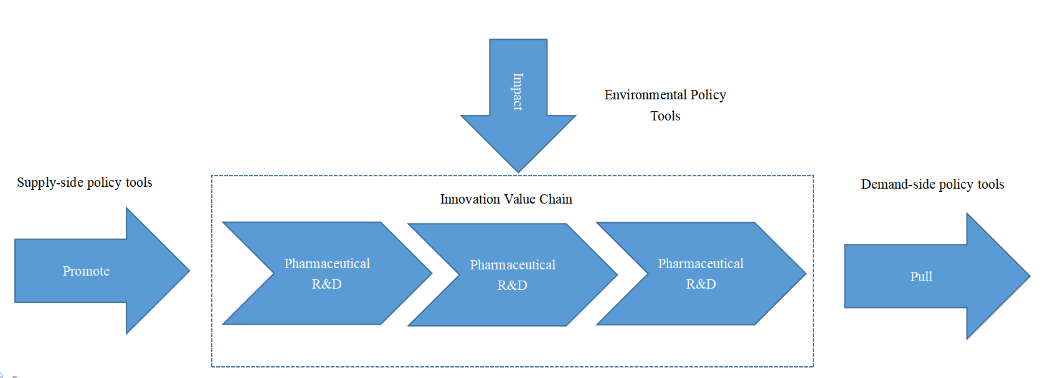

**3. Methodology**

**3.1 Commonly used Bayesian classification models**

**3.1.1 NB model**

In 1973, Duda proposed the model of Portsbies classifier, which is simple and fast. [24] In medical image classification, where our core problem is classification discrimination and prediction, Bayesian inference is used to find the posterior probability p of classifying patient I and assigning it to class C. In the same case, we can combine these data to determine if the probability of this patient is high. Under normal circumstances, these features are somewhat related to their attributes, and these connections can often be ignored, but sometimes they can become very critical. In cases where the attribute relationships are particularly salient, such associations cannot be ignored. However, in some cases, the number of features is so large that the relationships between these attributes are more complex.

Advantages. The format of the formula is very simple, the most basic arithmetic formula, with good scalability; the model has low time and space complexity and is easy to implement; the method has good robustness and stability. Disadvantages are:In practical problems, it is impossible to analyze the changes caused by combining features because it is difficult to achieve independent relationships between the attributes of the tuples; the method is related to the quality of the selected training set, and when the training set contains a large amount of noise, it will have a great impact on the classification results.

The naïve Bayesian classification model gives an extremely simple simplification of the relational assumption that all attributes of the classified objects have no dependencies and are conditionally independent. In the case of dependencies between attributes, this can be represented in Figure 5.

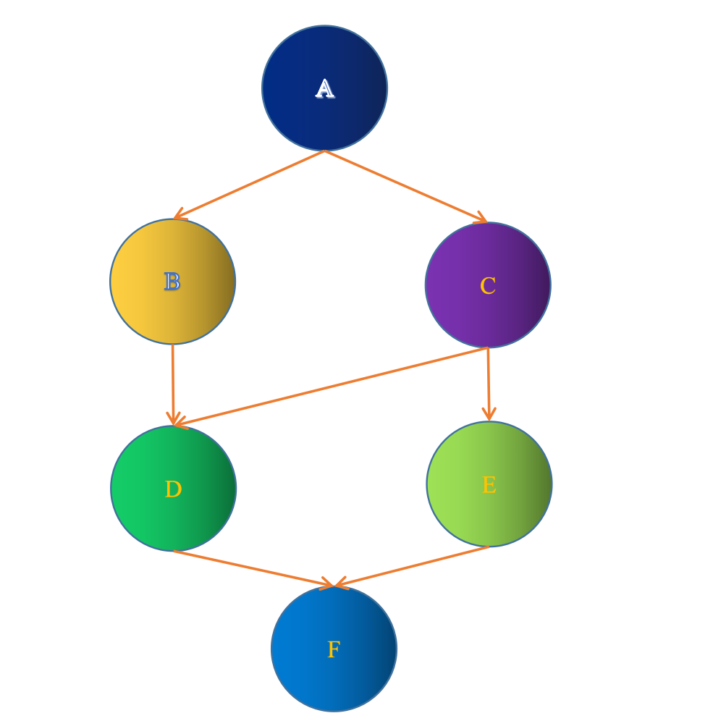

The naive Bayesian classification is a very simple classification method. Its basic idea is to deal with categorized items. In the case of the item to be classified, the item to be classified has the highest probability of occurrence, then it is possible to determine which class the item to be classified belongs to. The steps are defined as follows.

1. Let x={a1,a2,... ,an} be the items to be classified, and each ai is a characteristic attribute of x.

(2) There is a set of categories C = {y1, y2, ... , yn).

The key to its implementation is how to calculate each conditional probability in step (2). If each feature attribute is conditionally independent, the following derivation can be obtained according to Bayes' theorem.

(4)

(5)

Since the denominators are the same, we can add all the numerators to the maximum. Since these properties are independent of each other, the following is shown.

(6)

(7)

**3.1.2 AAPE classification model**

By choosing a parent attribute to construct the above xDBCM, which is a Bayesian classification model, the computational complexity of the model is reduced. However, the attribute of the father is also a very important issue. If it is chosen well, the relationship between each child attribute and the parent attribute will be tighter, so that the classification will be better. Variety. The average dependency evaluation method was first proposed by Geoff Webb, a famous scholar, and its main purpose is to solve the AODE and then average the obtained values to get the final classification result, which can avoid the sudden change of performance in the classification process. [25] so that it has a wider practical value. the AODE treats each attribute in turn as SP and then calculates the posterior probability of I = (x1, x2, ... , xm) of posterior probabilities, I has m attributes, so for m instances, the posterior probabilities of I belonging to different types are calculated and they are classified into the class with the highest average posterior probability.AODE considers the conditional dependency between each feature term with respect to the parent attributes, so it has better recognition accuracy.

**3.2 Overall design of the platform**

The platform uses a three-layer B/S structure, as shown in Figure 6, including a presentation layer, a logic layer and a data layer. Different layers of the multi-tier structure are independent of each other, and changes in one layer will not have any impact on other layers, so it is highly reusable. Presentation layer. Receives user requests, returns data, and allows clients to access the application. Its task is to send a service request to the web server through the web browser, the web server sends the required protocol to the client, and the client receives the sent page. Then it is displayed in the browser. Logic layer: refers to the operation of the data layer, which is the core part of the system that implements the business logic and data processing. Data layer. Processes the data in the database and completes the functions of querying, modifying, updating, deleting, etc. of the database.

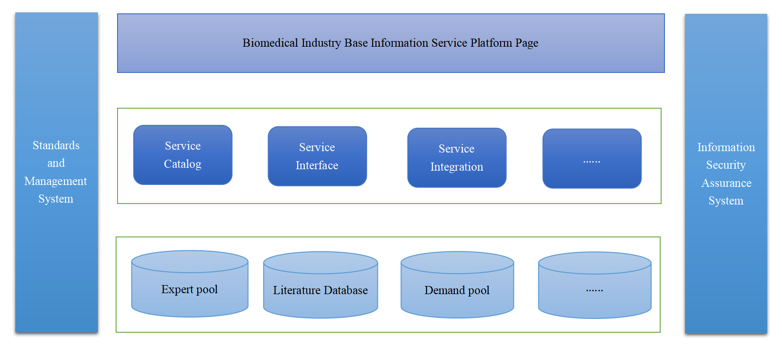

**3.3 Principles and Methods**

BayesSSE is an interactive Bayesian sample estimation program that allows the user to update the sample output in real time by entering the user's parameters while using the Bayesian algorithm. In this paper, the application is hosted on a server that allows the user to explore its functionality and estimate the sample size. [26] Figure 7 shows an overview of the architecture of BayesSSE. The development of the application mainly includes the design of the front-end pages and the implementation of the back-end algorithms, as well as the calls to R packages such as LearnBayes, SampleSizeMeans, BFDA, BFDA, etc. The BayesSSE application is built on a server and the user can access the application through a browser client, sending parameter requests to Shiny Shiny accepts the user's data, then runs the algorithm code in the background, renders it on the front page, and then feeds the relevant graphs and tables to the user. This is shown in Figure 7.

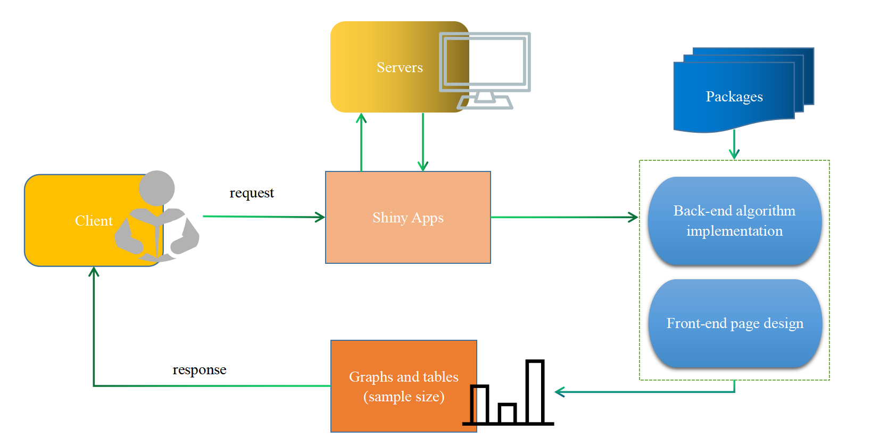

BayesSSE works as follows: the user can select the test type, data type and method type according to the number of samples; secondly, the user fills in the parameters according to a pre-defined parameter table; finally, the user can obtain the number of samples. As the user adjusts the data, the application updates the data and graphs in real time.

**3.4 Main working mode and operation mechanism of technology innovation platform of biopharmaceutical enterprises**

Knowledge sharing in the innovation platform of biopharmaceutical industry refers to the interaction and learning of organizational knowledge through the knowledge sharing system by different subjects in the innovation chain of biopharmaceutical industry, including universities, research institutions, large pharmaceutical enterprises, government regulatory agencies, etc. , In the innovation chain of biopharmaceutical industry, the knowledge sharing system of the innovation platform provides support for knowledge sharing among members.

Knowledge sharing includes explicit knowledge sharing and tacit knowledge sharing. With the rapid development of information technology and network technology, the innovation platform of enterprises can realize the information sharing within enterprises through data warehouse and document management system, etc. [27] In the knowledge sharing system, each member uploads personal knowledge to the knowledge warehouse according to the rules of knowledge uploading. The principles of knowledge uploading are: sharing intellectual property between members and other partners, criteria for uploading knowledge, and opportunistic penalties for members. Meanwhile, through uniform knowledge acquisition rules, platform members can acquire valuable knowledge from the knowledge repository. The knowledge acquisition rules include the criteria for members to acquire and charge for knowledge, and the criteria for members to acquire and charge for knowledge. In addition, organizations outside the platform can also access and utilize knowledge according to the knowledge sharing system, but in general, the rights and fees for external organizations to access and utilize knowledge will be significantly different.

The efficiency of knowledge sharing in innovation platforms of biopharmaceutical companies determines the willingness of companies to share knowledge, distribution methods and costs, which are based on the rules of platform design.

**3.5 Ways to strengthen cooperation between biomedical industry and emerging industries**

1. Accelerate the construction and improvement of China's clinical research service system. First, strengthen the construction of clinical research infrastructure capacity, coordinate the allocation of various types of clinical research support resources, increase support for the construction of key disciplines and specialties, accelerate the construction of research hospitals, and strongly support the construction of national clinical medical research centers to shorten the gap with Beijing and other international cities [38]. Second, promote the reform of research institutions. We should strengthen the scientific research investment of medical institutions and medical personnel, improve the assessment system of medical institutions, optimize the evaluation system of clinical research talents, build an incentive performance mechanism oriented to knowledge value-added, reform the management of the rights and interests of clinical research results, and promote the reform of the management system and mechanism of clinical research in many aspects to improve the enthusiasm of medical institutions and medical personnel to participate in clinical research. Third, accelerate the construction of public platforms for clinical research. Build a municipal medical research and translation service platform, integrate medical resources, and build a collaborative mechanism of multi-center linkage, professional service docking, and data sharing. On the one hand, provide support for biomedical clinical research, shorten the research cycle and reduce research costs; at the same time, we should strongly support hospitals to carry out clinical research, actively participate in the development of national clinical trial specifications, reform the system, and align with international advanced level research hospitals.

2. Strengthen support for medical services. First, pricing, procurement and payment according to the value of the product. We should aim at medical insurance cost control and not blindly reduce the price of biological drugs, but adhere to the concept and principle of "value-based", value-based and reasonable pricing, balancing medical insurance cost control and the development of biomedical industry. Second, establish a green channel for the procurement of domestically produced drugs. Prioritize the evaluation of new domestically produced drugs. When assessing such drugs, we should not only focus on their traditional clinical and microeconomic value, but also assess their value from macro and social perspectives (e.g. technological innovation, industrial development, etc.). For new drugs, conditional reimbursement (e.g., tied to efficacy) can be implemented to strengthen the post-marketing management of drugs. Third, accelerate the reform of payment methods. Innovative and high-priced drugs should not only adopt a single traditional payment model, but should draw on advanced foreign experience and actively explore new payment models. Fourth, we should vigorously develop commercial health services. Commercial health insurance in China is still in its infancy, there is a lot of room for development. We should increase the support for commercial health insurance, strengthen information sharing, provide support for the design of commercial health insurance products and provide more funds for enterprises.

**4. Analysis and discussion of the results**

**4.1 Analysis of technological innovation capability of biopharmaceutical enterprises in China**

In this section, SPSSl6.0 statistical software was used to analyze the factors. The 12 variables of SPSS are first established and a sampling point identification variable is added to the above 12 variables: area, named in turn a, cl, c2, . . c12. Inputting the raw data, the data normalization process of SPSS is automatically completed [39]. This is done as follows.

1 Factor Extraction

as shown in Table 2.

Table 2 Total variance explained

|  |  |  |  |  |  |  |
| --- | --- | --- | --- | --- | --- | --- |
| Element | Initial Eigenvalue | | | Extracts the sum of squares and loads | | |
| Total | Percentage of variance | Accumulation % of | Total | Percentage of variance | Accumulation % of |
| 1 | 6.81 | 56.77 | 56.779 | 6.814 | 56.779 | 56.779 |
| 2 | 2.92 | 24.35 | 81.136 | 2.923 | 24.356 | 81.136 |
| 3 | 1.08 | 8.99 | 90.133 | 1.080 | 8.997 | 90.133 |
| 4 | 685 | 5.70 | 95.842 |  |  |  |
| 5 | 499 | 4.15 | 100.000 |  |  |  |
| 6 | 2.927E-16 | 2.440E-15 | 100.000 |  |  |  |
| 7 | 1.504E-16 | 1.253E-15 | 100.000 |  |  |  |
| 8 | 4.4.1E-17 | 3.668E-16 | 100.000 |  |  |  |
| 9 | -4.401E-17 | -3.715E-16 | 100.000 |  |  |  |
| 10 | -1.174E-16 | -9.784E-16 | 100.000 |  |  |  |

2 Common degree analysis

Table 3 shows the characteristic quantities, variance contribution and cumulative contribution calculated from the correlation coefficient matrix R. From the table, it can be seen that the variance of the first factor is about 57%, while the variance of the first three factors. The contribution rate was 90.133% (to 85%), so only the first three factors were considered. After extracting the three common factors, the commonness of the variables can be calculated as shown in Table 3. From the perspective of the similarity of variables, it can be seen that the similarity between different variables varies from 69.1% between different variables to more than 80% between different variables, and these three different common factors have good explanatory power for different economic indicators.

Table 3 List of common degrees of variables

|  |  |  |
| --- | --- | --- |
|  | Initial | Extraction |
| C1 | 1.000 | .939 |
| C2 | 1.000 | .933 |
| C3 | 1.000 | .977 |
| C4 | 1.000 | .912 |
| C5 | 1.000 | .836 |
| C6 | 1.000 | .921 |
| C7 | 1.000 | .984 |
| C8 | 1.000 | .887 |
| C9 | 1.000 | .834 |
| C10 | 1.000 | .691 |
| C11 | 1.000 | .996 |
| C12 | 1.000 | .936 |

(3) Factor rotation and factor interpretation

Since the initial factor loading matrix coefficients are not very obvious, in order to spread the coefficients in the factor loading matrix to 0.1, the indices have larger loadings on one common factor and decreasing loadings on other common factors, so the initial loading matrix has the largest variation, after editing to remove some small values, as shown in Table 4. Through the factor loading matrix, factor F1 has larger loading values on the proportion of loans from financial institutions C4, the proportion of government funds C5, the intensity of R&D capital investment C6, the number of research institutions C7, the full-time equivalent of R&D personnel C8, and the number of collaborative projects C9[40] . This indicator represents the technological innovation environment of biopharmaceutical industry clusters and is known as innovation environment utilization capacity Silver; F2 scientists and engineers in C1, C2, C2, C3, C3, C10 are the technological innovation material of biopharmaceutical industry clusters. resource and human resource base; F3 accounts for a relatively large proportion of C11 patent applications and C12 new products, which are the main manifestations of technological innovation in biopharmaceutical enterprises.

Table 4. rotated component matrix

|  |  |  |  |
| --- | --- | --- | --- |
|  | Element | | |
|  | 1 | 2 | 3 |
| C1 |  | .967 | .401 |
| C2 |  | .532 |  |
| C3 |  | .433 |  |
| C4 | .849 | .421 |  |
| C5 | .688 |  | .600 |
| C6 | .963 |  |  |
| C7 | .754 | .727 | .544 |
| C8 | .940 |  |  |
| C9 | .799 | .421 |  |
| C10 | .458 | .609 |  |
| C11 |  | .924 | .315 |
| C12 |  |  | .965 |

**4.2 Simulated data studies and case studies**

In this paper, the Bender method is used to model the life data. First, the covariance matrices of the three data cases are built.

Scenario 1: The number of independent variables is 20 and there is no real predictor variable, i.e., B; also, the variables are independent of each other, as shown in Table 5.

Table 5. Comparison of the results of the three variable selection methods for different residual items in simulated data scenario 1 when the sample size is 50

|  |  |  |  |  |  |  |  |  |
| --- | --- | --- | --- | --- | --- | --- | --- | --- |
| Î | BMA(50%) | | BMA (95%) | | Lasso | | Progressive | |
| ǞǞPNSRV | ǞǞǞǞ | ǞǞPNSRV | ǞǞǞǞ | ǞǞPNSRV | ǞǞǞǞ | ǞǞPNSRV | ǞǞǞǞ |
| 0.1 | 17.00 | 2.302 | 67.60 | 0.562 | 72.40 | 0.69 | 59.20 | 0.586 |
| 0.2 | 12.80 | 2.254 | 64.80 | 0.53 | 66.40 | 0.684 | 56.00 | 0.592 |
| 0.3 | 16.40 | 2.332 | 68.00 | 0.506 | 70.20 | 0.702 | 58.60 | 0.556 |
| 0.4 | 14.20 | 2.248 | 67.00 | 0.518 | 67.60 | 0.7 | 54.60 | 0.594 |
| 0.5 | 14.00 | 2.306 | 66.80 | 0.598 | 71.40 | 0.684 | 57.20 | 0.564 |

Scenario 2: The number of independent variables i = 20, where x is the true predictor variable, the regression coefficient of the actual variable is 1, the variable x2 is the actual variable x, the relevant variables are independent variables, and other variables are independent of each other and the actual variables, when the correlation between the variables and the actual variables is affected, some variable selection methods select the ability of the true variables and exclude the ability of the irrelevant variables to select the appropriate model. As shown in Table 6.

Table 6. Comparison of the results of the three variable selection methods for the different remaining items in the simulated data scenario 2 when the sample size is 50

|  |  |  |  |  |  |  |  |  |
| --- | --- | --- | --- | --- | --- | --- | --- | --- |
| Î | BMA(50%) | | BMA (95%) | | Lasso | | Progressive | |
| PSTM | ǞǞǞǞ | PSTM | ǞǞǞǞ | PSTM | ǞǞǞǞ | PSTM | ǞǞǞǞ |
| 0.1 | 2.318 | 3.80 | 0.628 | 6.40 | 0.784 | 5.60 | 0.614 | 11.60 |
| 0.2 | 2.444 | 2.20 | 0.636 | 5.60 | 0.926 | 5.00 | 0.64 | 12.00 |
| 0.3 | 2.274 | 5.00 | 0.558 | 7.80 | 0.778 | 7.00 | 0.574 | 15.20 |
| 0.4 | 2.064 | 5.20 | 0.464 | 7.40 | 0.742 | 7.40 | 0.524 | 14.20 |
| 0.5 | 2.362 | 4.80 | 0.598 | 9.40 | 0.87 | 5.20 | 0.638 | 15.40 |

**4.3 Analysis of policy texts from the perspective of policy instruments**

With the emergence of policy science, policy tools have gradually become an important way to study public policy [30] . The analysis of policy instruments shows that they are composed of a series of basic elements that reflect the values and ideas of policy makers. According to the objectivity of the policy, the policy subject combines them organically so as to achieve functional complementarity and achieve the desired effect of the policy. There are various ways of expressing policy instruments. One of the common approaches is to combine the views of Rothwell and Siegweil to classify basic policy instruments into three categories: supply-based, environment-based, and demand-based. In terms of analytical unit settings, some set them up as specific policy texts, while others set them up as separate policy documents. In this report, individual policy documents are used as the unit of analysis. The paper analyzes in detail 85 valid samples, which are classified according to the criteria in combination with the classification method of the following tools, as shown in Figure 8.

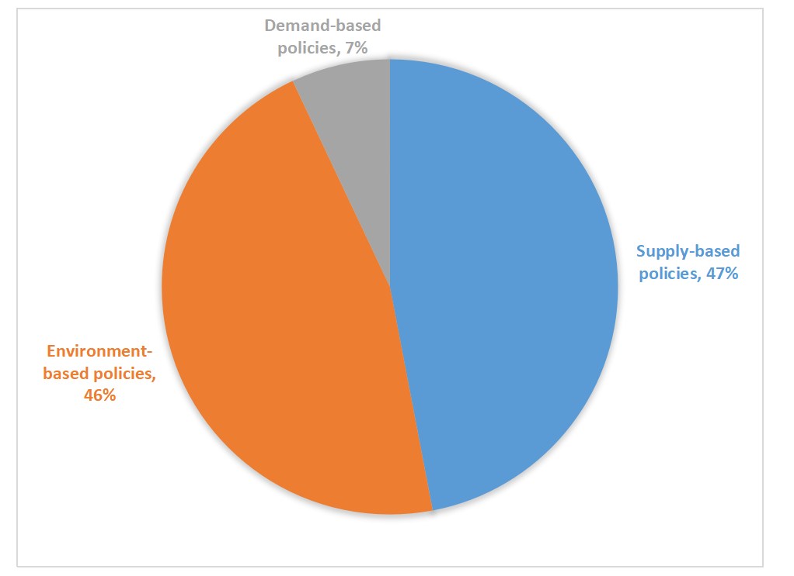

Supply-based policy tools are more manifested as policies to promote the biomedical industry, i.e., the government improves its supply level by means of talents, information, technology, capital, public services, etc., so as to promote its development. Supply-based policies can be subdivided into talent training, technical support, financial support, public services, etc.

Environmental policy tools are reflected in the impact of policies on the development of the biopharmaceutical industry, especially those that have an environmental impact on the biopharmaceutical industry through finance, taxation, and regulations. The development of the industry is indirectly promoted through policy support for enterprise development and technological innovation. Environmental policy tools include target planning, regulations, financial support, tax incentives, property rights protection, etc.

Demand-oriented policy refers to the government's efforts to guide market demand through government procurement, trade, user subsidies, demonstration applications, price guidance, etc. to reduce market uncertainty and promote the healthy development of the industry.

Demand-oriented policy tools are important tools to promote the healthy development of biopharmaceutical industry. By increasing demand-oriented policy tools, reducing the frequency of environmental policy tools, promoting the development of the biopharmaceutical industry from the actual demand side, rationalizing the use of supply-oriented policy tools, and balancing the design and overall layout of policy tools. In specific aspects, we should encourage the participation of enterprises, encourage them to undertake outsourcing of services, and strengthen government procurement and overseas exchanges. The design principles of various policy tools should be fully considered to give full play to their implementation effects.

**4.4 Develop and improve industrial policies to promote the development of China's biopharmaceutical industry**

The new drug development cycle is long, generally 10-12 years; due to the long decision-making chain, it is difficult for enterprises to establish a performance evaluation system, which prevents the incentive mechanism from playing an effective role. In addition, industrialization requires a large amount of long-term investment, especially for startups, where initial financing is difficult, team building and bonding cycles are long, laws and regulations take a long time to understand and master, and new drug research is multidisciplinary. And the multidisciplinary team composed of M1 is a multidisciplinary team composed of one project. There are difficulties in building a fully functional laboratory, and innovation in systems and policies is needed.

With the rapid development of global biopharmaceutical industry, the improvement of people's material living standard and the enhancement of people's health consciousness, on the one hand, the demand for biopharmaceuticals in the international market will grow rapidly and the scale will be expanded; at the same time, due to the rapid development of global biopharmaceutical industry, it is more difficult to develop the international market. Therefore, only by correctly determining their positioning in the international market can they stand firm in the fierce competition. In the long run, in order to achieve a balance of supply and demand in China's biopharmaceutical industry, it is necessary to export some competitive products on the one hand, and import some high-end products that cannot be produced domestically on the other hand, in order to reduce trade friction.

**4.5 Analysis of factors constraining the development of China's biopharmaceutical industry**

The role of industrial clusters is not strong, and there is no interdependent mechanism of division of labor and cooperation. Most of China's industrial parks are formed "top-down", i.e., they emerge, develop and grow under the active planning of local governments. These high-tech parks are supported by various national preferential policies and lack internal linkages among large local enterprises. At present, in some local industrial parks, there is "only one and no one". Most of the enterprises are working alone and have not yet formed industrial strength. Many enterprises enter the parks because they enjoy government policies rather than the agglomeration power of the parks themselves. Industrial clusters lack leading enterprises, lack of cooperation and communication among economic entities, enterprises cannot form interdependent professional division of labor, industries are widely distributed, but competition is fierce, production and output value are growing rapidly, but the overall level is not high, innovation is not obvious, and drugs with independent intellectual property rights are not yet available.

Policies need to be optimized and adjusted. The lack of policies has caused the organizational structure of the park to professionally manage the development of industrial clusters, the implementation of government policies, insufficient support for new enterprises, insufficient investment in R&D, and lack of government investment in R&D. The hardware facilities of the park, such as transportation, entertainment and catering, need to be further strengthened; in addition, the prices of drugs in the medical insurance catalog are determined through bidding, and it is difficult for high-priced patented drugs to enter the medical insurance catalog; in addition, the strategies of some enterprises need to be discussed, such as whether scholars can become entrepreneurs.

1. **Summary**

At present, the agglomeration development of biopharmaceutical industry in China is very obvious. Although there are obvious economic conflicts among economic regions, the literature on the industrial division of labor in the region is scarce. This paper focuses on the industrial chain division of labor in a specific industrial cluster. Generally speaking, the domestic industrial division of labor theory is still weak. Under the theoretical framework of regional industrial division of labor, the current situation of industrial division of labor is evaluated based on specific industrial division of labor, and the evolution of industrial division of labor, cooperative evolution and influencing factors are further improved on this basis. Focusing on the industrial chain division of labor in the region; the empirical study of regional industrial division of labor involves different spatial, contextual and comparative relationships, but there are few studies on specific industries. At present, the division of domestic biopharmaceutical industry mainly focuses on its industrial chains, but there is a lack of comparative studies on its industrial chain division. This paper argues that the industrial division of China's biopharmaceutical industry should be strengthened to guide and enhance the division of its industrial chain.

The biopharmaceutical industry is on the rise of development and needs to continue to strengthen policy support, while the current policy tools used by the government, there is a structural imbalance, and the relevant policies introduced in the future need to be further adjusted. In conclusion, it is important to recognize the role of demand-oriented policy tools to promote industrial development, strengthen government procurement tools, and timely include new drugs that meet the requirements in the government procurement catalog to promote the clinical application and marketing of new drugs.