Bone Mass Density (BMD) Classification Analysis
Zihan Yan
This report presents an analysis of the BMD patient dataset using three machine learning models: Decision Tree, Random Forest, and Logistic Regression. The goal was to classify patients as 'fracture' or 'no fracture' based on Age, Weight, Height, and Bone Mineral Density (BMD).

Decision Tree Analysis
Decision Tree with Depth 3 achieved an accuracy of 0.7843, with 4 'no fracture' cases and 7 'fracture' cases misclassified.
Decision Tree with Depth 5 achieved an accuracy of 0.8039, with 3 'no fracture' cases and 7 'fracture' cases misclassified.
The Decision Tree model was evaluated using two different depths: 3 and 5. The accuracy increased from 0.7843 at depth 3 to 0.8039 at depth 5, indicating that a deeper tree captures more complexity in the data. However, the misclassification of 'fracture' cases remained consistent, suggesting that further increases in depth might not significantly improve performance for this class.

Random Forest Analysis
Random Forest with 50 estimators achieved an accuracy of 0.7843, with 4 'no fracture' cases and 7 'fracture' cases misclassified.
Random Forest with 100 estimators achieved an accuracy of 0.8235, with 3 'no fracture' cases and 6 'fracture' cases misclassified.
The Random Forest model was evaluated with 50 and 100 estimators. The accuracy increased from 0.7843 to 0.8235 with 100 estimators, demonstrating that a larger ensemble size can improve the model's robustness and predictive capability. The model misclassified fewer 'fracture' cases compared to the Decision Tree, indicating improved performance through ensemble learning.

Logistic Regression Analysis
Logistic Regression achieved an accuracy of 0.8431, with 2 'no fracture' cases and 6 'fracture' cases misclassified.
The Logistic Regression model achieved an accuracy of 0.8431, making it competitive with the Random Forest model with 100 estimators. This suggests that even simpler linear models can perform well in certain classification tasks, especially when the underlying relationship between features and the target variable is relatively linear.

Comparative Analysis
The comparison of classification accuracies shows that Random Forest with 100 estimators performed the best, followed by Logistic Regression. Decision Tree with depth 5 outperformed the one with depth 3. Overall, ensemble models like Random Forest tend to generalize better and provide more accurate predictions.
- Model Classification Accuracies
  - This bar chart compares the accuracy of the five models evaluated: Decision Tree with depths 3 and 5, Random Forest with 50 and 100 estimators, and Logistic Regression. It shows that the Logistic Regression and Random Forest with 100 estimators had the highest accuracies, highlighting their superior performance in classifying 'fracture' vs. 'no fracture' cases.
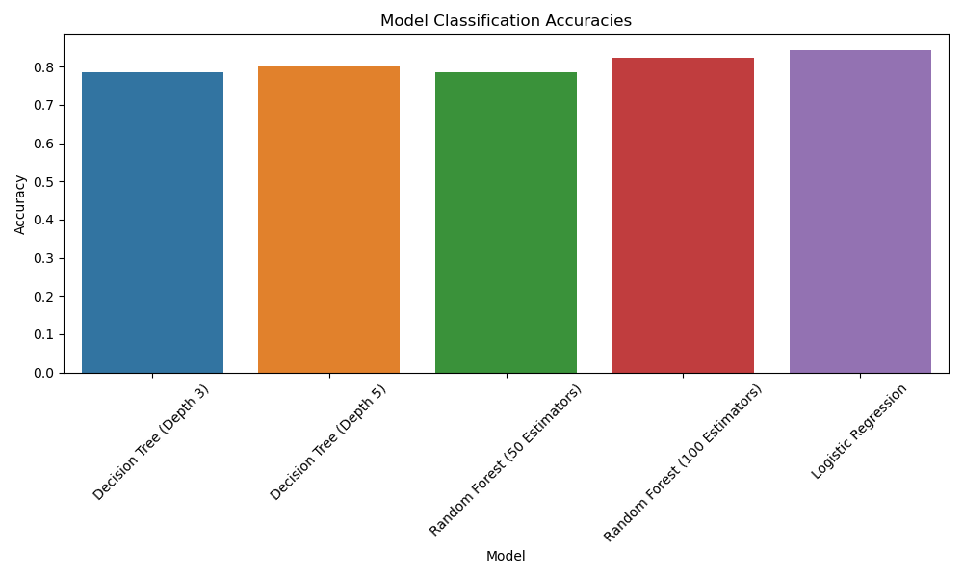
- Number of Misclassified Patients by Model
  - This stacked bar chart illustrates the number of 'no fracture' and 'fracture' cases that were misclassified by each model. The chart reveals that while all models struggled with misclassifying 'fracture' cases, Random Forest with 100 estimators and Logistic Regression had the lowest total misclassification, indicating their reliability in handling the classification task.
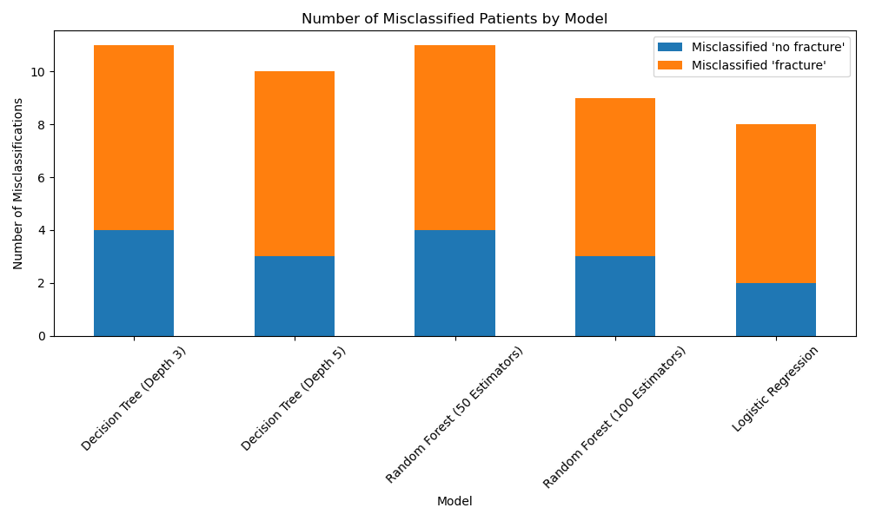
- Feature Importance (Random Forest with 100 Estimators)
  - The horizontal bar chart displays the importance of each feature (Age, Weight_kg, Height_cm, and BMD) in predicting fractures, as determined by the Random Forest model with 100 estimators. BMD was the most significant predictor, followed by Age, suggesting that these features are crucial for identifying fracture risk.
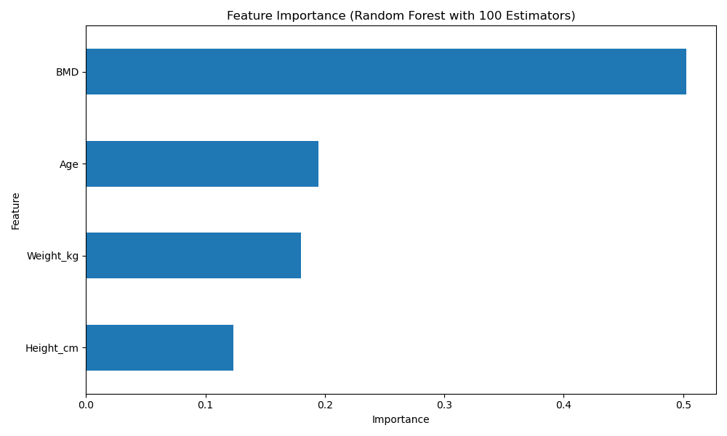
- ROC Curve Comparison
  - This ROC (Receiver Operating Characteristic) curve compares the true positive rates against the false positive rates for Decision Tree, Random Forest, and Logistic Regression models. The area under the curve (AUC) is highest for Random Forest (100 estimators) and Logistic Regression, indicating their superior ability to distinguish between fracture and non-fracture cases.
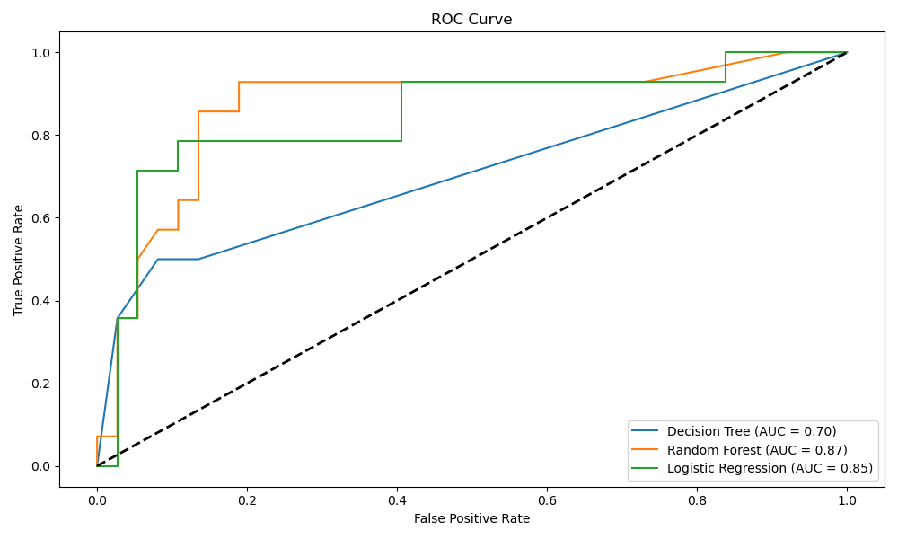
- Precision-Recall Curve Comparison
  - The Precision-Recall curve illustrates the trade-off between precision and recall for each model. Random Forest (100 estimators) and Logistic Regression maintain higher precision and recall across thresholds, demonstrating their robustness in correctly identifying fracture cases while minimizing false positives.
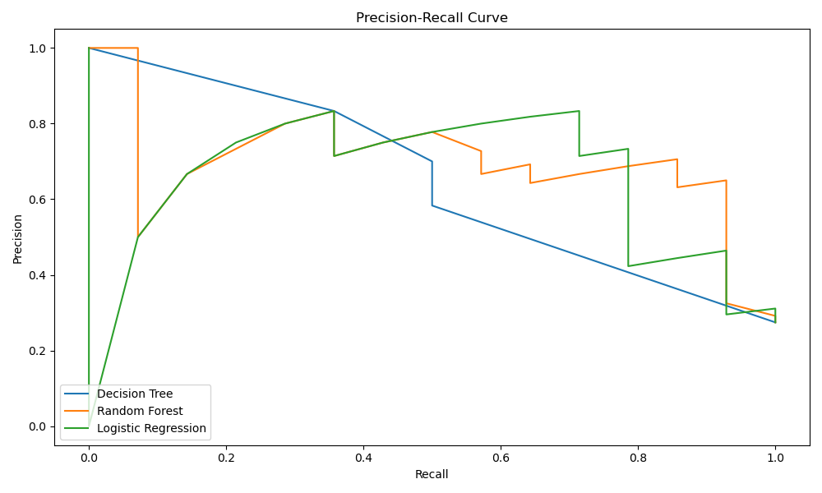
- Decision Boundaries
  - The decision boundary plots for the Decision Tree (depth 5) and Random Forest (100 estimators) visually demonstrate how each model separates the 'fracture' and 'no fracture' classes based on Age and BMD. The smoother boundary of the Random Forest indicates its ability to capture more complex relationships in the data.

