SVM Analysis
Assignment 6
Name: Zihan Yan

SVM with Linear Kernel Function
- Classification accuracy: 0.7941176470588235
  - The classification accuracy was calculated by splitting the dataset into training and testing subsets. The SVM model with a linear kernel was trained on the training data and evaluated using the testing set, yielding an accuracy of 79.41%.
- Number of patients misclassified for each target class.
  - The model showed a higher accuracy in predicting class 1, which could suggest that the data points for this class are more linearly separable compared to class 0.
    - Top-left (True Negative): The model correctly predicted 3 instances as class 0.
    - Top-right (False Positive): The model incorrectly predicted 5 instances as class 1 when they were actually class 0.
    - Bottom-left (False Negative): The model incorrectly predicted 2 instances as class 0 when they were actually class 1.
    - Bottom-right (True Positive): The model correctly predicted 24 instances as class 1.
- The imbalance in the classification could be due to overlapping features or the dataset's distribution that makes class 0 harder to distinguish.
- 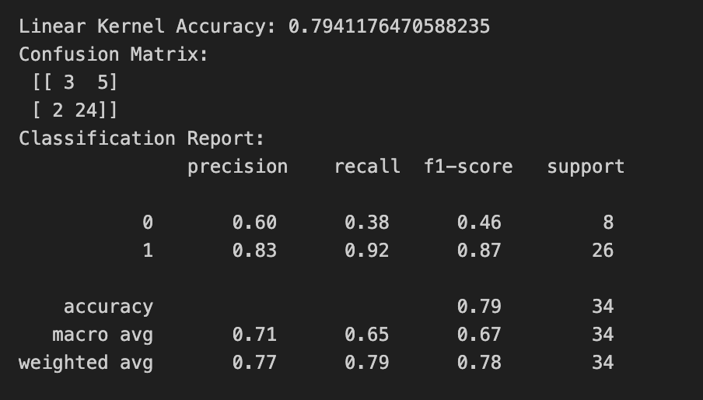
- 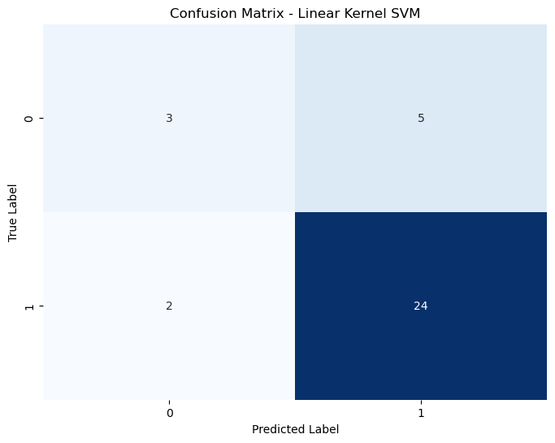
- 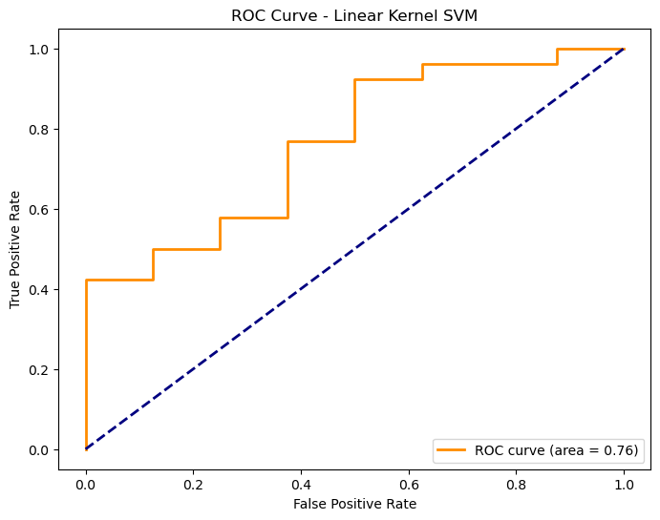

SVM with Radial Basis Function
- Classification accuracy: 0.7941176470588235
  - The SVM model using the RBF kernel also achieved an accuracy of 79.41%. This consistency indicates that both kernels perform similarly on the given dataset.
- Number of patients misclassified for each target class.
  - The RBF kernel did not improve the classification accuracy, which may indicate that the dataset’s feature space does not benefit from the non-linear transformation applied by the RBF kernel, or the parameters (e.g., gamma) might require further tuning.
    - Top-left (True Negative): The model did not correctly classify any instances as class 0 (value is 0).
    - Top-right (False Positive): The model incorrectly classified all 8 instances of class 0 as class 1.
    - Bottom-left (False Negative): The model correctly classified all 26 instances of class 1 (no false negatives, value is 0).
    - Bottom-right (True Positive): The model correctly classified 26 instances as class 1.
- The RBF kernel’s performance suggests potential issues in parameter tuning (e.g., gamma) or that the dataset might not be well-suited for non-linear decision boundaries without further preprocessing.
- 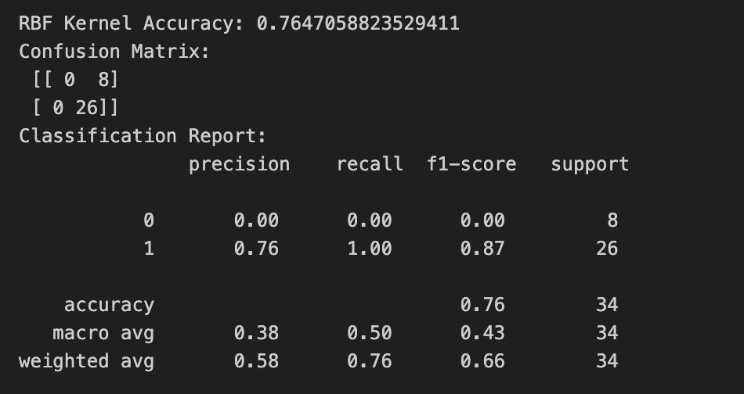
- 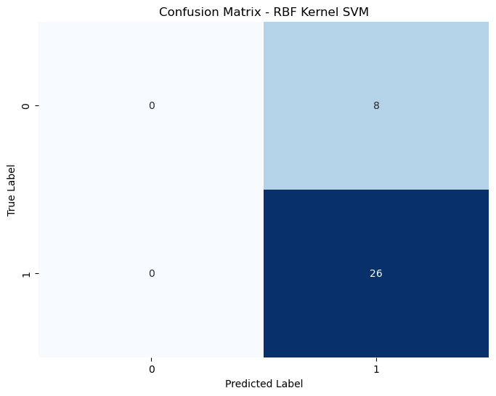
- 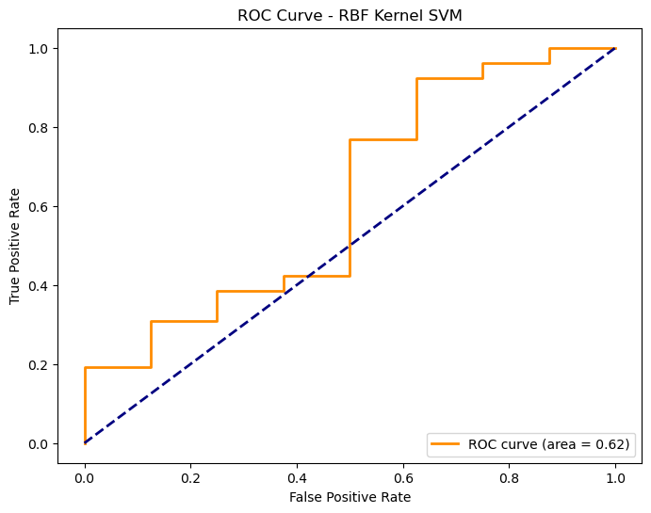

Comparison of Kernels
- Both kernels achieved identical classification accuracy, suggesting that the linear and RBF kernels are equally effective for this dataset. This may be due to the dataset's linear separability or the parameter settings chosen for the models.
- Further parameter tuning for the RBF kernel, including adjustments to gamma and C values, could help determine whether a non-linear kernel could offer better accuracy.

Compare SVM and Other Models
- Accuracy Comparision
  - Decision Tree Accuracy: 0.8529411764705882
  - Random Forest Accuracy: 0.7941176470588235
  - Logistic Regression Accuracy: 0.7941176470588235
- The Decision Tree model outperformed the SVM models, suggesting that tree-based models might better capture the decision boundaries in this dataset. The similarity in performance between the Random Forest, Logistic Regression, and SVM models may imply that the current dataset features constrain these models.
- The higher accuracy of the Decision Tree suggests that it may better capture the decision boundaries of the dataset, likely due to its capability of handling non-linear patterns. In contrast, the SVM and other models may require further tuning or feature engineering.
- In other words, while SVM models with both linear and RBF kernels achieved moderate accuracy, they did not outperform the Decision Tree model. This suggests that, for this specific dataset, tree-based methods may be more effective. Future steps could involve fine-tuning the SVM parameters or exploring other kernel functions to improve performance.
- 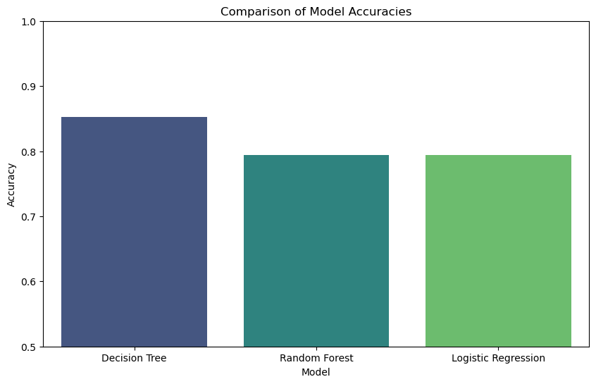
- 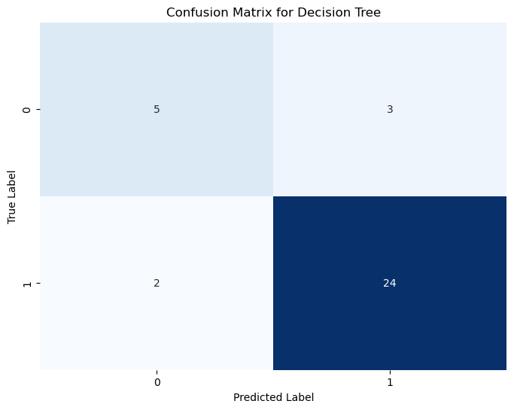
- 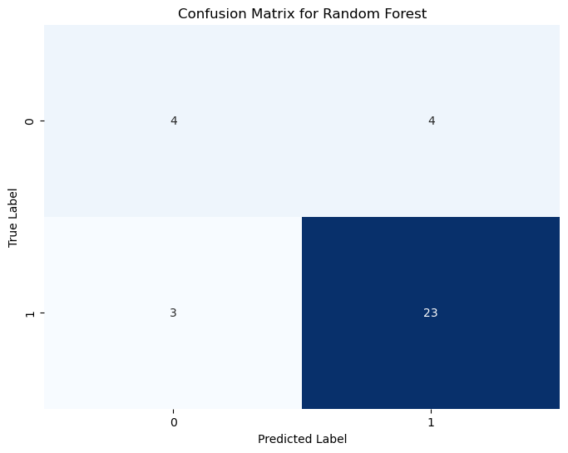
- 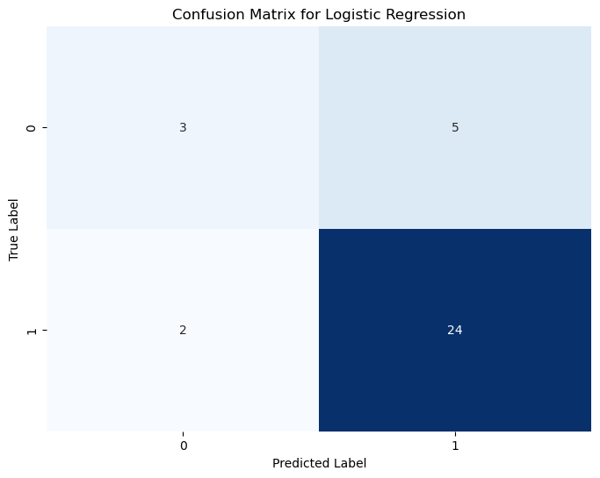

Codes
