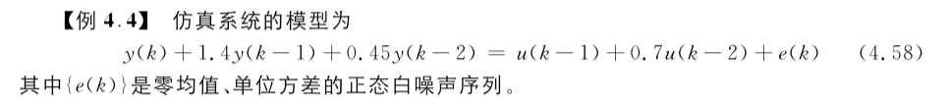



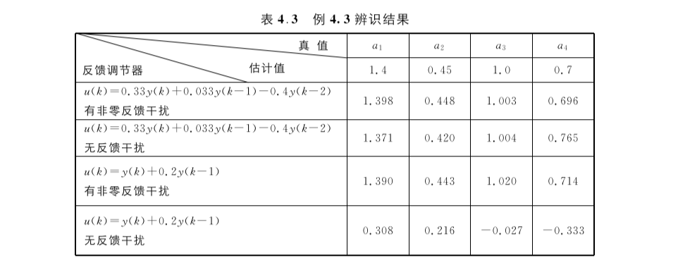

代码如下:

clear;clc

*%产生白噪声*

noise = 0+randn(1,4000);

realTheta = [1.4;0.45;1;0.7];

y=zeros(2002,1);

u=zeros(2002,1);

y(1) = 100;

y(2) = 100;

u(1) = 1;

u(2) = 1;

y(3) = [-1*y(2);-1*y(1);u(2);u(1)]'*realTheta + noise(3);

u(3) = 0.33*y(3)+0.033*y(2)-0.4*y(1);

y(4) = [-1*y(3);-1*y(2);u(3);u(2)]'*realTheta + noise(4);

u(4) = 0.33*y(4)+0.033*y(3)-0.4*y(2);

n = 3;

k = 0;

theta = zeros(4,2);*%theta 初值*

alpha = 10000;*%alpha为大实数*

P = alpha*alpha * eye(4,4);

*for* k = 2:2000

    Phi = [-1*y(n+k-1);-1*y(n+k-2);u(n+k-1);u(n+k-2)];

    Phi_T = Phi';

    y(n+k) = Phi_T*realTheta + noise(n+k);

    u(n+k) = 0.33*y(n+k)+0.033*y(n+k-1)-0.4*y(n+k-2);

*% u(n+k) = y(n+k)+0.2*y(n+k-1);*

*end*

*for* k = 2:2000

    Phi = [-1*y(n+k-1);-1*y(n+k-2);u(n+k-1);u(n+k-2)];

    Phi_T = Phi';

*%y(n+k) = Phi_T*realTheta + noise(k);*

*% y(n+k) = Phi_T*theta(:,k) + noise(k);*

*%反馈控制器*

*%非零反馈干扰*

*%u(n+k) = 0.33*y(n+k)+0.033*y(n+k-1)-0.4*y(n+k-2);*

    theta(:,k+1) = theta(:,k) + ((P*Phi)/(Phi_T*P*Phi+1))*(y(n+k)-Phi_T*theta(:,k));

    P = P - (P*Phi*Phi_T*P)/(Phi_T*P*Phi+1);

*end*

theta(:,2000)

对于不同种类的反馈控制器的辨识结果如下:



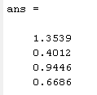



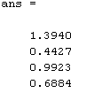



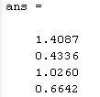



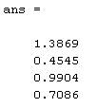



代码如下：

clc;clear;

O=[];

J=[];

AIC=[];

F=[];

n=1;*%初始阶次*

Forder=0;*%估计阶次*

Fvalue=0;

AICorder=0;

AICvalue=0;

N=1000;

F_signal=0;AIC_signal=0;

y=[0.1;0.2];

u=[];u=[u;randn];u=[u;randn];

*for* k=3:N

    y_temp = 1.5*y(k-1)-0.7*y(k-2)+u(k-1)+0.5*u(k-2)+randn;

    u=[u;randn];

    y=[y;y_temp];

*end*

*while* true

    Q=[];

*for* s=n:N

        vector_temp=[];

*for* i=s:-1:(s-n+1)

            vector_temp=[vector_temp,-y(i)];

*end*

*for* i=s:-1:(s-n+1)

            vector_temp=[vector_temp,u(i)];

*end*

        Q=[Q;vector_temp];

*end*

    O_hat = (Q'*Q)^-1*Q'*y(n:N);

    J_temp = (y(n:N)-Q*O_hat)'*(y(n:N)-Q*O_hat);

    O=[[O,zeros(n,2)];O_hat'];

    J=[J;J_temp];

    AIC=(1+2*n/N)*J_temp; *%AIC检验值计算*

    AIC=[AIC;AIC];

    fprintf(" n: %d,AIC:%f",n,AIC);

*if* n>1

         F = (J(end-1)-J(end))/J(end)*(N-2*n^2)/2;

         F=[F;F];

         fprintf(" F：%f",F);

*end*

*%阶次判断*

*if* n>2&&F(end)<3.083  %F<Fa

        Forder=n-1;

        Fvalue = F(end);

        F_signal=1;

*end*

*if* n>3&&(AIC(n-2)>AIC(n-1)&&AIC(n-1)<AIC(n))

        AICorder=n-1;

        AICvalue = AIC(n-1);

        AIC_signal=1;

*end*

*if* F_signal&&AIC_signal

        fprintf("\r\nF检验：%f,阶次%d",Fvalue,Forder);

        fprintf("\r\nAIC检验：%f,阶次为%d",AICvalue,AICorder);

*break*;

*end*

    fprintf("\r\n");

    n=n+1;*%阶次增长*

*end*

代码运行结果如下:

进行5次判断

1.



2.



3.



4.



5.

