第三章第六题

**%递推最小二乘法**

e=normrnd(0,0.05,400,1);

u=randn(400,1);

y=zeros(400,1);

x=zeros(2,2);

u(1)=1;

y(1)=0; %取初值

for i=2:400

if i<201

y(i)=0.5*u(i-1)-0.8*y(i-1)+e(i-1);

else

y(i)=0.3*u(i-1)-0.6*y(i-1)+e(i-1);

end

end

R0=1;%就是一个赋值

P=10^4*eye(2);

theta=[0.1;0.1];

for k=2:400

X=[ y(k-1) u(k-1)]';

alfa=1/(R0+X'*P*X);%计算因子

L=alfa*P*X;

theta(:,k)=theta(:,k-1)+L*(y(k)-X'*theta(:,k-1));%theta=θ?????%每迭代一次，theta就增加一列，新增加的那一列就是最新的参数估值。

P=P/R0-alfa*P*X*X'*P;

end

figure(1)

i=1:400;

plot(i,theta(1,:),i,theta(2,:))

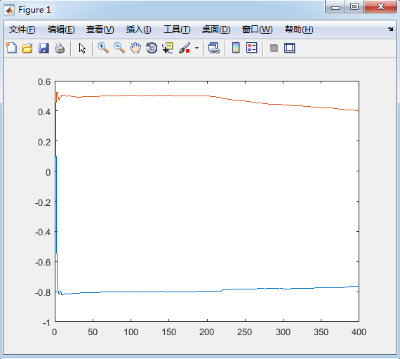

**%带遗传因子的最小二乘参数估计**

e=normrnd(0,0.05,400,1);

u=randn(400,1);

y=zeros(400,1);

x=zeros(2,2);

u(1)=1;

y(1)=0; %取初值

for i=2:400

if i<201

y(i)=0.5*u(i-1)-0.8*y(i-1)+e(i-1);

else

y(i)=0.3*u(i-1)-0.6*y(i-1)+e(i-1);

end

end

R0=0.98;%遗传因子

P=10^4*eye(2);

theta=[0.1;0.1];

for k=2:400

X=[ y(k-1) u(k-1)]';

alfa=1/(R0+X'*P*X);%计算因子

L=alfa*P*X;

theta(:,k)=theta(:,k-1)+L*(y(k)-X'*theta(:,k-1));%theta=θ?????%每迭代一次，theta就增加一列，新增加的那一列就是最新的参数估值。

P=1/R0*(P-alfa*P*X*X'*P);

end

figure(1)

i=1:400;

plot(i,theta(1,:),i,theta(2,:))

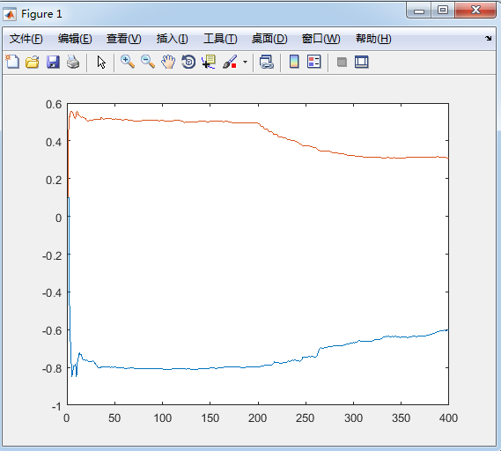

**%变遗传因子的最小二乘估计**

e=normrnd(0,0.05,400,1);

theta=zeros(2,400);

u=randn(400,1);

y=zeros(400,1);

x=zeros(2,2);

u(1)=1;

y(1)=0; %取初值

for i=2:400

if i<201

y(i)=0.5*u(i-1)-0.8*y(i-1)+e(i-1);

else

y(i)=0.3*u(i-1)-0.6*y(i-1)+e(i-1);

end

end

R0=0.98;%初始遗传因子

P=10^4*eye(2);

theta=[0.1;0.1];

Sum=2.5;

for k=2:400

X=[ y(k-1) u(k-1)]';

E=y(k)-X'*theta(:,k-1);

N=P*X/(X'*P*X+1);

theta(:,k)=theta(:,k-1)+N*E;

R0=1-(1-X'*N)*power(E,2)/Sum;

if R0<=0.5

R0=0.5;

end

P=(1-N'*X)*P/R0;

end

figure(1)

i=1:400;

plot(i,theta(1,:),i,theta(2,:))

