燕山大学研究生课程结课论文

《鲁棒控制》

任课教师：赵广磊

|  |  |
| --- | --- |
| 班 级： | 双控三班 |
| 学 号： | 202221030205 |
| 姓 名： | 杨泽坤 |

# 具有时滞切换的不确定切换中立系统的鲁棒稳定性

## 一、介绍

切换系统由有限个连续时间或离散时间子系统和一个指定这些子系统之间切换的切换信号组成。这类系统在过去的几十年中引起了相当大的关注，因为各种实际系统，如化学加工、通信网络、交通控制[、制造系统控制、汽车发动机控制和飞机控制等都可以建模为切换系统。在切换系统的稳定性分析和控制综合领域，出现了许多工作。

人们注意到，时滞现象广泛存在于工程和系统中，它可能导致控制系统不稳定或系统性能变差。中立型系统是一类重要的时滞系统，它不仅依赖于状态的时滞，还依赖于状态导数的时滞。中性系统的一些实际例子包括分布式网络、热交换和包括蒸汽在内的过程。近年来，该方向的研究活动日益增多。

另一方面，在实际环境中，执行器可能会发生故障。如果一个控制系统在发生故障时仍能保持某些特性，则称其是可靠的。值得注意的是，通常情况下，固定增益的控制器易于实现，能够满足实际应用的要求。但当故障发生时，常规控制器将变得保守，可能无法满足某些控制性能指标。可靠控制是一种有效的提高系统可靠性的控制方法，其目标是在执行器发生故障的情况下，设计一个结构合适的控制器来保证稳定性和令人满意的性能。自20世纪70年代Siljak提出可靠控制的概念以来，可靠控制问题引起了众多学者的关注。

最近，由于切换中立系统在实际系统中的大量应用，一些研究者开始关注切换中立系统。文献研究了切换中立系统的稳定性分析和控制综合问题。然而，正如文献所指出的，实际运行中不可避免地存在控制器与系统的异步切换，即控制器的切换时刻超过或滞后于系统的切换时刻。在现有研究成果中，已经提出了时滞切换中立系统的镇定问题的一些结果。据我们所知，异步切换下切换中立系统的鲁棒可靠控制问题尚未被研究。采用驻留时间方法进行稳定性分析和控制器设计，为具有时滞切换和执行器故障的切换中立系统设计一个可靠的镇定控制器，使得闭环系统是指数稳定的。

## 二、问题模型和预备知识

具有执行器故障的不确定中立切换系统

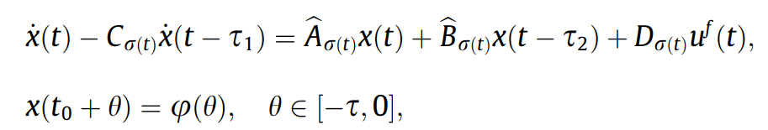

对于执行器故障的控制输入可以被描述为



为了形式简单，我们定义

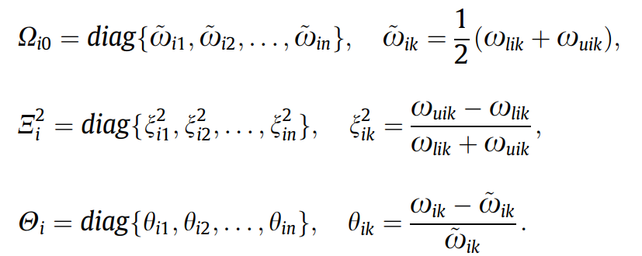

因此，我们有如下公式

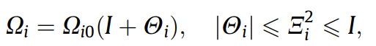

然而在实际运行中，不可避免地存在控制器与系统之间的异步切换。不失一般性，我们只考虑控制器的切换时刻相对于系统的切换时刻发生时滞的情况。控制器的切换时刻可以描述为



## 三、主要结果

### 1.稳定性分析

首先我们分析无切换的中立系统稳定性

**引理1**

考虑以下中立系统

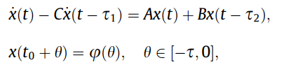

如果存在合适维数常量矩阵A,B,C，对于给定常数 $α$ 如果存在正定系统矩阵P,R满足

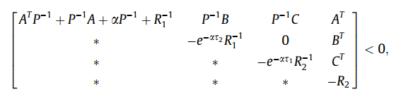

那么有沿着系统轨迹以下不等式成立



**引理2**

对于给定的正常数 $β$，如果存在具有适当的维数的正定对称矩P,R满足

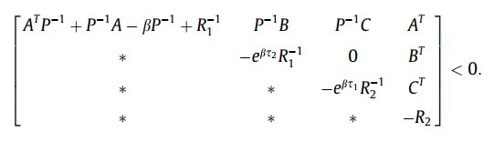

那么有沿着系统轨迹以下不等式成立



**注释**

引理1，2给出了候选Lyapunov泛函的评估方法，并将其用于异步切换中立系统的控制器设计。

### 2.鲁棒稳定性控制器设计

考虑上述系统在异步切换控制器,相对应的闭环系统可以写为

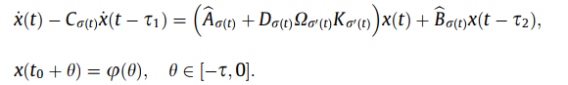

假设第i个子系统在切换时刻 $t_{k}$ 被激活，第j个子系统在切换时刻 $t_{k}+1$ 被激活，相应的切换控制器分别在切换时刻 $t_{k}+∆_{k}$， $t_{k+1}+∆_{k+1}$ 被激活。

**定理1**

考虑系统( 1 )和( 2 )，对于给定的正常数 $α$， $β$，如果存在正定对称矩阵P，R适当维数的矩阵 $W$ 和正标量 $ε$， $δ$ 使得对i,j,下列不等式成立.

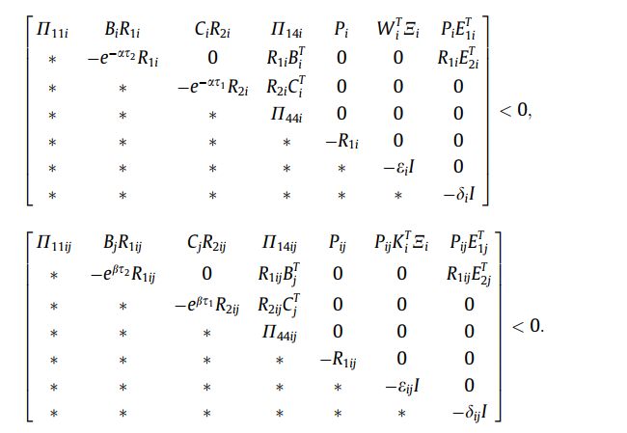

**那么**在异步切换控制器安定平均驻留时间满足



**时，对应的闭环系统是渐近稳定的，其中**

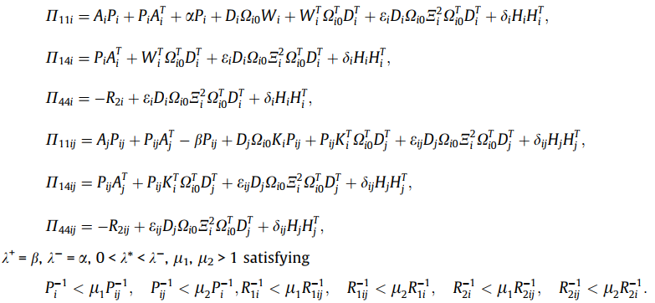

### 四、仿真

在这一部分我们给出一个例子来说明所提出方法的有效性。考虑上述系统，给出参数如下：

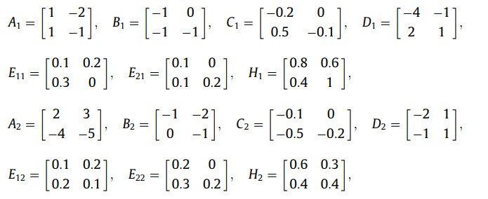



故障矩阵为，其中



**在定理1中的各个参数取为**

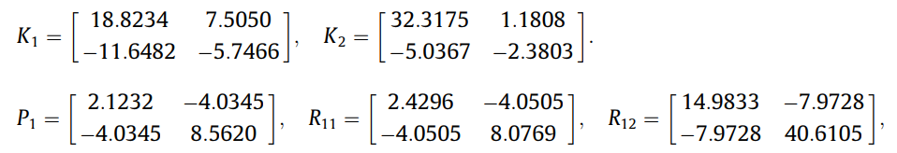

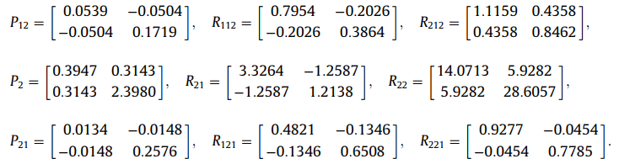

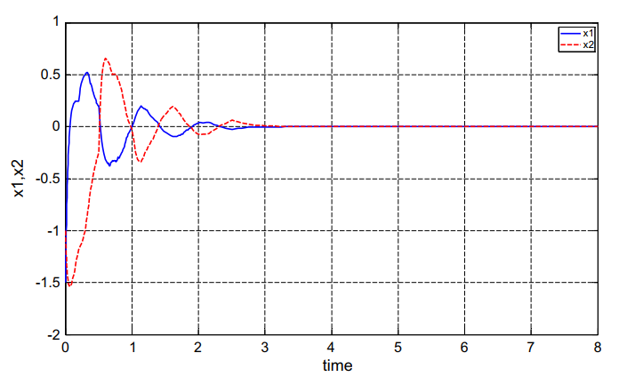

图 1闭环系统状态轨迹

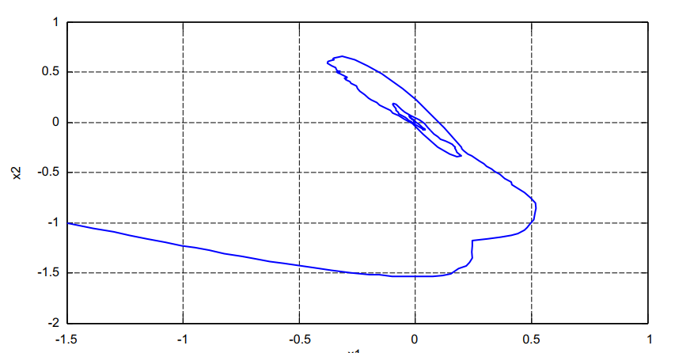

图 2闭环系统的相轨迹图

从图1和2中，可以观察到可靠控制器可以保证闭环系统的渐近稳定性和可靠性。这证明了所提方法的有效性。

## 四、总结

本文主要针对一类具有时滞切换和执行器故障的不确定切换中立系统设计鲁棒可靠控制器。提出了一种可靠的控制器设计方法，并采用驻留时间方法进行稳定性分析。以线性矩阵不等式的形式给出了此类控制器存在的充分条件。还给出了一个例子来说明所提方法的适用性。

### 参考文献

[1] S. Engell, S. Kowalewski, C. Schulz, O. Strusberg, Continuous-discrete interactions in chemical processing plants, Proceedings of the IEEE 88 (7) (2000)1050–1068.[2] R. Horowitz, P. Varaiya, Control design of an automated highway system, Proceedings of the IEEE 88 (7) (2000) 913–925.  
[3] C. Livadas, J. Lygeros, N.A. Lynch, High-level modeling and analysis of the traffic alert and collision avoidance system, Proceedings of the IEEE 88 (7)(2000) 926–948.[4] D. Pepyne, C. Cassandaras, Optimal control of hybrid systems in manufacturing, Proceedings of the IEEE 88 (7) (2000) 1008–1122.[5] M. Song, T.J. Tarn, N. Xi, Integration of task scheduling, action planning, and control in robotic manufacturing systems, Proceedings of the IEEE 88 (7)(2000) 1097–1107.[6] P.J. Antsaklis, Special issue on hybrid systems: theory and applications: A brief introduction to the theory and applications of hybrid systems,Proceedings of the IEEE 88 (7) (2000) 887–897.[7] Z. Sun, Combined stabilizing strategies for switched linear systems, IEEE Transactions on Automatic Control 51 (4) (2006) 666–674.  
[8] D. Cheng, L. Guo, Y. Lin, Y. Wang, Stabilization of switched linear systems, IEEE Transactions on Automatic Control 50 (5) (2005) 661–666.  
[9] H. Lin, P.J. Antsaklis, Stability and stabilizability of switched linear systems: a survey of recent results, IEEE Transactions on Automatic Control 54 (2)(2009) 308–322.

[10] J.P. Hespanha, D. Liberzon, D. Angeli, E.D. Sontag, Nonlinear norm-observability notions and stability of switched systems, IEEE Transactions onAutomatic Control 50 (2) (2005) 154–168.

[11] J.P. Hespanha, Uniform stability of switched linear systems: extension of LaSalle’s invariance principle, IEEE Transactions on Automatic Control 49 (4)(2004) 470–482.  
[12] R. Wang, J. Zhao, Guaranteed cost control for a class of uncertain switched delay systems: An average dwell-time method, Cybernetics and Systems 38(1) (2007) 105–122.  
[13] Q.K. Li, J. Zhao, G.M. Dimirovski, Tracking control for switched time-varying delays systems with stabilizable and unstabilizable subsystems, NonlinearAnalysis: Hybrid Systems 3 (2) (2009) 133–142.  
[14] G.S. Zhai, B. Hu, K. Yasuda, A.N. Michel, Disturbance attenuation properties of time-controlled switched systems, Journal of the Franklin Institute 338(7) (2001) 765–779.  
[15] J. Liu, X.Z. Liu, W.C. Xie, Delay-dependent robust control for uncertain switched systems with time-delay, Nonlinear Analysis: Hybrid Systems 2 (1)(2008) 81–95.  
[16] M.S. Mohamad, S. Alwan, X.Z. Liu, On stability of linear and weakly nonlinear switched systems with time delay, Mathematical and ComputerModeling 48 (7–8) (2008) 1150–1157.  
[17] P. Niamsup, Controllability approach to H1 control problem of linear time-varying switched systems, Nonlinear Analysis: Hybrid Systems 2 (3) (2008)875–886.  
[18] C.H. Lien, K.W. Yu, Non-fragile H1 control for uncertain neutral systems with time-varying delays via the LMI optimization approach, IEEE Transactionson Systems, Man, and Cybernetics, Part B 37 (2) (2007) 493–499.  
[19] O.M. Kwon, J.H. Park, S.M. Lee, Augmented Lyapunov functional approach to stability of uncertain neutral systems with time-varying delays, AppliedMathematics and Computation 207 (1) (2009) 202–212.  
[20] O.M. Kwon, J.H. Park, S.M. Lee, On delay-dependent robust stability of uncertain neutral systems with interval time-varying delays, AppliedMathematics and Computation 203 (2) (2008) 843–853.  
[21] O.M. Kwon, J.H. Park, S.M. Lee, On stability criteria for uncertain delay-differential systems of neutral type with time-varying delays, AppliedMathematics and Computation 197 (2) (2008) 864–873.  
[22] R. Wang, M. Liu, J. Zhao, Reliable H1 control for a class of switched nonlinear systems with actuator failures, Nonlinear Analysis: Hybrid Systems 1 (3)(2007) 317–325.

[23] R. Wang, G.M. Dimirovski, J. Zhao, G. P Liu, Output feedback control for uncertain linear systems with faulty actuators based on a switching method,International Journal of Robust and Nonlinear Control 19 (12) (2008) 1295–1312.  
[24] R. Wang, G. Jin, J. Zhao, Roust fault-tolerant control for a class of switched nonlinear systems in lower triangular form, Asian Journal of Control 9 (1)(2007) 68–72.  
[25] Z. Xiang, R. Wang, Robust L1 reliable control for uncertain nonlinear switched systems with time delay, Applied Mathematics and Computation 210 (1)(2009) 202–210.  
[26] M.D. Sen, J.L. Malaina, A. Gallego, J.C. Soto, Stability of non-neutral and neutral dynamic switched systems subject to internal delays, American Journalof Applied Sciences 2 (10) (2005) 1481–1490.  
[27] X.M. Sun, J. Fu, H.F. Sun, J. Zhao, Stability of linear switched neutral delay systems, Proceedings of the Chinese Society for Electrical Engineering 25 (23)(2005) 42–46.  
[28] Y. Zhang, X. Liu, H. Zhu, Stability analysis and control synthesis for a class of switched neutral systems, Applied Mathematics and Computation 190 (2)(2007) 1258–1266.  
[29] D.Y. Liu, X.Z. Liu, S.M. Zhong, Delay-dependent robust stability and control synthesis for uncertain switched neutral systems with mixed delays,Applied Mathematics and Computation 202 (2) (2008) 828–839.  
[30] S. Zhong, M. Ye, S. Wu, New stability, New stability and stabilization for switched neutral control systems, Chaos, Solitons and Fractals 42 (3) (2009)1800–1811.  
[31] G. Xie, L. Wang, Stabilization of switched linear systems with time-delay in detection of switching signal, Journal of Mathematical Analysis andApplications 305 (6) (2005) 277–290.  
[32] W. Xie, C. Wen, Z. Li, Input-to-state stabilization of switched nonlinear systems, IEEE Transactions on Automatic Control 46 (7) (2001) 1111–1116.[33] Z. Ji, X. Guo, S. Xu, L. Wang, Stabilization of switched linear systems with time-varying delay in switching occurrence detection, Circuits, Systems andSignal Processing 26 (3) (2007) 361–367.  
[34] D. Xie, X. Chen, Observer-based switched control design for switched linear systems with time-delay in detection of switching signal, IET ControlTheory and Applications 2 (5) (2008) 437–445.  
[35] Z.R. Xiang, R.H. Wang, Robust control for uncertain switched non-linear systems with time delay under asynchronous switching, IET Control Theoryand Applications 3 (8) (2009) 1041–1050.  
[36] Z.R. Xiang, R.H. Wang, Robust stabilization of switched non-linear systems with time-varying delays under asynchronous switching, Proc IMechE, PartI: Journal of Systems and Control Engineering 223 (8) (2009) 1111–1128.  
[37] X.M. Sun, J. Zhao, D.J. Hill, Stability and L2-gain analysis for switched delay systems: a delay-dependent method, Automatica 42 (10) (2006) 1769–1774.[38] D. Liberzon, Switching in Systems and Control, Birkhauser, Boston, 2003.  
[39] I.R. Petersen, A stabilization algorithm for a class of uncertain linear systems, Systems and Control Letters 8 (4) (1987) 351–357.  
[40] L. Xie, Output feedback H1 control of systems with parameter uncertainty, International Journal of Control 63 (4) (1996) 741–750.