Name: Ysmael Joss B. Bumolyad Course: BSIT3D

Compilation of Laboratory Activity
Second Sem 2024-2025

Screenshots
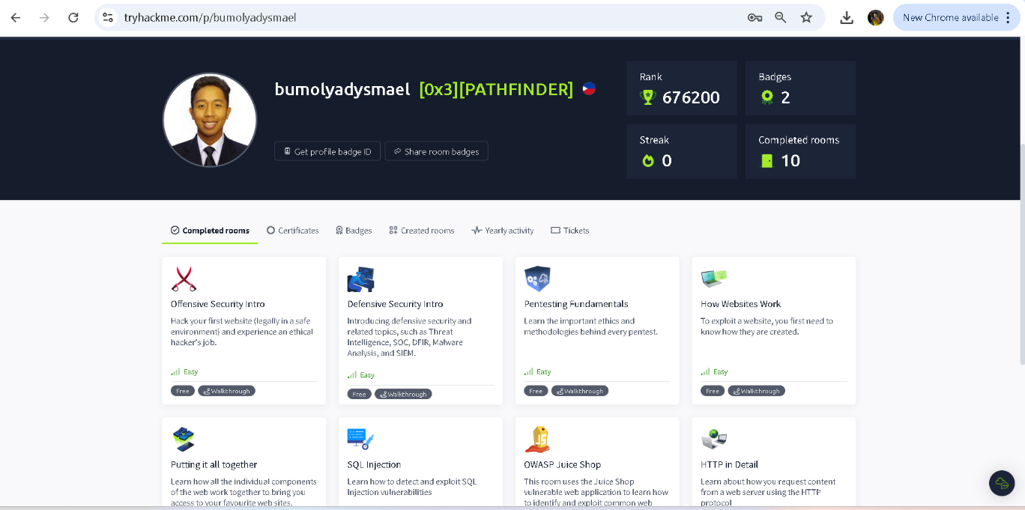
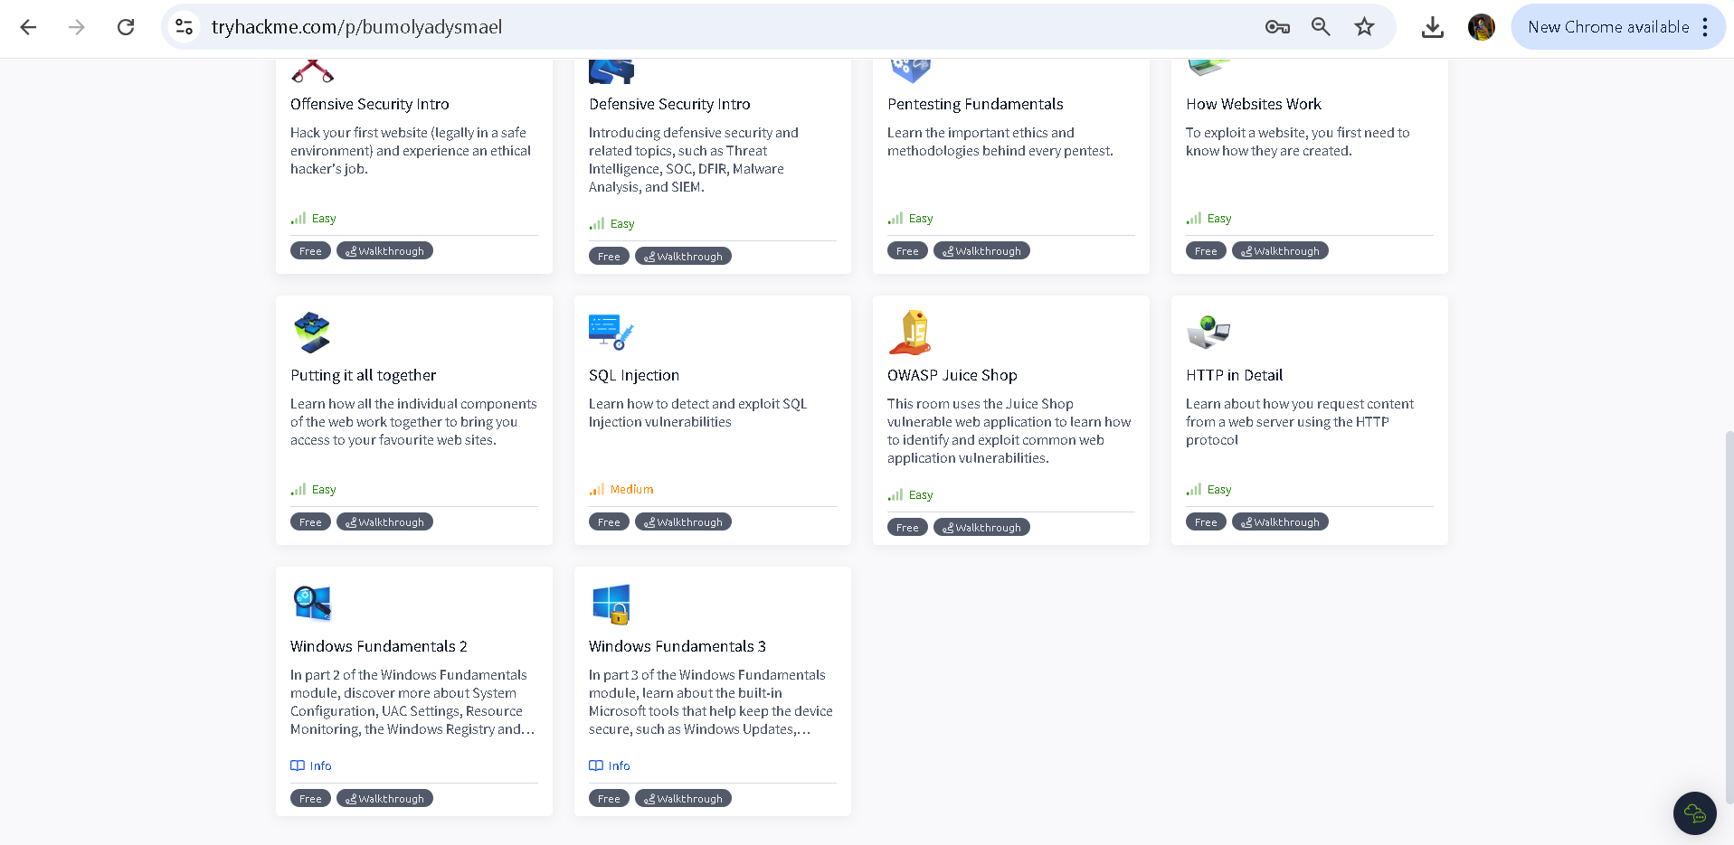

Questions:

- As a student, how can you ensure the security of your data on social media platforms?
- To ensure the security of my data on social media I must implement two factor authentication and be careful of random links sent to me.
- In the course Information Assurance and Security 1, what did you learn?
- In the course Information Assurance and Security 1, I learned about protecting information systems, fundamental of information security, the threats and vulnerabilities, and security policies and controls.

