1. 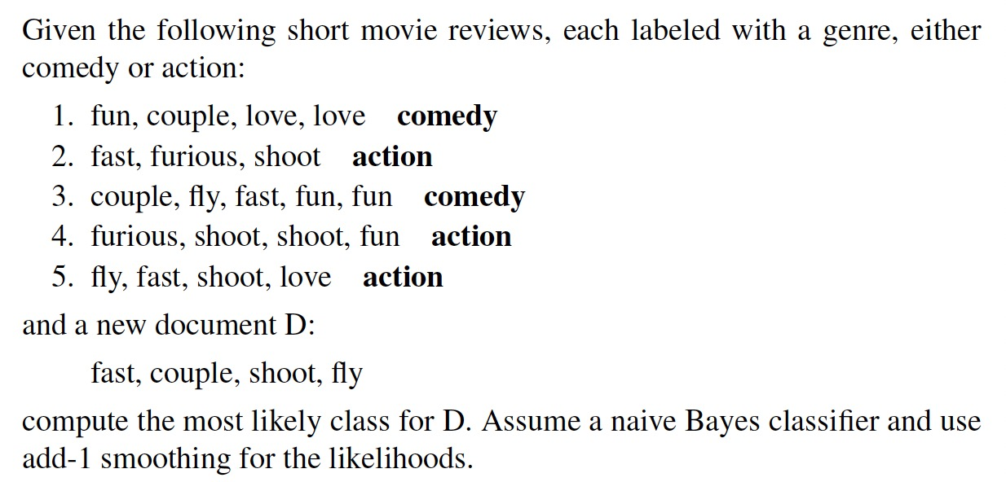

2 The words “**car, auto, best**” should have the following frequencies in the ten documents “Doc1, .., Doc10”. Simply assume that all other words in the documents are stop words. Please, compute the tf-idf weight for each term.

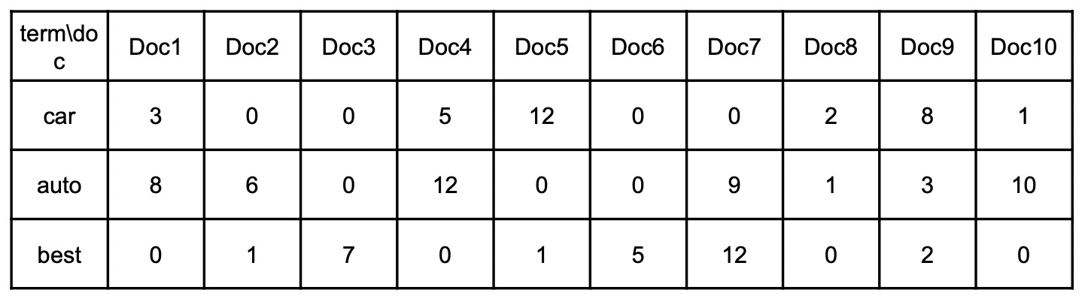

3. 给出损失函数*LCE*，请给出得到梯度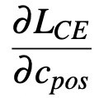、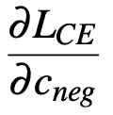、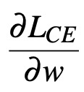的推到过程。