**Problem 1**

1. These is generally less requests in winter (Dec, Jan), but more requests during good weather months (Aug, Sep) for all types of requests
2. People tend to report more Pot Holes then other types of request in Feb
3. Most of the request (for all types) come from Community Area No.24 (West Town)
4. Graffiti Removal is the most common type of request (account for 59%) among the listed requests.
5. Government response most quickly to Graffiti Removal on average, and most slowly to Pot Hole in Street on average

**Problem 2:**

I really lack time to finish this. And I would probe into API more in the future.

**Problem 3:**

1. 7500 S Wolcott Ave is in community 71 (Auburn Gresham). Of the four types of requests you have data for, pot hole in street is the most likely given the call came from 7500 S Wolcott. See the following for the probabilities for each type of request.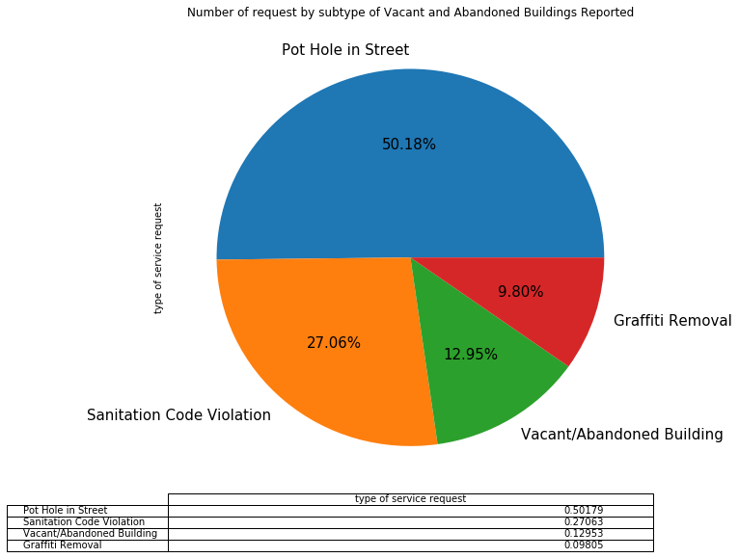
2. Based on the graph shown in question 1, Lawndale is in community 29, Uptown is in community 3. Lawndale is (0.0437+0.00348=0.04781), uptown is 0.01547

(both of the probability is based on total number of request on all types). Thus, Lawndale is 0.04781/0.01547 = 3 times more likely to have Graffiti Removal then uptown.

1. P(from E) = 160/(160+100) = 61.5%

P(from U) = 100/(160+100) = 38.5%

🡪 23% more likely that the call came from Englewood.