ASMedia端口共计**4**个，分别为Port1-4，在主板上的位置为

* 1. **USB端口**：USB2.0 ==> Port4 ==> **HS02**; USB3.0 ==> Port2 ==> **SS02**; 端口数+2
  2. **USB端口**：USB2.0 ==> Port3 ==> **HS03**; USB3.0 ==> Port1 ==> **SS01**; 端口数+2

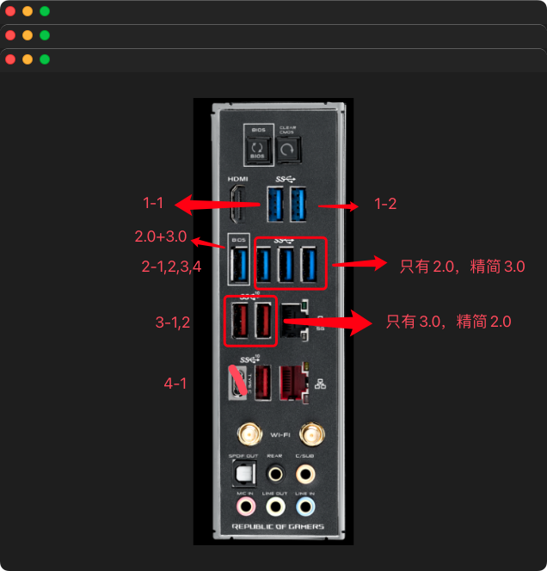

Intel端口总数=1+1+1+2+1+1+1+2+1+1+2+1=15个

未知口：USB2.0 ==> Port2==> **HS01（保留）**端口数+1;

3-2 **USB端口**：USB2.0 ==> Port3 ==> **HS02（删）**; USB3.0 ==> Port19 ==> **SS02**; 端口数+1

3-1 **USB端口**：USB2.0 ==> Port4 ==> **HS03（删）**; USB3.0 ==> Port20 ==> **SS03**; 端口数+1

4-1 **USB端口**：USB2.0 ==> Port5 ==> **HS04**; USB3.0 ==> Port21 ==> **SS04**; 端口数+2

2-4 **USB端口**：USB2.0 ==> Port7 ==> **HS05**; USB3.0 ==> Port23 ==> **SS05（删）**; 端口数+1

2-3 **USB端口**：USB2.0 ==> Port8 ==> **HS06**; USB3.0 ==> Port24 ==> **SS06（删）**; 端口数+1

2-2 **USB端口**：USB2.0 ==> Port9 ==> **HS07**; USB3.0 ==> Port25 ==> **SS07（删）**; 端口数+1

2-1 **USB端口**：USB2.0 ==> Port10 0A==> **HS08**; USB3.0 ==> Port26 1A==> **SS08**; 端口数+2

前面板 usb2.0 ==> Port11 0B ==> **HS09**端口数+1

前面板 usb2.0 ==> Port12 0C ==> **HS10**端口数+1

未知口：USB2.0 ==> Port13 0D==> **HS11**; USB3.0 ==> Port18 ==> **SS01**; 端口数+2

**intel蓝牙独占端口： Port14 0E** ==> **HS12** 端口数+1

