**lab 7**

57118110 杨紫瑄

**实验手册上的lab1:**

将密文编写在文件ciphertext.txt中

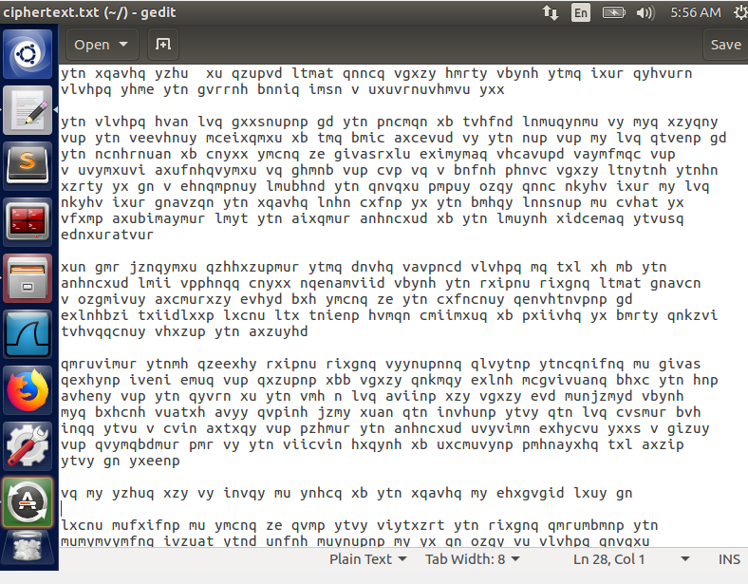

将密文复制到网站<http://www.richkni.co.uk/php/crypta/freq.php>中并统计文本个数

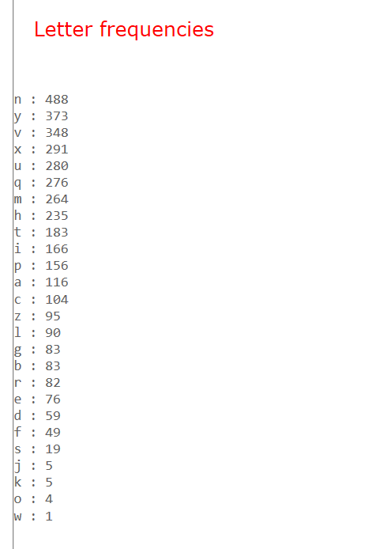

再对应标准英文字母概率表一一对应替换：

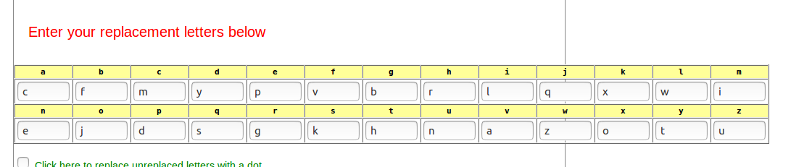

替换后得到明文：

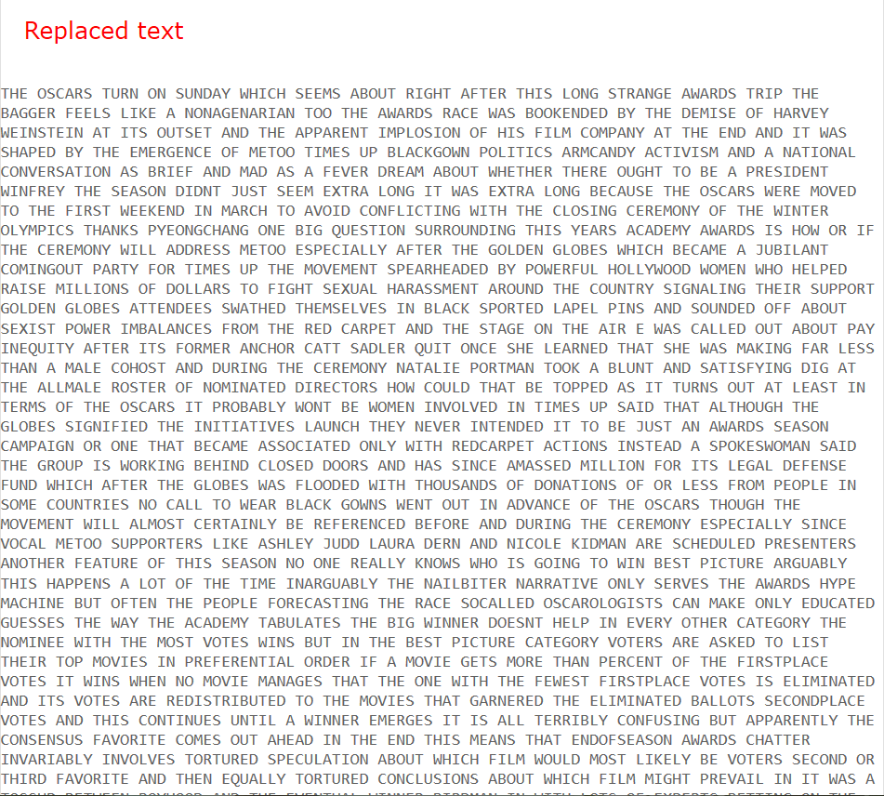

THE OSCARS TURN ON SUNDAY WHICH SEEMS ABOUT RIGHT AFTER THIS LONG STRANGE AWARDS TRIP THE BAGGER FEELS LIKE A NONAGENARIAN TOO THE AWARDS RACE WAS BOOKENDED BY THE DEMISE OF HARVEY WEINSTEIN AT ITS OUTSET AND THE APPARENT IMPLOSION OF HIS FILM COMPANY AT THE END AND IT WAS SHAPED BY THE EMERGENCE OF METOO TIMES UP BLACKGOWN POLITICS ARMCANDY ACTIVISM AND A NATIONAL CONVERSATION AS BRIEF AND MAD AS A FEVER DREAM ABOUT WHETHER THERE OUGHT TO BE A PRESIDENT WINFREY THE SEASON DIDNT JUST SEEM EXTRA LONG IT WAS EXTRA LONG BECAUSE THE OSCARS WERE MOVED TO THE FIRST WEEKEND IN MARCH TO AVOID CONFLICTING WITH THE CLOSING CEREMONY OF THE WINTER OLYMPICS THANKS PYEONGCHANG ONE BIG QUESTION SURROUNDING THIS YEARS ACADEMY AWARDS IS HOW OR IF THE CEREMONY WILL ADDRESS METOO ESPECIALLY AFTER THE GOLDEN GLOBES WHICH BECAME A JUBILANT COMINGOUT PARTY FOR TIMES UP THE MOVEMENT SPEARHEADED BY POWERFUL HOLLYWOOD WOMEN WHO HELPED RAISE MILLIONS OF DOLLARS TO FIGHT SEXUAL HARASSMENT AROUND THE COUNTRY SIGNALING THEIR SUPPORT GOLDEN GLOBES ATTENDEES SWATHED THEMSELVES IN BLACK SPORTED LAPEL PINS AND SOUNDED OFF ABOUT SEXIST POWER IMBALANCES FROM THE RED CARPET AND THE STAGE ON THE AIR E WAS CALLED OUT ABOUT PAY INEQUITY AFTER ITS FORMER ANCHOR CATT SADLER QUIT ONCE SHE LEARNED THAT SHE WAS MAKING FAR LESS THAN A MALE COHOST AND DURING THE CEREMONY NATALIE PORTMAN TOOK A BLUNT AND SATISFYING DIG AT THE ALLMALE ROSTER OF NOMINATED DIRECTORS HOW COULD THAT BE TOPPED AS IT TURNS OUT AT LEAST IN TERMS OF THE OSCARS IT PROBABLY WONT BE WOMEN INVOLVED IN TIMES UP SAID THAT ALTHOUGH THE GLOBES SIGNIFIED THE INITIATIVES LAUNCH THEY NEVER INTENDED IT TO BE JUST AN AWARDS SEASON CAMPAIGN OR ONE THAT BECAME ASSOCIATED ONLY WITH REDCARPET ACTIONS INSTEAD A SPOKESWOMAN SAID THE GROUP IS WORKING BEHIND CLOSED DOORS AND HAS SINCE AMASSED MILLION FOR ITS LEGAL DEFENSE FUND WHICH AFTER THE GLOBES WAS FLOODED WITH THOUSANDS OF DONATIONS OF OR LESS FROM PEOPLE IN SOME COUNTRIES NO CALL TO WEAR BLACK GOWNS WENT OUT IN ADVANCE OF THE OSCARS THOUGH THE MOVEMENT WILL ALMOST CERTAINLY BE REFERENCED BEFORE AND DURING THE CEREMONY ESPECIALLY SINCE VOCAL METOO SUPPORTERS LIKE ASHLEY JUDD LAURA DERN AND NICOLE KIDMAN ARE SCHEDULED PRESENTERS ANOTHER FEATURE OF THIS SEASON NO ONE REALLY KNOWS WHO IS GOING TO WIN BEST PICTURE ARGUABLY THIS HAPPENS A LOT OF THE TIME INARGUABLY THE NAILBITER NARRATIVE ONLY SERVES THE AWARDS HYPE MACHINE BUT OFTEN THE PEOPLE FORECASTING THE RACE SOCALLED OSCAROLOGISTS CAN MAKE ONLY EDUCATED GUESSES THE WAY THE ACADEMY TABULATES THE BIG WINNER DOESNT HELP IN EVERY OTHER CATEGORY THE NOMINEE WITH THE MOST VOTES WINS BUT IN THE BEST PICTURE CATEGORY VOTERS ARE ASKED TO LIST THEIR TOP MOVIES IN PREFERENTIAL ORDER IF A MOVIE GETS MORE THAN PERCENT OF THE FIRSTPLACE VOTES IT WINS WHEN NO MOVIE MANAGES THAT THE ONE WITH THE FEWEST FIRSTPLACE VOTES IS ELIMINATED AND ITS VOTES ARE REDISTRIBUTED TO THE MOVIES THAT GARNERED THE ELIMINATED BALLOTS SECONDPLACE VOTES AND THIS CONTINUES UNTIL A WINNER EMERGES IT IS ALL TERRIBLY CONFUSING BUT APPARENTLY THE CONSENSUS FAVORITE COMES OUT AHEAD IN THE END THIS MEANS THAT ENDOFSEASON AWARDS CHATTER INVARIABLY INVOLVES TORTURED SPECULATION ABOUT WHICH FILM WOULD MOST LIKELY BE VOTERS SECOND OR THIRD FAVORITE AND THEN EQUALLY TORTURED CONCLUSIONS ABOUT WHICH FILM MIGHT PREVAIL IN IT WAS A TOSSUP BETWEEN BOYHOOD AND THE EVENTUAL WINNER BIRDMAN IN WITH LOTS OF EXPERTS BETTING ON THE REVENANT OR THE BIG SHORT THE PRIZE WENT TO SPOTLIGHT LAST YEAR NEARLY ALL THE FORECASTERS DECLARED LA LA LAND THE PRESUMPTIVE WINNER AND FOR TWO AND A HALF MINUTES THEY WERE CORRECT BEFORE AN ENVELOPE SNAFU WAS REVEALED AND THE RIGHTFUL WINNER MOONLIGHT WAS CROWNED THIS YEAR AWARDS WATCHERS ARE UNEQUALLY DIVIDED BETWEEN THREE BILLBOARDS OUTSIDE EBBING MISSOURI THE FAVORITE AND THE SHAPE OF WATER WHICH IS THE BAGGERS PREDICTION WITH A FEW FORECASTING A HAIL MARY WIN FOR GET OUT BUT ALL OF THOSE FILMS HAVE HISTORICAL OSCARVOTING PATTERNS AGAINST THEM THE SHAPE OF WATER HAS NOMINATIONS MORE THAN ANY OTHER FILM AND WAS ALSO NAMED THE YEARS BEST BY THE PRODUCERS AND DIRECTORS GUILDS YET IT WAS NOT NOMINATED FOR A SCREEN ACTORS GUILD AWARD FOR BEST ENSEMBLE AND NO FILM HAS WON BEST PICTURE WITHOUT PREVIOUSLY LANDING AT LEAST THE ACTORS NOMINATION SINCE BRAVEHEART IN THIS YEAR THE BEST ENSEMBLE SAG ENDED UP GOING TO THREE BILLBOARDS WHICH IS SIGNIFICANT BECAUSE ACTORS MAKE UP THE ACADEMYS LARGEST BRANCH THAT FILM WHILE DIVISIVE ALSO WON THE BEST DRAMA GOLDEN GLOBE AND THE BAFTA BUT ITS FILMMAKER MARTIN MCDONAGH WAS NOT NOMINATED FOR BEST DIRECTOR AND APART FROM ARGO MOVIES THAT LAND BEST PICTURE WITHOUT ALSO EARNING BEST DIRECTOR NOMINATIONS ARE FEW AND FAR BETWEEN

将明文编译到文件code.txt中后输入命令

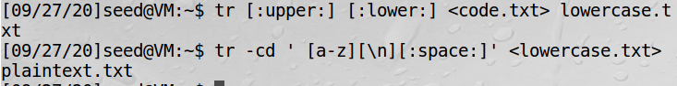

打开文件plaintext.txt 发现明文如下：

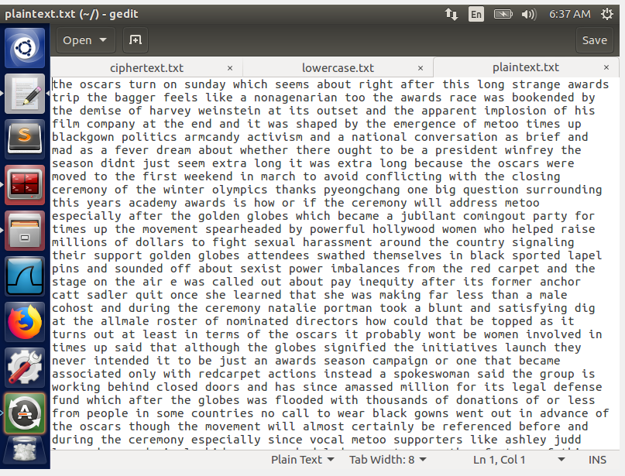

the oscars turn on sunday which seems about right after this long strange awards trip the bagger feels like a nonagenarian too the awards race was bookended by the demise of harvey weinstein at its outset and the apparent implosion of his film company at the end and it was shaped by the emergence of metoo times up blackgown politics armcandy activism and a national conversation as brief and mad as a fever dream about whether there ought to be a president winfrey the season didnt just seem extra long it was extra long because the oscars were moved to the first weekend in march to avoid conflicting with the closing ceremony of the winter olympics thanks pyeongchang one big question surrounding this years academy awards is how or if the ceremony will address metoo especially after the golden globes which became a jubilant comingout party for times up the movement spearheaded by powerful hollywood women who helped raise millions of dollars to fight sexual harassment around the country signaling their support golden globes attendees swathed themselves in black sported lapel pins and sounded off about sexist power imbalances from the red carpet and the stage on the air e was called out about pay inequity after its former anchor catt sadler quit once she learned that she was making far less than a male cohost and during the ceremony natalie portman took a blunt and satisfying dig at the allmale roster of nominated directors how could that be topped as it turns out at least in terms of the oscars it probably wont be women involved in times up said that although the globes signified the initiatives launch they never intended it to be just an awards season campaign or one that became associated only with redcarpet actions instead a spokeswoman said the group is working behind closed doors and has since amassed million for its legal defense fund which after the globes was flooded with thousands of donations of or less from people in some countries no call to wear black gowns went out in advance of the oscars though the movement will almost certainly be referenced before and during the ceremony especially since vocal metoo supporters like ashley judd laura dern and nicole kidman are scheduled presenters another feature of this season no one really knows who is going to win best picture arguably this happens a lot of the time inarguably the nailbiter narrative only serves the awards hype machine but often the people forecasting the race socalled oscarologists can make only educated guesses the way the academy tabulates the big winner doesnt help in every other category the nominee with the most votes wins but in the best picture category voters are asked to list their top movies in preferential order if a movie gets more than percent of the firstplace votes it wins when no movie manages that the one with the fewest firstplace votes is eliminated and its votes are redistributed to the movies that garnered the eliminated ballots secondplace votes and this continues until a winner emerges it is all terribly confusing but apparently the consensus favorite comes out ahead in the end this means that endofseason awards chatter invariably involves tortured speculation about which film would most likely be voters second or third favorite and then equally tortured conclusions about which film might prevail in it was a tossup between boyhood and the eventual winner birdman in with lots of experts betting on the revenant or the big short the prize went to spotlight last year nearly all the forecasters declared la la land the presumptive winner and for two and a half minutes they were correct before an envelope snafu was revealed and the rightful winner moonlight was crowned this year awards watchers are unequally divided between three billboards outside ebbing missouri the favorite and the shape of water which is the baggers prediction with a few forecasting a hail mary win for get out but all of those films have historical oscarvoting patterns against them the shape of water has nominations more than any other film and was also named the years best by the producers and directors guilds yet it was not nominated for a screen actors guild award for best ensemble and no film has won best picture without previously landing at least the actors nomination since braveheart in this year the best ensemble sag ended up going to three billboards which is significant because actors make up the academys largest branch that film while divisive also won the best drama golden globe and the bafta but its filmmaker martin mcdonagh was not nominated for best director and apart from argo movies that land best picture without also earning best director nominations are few and far between

**Word实验：**

1. 破解维吉尼亚密码

def findindexkey(subarr):  
    visiable_chars=[]  
    for x in range(32,126):  
        visiable_chars.append(chr(x))  
    #print(vi)  
    test_keys=[]  
    ans_keys=[]  
    for x in range(0x00,0xFF):  
        test_keys.append(x)  
        ans_keys.append(x)  
    for i in test_keys:   
        for s in subarr:  
            if chr(s^i) not in visiable_chars:  
                ans_keys.remove(i)  
                break  
    #print(ans_keys)  
    return ans_keys  
strmi=&apos;F96DE8C227A259C87EE1DA2AED57C93FE5DA36ED4EC87EF2C63AAE5B9A7EFF\  
D673BE4ACF7BE8923CAB1ECE7AF2DA3DA44FCF7AE29235A24C963FF0DF3CA3\  
599A70E5DA36BF1ECE77F8DC34BE129A6CF4D126BF5B9A7CFEDF3EB850D37CF\  
0C63AA2509A76FF9227A55B9A6FE3D720A850D97AB1DD35ED5FCE6BF0D138A\  
84CC931B1F121B44ECE70F6C032BD56C33FF9D320ED5CDF7AFF9226BE5BDE3F\  
F7DD21ED56CF71F5C036A94D963FF8D473A351CE3FE5DA3CB84DDB71F5C17F\  
ED51DC3FE8D732BF4D963FF3C727ED4AC87EF5DB27A451D47EFD9230BF47CA\  
6BFEC12ABE4ADF72E29224A84CDF3FF5D720A459D47AF59232A35A9A7AE7D3\  
3FB85FCE7AF5923AA31EDB3FF7D33ABF52C33FF0D673A551D93FFCD33DA35B\  
C831B1F43CBF1EDF67F0DF23A15B963FE5DA36ED68D378F4DC36BF5B9A7AFF\  
D121B44ECE76FEDC73BE5DD27AFCD773BA5FC93FE5DA3CB859D26BB1C63CE\  
D5CDF3FE2D730B84CDF3FF7DD21ED5ADF7CF0D636BE1EDB79E5D721ED57CE\  
3FE6D320ED57D469F4DC27A85A963FF3C727ED49DF3FFFDD24ED55D470E69E\  
73AC50DE3FE5DA3ABE1EDF67F4C030A44DDF3FF5D73EA250C96BE3D327A84D\  
963FE5DA32B91ED36BB1D132A31ED87AB1D021A255DF71B1C436BF479A7AF0\  
C13AA14794&apos;  
arr=[]  
for x in range(0,len(strmi),2):  
    arr.append(int(strmi[x:2+x],16))  
for keylen in range(1,14):  
    for index in range(0,keylen):  
        subarr=arr[index::keylen]  
        ans_keys=findindexkey(subarr)  
        print(&apos;keylen=&apos;,keylen,&apos;index=&apos;,index,&apos;keys=&apos;,ans_keys)  
        if ans_keys:  
            ch=[]  
            for x in ans_keys:  
                ch.append(chr(x^subarr[0]))  
            print(ch)  
print(&apos;###############&apos;)  
import string  
def findindexkey2(subarr):  
    test_chars=string.ascii_letters+string.digits+&apos;,&apos;+&apos;.&apos;+&apos; &apos;  
    #print(test_chars)  
    test_keys=[]  
    ans_keys=[]  
    for x in range(0x00,0xFF):  
        test_keys.append(x)  
        ans_keys.append(x)  
    for i in test_keys:  
        for s in subarr:  
            if chr(s^i) not in test_chars:  
                ans_keys.remove(i)  
                break  
    return ans_keys  
vigenerekeys=[]  
for index in range(0,7):  
    subarr=arr[index::7]  
    vigenerekeys.append(findindexkey2(subarr))  
print(vigenerekeys)  
print("#########")  
ming=&apos;&apos;  
for i in range(0,len(arr)):  
    ming=ming+chr(arr[i]^vigenerekeys[i%7][0])  
print(ming)

运行结果如下：

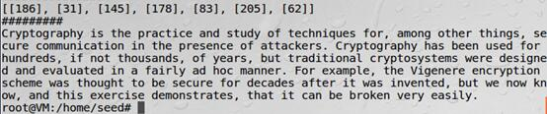

2. 以下密文使用了重复的一次一密密码，请通过异或运算和ASCII码的计算规律破解原始消息

import binascii  
import argparse  
  
SPACE = ord(' ')  
  
  
def countalphas(char, position, ciphertexts):  
 count = 0  
 for ciphertext in ciphertexts:  
 if len(ciphertext) > position:  
 if chr(ciphertext[position] ^ char).isalpha(): count += 1  
 return count  
  
  
def main():  
 parser = argparse.ArgumentParser(description="Many-time Pad Cracker")  
 parser.add_argument("--filename", type=str,  
 help="Name of the file containing the ciphertexts (default: ciphertexts.txt)",  
 default="ciphertexts.txt")  
 args = parser.parse_args()  
 try:  
 with open(args.filename) as f:  
 ciphertexts = [binascii.unhexlify(line.rstrip()) for line in f]  
 # Cyphertexts puliti (tolgo i vuoti), anche se non è necessario  
 # ciphertexts = [c for c in ciphertexts if c]  
 cleartexts = [bytearray(b'?' * len(c)) for c in ciphertexts]  
 except Exception as e:  
 print("Cannot crack {} --- {}".format(args.filename, e))  
 raise SystemExit(-1)  
  
 # 'a'.isalpha() => true  
 # '!'.isalpha() => false  
 # ord('z') => 122  
  
  
 for col in range(max([len(x) for x in ciphertexts])):  
 for c1 in ciphertexts:  
 for c2 in ciphertexts:  
 if (len(c1) > col) and (len(c2) > col):  
 if chr(c1[col] ^ c2[col]).isalpha():  
 for k, c in enumerate(ciphertexts):  
 if len(c) > col:  
 if countalphas(c1[col], col, ciphertexts) >= countalphas(c2[col], col, ciphertexts):  
 cleartexts[k][col] = c1[col] ^ 0b100000 ^ c[col]  
 else:  
 cleartexts[k][col] = c2[col] ^ 0b100000 ^ c[col]  
  
 break  
  
 for line in cleartexts:  
 print(line)  
  
  
if __name__ == "__main__":  
 main()

并将密文保存到ciphertexts.txt文件中

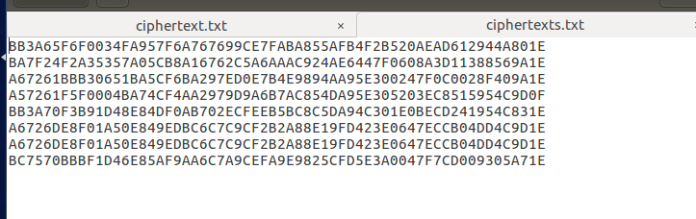

补全缺失的字母后得到明文：

I am planning a secret mission.

He is the only person to trust.

The current plan is top secret.

When should we meet to do this?

I think they should follow him.

This is purer than that one is.

Not one cadet is better than I.

实验总结：本次实验主要是围绕加密解密展开的，通过此次试验我对密码学方面的知识有了更深刻的了解。此次的实验手册LAB1进行的较为顺利，但是word文档中的两个题稍有些艰难，但是在询问过同学之后最终解决了。