实验报告
2016 年 5 月 20 日 成绩：
姓名 | 王应南  熊陈鋆  杨彦朋 | 学号 | 14051131  14051133  14051135 | 班级 | 14052411
专业 | 网络工程 |  | 课程名称 | 《计算机组成原理课程设计》
任课老师 | 赵备 | 指导老师 | 赵备 | 机位号
实验序号 | 实验八 | 实验名称 | 实现R型指令的CPU设计实验
实验时间 |  | 实验地点 | 一教235 | 实验设备号
一、实验程序源代码
module TopTest(
input rst,
input btn,
input clk_100MHz,
input [2:0] SW,
output reg [7:0] LED
);

wire ZF, OF;
wire [31:0] ALU_F;

BTN_OK btn_ok(clk_100MHz, btn, clk);
CPU cpu(rst, clk, ZF, OF, ALU_F);

always@(*)
begin
case(SW)
3'b000: LED = ALU_F[7:0];
3'b001: LED = ALU_F[15:8];
3'b010: LED = ALU_F[23:16];
3'b011: LED = ALU_F[31:24];
default: begin LED[7] = ZF; LED[0] = OF; LED[6:1] = 6'b0; end
endcase
end

endmodule

/////////////////////////////////////////////////////
module BTN_OK(
input clk_100MHz,
input BTN,
output reg BTN_Out
);
reg BTN1, BTN2;
wire BTN_Down;
reg [21:0] cnt;
reg BTN_20ms_1, BTN_20ms_2;
wire BTN_Up;

always@(posedge clk_100MHz)
begin
BTN1 <= BTN;
BTN2 <= BTN1;
end

assign BTN_Down = (~BTN2) && BTN1;
always@(posedge clk_100MHz)
begin
if(BTN_Down)
begin
cnt <= 22'b0;
BTN_Out <= 1'b1;
end
else
cnt <= cnt + 1'b1;
if(cnt == 22'h20000)
BTN_20ms_1 <= BTN;
BTN_20ms_2 <= BTN_20ms_1;
if(BTN_Up)
BTN_Out <= 1'b0;
end

assign BTN_Up = BTN_20ms_2 && (~BTN_20ms_1);

endmodule

//////////////////////////////////////////////////////////////////////////////////
module CPU(
input rst,
input clk,
output ZF,
output OF,
output [31:0] ALU_F
);

reg [31:0] PC, PC_New;
reg [2:0] ALU_OP; //cao zuo shu
reg Write_Reg;

wire [31:0] Inst_code;
wire [31:0] R_Data_A, R_Data_B;
wire [5:0] OP, func;
wire [4:0] rd, rs, rt, shamt;

assign OP = Inst_code[31:26];
assign rs = Inst_code[25:21];
assign rt = Inst_code[20:16];
assign rd = Inst_code[15:11];
assign shamt = Inst_code[10:6];
assign func = Inst_code[5:0];

Ins_ROM ins_rom (
.clka(clk), // input clka
.addra(PC[7:2]), // input [5 : 0] addra
.douta(Inst_code) // output [31 : 0] douta
);

Register register(rs, rt, rd, ALU_F, Write_Reg, ~clk, rst, R_Data_A, R_Data_B);//

ALU alu(ALU_OP, R_Data_A, R_Data_B, ZF, OF, ALU_F);

always@(negedge clk or posedge rst)
begin
if(rst)
PC = 32'h0;
else
PC = PC_New;
end

always@(*)
begin
if(clk)
begin
PC_New = PC + 32'h4;
if(OP == 6'b0)
begin
case(func)
6'b100000: ALU_OP = 3'b100;
6'b100010: ALU_OP = 3'b101;
6'b100100: ALU_OP = 3'b000;
6'b100101: ALU_OP = 3'b001;
6'b100110: ALU_OP = 3'b010;
6'b100111: ALU_OP = 3'b011;
6'b101011: ALU_OP = 3'b110;
6'b000100: ALU_OP = 3'b111;
default: ALU_OP = 3'b000;
endcase
Write_Reg = 1;
end
else
Write_Reg = 0; //write
end
end

endmodule
//////////////////////////////////////////////////////////////////////////////////
module Register(
input [4:0] R_Addr_A,
input [4:0] R_Addr_B,
input [4:0] W_Addr,
input [31:0] W_Data,
input Write_Reg,
input Clk,
input Reset,
output [31:0] R_Data_A,
output [31:0] R_Data_B
);

reg[31:0] REG_Files[0:31];//32 register
reg[5:0] i;

assign R_Data_A = REG_Files[R_Addr_A];
assign R_Data_B = REG_Files[R_Addr_B];

always@(posedge Clk or posedge Reset)
begin
if(Reset)
begin
i = 0;
while(i <= 31)
begin
REG_Files[i] = 32'b0;
i = i + 1;
end
end
else
begin
if(Write_Reg)
REG_Files[W_Addr] = W_Data;//
end
end

endmodule
//////////////////////////////////////////////////////////////////////////////////
module ALU(
input [2:0] ALU_OP,
input [31:0] A,
input [31:0] B,
output reg ZF,
output reg OF,
output reg [31:0] F
);
reg C32;
always@(*)
begin
OF = 1'b0;
C32 = 1'b0;
case(ALU_OP)
3'b000: F = A & B;
3'b001: F = A | B;
3'b010: F = A ^ B;
3'b011: F = ~(A | B);
3'b100: begin {C32, F} = A + B; OF = A[31] ^ B[31] ^ F[31] ^ C32; end
3'b101: begin {C32, F} = A - B; OF = A[31] ^ B[31] ^ F[31] ^ C32; end
3'b110: F = A < B ? 1 : 0;
3'b111: F = B << A;
endcase
ZF = ~(|F);
end
endmodule

二、仿真波形
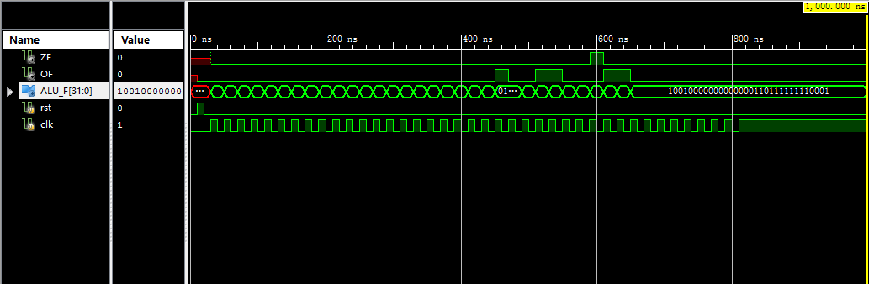
三、电路图
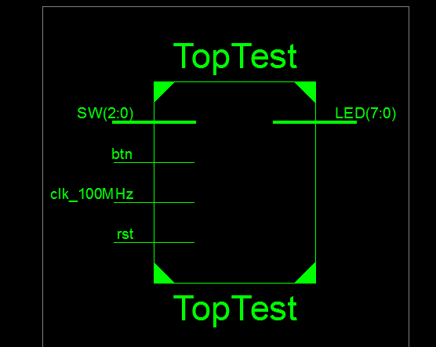
四、引脚配置（约束文件）
NET "LED[7]" LOC = T11;
NET "LED[6]" LOC = R11;
NET "LED[5]" LOC = N11;
NET "LED[4]" LOC = M11;
NET "LED[3]" LOC = V15;
NET "LED[2]" LOC = U15;
NET "LED[1]" LOC = V16;
NET "LED[0]" LOC = U16;
NET "SW[2]" LOC = V9;
NET "SW[1]" LOC = T9;
NET "SW[0]" LOC = T10;
NET "rst" LOC = D9;
NET "clk_100MHz" LOC = V10;
NET "btn" LOC = C9;

五、思考与探索
序号 | 指令 | 结果 | ZF | OF | 结论
1 | 00000827 | FFFF_FFFF | 0 | 0 | 对
2 | 0001102b | 0000_0001 | 0 | 0 | 对
3 | 00421820 | 0000_0002 | 0 | 0 | 对
4 | 00622020 | 0000_0003 | 0 | 0 | 对
5 | 00832820 | 0000_0005 | 0 | 0 | 对
6 | 00a33020 | 0000_0007 | 0 | 0 | 对
7 | ,00463804 | 0000_000E | 0 | 0 | 对
8 | 00a64820 | 0000_000C | 0 | 0 | 对
9 | 01264004 | 0000_7000 | 0 | 0 | 对
10 | 00284826 | FFFF_8FFF | 0 | 0 | 对
11 | 01215020 | FFFF_8FFE | 0 | 0 | 对
12 | 01075822 | 0000_6FF2 | 0 | 0 | 对
13 | 00e86022 | FFFF_900E | 0 | 0 | 对
14 | 012c6824 | FFFF_800E | 0 | 0 | 对
15 | 012c7025 | FFFF_9FFF | 0 | 0 | 对
16 | 00c77825 | 0000_000F | 0 | 0 | 对

