# Synchronization Tool Usage

## Way 1:

1. Click [Select Board] Button

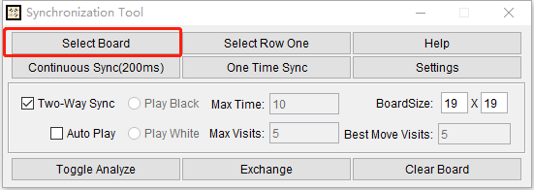

1. Select the whole board region(a little more is fine)

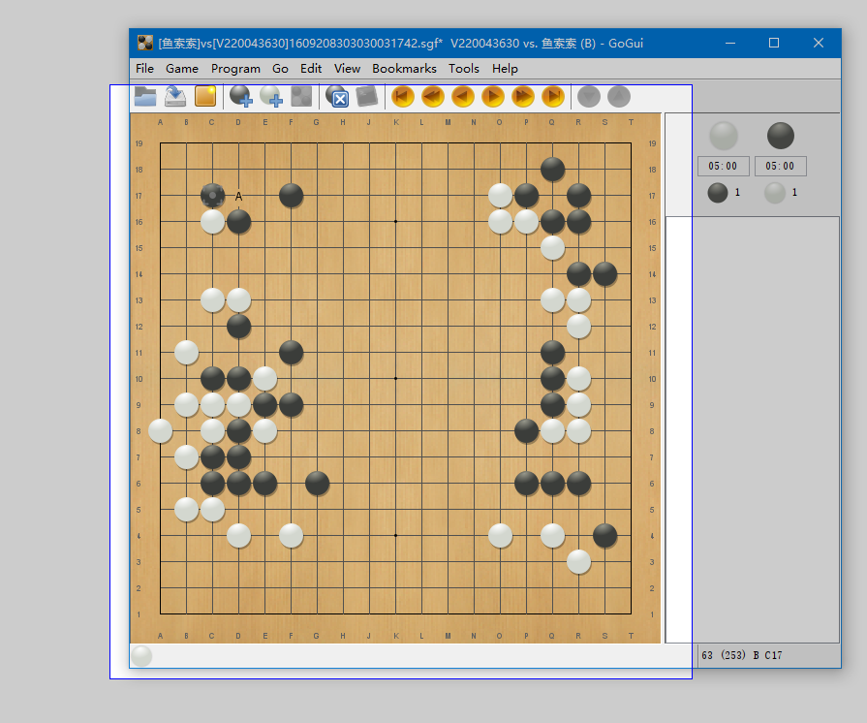

1. Click [Continuous Sync]/[One Time Sync] button

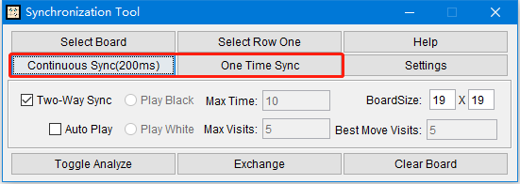

## Way2(Use it only if way 1 does not work)

1. Click [Select Row One] Button

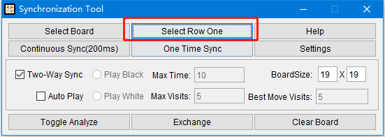

1. Select Row One accurately

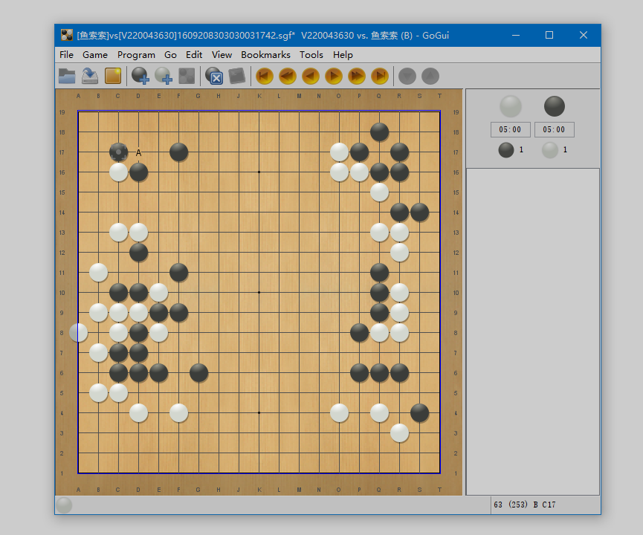

3. Click [Continuous Sync]/[One Time Sync] button



## Other

1. Two-Way Sync and Auto Play: If selected ‘Two-Way Sync’, Synchronization Tool will place stone on the selected board when a stone placed in ‘LizzieYzy’,if ‘Auto Play’ is selected,’LizzieYzy’ will automatically place stones on the condition of Max Time/Max Visits/Best Move Visits.
2. KataGo Rules Settings: Because of lack of move history,captures will be incorrectly,So we can only use area scoring.You can set area scoring+7.0komi+hasbutton to simulate Japanese rule.
3. Require the original board can not be moved or resized or coverd during Synchronization.