Practice Questions for DFA’s along with solutions
Instructor: Asma Sanam Larik
Q1.
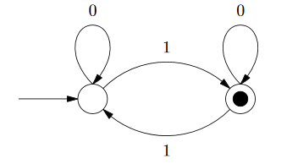
Q2.
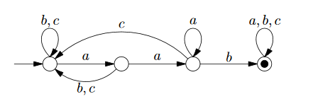
Q3.
Give a DFA that accepts any string that contains “abc” as substring
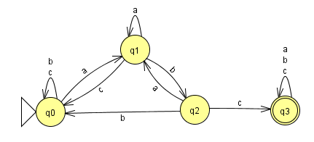
Q4.
Given a DFA that accepts any string that does not contain “abc” as substring
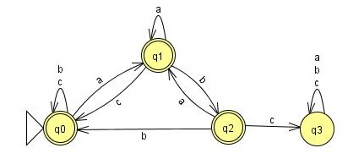
Q5.
Give a DFA that accepts set of strings that are at least length 4 and contains even number of 1’s
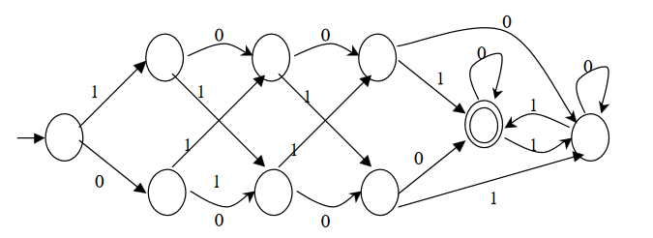
Q6. Set of all strings with number of 0’s in multiples of 5 and number of 1’s in multiples of 3
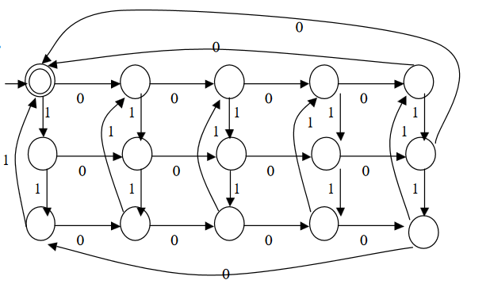

------------------------------------ The End ----------------------------------------

