Programming Assignment 1

Name: Zuha Aqib
ERP ID: 26106
Course: Introduction to Blockchain
Instructor: Ahmed Akhter
Date: 17th April 2026

So this is basically a document with all the OUTPUT PROOFs. My code file is attached too.

Table of Contents
PROOF 1: test.py got 40/40 marks 2
PROOF 2: Mining was successful 3
PROOF 3: chain successfully sent to backend 4
PROOF 4: chain fetched and printed to see if my block was added 5
PROOF 5: checked chain for my ERP using commands 5

PROOF 1: test.py got 40/40 marks
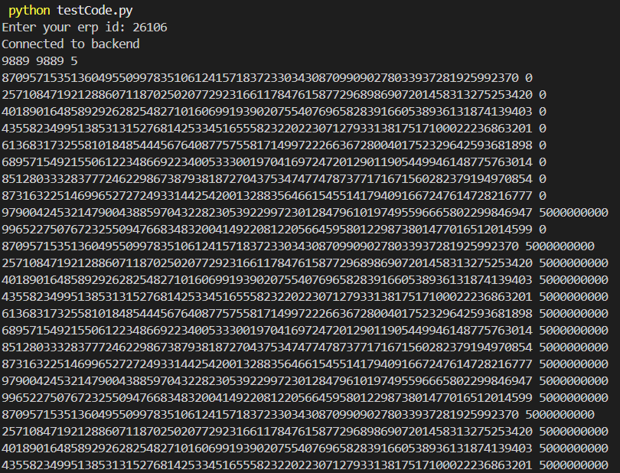
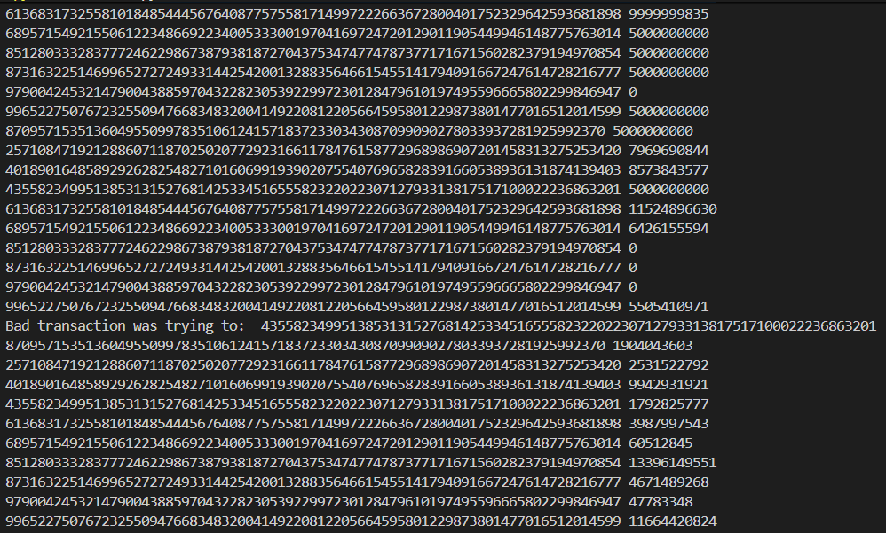
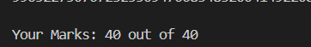

Then main.py was run, “rl” to fetch the latest chain of 696 blocks, and “validate” was run to validate the file, and “print” was done to print the chain. Then mining was begun.

PROOF 2: Mining was successful
> mine
Mining... this may take a while with difficulty 4
Still mining... tried up to nonce 50000
Still mining... tried up to nonce 100000
Still mining... tried up to nonce 150000
Still mining... tried up to nonce 200000
Still mining... tried up to nonce 250000
Still mining... tried up to nonce 300000
Still mining... tried up to nonce 350000
Still mining... tried up to nonce 400000
Still mining... tried up to nonce 450000
Still mining... tried up to nonce 500000
Still mining... tried up to nonce 550000
Still mining... tried up to nonce 600000
Still mining... tried up to nonce 650000
Still mining... tried up to nonce 700000
Still mining... tried up to nonce 750000
Still mining... tried up to nonce 800000
Still mining... tried up to nonce 850000
Still mining... tried up to nonce 900000
Still mining... tried up to nonce 950000
Still mining... tried up to nonce 1000000
Still mining... tried up to nonce 1050000
Still mining... tried up to nonce 1100000
Still mining... tried up to nonce 1150000
Still mining... tried up to nonce 1200000
Still mining... tried up to nonce 1250000
Still mining... tried up to nonce 1300000
block hash found
0000c88055d80223236e80abbffc460a381b0a5e0d492ca30f722e9ccf74b1b3
Block successfully mined!

PROOF 3: chain successfully sent to backend
> send state
State sent to backend

PROOF 4: chain fetched and printed to see if my block was added
> rl
Requested longest chain, check pending_chains folder
Backend has no longer chain yet, please try again after some time...
> validate
No pending chains found to validate.
> print
… excluded al 686 blocks
***************************
Block index # 687
Transaction number 1276 with hash 106897296527924764199667125552980890037746170738505784713432458442547679971572
Transaction number 1279 with hash 4348696049650101035633769778528607889714584734871062526600404328859556934820
Transaction number 1283 with hash 15206552066005789095658745641384009236848085361028234329244152637804893412115
Transaction number 1290 with hash 98690495398309002924443911061725567558432810741273202135647905795356076794112
Transaction number 1295 with hash 46911183463424891503636513496414637039836375655325814063081513851381921458587
---------------------------
nonce: 1300460
previous_hash: 00004a3ec2f86ddc5b0bbe0573d23906e9adbef9d12a552d27b64472b145469c
hash: 0000c88055d80223236e80abbffc460a381b0a5e0d492ca30f722e9ccf74b1b3
Miner: 26106
***************************

PROOF 5: checked chain for my ERP using commands
> python -c "import glob,os,pickle; from FullNode import FullNode; files=sorted(glob.glob('valid_chain/block*.block'), key=lambda x:int(os.path.basename(x)[5:-6])); f=[f for f in files if os.path.basename(f)=='block687.block'][0]; b=pickle.load(open(f,'rb')); n=FullNode('26106'); print('index=', b.index); print('miner=', b.miner); print('hash=', n.computeBlockHash(b))"
index= 687
miner= 26106
hash= 0000c88055d80223236e80abbffc460a381b0a5e0d492ca30f722e9ccf74b1b3

> python -c "import glob,os,pickle; files=sorted(glob.glob('valid_chain/block*.block'), key=lambda x:int(os.path.basename(x)[5:-6])); found=[]; [found.append((b.index,b.miner)) for f in files for b in [pickle.load(open(f,'rb'))] if str(b.miner)=='26106']; print(found[-20:]); print('total matches =', len(found))"
[(687, '26106')]
total matches = 1

