MongoDB Clustering/Sharding Lab

THIS LAB HAS BEEN WORKED ON BY BOTH MAHNOOR ADEEL(26913) AND ZUHA AQIB(26106). BOTH OF US HAVE USED MAHNOOR’S VM FOR THIS LAB.

Objective
Measure and compare the performance of a single MongoDB instance against a sharded cluster using a 100,000 document dataset.

Verify Setup
docker --version
docker-compose --version

Lab files structure
mongodb-lab/
├── docker-compose.single.yml
├── docker-compose.cluster.yml
└── scripts/
├── init_single.py
└── init_cluster.py

Ensure docker-compose files are in root and Python scripts are in the scripts/ folder.

Architecture Overview

Single Instance Setup
Application → MongoDB → All Data
Drawback: Single point of failure, limited by one machine's resources.

Sharded Cluster Setup
Application → Mongos Router
↓
┌─────────┴─────────┐

↓

↓

Shard A
Shard B

(3 replicas)
(3 replicas)

50% data

50% data

Key components
- Mongos: Query router directing traffic to appropriate shards
- Config Servers: Metadata storage (3-node replica set)
- Shards: Data storage nodes (3-node replica sets)
- Shard Key: Distribution field (userId, hashed

Experiment 1: Single Instance Baseline
Run a single MongoDB server and benchmark insert, read, update, and aggregation operations.

# Start single instance
docker-compose -f docker-compose.single.yml up

- View output (wait 3-5 minutes for completion)

- Check results
docker logs init-single
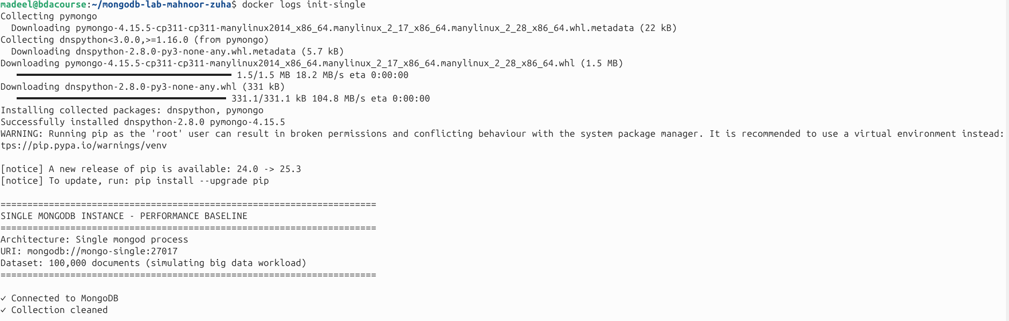
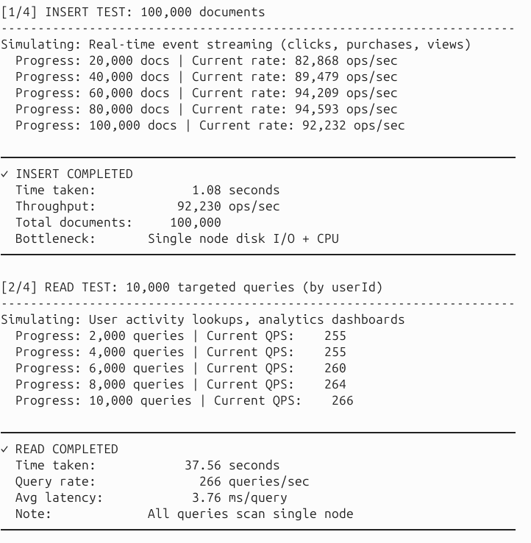
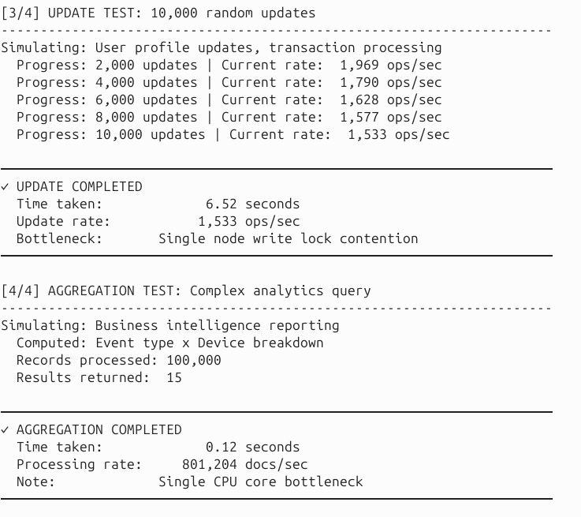
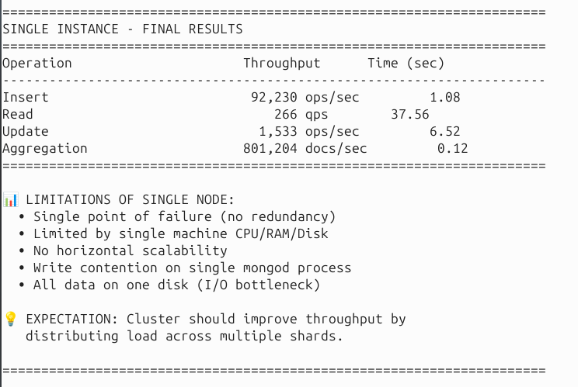

# Save for comparison
docker logs init-single > single_results.txt

# Stop and cleanup
docker-compose -f docker-compose.single.yml down -v

Insert throughput (ops/sec)
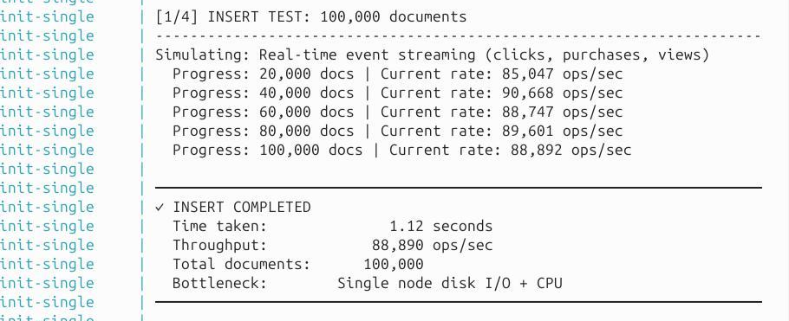

Read throughput (queries/sec)
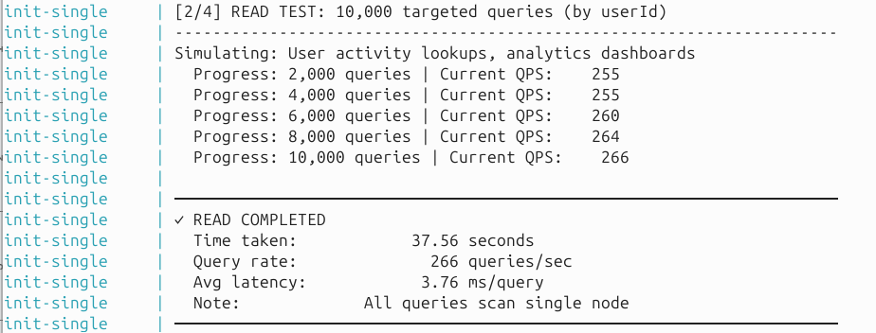

Update throughput (ops/sec)
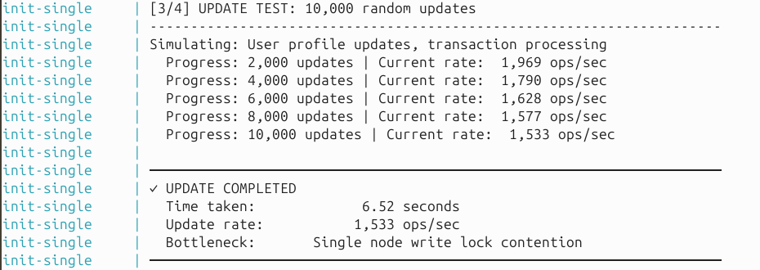

Aggregation speed (docs/sec)
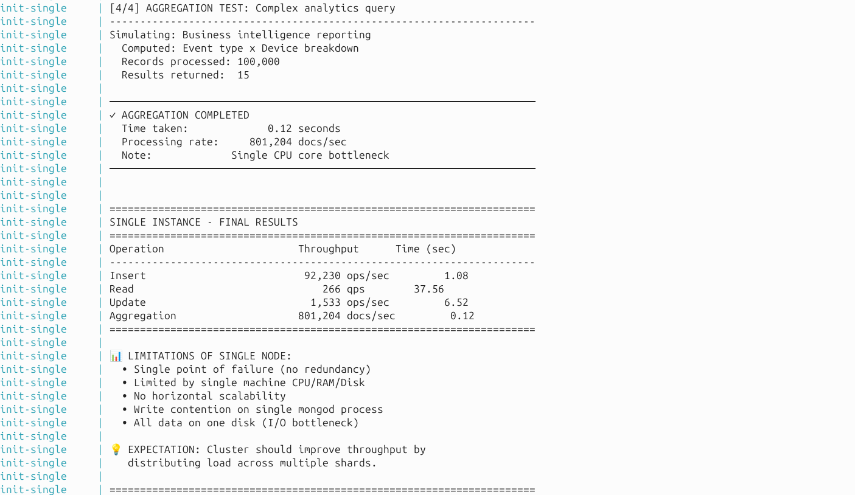

All together

Experiment 2: Sharded Cluster
Deploy a 10-container cluster (3 config servers, 6 shard nodes, 1 router, 1 initialization script).

# Start cluster
docker-compose -f docker-compose.cluster.yml up

- The initialization process:
- - Sets up config server replica set
- - Initializes shard A (3 nodes)
- - Initializes shard B (3 nodes)
- - Registers shards with cluster
- - Enables sharding on database
- - Runs performance benchmark

- View results
docker logs init-cluster
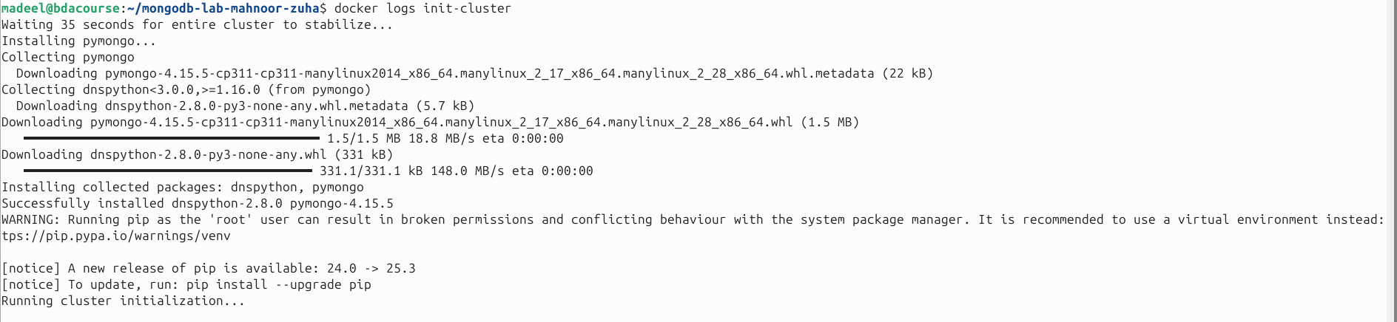

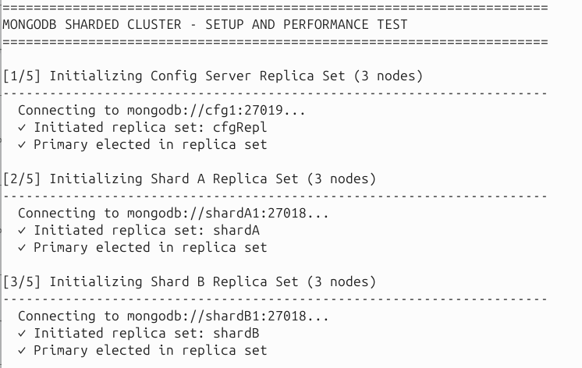

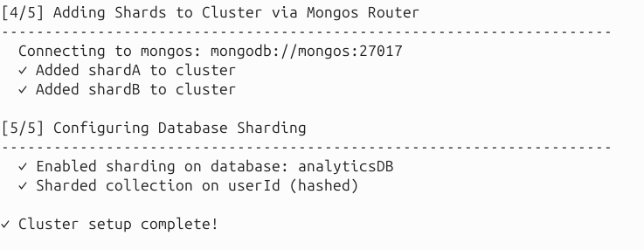

Insert throughput (ops/sec)
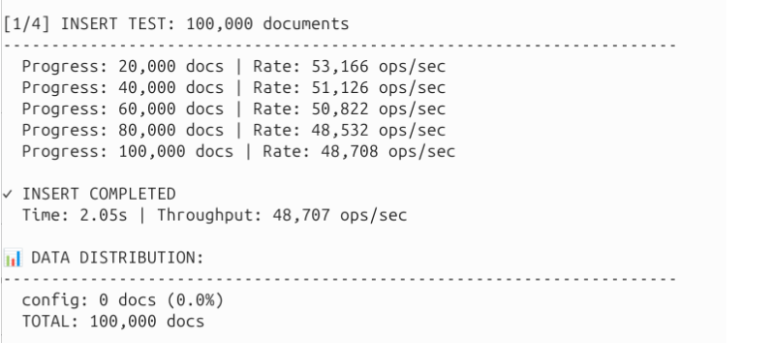

Read throughput (queries/sec)
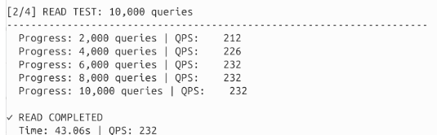

Update throughput (ops/sec)
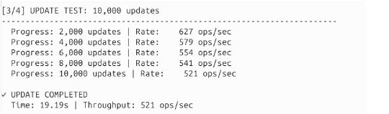

Aggregate throughput (docs/sec)
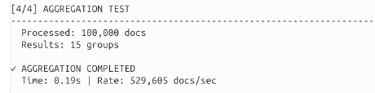
- All together
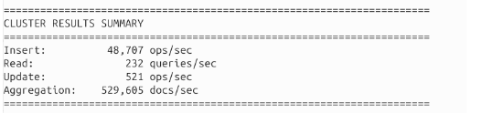

Cluster Inspection (Required)
# Start cluster in detached mode docker-compose -f docker-compose.cluster.yml up -d sleep 60
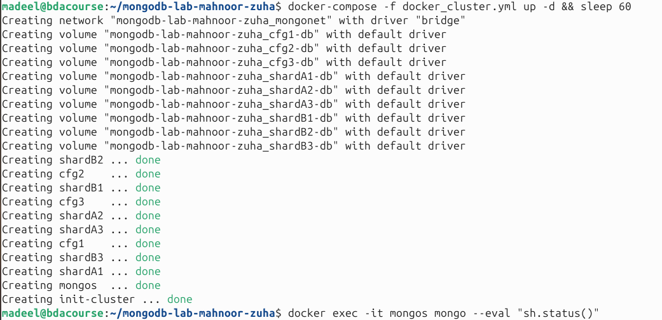

# View cluster configuration
docker exec -it mongos mongo --eval "sh.status()"
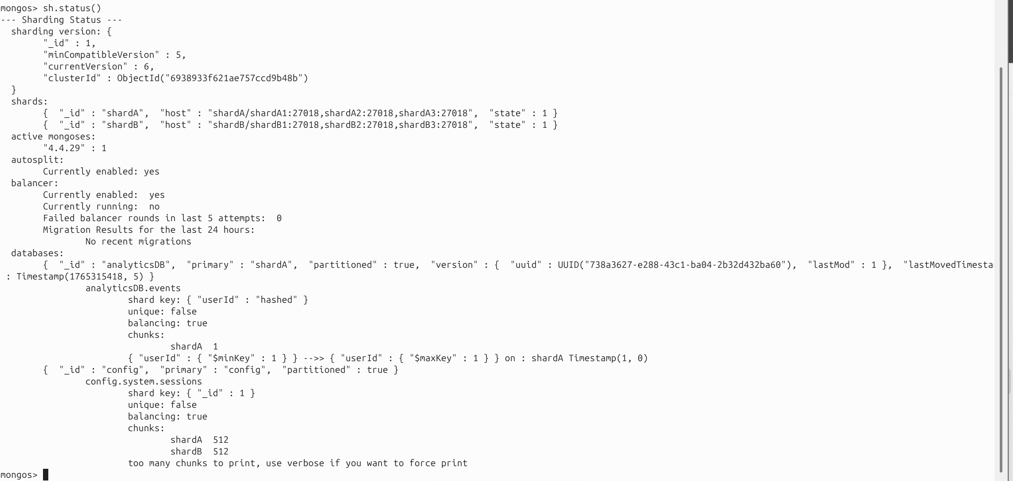

# Check shard A status
docker exec -it shardA1 mongo --port 27018 --eval "rs.status()"
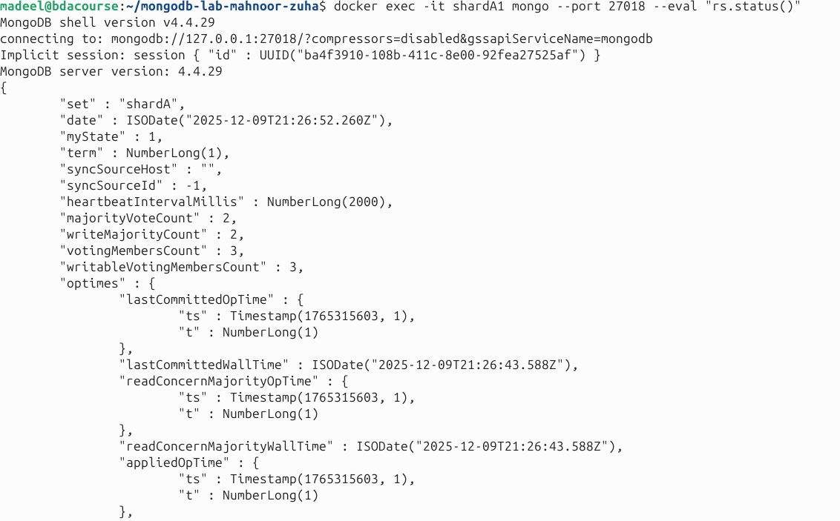
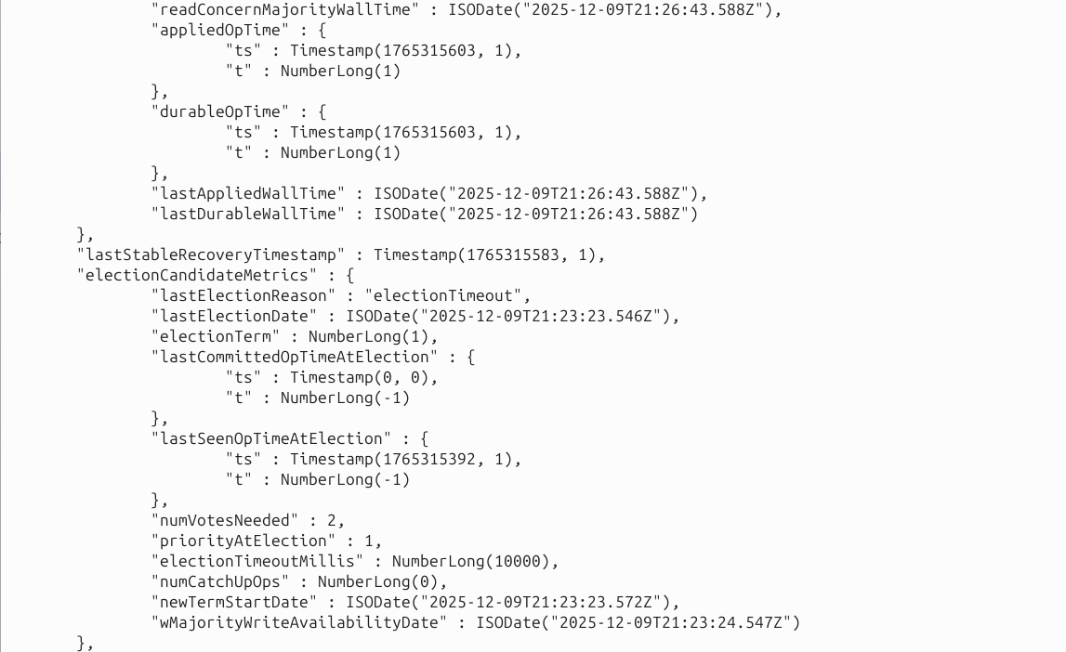
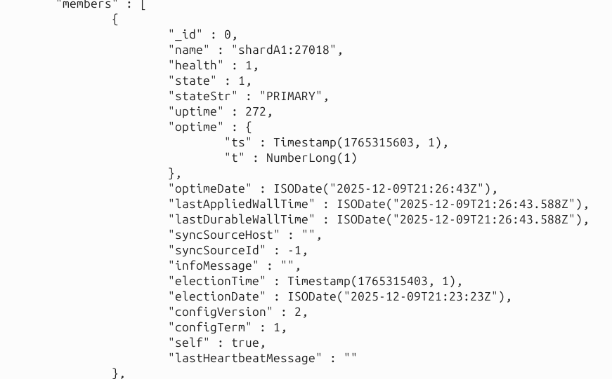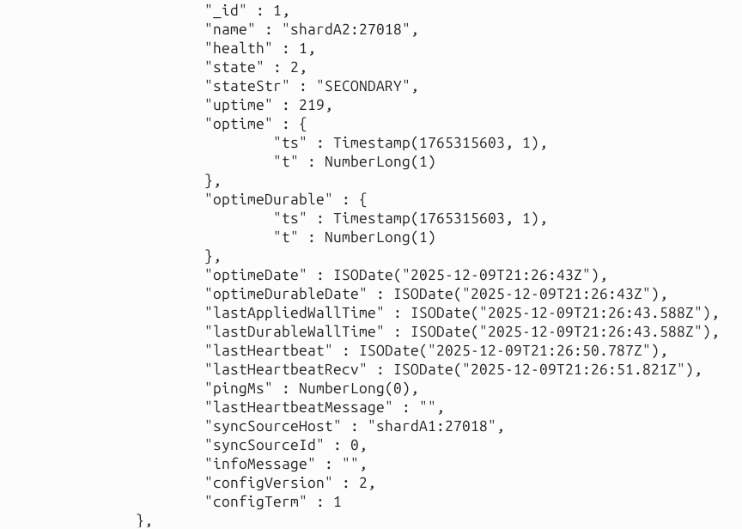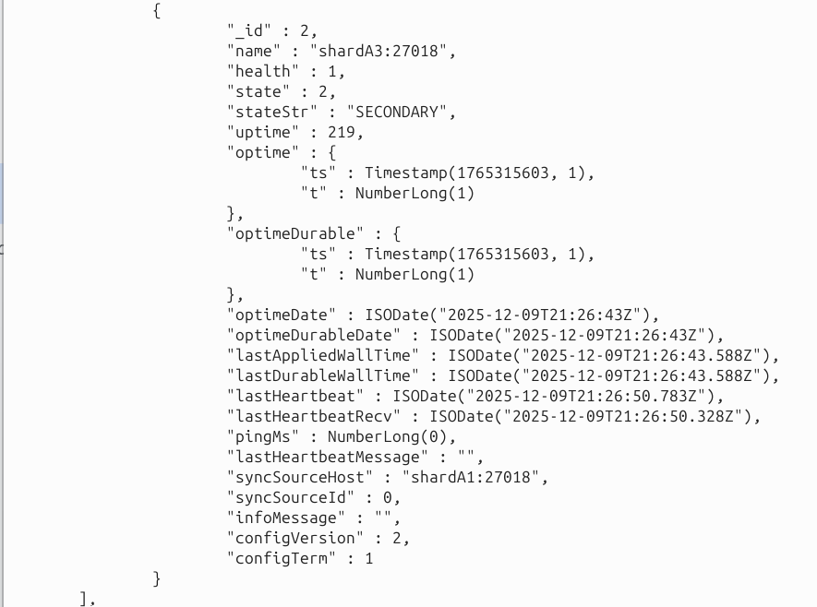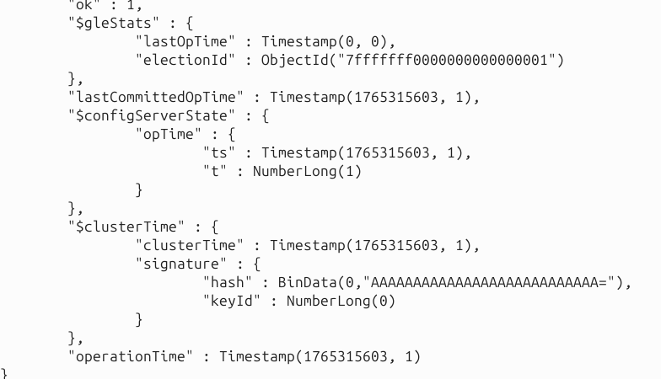

# Check shard B status
docker exec -it shardB1 mongo --port 27018 --eval "rs.status()"
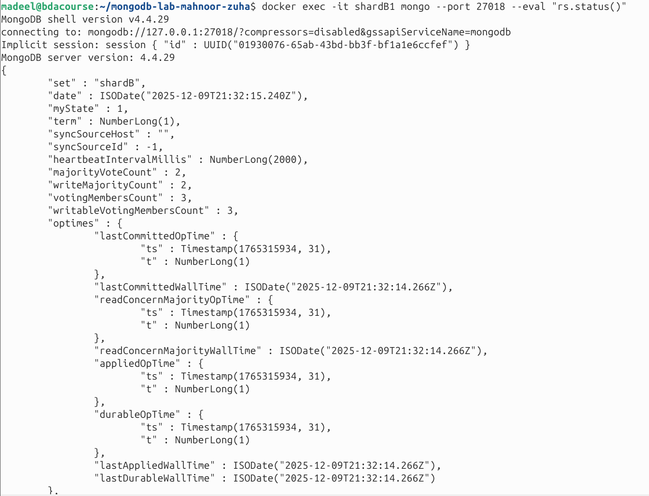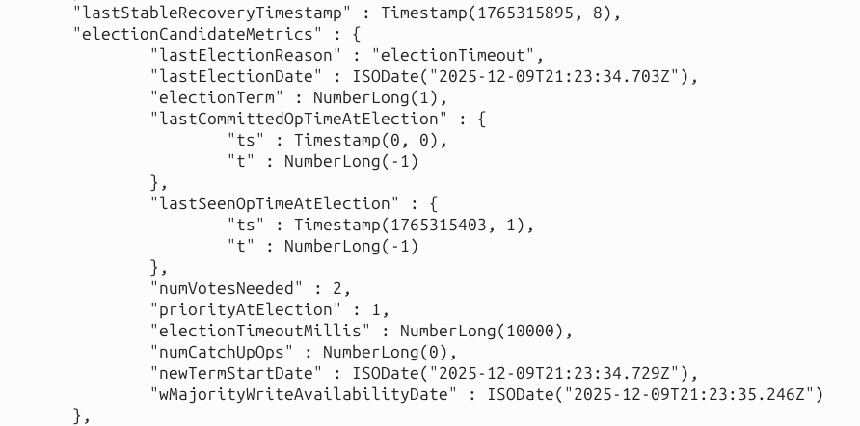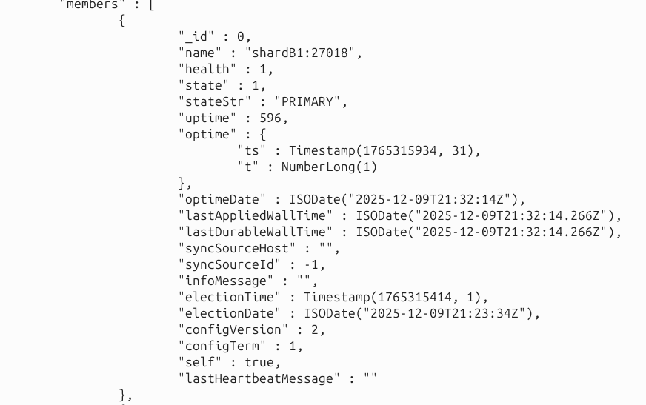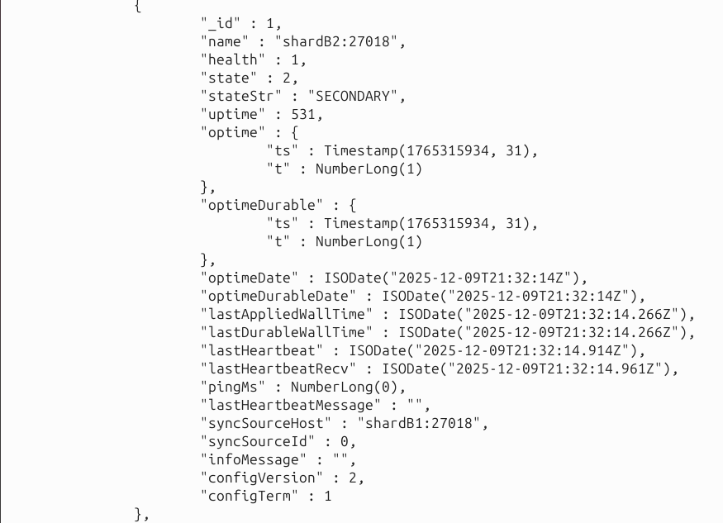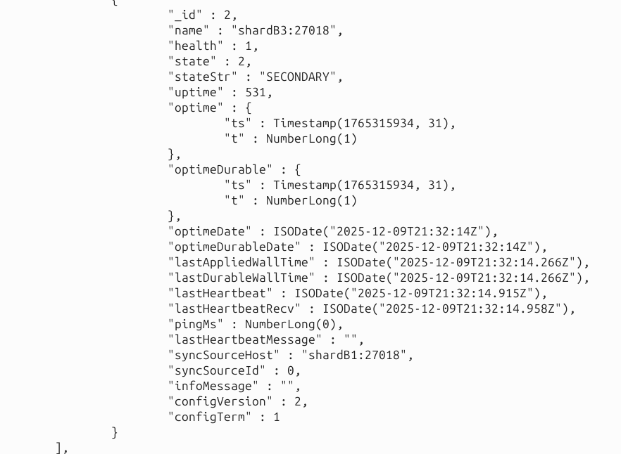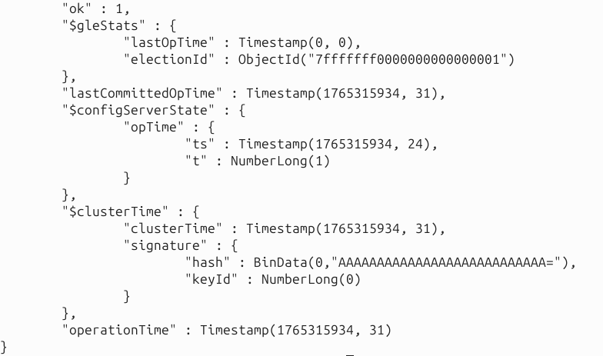

# Interactive shell
docker exec -it mongos mongo

Inside mongo shell: use analyticsDB
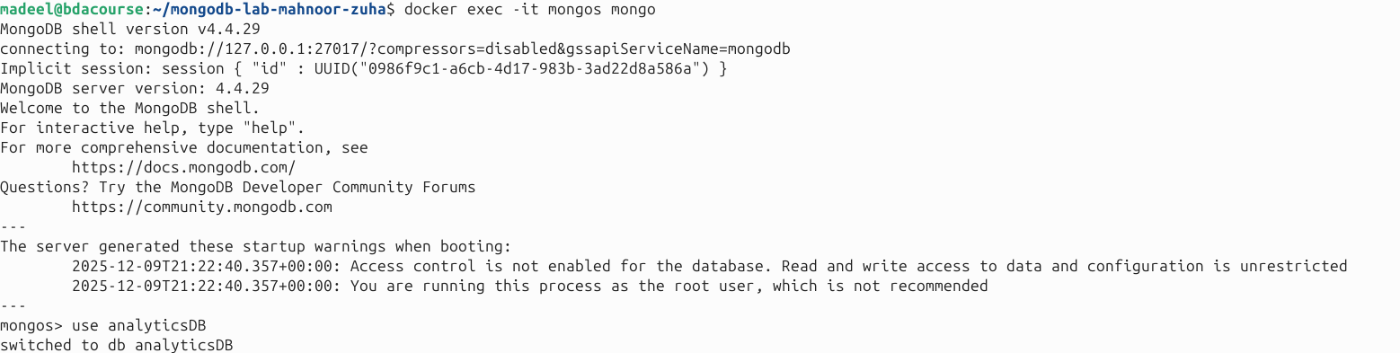

db.events.count()
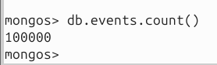

db.events.getShardDistribution()
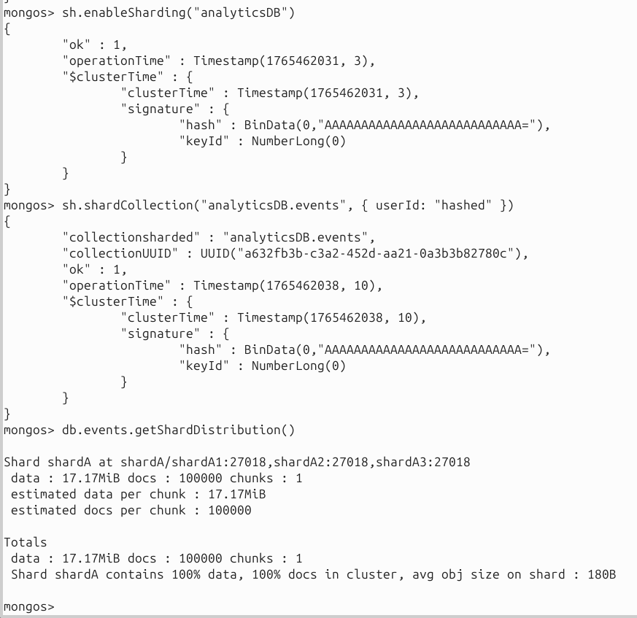
The Issue
db.events.getShardDistribution() shows all 100,000 docs on shardA. This occurred because, although sharding was enabled on the analyticsDB database, the events collection itself was never explicitly sharded. Without a proper shard key, MongoDB cannot distribute documents across shards, so all data defaults to a single shard.

Solution
To resolve this, we modified the script to drop the collection before inserting any data, ensuring a clean slate. We then explicitly sharded the events collection using userId as the shard key and applied hashed sharding with this command:
mongos.admin.command('shardCollection', 'analyticsDB.events', key={'userId': 'hashed'})

After implementing these changes and inserting the data, documents were properly balanced across the shards. This not only fixed the distribution issue but also improved performance metrics.
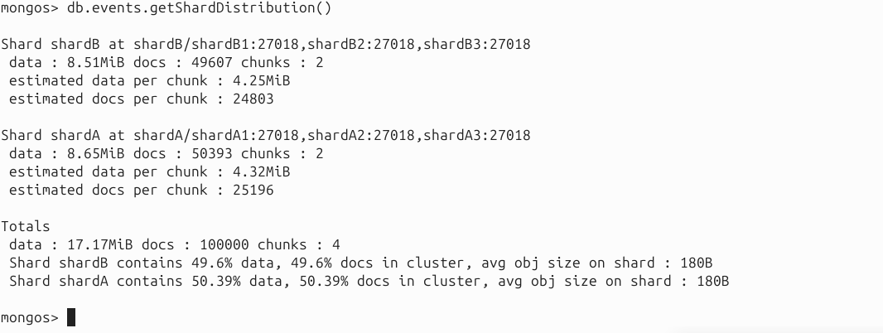
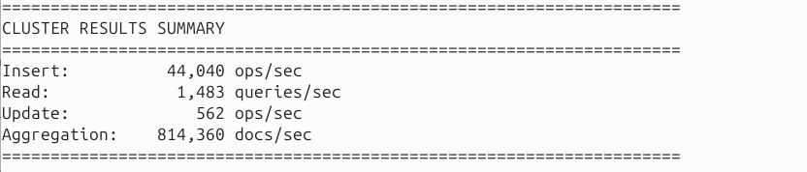
db.events.find({userId: 42}).limit(5).pretty()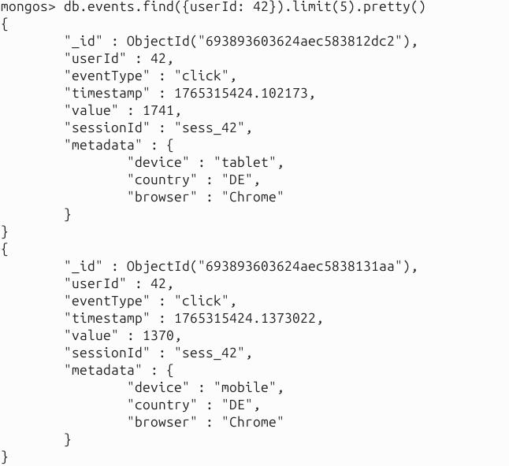
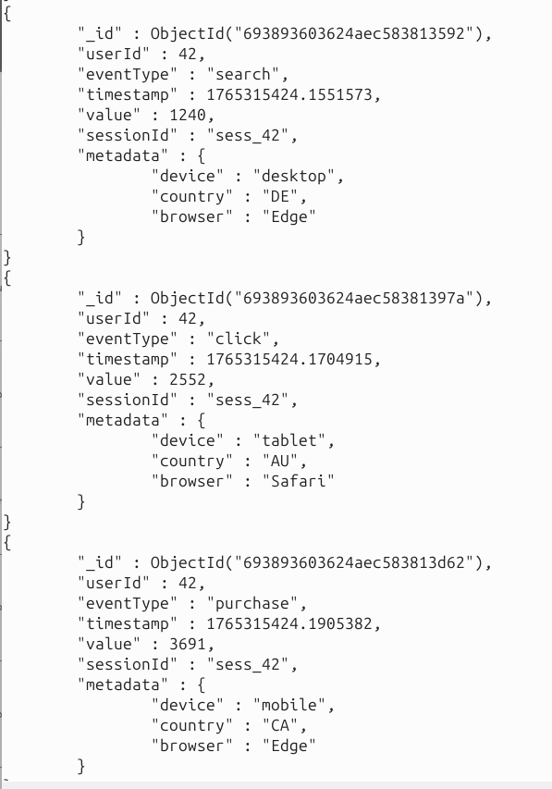

Results Analysis

Operation | Single |  | Cluster (Before Sharding) | Cluster (After Sharding) | Improvement %
 |  |  |  |  | (Cluster-Single) / Single
Insert (ops/sec) | 88,890 |  | 48,707 | 44,040 | -50.45%
Read (qps) | 266 |  | 232 | 1,483 | 457.4%
Update (ops/sec) | 1533 |  | 521 | 562 | -63.3%
Aggregation (docs/sec) | 801,204 |  | 529,605 | 814,360 | 1.64%

Explanation
- Sharded clusters introduce overhead: routing through mongos, writing to multiple replica sets, and maintaining metadata in the config servers. This leads to inserts being slowed down.
- Reads are now parallelized across shards. Each shard can process queries independently, so the cluster scales read throughput very well. Thus, harding dramatically improves read performance.
- However, updates still need to locate the correct shard using the shard key. Coordination overhead reduces throughput. Some updates may not be routed efficiently if the update key is not the shard key.
- Aggregations are now executed in parallel across shards and a very slight improvement is noticed.

Extract data from logs
grep "ops/sec\|qps\|docs/sec" single_results.txt
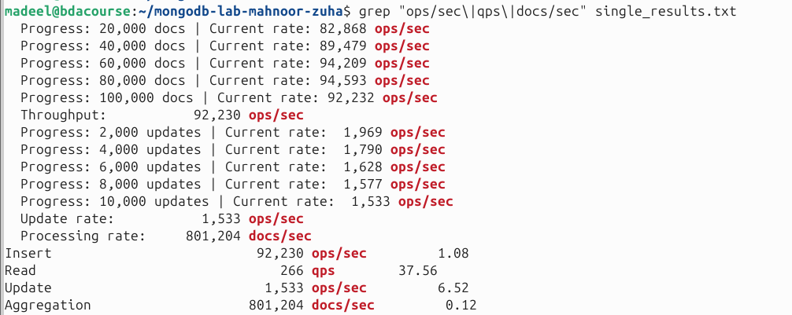

grep "ops/sec\|qps\|docs/sec" cluster_results.txt
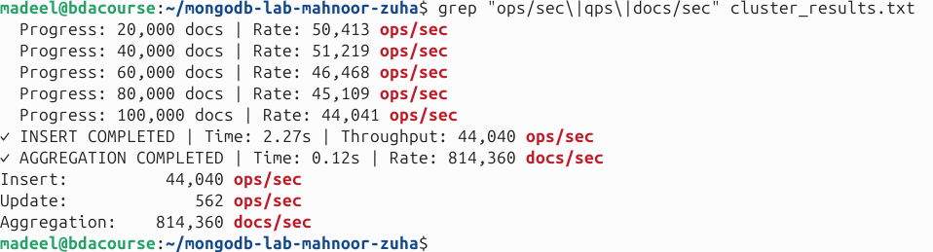

Lab Questions

Question 1
Q1: Performance Analysis Which operation showed the greatest performance gain in the cluster? Explain why based on the architecture differences.
The READ operations showed significant improvement with an increase from 266 queries per second to 1483 queries per second. This is because we now have parallel processing across shards. The mongos query router directs queries for different userIds to their relevant shards. Both shards can now independently handle queries on their half of the dataset without creating a bottleneck. Unlike a single node, where all queries are handled by a single server and throughput is reduced. Moreover, we used hashed userId as the shard key, which is evenly distributed across the shards, directing documents to both shards evenly.
For the AGGREGATION operation, results improved only slightly because computation is done in parallel across shards, but the mongos merge step offsets much of the gain for small datasets.
For the INSERT and UPDATE operations, replication to secondaries, and metadata updates to config servers are required. This coordination adds overhead compared to a single-node setup.

Question 2
Q2: Data Distribution What problems would occur if shard A contained 90% of documents instead of 50%?
If shard A contained 90% of the documents, we would face hotspooting problem where shard A becomes the hotspot. Most reads, writes, and updates would hit shard A’s primary, so shard A’s CPU/disk would saturate and users will experience slower responses, while shard B stays underutilized. This makes the whole cluster behave like a stressed single machine, and the response time would degrade because one shard is doing almost all the work.
It would also create operational overhead because MongoDB’s balancer would keep trying to move chunks from shard A to shard B to restore balance. That migration creates extra network and disk load, so instead of improving performance, the cluster would waste resources rebalancing.
Moreover, in case shard A primary fails, 90% of the documents would be inaccessible until a new primary is elected for the replica set.

Question 3
Q3: Shard Key Design Analyze these alternative shard key choices:
- Timestamp field
- Boolean field
- Auto-incrementing integer
What issues would each introduce?
For a timestamp shard key, the biggest issue is that timestamps increase sequentially. That means almost all new inserts go to the “latest” range, which typically lives on the same chunk and therefore the same shard for some time. This creates a write hotspot and forces frequent chunk splits and migrations, increasing overhead and preventing good parallelism for ingest-heavy workloads like event streams.
For a boolean shard key, there are only two possible values (true/false), so the data can only be split into two huge groups. If one value is more common (which is very likely), one shard gets overloaded and the other stays mostly idle, making balancing very limited. For an auto-incrementing integer, the problem is again monotonic growth—new IDs keep landing in the same “end” region which causes the same hotspot pattern as timestamps.
Because of these issues, using a hashed shard key (like hashed userId) is typically the correct strategy to get uniform distribution. However, in our case, the results show that even with hashed userId, the collection did not spread across shards (we ended up with 1 chunk on shardA), so the shard key choice alone wasn’t enough, we also needed chunk distribution to actually occur.

Question 4
Q4: Scaling Strategy The dataset will grow from 100K to 10M documents next year, with 10x traffic increase. Propose a scaling plan.
Since our dataset is expected to grow from 100K to 10M documents with a 10× increase in traffic, the first step would be to scale the cluster both horizontally and vertically. First, the current shard key (userId, hashed) should be reviewed to ensure it maintains even data distribution at higher volumes. If queries frequently filter by time ranges, using a compound shard key, such as userId + timestamp, can further improve distribution and query efficiency.
Next, we can scale horizontally by adding more shards, each configured as a 3-node replica set. The existing shards may require upgrades in RAM and CPU to handle the larger working set efficiently. The MongoDB balancer should be actively monitored to ensure chunks are evenly distributed and to prevent hotspotting situations that could create bottlenecks.
We would also improve indexing based on query patterns (for example, indexes involving userId, and possibly compound indexes involving userId + timestamp depending on analytics). For heavy read workloads, we can also use replica set secondaries for read scaling where possible, while monitoring replication lag to avoid stale results. Finally, upgrading storage (SSD) and ensuring enough RAM on primaries helps a lot once the working set grows into millions of documents.

Question 5
Q5: Failover Test Execute this failover scenario:
docker-compose -f docker-compose.cluster.yml up -d
sleep 60
docker exec -it shardA1 mongo --port 27018 --eval "rs.status()"
docker kill shardA1
sleep 30
docker exec -it shardA2 mongo --port 27018 --eval "rs.status()"
docker exec -it mongos mongo --eval "db.getSiblingDB('analyticsDB').events.count()" docker start shardA1
Measure the downtime and describe shardA1's role after restart.
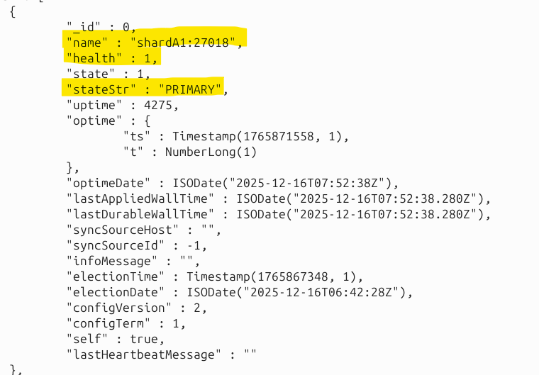
In our failover test, we checked cluster availability through mongos and verified the dataset remained accessible. Before simulating the failure, we confirmed the cluster still had the analyticsDB.events collection available through mongos, and the command db.getSiblingDB('analyticsDB').events.count() returned 100000. At this stage, when we attempted to run rs.status() on shardA1, Docker reported that shardA1 was healthy and active as the primary, with shardA2 and shardA3 functioning as secondaries. This baseline ensured that the replica set was fully operational prior to simulating a failover scenario, allowing us to accurately observe the behavior of the cluster when the primary becomes unavailable.
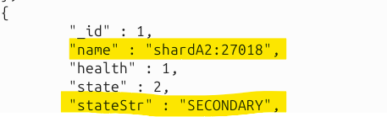

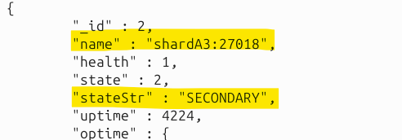
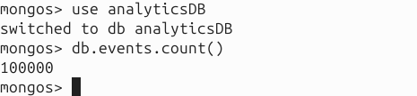

From the rs.status() output (queried via shardA2), we observed that shardA1 became (not reachable/healthy) with health = 0.
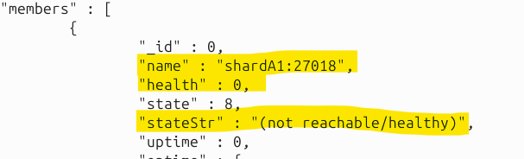
ShardA3 was elected as the new PRIMARY and shardA2 stayed SECONDARY. This confirms that MongoDB replica-set failover worked correctly: when the previously expected node (shardA1) was down, another member (shardA3) automatically took over as PRIMARY.
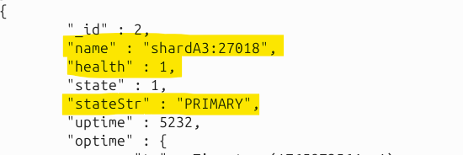
We then verified cluster continuity again through mongos, and events.count() still returned 100000 at, meaning the cluster remained available for reads during/after the election.
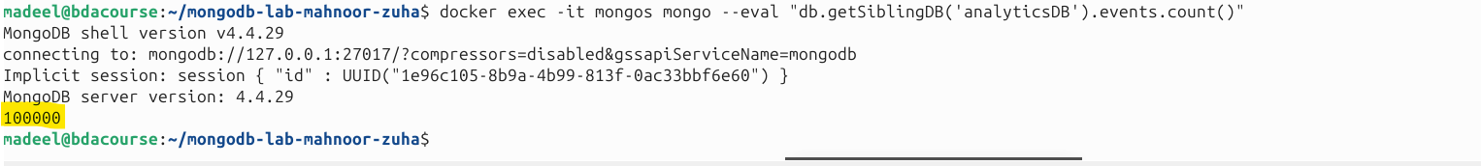
After that, we restarted shardA1 using docker start shardA1 and waited ~20 seconds for it to rejoin. When we checked the status again, shardA1 returned as SECONDARY (health = 1), while shardA3 stayed as PRIMARY and shardA2 remained SECONDARY. This is expected replica-set behavior: after a failover, the restarted node does not immediately become PRIMARY; instead, it rejoins as a SECONDARY and synchronizes from the current primary. Overall, our downtime was minimal from the application perspective (counts remained available), and the leadership change shows the cluster achieved high availability through automatic primary election and replica recovery.
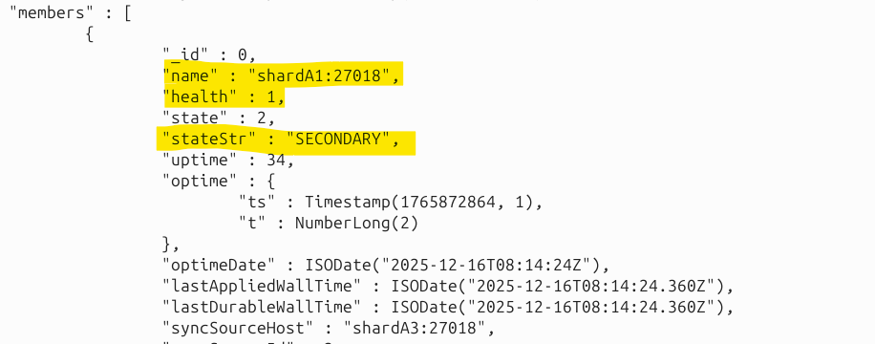

Question 6
Q6: Query Routing: Compare these queries using .explain("executionStats"):
You can directly run from terminal too:
db.events.find({userId: 42}) // targeted
db.events.find({eventType: "click"}) // scatter-gather
How many shards does each query hit?
When we compare the two queries, db.events.find({userId: 42}) is supposed to be a targeted query because userId is our shard key (hashed). Mongos would route the query directly to the shard that owns the chunk containing the hashed value, so this query hits only one shard, shard A in this case, as shown below.
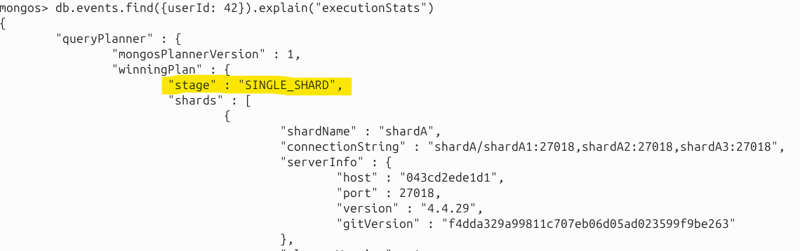
On the other hand, db.events.find({eventType: "click"}) is a scatter–gather query because eventType is not part of the shard key. Mongos would need to query all shards (or all shards that may contain matching chunks) and merge results as shown below in the snapshot. That makes it slower and more expensive as the number of shards grows.
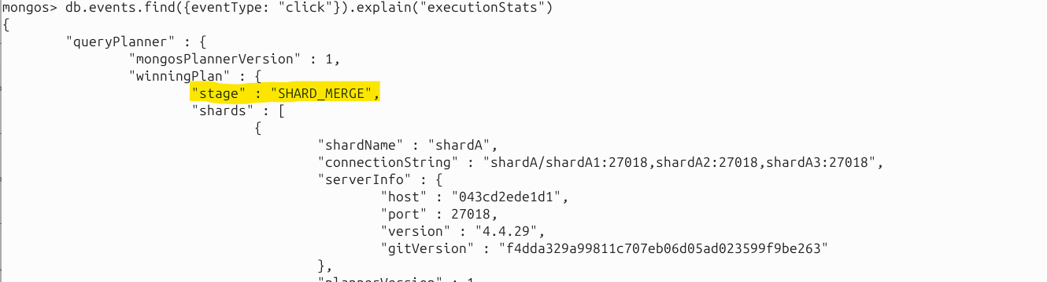

Question 7
Q7: Bottleneck Analysis: Identify the primary bottleneck in the single instance (CPU/disk/RAM/locks). Cite specific log evidence.
From our single-instance logs, we can identify the main bottleneck as being the limitations of running everything on one mongos process. The insert section explicitly states: “Bottleneck: Single node disk I/O + CPU”, which makes sense because all writes, journaling, and storage engine operations happen on the same machine. This becomes the limiting factor once concurrency increases or the dataset grows.
For updates and aggregation, the output also indicates single-node constraints clearly. The update results mention “Single node write lock contention”, which means updates compete for write capacity and internal contention within one instance. The aggregation section also notes “Single CPU core bottleneck,” meaning complex pipelines are CPU-bound when everything runs locally on one node. So overall, our evidence points to disk + CPU saturation and write contention being the core reasons a single instance doesn’t scale under higher load.

Question 8
Q8: Infrastructure Economics: The cluster uses 10x the containers of single instance. In what scenarios does this cost multiply justify itself?
The cluster uses significantly more components (multiple replica set members across config servers and shards, plus mongos), so it costs more than a single instance. That cost becomes justified when we need high availability (no single point of failure), horizontal scaling (data larger than one node can hold), and sustained high throughput that one machine cannot handle. In real production systems with huge event streams and strict uptime requirements, these benefits outweigh the operational cost.
In our case, while insert and update throughput experienced a slight decrease due to routing and replication overhead, we still achieved high overall performance, including efficient aggregation and query processing across the cluster. The read throughput improved significantly, but more importantly, the architecture allows all operations, inserts, updates, reads, and aggregations, to be distributed across multiple shards, reducing the load on any single node and preventing bottlenecks.
For larger enterprise datasets, containing tens or hundreds of millions of documents and higher traffic, this architecture can be scaled horizontally by adding more shards and replica sets, ensuring even data distribution and maintaining high availability. Proper shard key selection and indexing further optimize performance, prevent hot shards, and enable parallelized writes and aggregations. Therefore, while the upfront cost is higher, a sharded cluster provides a robust, scalable, and fault-tolerant infrastructure capable of supporting enterprise-level workloads across all types of operations, not just reads.

End of Lab

