HandOut.3: Docker-Images-Containers-Volumes-Compose
All the commands are in RED should be tried out in sequence mentioned on CMD

Login to Docker:
Confirm that you have docker installed: docker --version
Login: docker login (you might be asked your credentials for hub.docker.com)
You will receive a success message “Login Succeeded”

Docker Images
You can also pull images with their tags. To get the latest tag, search for this image from
hub.docker.com and click on “Tags” tab. The latest tag is at the top.
Remember that “Docker Official Image” with any image name on hub.docker.com means
an official image of the Docker company (so it is most reliable). The pull command to use is also specified on the hub page:
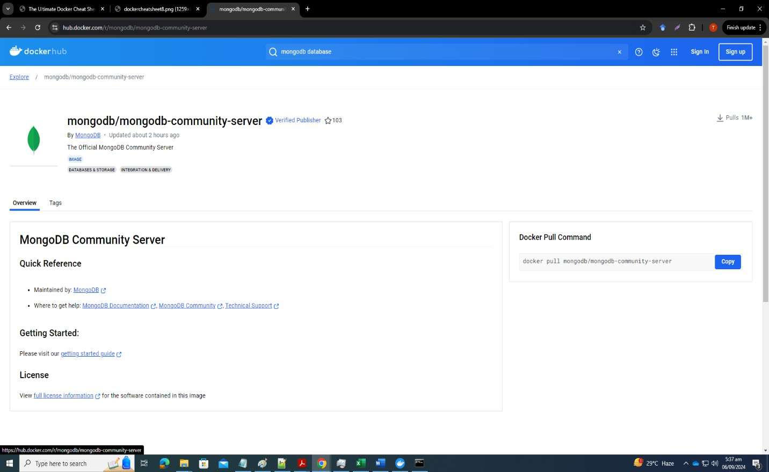

Pull the nginx image: docker pull nginx
Show list of all downloaded images: docker images (cross-check downloaded image)
Remove nginx image: docker rmi nginx (some stats will be shown confirming that the image was untagged and then deleted with the SHA256 key – it is a secure hash function with a 64-character hexadecimal number used for data integrity and digital signatures)
Pull mongodb community server image with specified tag: docker pull mongodb/mongodb- community-server:7.0.2-ubi8 (I copied this from the hub page – you should copy as well since versions and commands may change)
Pull redis image: docker pull redis
Now check: docker images (how many do you see?) Delete dangling images: docker image prune
Now check: docker images
You will see all images you downloaded are still there because none of them is dangling.
A “dangling” image is one that is no longer associated with any tagged repository names. These are intermediate layers that were used in the creation of other images but are no longer needed. Dangling images are identified by <none> tag.
Delete all unused images which do not have any container associated with them: docker image prune -a
Now check: docker images (All are now removed. So, it is a shortcut to delete all unused ones rather than deleting each separately through rmi command)
Now pull nginx again: docker pull nginx
Now check: docker images (it must be tagged with latest) Create a new tag: docker tag nginx:latest nginx:22sep
This will just create a reference to the latest tag (not a new copy) Now check: docker images (you will see the two different tags) Delete it: docker rmi nginx
You deleted the original ngnix with latest tag – the reference one remains Check: docker images
Better to prune: docker image prune -a

If you want a full cleanup: docker system prune

If you want a full cleanup: docker system prune -a (also removes all unused images, not just dangling ones)

Building an Image:
Now let us do an example to build an image from a Dockerfile.
- Create a working directory – e.g., F:\dockerwd
- Create an html file called index.html in this directory and paste the following content in it
<!DOCTYPE html>
<html lang="en">
<head>
<meta charset="UTF-8">
<title>Simple App</title>
</head>
<body>
<h1>Hello World</h1>
<p>This is running in a docker container</p>
</body>
</html>
- Save index.html. This is the webpage which will be shown by the webserver nginx in a container
- Access F:\dockerwd on CMD
- Do: docker pull nginx
- Now create a file called Dockerfile (make sure it has no extension like txt etc.) in the same directory
- Copy the following content into it
FROM nginx:stable-alpine3.17-slim COPY index.html /usr/share/nginx/html

EXPOSE 80
CMD ["nginx", "-g", "daemon off;"]
- This will create a Docker image that serves the provided "index.html" file through the Nginx web server when a container is launched based on that image.
- FROM initializes a new build stage and sets the base image for subsequent instructions.

- COPY copies files or directories (usually the source code) from the source to the specified location inside the image. It copies the file to the "/usr/share/nginx/html" directory, which is the default location for serving static files in the Nginx web server.
- The purpose of CMD is to provide defaults for executing containers.
- Now build the image: docker build -t justasample:v1 .
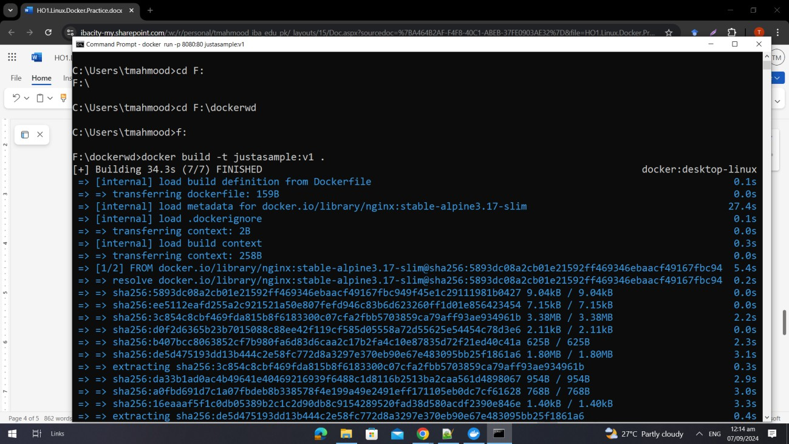
- The -t flag specifies a tag for the image, allowing you to assign a name and version to it. In this case, the image will be tagged as "justasample" with the version "v1" providing a descriptive identifier for the image, making it easier to reference and manage.
- Now check: docker images
- Now run the container for the image: docker run -p 8080:80 justasample:v1
- Note: If a Windows Security Alert pops up, allow it.
- This command tells Docker to run the sampleapp container. The -p flag specifies the port mapping, which maps a port from the host machine to a port inside the container. Here, you are mapping port 8080 of the host machine to port 80 of the container. You can modify the host port as per your preference. Ensure you specify the image name and version you used when building the image.
- Open a web browser and navigate to localhost:8080

Show the webserver output
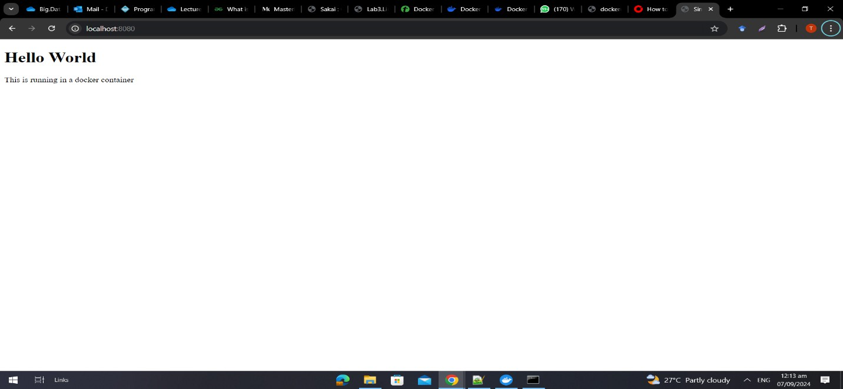

Tagging Image:
Now tag your image with your repo:
docker tag justasample:v1 compadrejaysee/sampleapp:v1 Now push the image to your repo:
docker push justasample:v1 compadrejaysee/sampleapp:v1 Check out Docker Hub
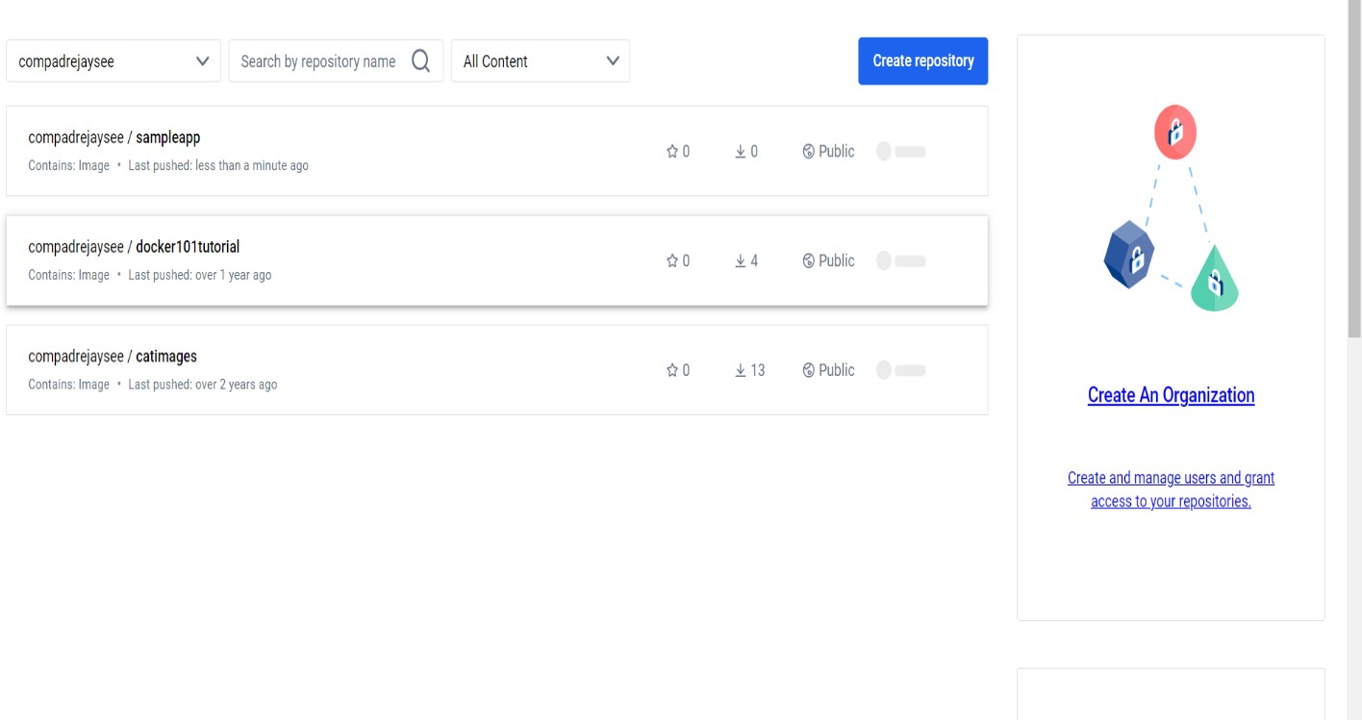

Check also the containers tab on Docker desktop:

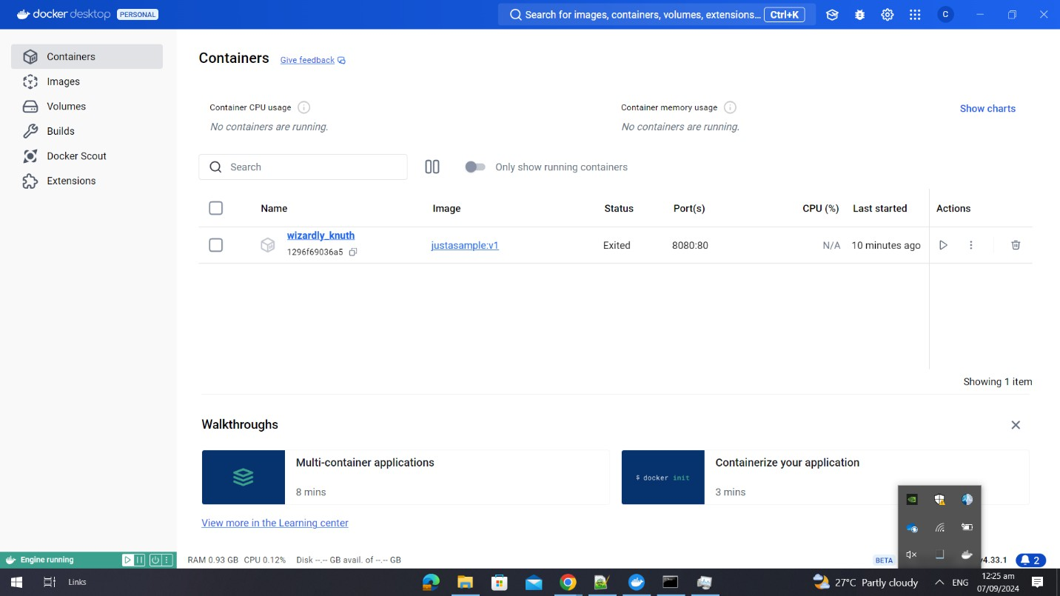

Press Ctrl+C to stop the running container.

Docker Containers
Pull redis image: docker image pull redis
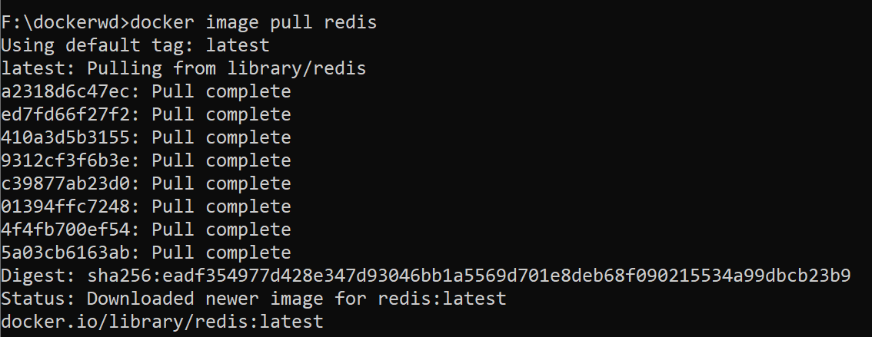
Now check: docker images
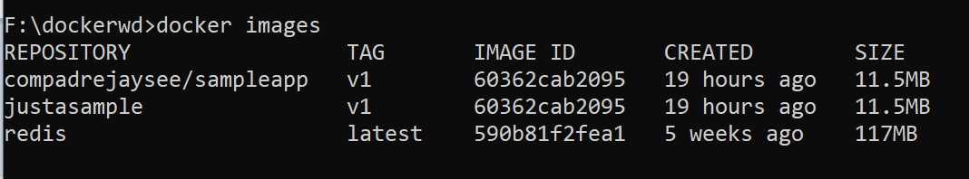
Run the redis container in detached mode: docker run -d --name myredis -p 6379:6379 redis:latest
-d means “detached mode”, i.e., your CMD doesn’t get blocked (like for the sampleapp)
Now run the sampleapp container in detached mode: docker run –d -p 8080:80 justasample:v1
Now check the list of all running containers: docker ps
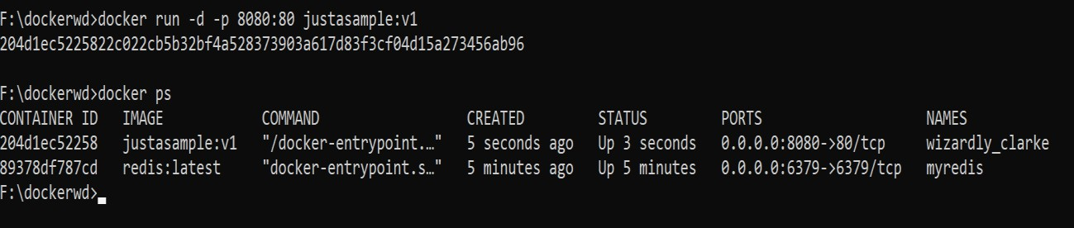
Hash is the containerID. This is a unique, alphanumeric string that Docker assigns to each running container. The full ID is typically 64 characters long, but Docker often displays only the first 12 characters for convenience, as these are usually sufficient to uniquely identify the container among others.
You can use the ContainerID to do many things, stop a running container: Stop the container:
docker stop 204d1ec52258 docker stop 89378df787cd docker ps
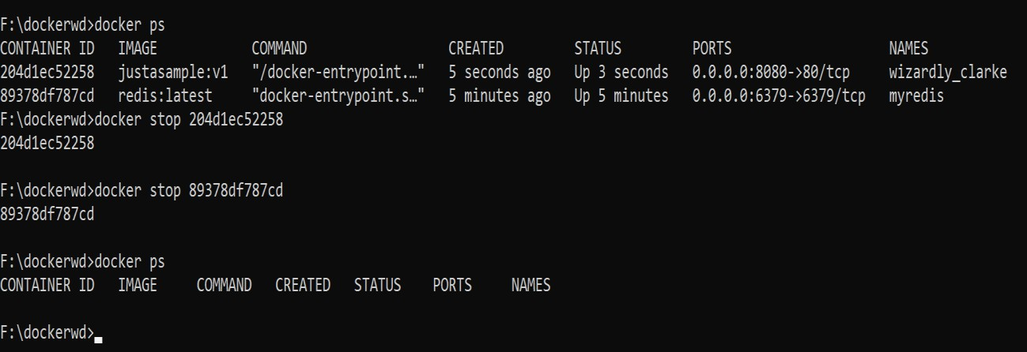
Prune all stopped containers: docker container prune
Verify there are no running containers or stopped containers:
docker ps (list of all running containers)
docker ps –a (list of all containers – both stopped and running in a session)
If you don’t do this, and run the Redis container again with the same name, it might give an error (because a container which has been run once and stopped remains in repo unless it is completely removed through prune or through rm)
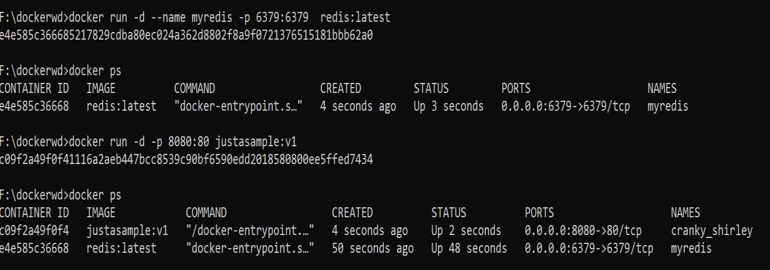
You can see that Docker itself assigns weird or humorous names to containers (if you don’t
assign it)
See the logs of a container: docker logs c09f2a49f0f4 docker logs e4e585c36668

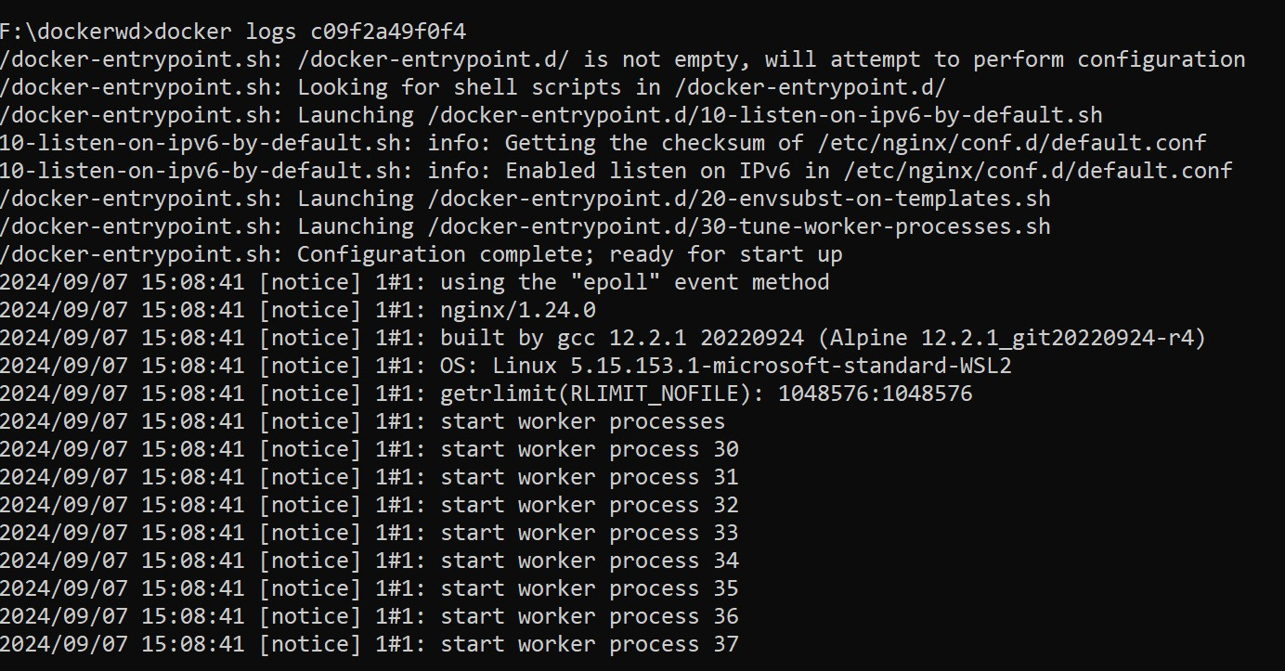
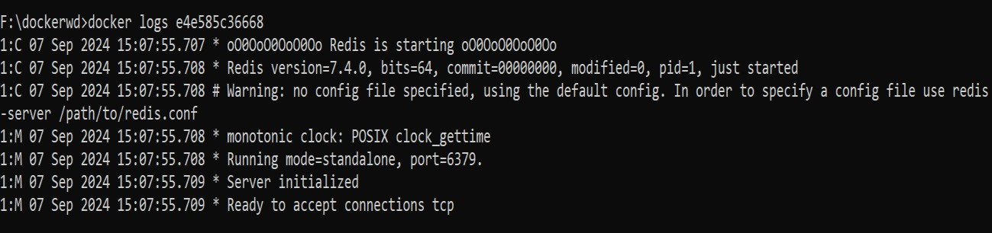
Now stop both containers with rm command:
Delete a running container: docker rm -f e4e585c36668 and docker rm –f c09f2a49f0f4
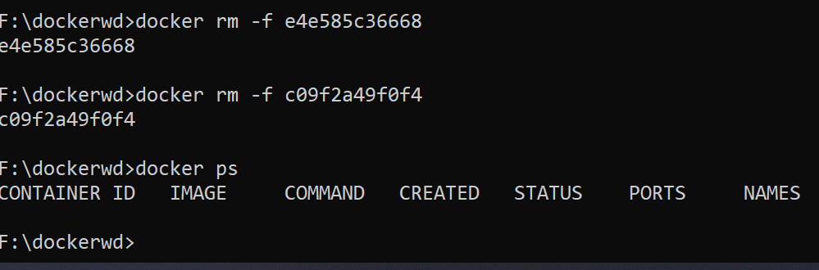

Run the container again: docker run -d -p 8080:80 justasample:v1 Check it running and get id: docker ps
Now stop it: docker stop <containerid> Check it's not running: docker ps
But it's in the repo: docker ps –a
Now start it: docker start <containerid> Check it running: docker ps
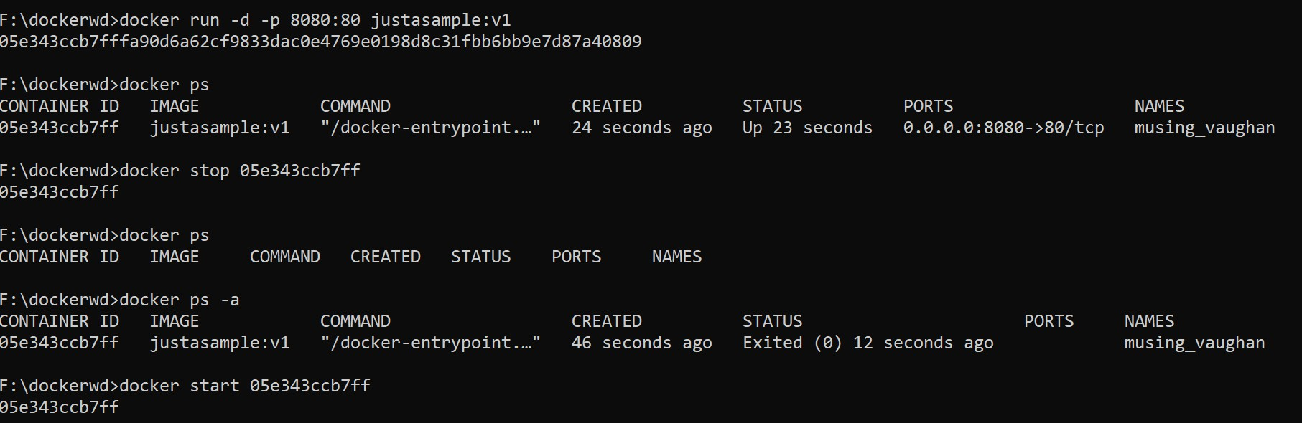
At any time, you can get information about docker through docker info: This will provide information about docker clients and server backends:
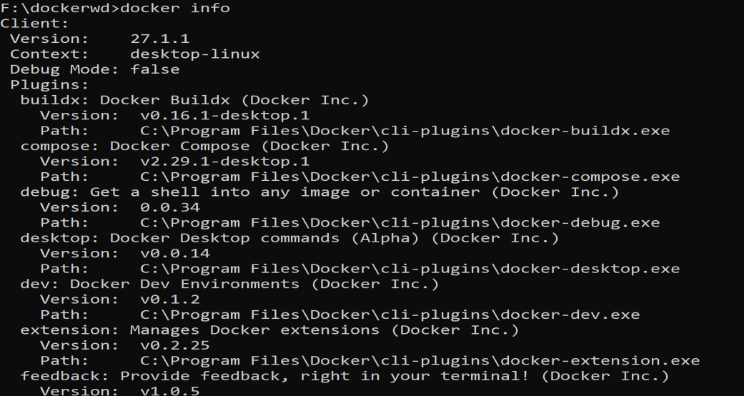

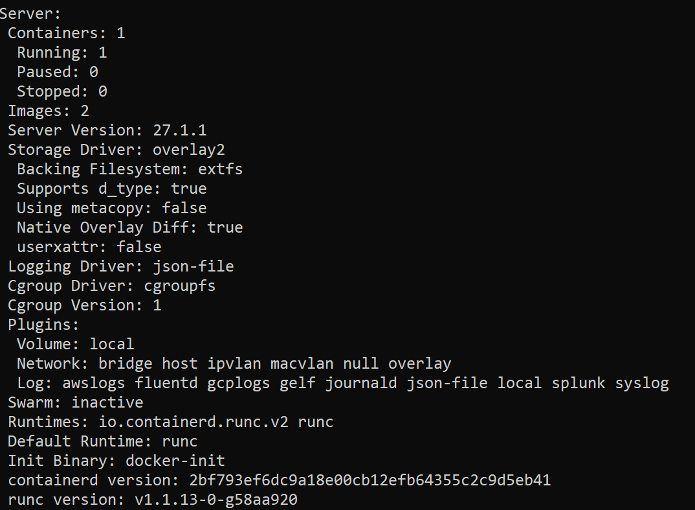
Now, let's try copying file from container to host Download nginx: docker pull nginx
Run a container in the background: docker run –d nginx Check the container id through docker ps: 69e7fe04f1a0
Copy the nginx config file from inside the container to the Windows host: docker cp 69e7fe04f1a0:/etc/nginx/nginx.conf F:/dockerwd
Verify:
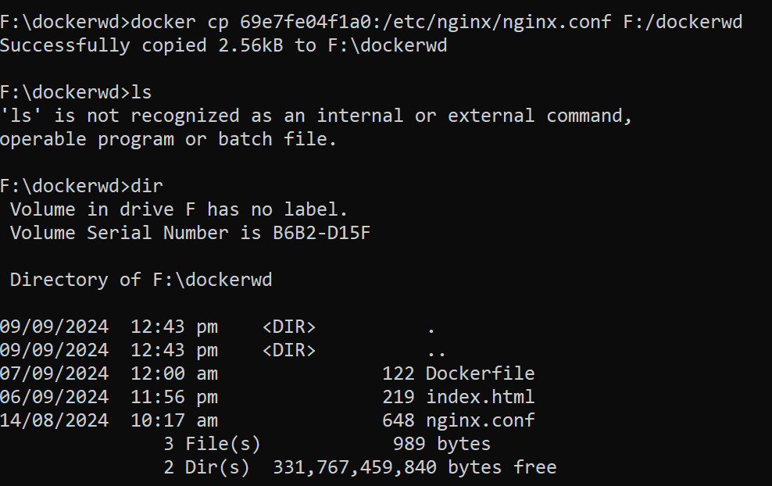

Now, lets copy from the host into the container:
Make a file check.txt in your WD Copy it inside the nginx container:
docker cp F:/dockerwd/check.txt 69e7fe04f1a0:/etc/nginx Should show a success message
Bash into the nginx container: docker exec –it 69e7fe04f1a0/bin/bash Search for directories: ls
Access /etc/nginx and verify your file within

Docker Storage:

Docker supports three main types of storage:
- Volumes → managed by Docker (/var/lib/docker/volumes/).
- Bind Mounts → link host paths into containers.
- tmpfs Mounts → in-memory only (useful for speed, temporary data) – like mounting an ephemeral file system into Docker.

Basic
Try out the following commands within any container of your choice and provide the output.

# Create a named volume
docker volume create myvol

# List all volumes
docker volume ls

# Inspect a specific volume (path, usage, driver)
docker volume inspect myvol

# Remove one or more volumes
docker volume rm myvol

# Remove all unused volumes
docker volume prune

Using Volumes within Containers

docker run -d \
--mount source=myvol,target=/app/data \
--name mount_container \
busybox sleep 3600

Extra: --mount type=volume,source=myvol,target=/data,readonly

Bind Mounts
Bind mounts link an existing host directory/file to a container.

docker run -d \
-v /home/user/data:/container/data \
--name bind_container \
busybox sleep 3600

Check: docker run -d -v /logs:/var/log:ro nginx (host logs mounted read-only into container)

Dockerfile Examples

Simple Python App:
# Base image
FROM python:3.9-slim

# Metadata
LABEL maintainer="teacher@bda.edu"

# Set working directory
WORKDIR /app

# Copy source code
COPY requirements.txt .
RUN pip install -r requirements.txt

COPY app.py .

# Run app
CMD ["python", "app.py"]

docker build -t mypythonapp .
docker run --rm mypythonapp

Web Server:
FROM nginx:alpine
COPY ./html /usr/share/nginx/html
EXPOSE 80

Spark Job in Docker:
FROM bitnami/spark:latest

WORKDIR /app

COPY wordcount.py .

CMD ["spark-submit", "wordcount.py", "hdfs://namenode:9000/input.txt", "hdfs://namenode:9000/output"]

Multi-Stage Build:
# Stage 1: build
FROM maven:3.6-jdk-11 AS builder
WORKDIR /build
COPY . .
RUN mvn package

# Stage 2: run
FROM openjdk:11-jre-slim
WORKDIR /app
COPY --from=builder /build/target/myapp.jar .
CMD ["java", "-jar", "myapp.jar"]

Docker Compose

Docker Compose is a tool to define and run multi-container applications.

Instead of running many docker run commands, you use one YAML file (docker-compose.yml).

With one command (docker-compose up), you can start a whole system (e.g., Spark cluster + Hadoop + Jupyter).

Workflow:
Write a docker-compose.yml file.
docker-compose up -d
docker-compose down

Keywords:
Keyword | Purpose
version | Compose file format (3.9 is latest stable).
services | Defines containers (each service = one container).
image | Use pre-built image.
build | Build from a Dockerfile.
ports | Expose container ports → "HOST:CONTAINER".
volumes | Attach volumes/bind mounts.
networks | Put containers on the same network.
depends_on | Control startup order.
environment | Set environment variables.
command | Override default CMD.
restart | Restart policy (no, always, on-failure).
scale | Run multiple replicas (or use docker-compose up --scale).

Anatomy:
version: "3.9" # Docker Compose file format version

services: # Define all containers here

web: # Service name (like container name)
image: nginx:latest # Use an image from Docker Hub
ports:
- "8080:80" # Map host:container port
volumes:
- webdata:/usr/share/nginx/html # Mount volume
networks:
- mynet # Connect to custom network

app:
build: ./app # Build from Dockerfile in ./app
depends_on:
- db # Start db before app
environment:
- DB_HOST=db
- DB_USER=root
networks:
- mynet

db:
image: mysql:8
environment:
MYSQL_ROOT_PASSWORD: root
MYSQL_DATABASE: testdb
volumes:
- dbdata:/var/lib/mysql
networks:
- mynet

volumes: # Declare named volumes
webdata:
dbdata:

networks: # Declare networks
mynet:

Simple NGINX web server:
version: "3.9"
services:
web:
image: nginx:latest
ports:
- "8080:80"
Run: docker-compose up -d
See: http://localhost:8080

Web + Database:
version: "3.9"
services:
db:
image: mysql:8
environment:
MYSQL_ROOT_PASSWORD: root
MYSQL_DATABASE: mydb
volumes:
- dbdata:/var/lib/mysql

web:
image: phpmyadmin/phpmyadmin
environment:
PMA_HOST: db
ports:
- "8081:80"
depends_on:
- db

volumes:
dbdata:

Python App and Redis:
version: "3.9"
services:
redis:
image: redis:alpine
ports:
- "6379:6379"

app:
build: ./app
command: python app.py
volumes:
- ./app:/usr/src/app
depends_on:
- redis

Spark Cluster (BDA):
version: "3.9"
services:
spark-master:
image: bitnami/spark:latest
environment:
- SPARK_MODE=master
ports:
- "7077:7077"
- "8080:8080"

spark-worker:
image: bitnami/spark:latest
environment:
- SPARK_MODE=worker
- SPARK_MASTER_URL=spark://spark-master:7077
depends_on:
- spark-master
deploy:
replicas: 2

Hadoop Namenode + Datanode:
version: "3.9"
services:
namenode:
image: bde2020/hadoop-namenode:2.0.0-hadoop3.2.1-java8
environment:
- CLUSTER_NAME=test
ports:
- "9870:9870"
volumes:
- namenode:/hadoop/dfs/name

datanode:
image: bde2020/hadoop-datanode:2.0.0-hadoop3.2.1-java8
environment:
- CLUSTER_NAME=test
ports:
- "9864:9864"
volumes:
- datanode:/hadoop/dfs/data
depends_on:
- namenode

volumes:
namenode:
datanode:

Useful Commands:
# Start services (detached)
docker-compose up -d

# Stop and remove
docker-compose down

# Rebuild images and restart
docker-compose up --build -d

# View logs
docker-compose logs -f

# List running services
docker-compose ps

# Scale service (e.g., 3 workers)
docker-compose up -d --scale spark-worker=3

Exercise – Combine it all

Exercise 1: Multi-Service Log Analyzer with Volumes & Compose
Statement: Create a system that ingests log files into a container, stores them in a volume, processes them with a Python app, and makes results accessible via a web dashboard.

Services:
- Python Log Processor → parses logs and writes summaries.
- Postgres → stores parsed results.
- Adminer (web UI for DB) → lets students access and query data.

Exercise 2: Word Frequency Analyzer with Web UI, Redis, and Background Worker
Statement: Build a web app where users upload text files through a Flask frontend. Files are stored in a volume, queued in Redis, processed by a worker container, and results (word counts) are stored back into Redis. The web app then displays processed results.
Hints:
- Write a Dockerfile for a custom Flask app.
- Use Redis as a message queue/cache.
- Run multi-container apps with Docker Compose.
- Mount bind mounts and named volumes to manage persistent storage.
- Access and interact with the system from a browser and CLI.

