Hadoop Single-Node Lab — Phase 1 & Phase 2
Concise explanations and all relevant commands for Phase 1 (single-worker, UI-friendly) and Phase 2 (scalable workers).

Phase 1 — Setup, single-worker (UI-friendly)
Goal: Install Docker & Compose, clone repos, expose UIs, run a 1-master + 1-worker cluster, basic HDFS/YARN tasks.

Prerequisites
- Ubuntu 18.04 / 20.04 / 22.04
- ≥8 GB RAM recommended; internet access
- Docker + Compose V2 plugin (commands use `docker compose`)

Install Docker & Compose (copy/paste)
sudo apt update && sudo apt upgrade -y
sudo apt install -y git curl ca-certificates gnupg lsb-release
curl -fsSL https://download.docker.com/linux/ubuntu/gpg | sudo gpg --dearmor -o /usr/share/keyrings/docker-archive-keyring.gpg
echo "deb [arch=amd64 signed-by=/usr/share/keyrings/docker-archive-keyring.gpg] https://download.docker.com/linux/ubuntu $(lsb_release -cs) stable" | sudo tee /etc/apt/sources.list.d/docker.list > /dev/null
sudo apt update
sudo apt install -y docker-ce docker-ce-cli containerd.io
sudo systemctl enable --now docker
sudo usermod -aG docker $USER
newgrp docker # or log out/in
sudo apt install -y docker-compose-plugin

Workspace & clone repos
mkdir -p ~/docker/hadoop && cd ~/docker/hadoop
git clone https://github.com/tomwhite/hadoop-book.git
git clone https://github.com/big-data-europe/docker-hadoop.git
cd docker-hadoop

Edit compose (expose UIs) — Phase 1 (optional)
For Phase 1 it's OK to map DataNode/NM ports so UIs are host-accessible. Edit docker-compose.yml and add ports for UI services:
# Example (add ports: under each service)
# NameNode: 9870:9870
# DataNode: 9864:9864 (only for single-replica/debug)
# ResourceManager: 8088:8088
# NodeManager: 8042:8042
# HistoryServer: 8188:8188

Start cluster (1 DataNode / 1 NodeManager)
docker compose up -d
docker compose ps
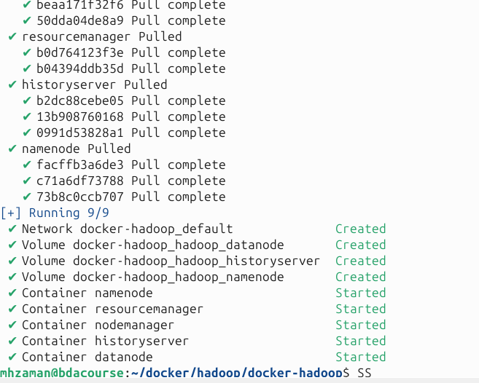

Basic HDFS & WordCount
# create HDFS dir and copy a sample file
docker compose exec namenode hdfs dfs -mkdir -p /user/root/input
cat > ~/docker/hadoop/words.txt <<'EOF'
The quick brown fox jumps over the lazy dog.
EOF
docker compose cp ~/docker/hadoop/words.txt namenode:/tmp/words.txt
docker compose exec namenode hdfs dfs -copyFromLocal /tmp/words.txt /user/root/input
# download examples jar (host) and copy to namenode
cd ~/docker/hadoop
curl -L -O https://repo1.maven.org/maven2/org/apache/hadoop/hadoop-mapreduce-examples/2.7.1/hadoop-mapreduce-examples-2.7.1.jar
docker compose cp hadoop-mapreduce-examples-2.7.1.jar namenode:/tmp/
# run WordCount
docker compose exec namenode hadoop jar /tmp/hadoop-mapreduce-examples-2.7.1.jar \
org.apache.hadoop.examples.WordCount /user/root/input /user/root/output_wc
# view output
docker compose exec namenode hdfs dfs -cat /user/root/output_wc/part-r-00000

Phase 1 checks & cleanup
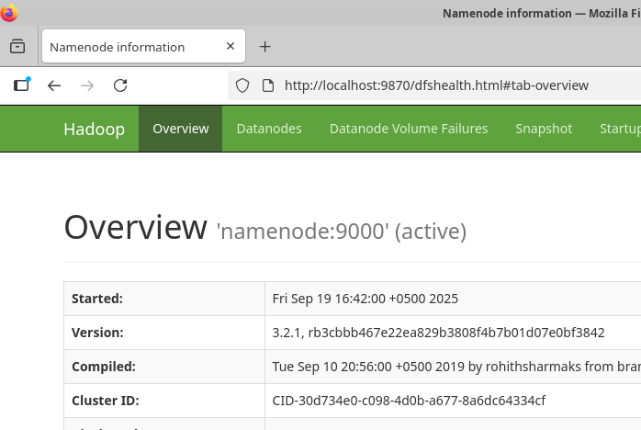
# UIs (host): http://<host>:9870 (NameNode), :8088 (ResourceManager), :8042 (NodeManager), :8188 (History), :9864 (DataNode if mapped)
docker compose logs <service> --tail 200
docker compose exec <service> jps
# stop/remove but keep volumes:
docker compose down
# remove volumes (delete HDFS data):
docker compose down -v

