Hadoop Single-Node Lab — Phase 1 & Phase 2
Concise explanations and all relevant commands for Phase 1 (single-worker, UI-friendly) and Phase 2 (scalable workers).

ZUHA AQIB & MAHNOOR ADEEL

Phase 1 — Setup, single-worker (UI-friendly)
Goal: Install Docker & Compose, clone repos, expose UIs, run a 1-master + 1-worker cluster, basic HDFS/YARN tasks.

Prerequisites
- Ubuntu 18.04 / 20.04 / 22.04
- ≥8 GB RAM recommended; internet access
- Docker + Compose V2 plugin (commands use `docker compose`)

Install Docker & Compose (copy/paste)
sudo apt update && sudo apt upgrade -y
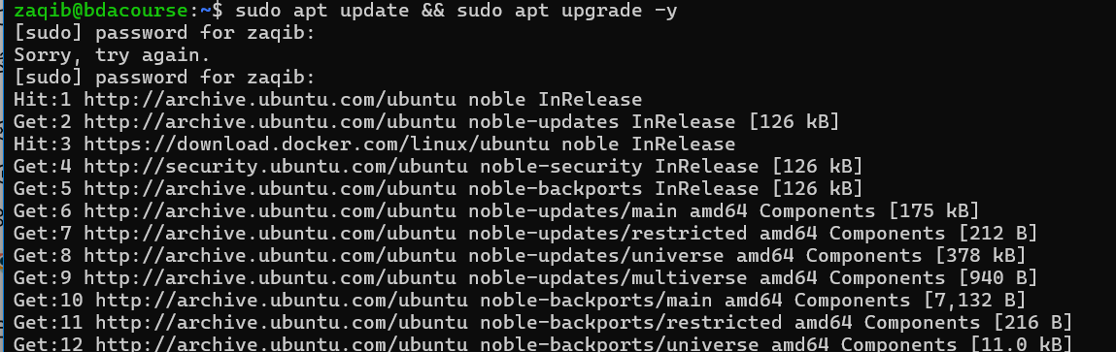
sudo apt install -y git curl ca-certificates gnupg lsb-release
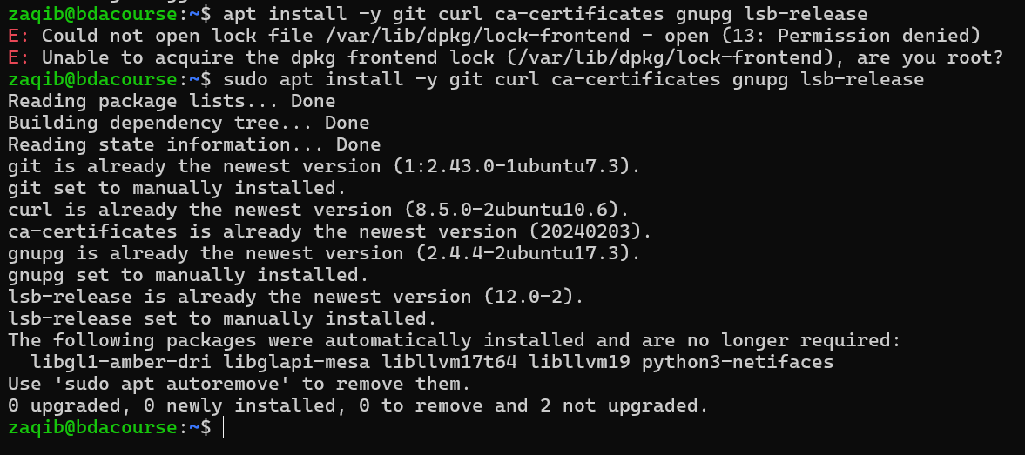
curl -fsSL https://download.docker.com/linux/ubuntu/gpg | sudo gpg --dearmor -o /usr/share/keyrings/docker-archive-keyring.gpg
echo "deb [arch=amd64 signed-by=/usr/share/keyrings/docker-archive-keyring.gpg] https://download.docker.com/linux/ubuntu $(lsb_release -cs) stable" | sudo tee /etc/apt/sources.list.d/docker.list > /dev/null
sudo apt update
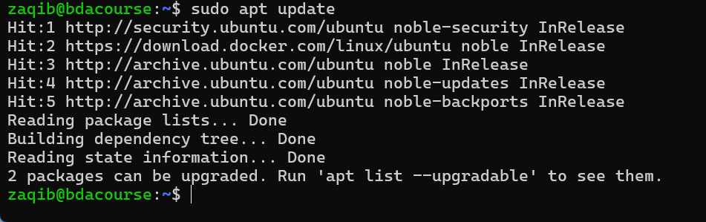
sudo apt install -y docker-ce docker-ce-cli containerd.io
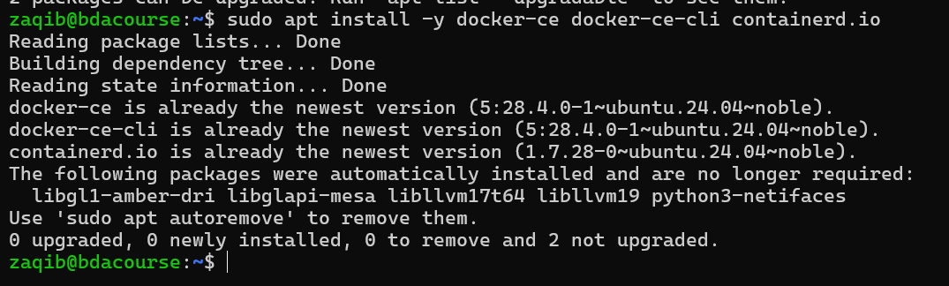
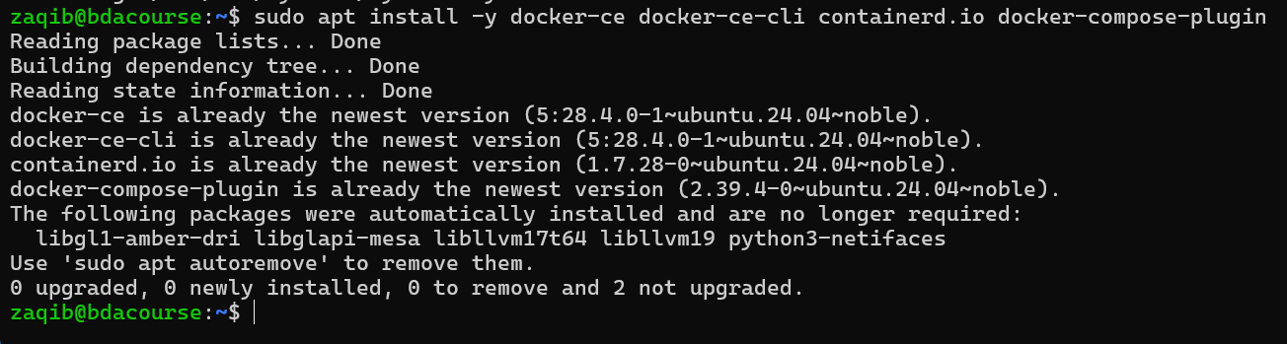
sudo systemctl enable --now docker
sudo usermod -aG docker $USER
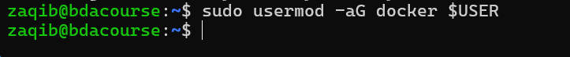
newgrp docker # or log out/in
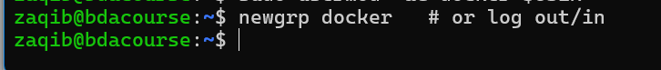
sudo apt install -y docker-compose-plugin
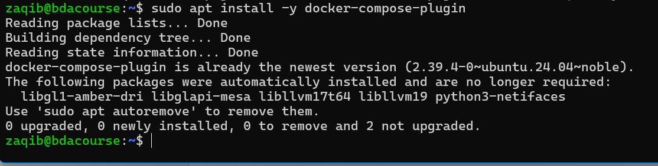

Workspace & clone repos
mkdir -p ~/docker/hadoop && cd ~/docker/Hadoop
git clone https://github.com/tomwhite/hadoop-book.git
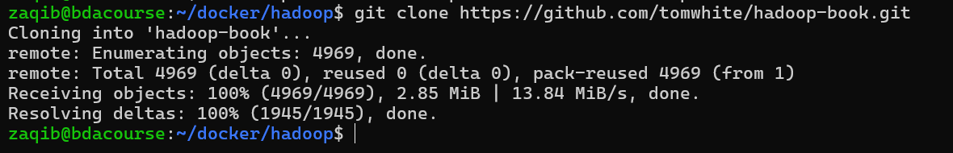
git clone https://github.com/big-data-europe/docker-hadoop.git
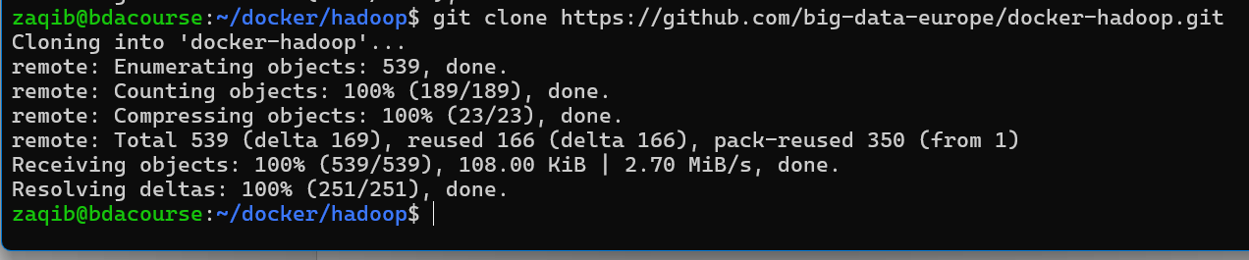
cd docker-hadoop
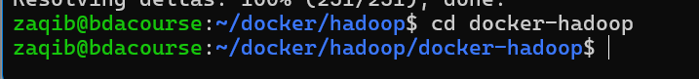

Edit compose (expose UIs) — Phase 1 (optional)
For Phase 1 it's OK to map DataNode/NM ports so UIs are host-accessible. Edit docker-compose.yml and add ports for UI services:
# Example (add ports: under each service)
# NameNode: 9870:9870
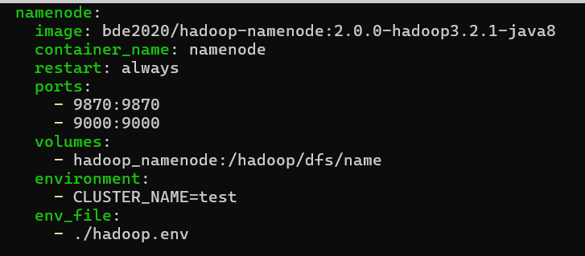
# DataNode: 9864:9864 (only for single-replica/debug)
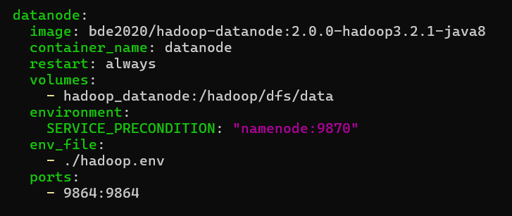
# ResourceManager: 8088:8088
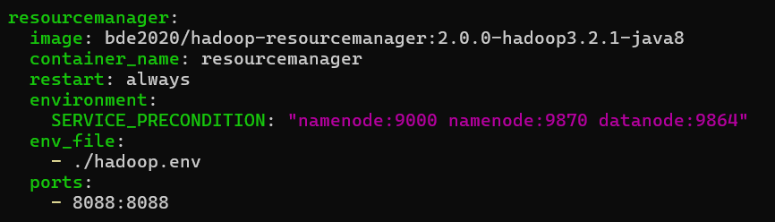
# NodeManager: 8042:8042
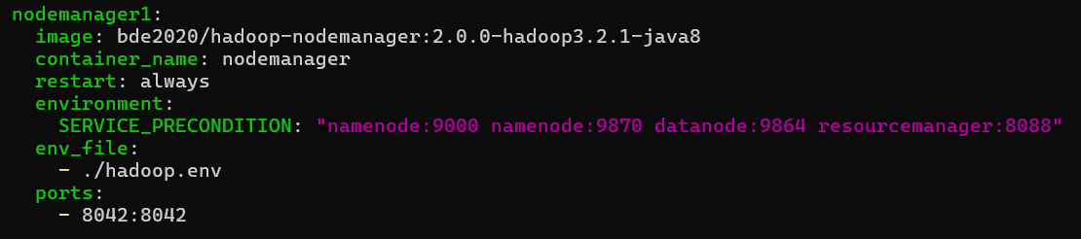
# HistoryServer: 8188:8188
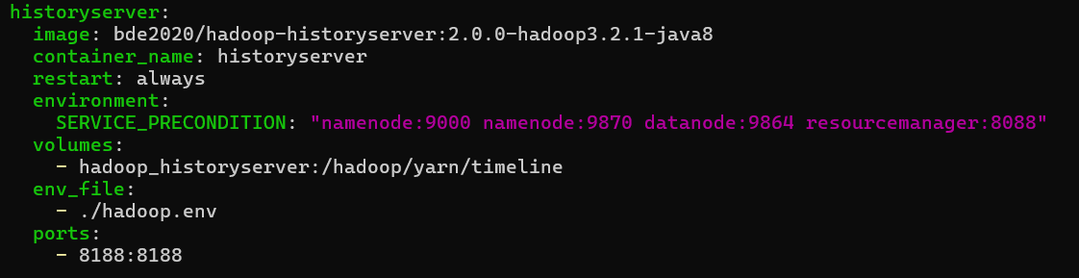

Start cluster (1 DataNode / 1 NodeManager)
docker compose up -d
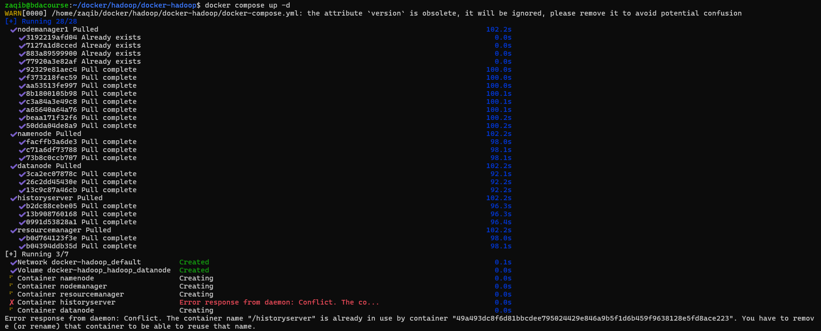
Gave error because me and my partner were running it together so only one docker container existed. So we both first stopped all:
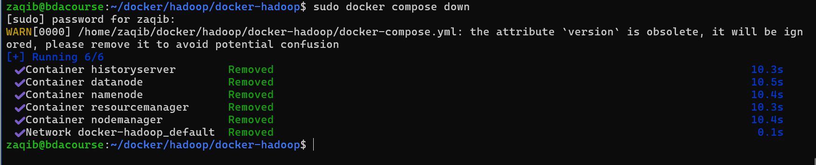
And now my partner is running it.
So now (its 6am) my partner isn’t running it so I am:
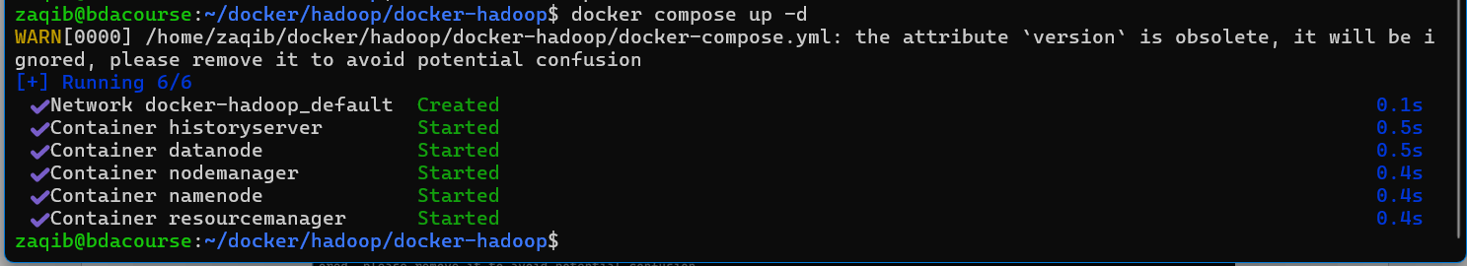
docker compose ps
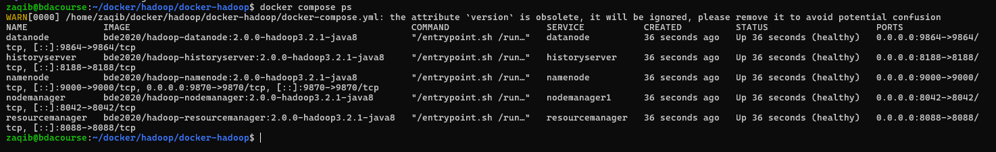
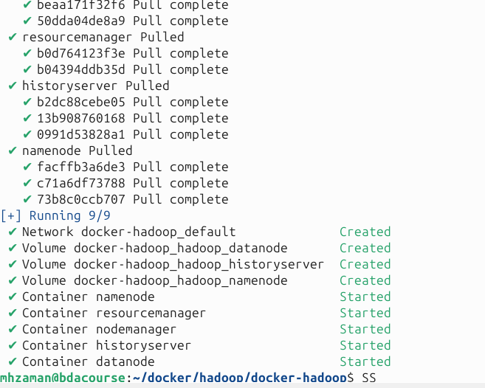

Basic HDFS & WordCount
SIR HAS TOLD US TO MAKE A 500MB TEXT FILE INSTEAD OF JUST A FEW WORDS. SO I WILL MAKE IT USING LINUX PRE INSTALLED LIBRARY “SHUF”.
First we make the words source txt FILE using linux pre installed dictionary
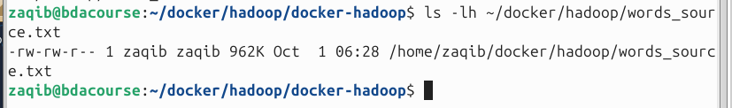
SO CURRENTLY THE SIZE OF THE FILE IS 962K. SO LETS USE “SHUF” LIBRARY TO GENERATE 10 MILLION MORE LINES
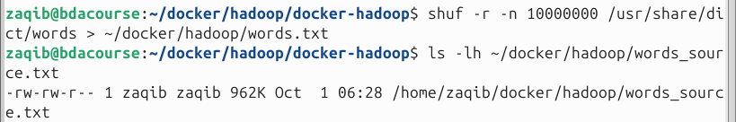
BUT 10 MILLION LINES ONLY GAVE US 90 MB. SO LETS 5-6 TIMES THAT. LETS MAKE 60 MILLION LINES
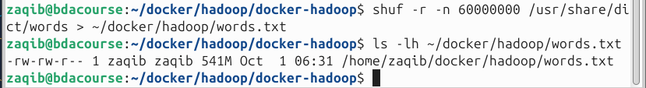
SO PERFECT – WE NOW HAVE 541MB OF DATA. LETS SEE IT
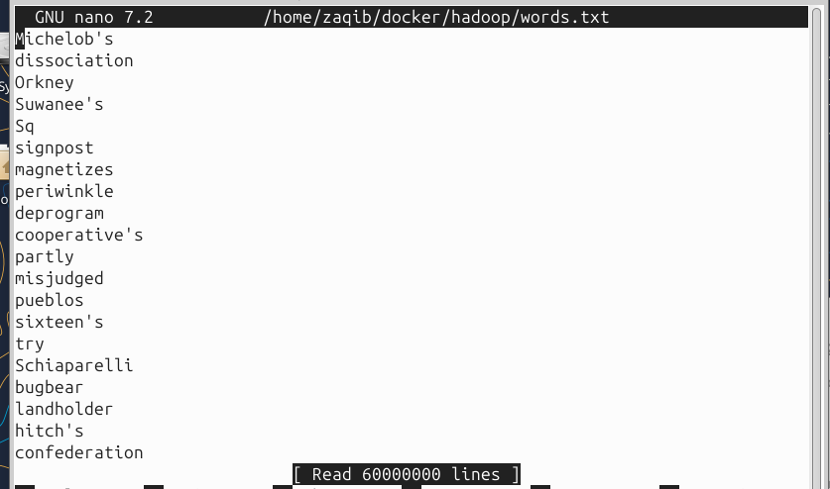
SO ITS CONFIRMED, ITS RANDOM ENGLISH WORDS. DONE.

# create HDFS dir and copy a sample file
docker compose exec namenode hdfs dfs -mkdir -p /user/root/input
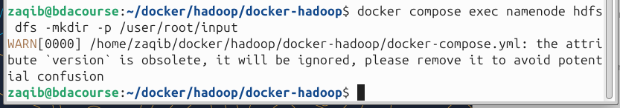
cat > ~/docker/hadoop/words.txt <<'EOF'
The quick brown fox jumps over the lazy dog.
EOF
COMMAND NOT NEEDED
docker compose cp ~/docker/hadoop/words.txt namenode:/tmp/words.txt
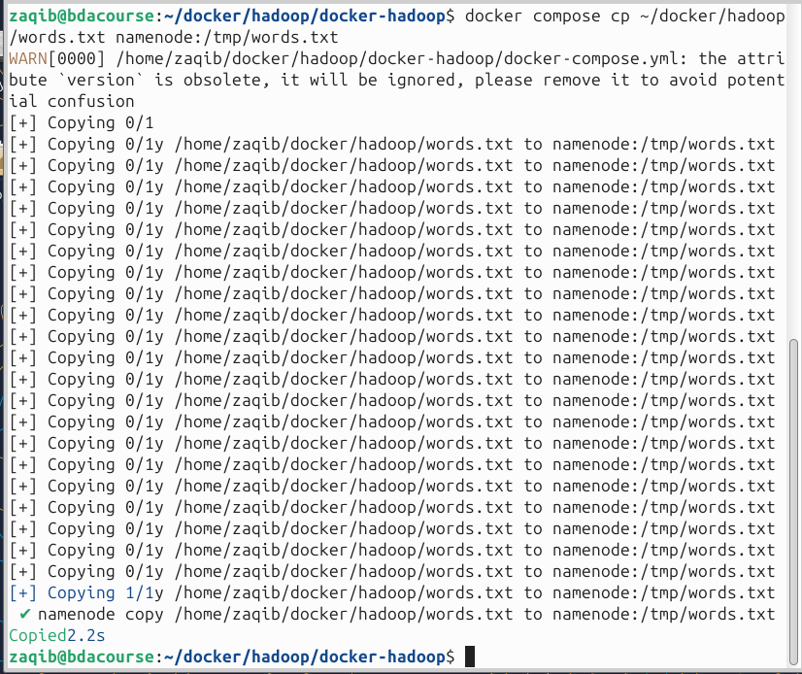
docker compose exec namenode hdfs dfs -copyFromLocal /tmp/words.txt /user/root/input
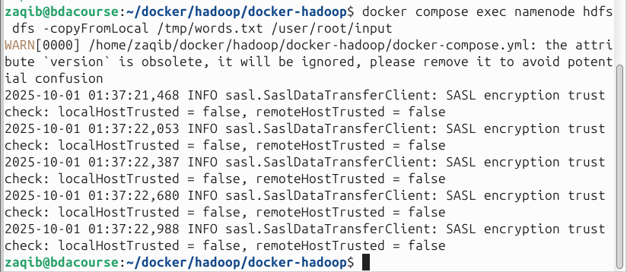
# download examples jar (host) and copy to namenode
cd ~/docker/hadoop
curl -L -O https://repo1.maven.org/maven2/org/apache/hadoop/hadoop-mapreduce-examples/2.7.1/hadoop-mapreduce-examples-2.7.1.jar
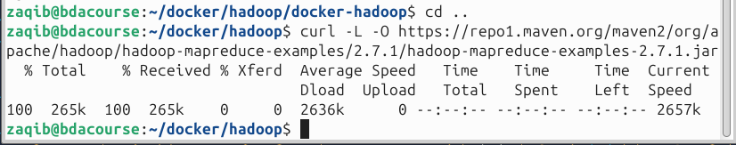
docker compose cp hadoop-mapreduce-examples-2.7.1.jar namenode:/tmp/
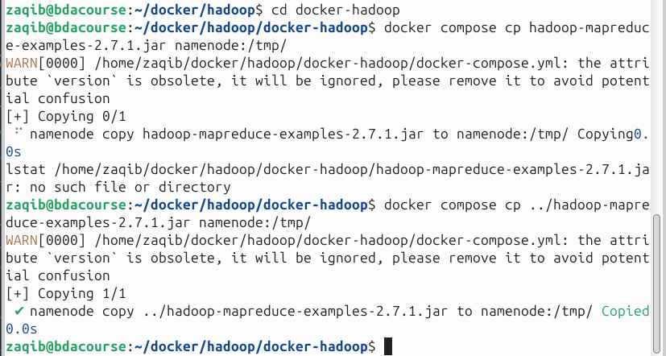
SO FIRST I GOT AN ERROR THAT IT COULD NOT FIND THE JAR FILE AND THAT WAS BECAUSE THE JAR FILE WAS IN /DOCKER/HADOOP/ BUT THE CONFIG FILE WAS IN /DOCKER/HADOOP/DOCKER-HADOOP/ SO WE HAD TO ADD ../ INFRONT OF THE JAR FILE NAME SO THAT IT WOULD FIND THE JAR FILE IN ONE DIRECTORY UP.
# run WordCount
docker compose exec namenode hadoop jar /tmp/hadoop-mapreduce-examples-2.7.1.jar \
org.apache.hadoop.examples.WordCount /user/root/input /user/root/output_wc
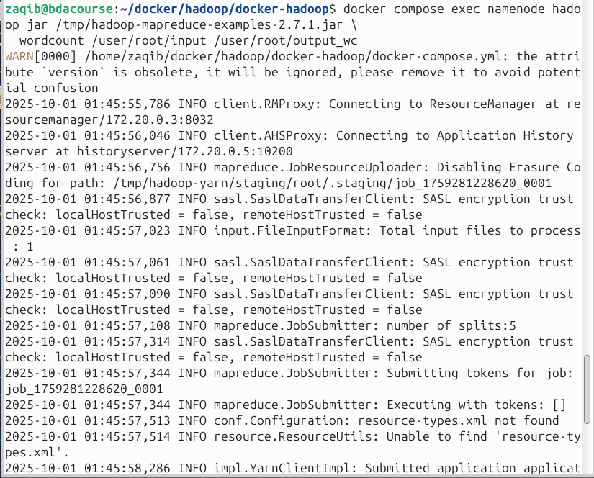
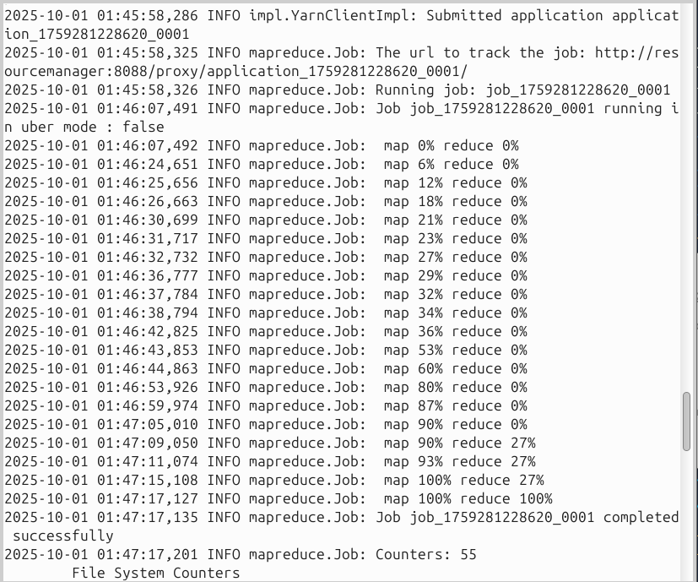
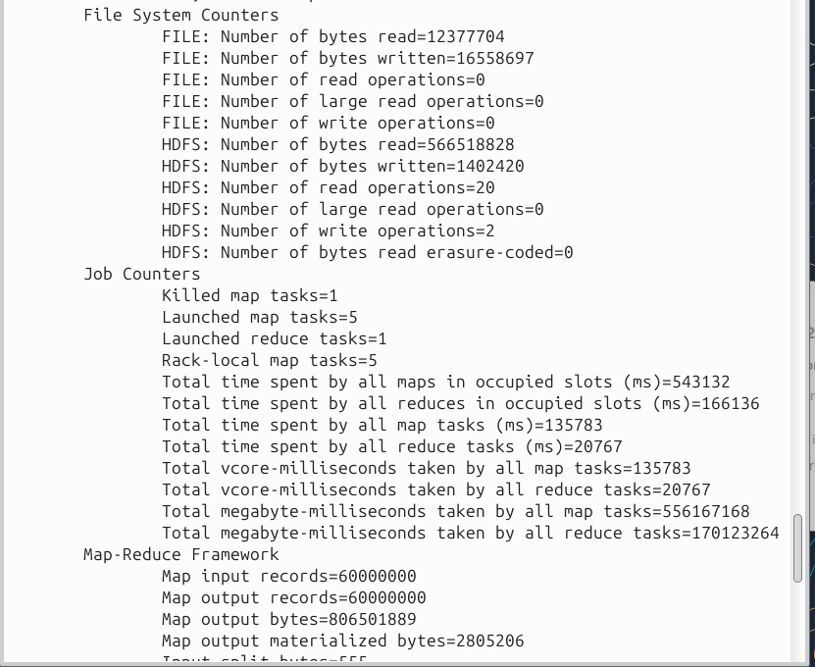
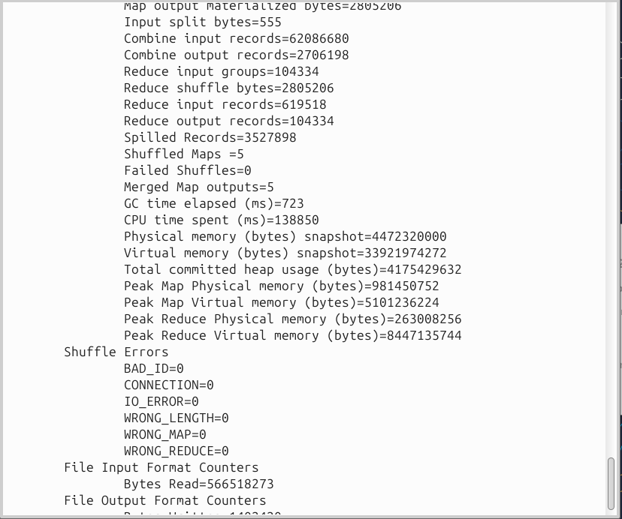
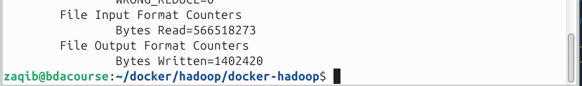
# view output
docker compose exec namenode hdfs dfs -cat /user/root/output_wc/part-r-00000
THE OUTPUT WAS TOO BIG
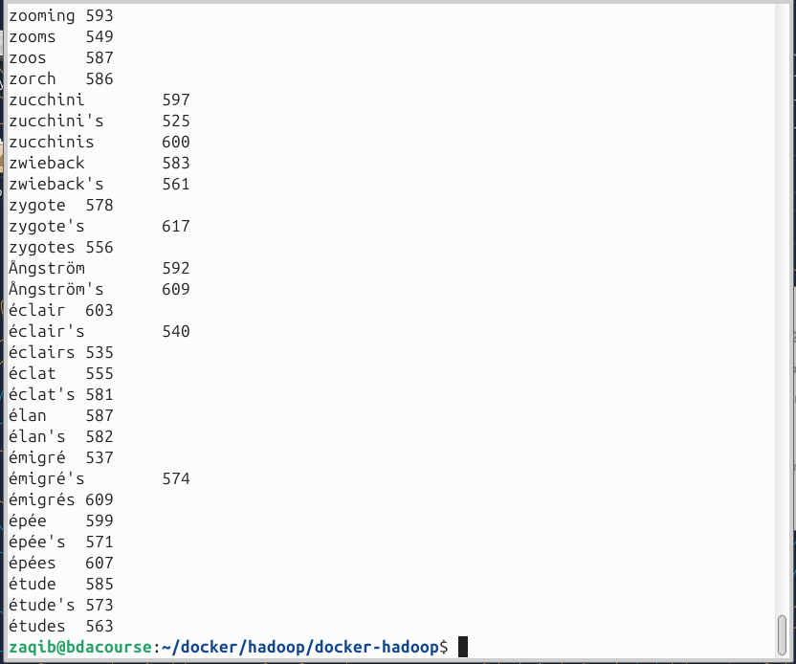

LETS SAVE THE OUTPUT IN A TXT FILE
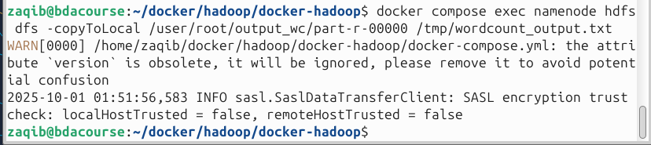
FIRST WE COPY THE OUTPUT INTO OUR CONTAINER
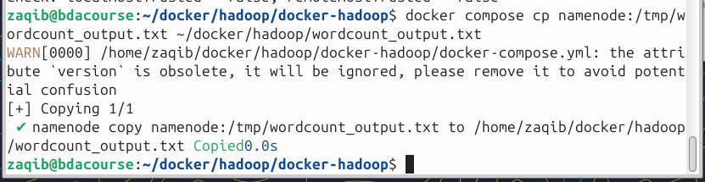
AND THEN FROM THE CONTAINER WE COPY IT INTO OUR LOCAL DIRECTORY. SO DONE

Phase 1 checks & cleanup
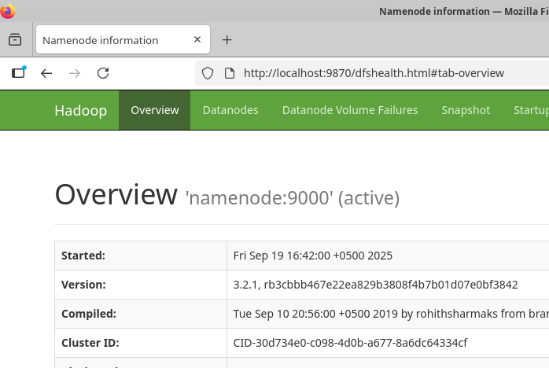
# UIs (host): http://<host>:9870 (NameNode), :8088 (ResourceManager), :8042 (NodeManager), :8188 (History), :9864 (DataNode if mapped)
docker compose logs <service> --tail 200
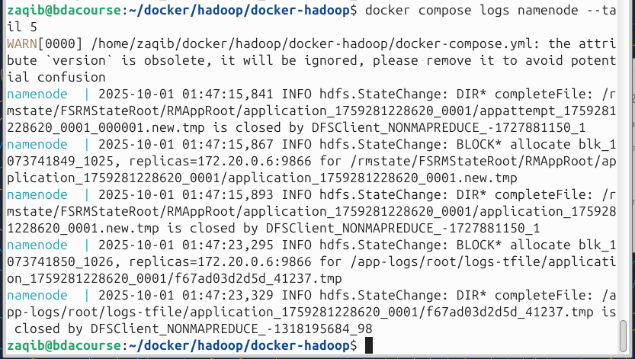
SO I DID 200 BUT IT WAS TOO LONG TO BE ATTACHED. THEN I DID 50 YET STILL TOO LONG. THEN 10 BUT TOO LONG. SO HERE IS 5.
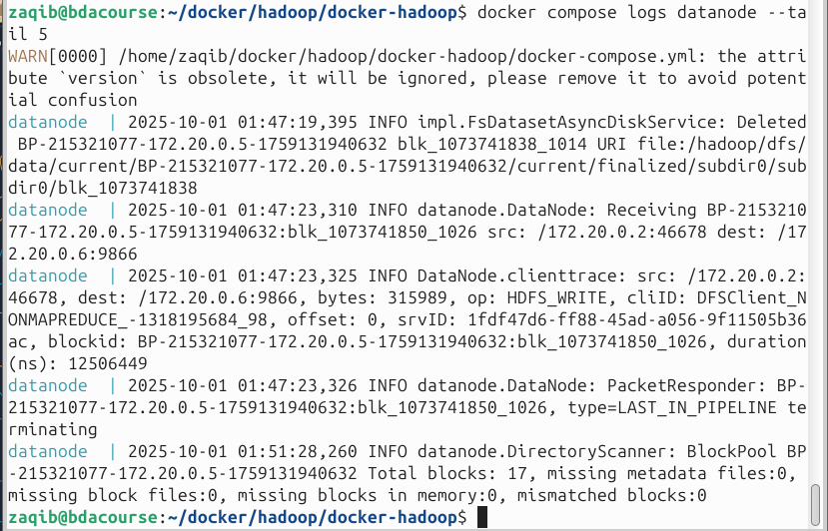
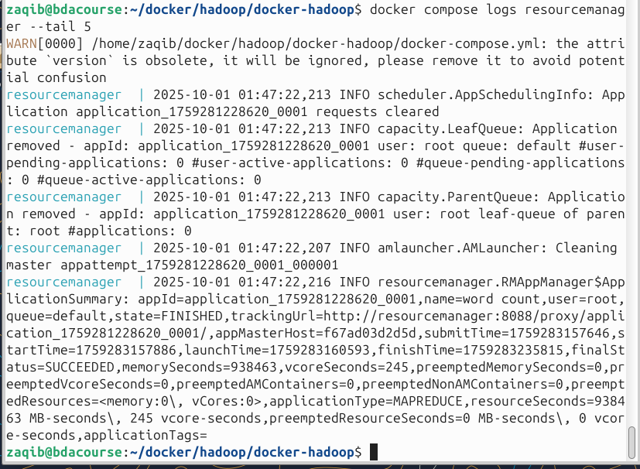
docker compose exec <service> jps
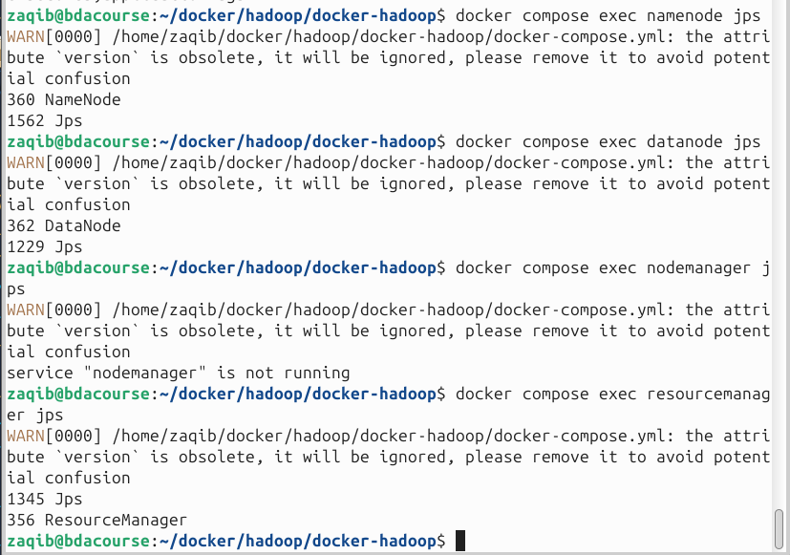
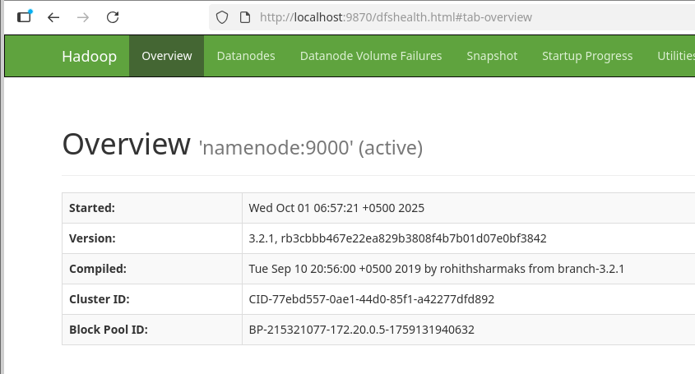
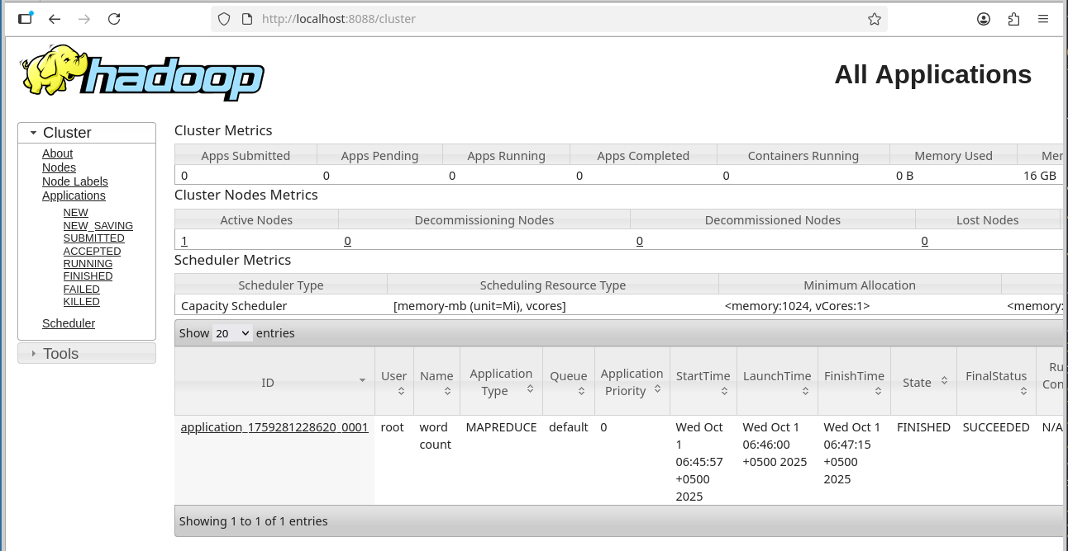
SO WE SEE THAT THE WORD COUNT HADOOP IS COMPLETED
# stop/remove but keep volumes:
docker compose down
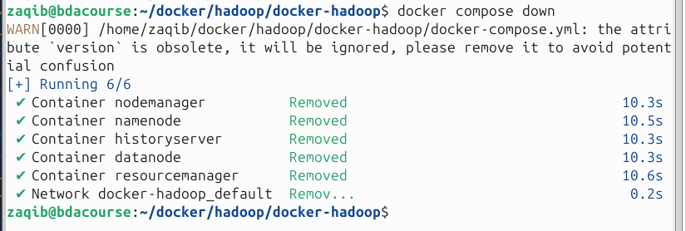
# remove volumes (delete HDFS data):
docker compose down -v

