Lab: Introduction to Linux & Scripting

Part A: The Basics
This lab is designed to give you hands-on experience with fundamental Linux commands, file system navigation, and basic shell scripting within a safe, disposable container environment.

1. Launch a Container
Start a fresh, interactive container with a mounted volume to save your work on the host system.
sudo docker run -it --rm -v ~/lab_out:/root ubuntu:24.04 bash
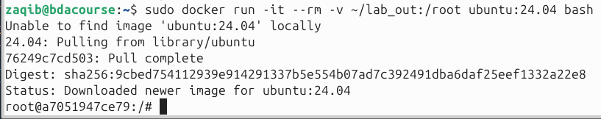

2. Install Necessary Utilities
Inside the container, update the package list and install the tools we'll need for the exercises.
apt update
apt install -y file tar gzip findutils coreutils
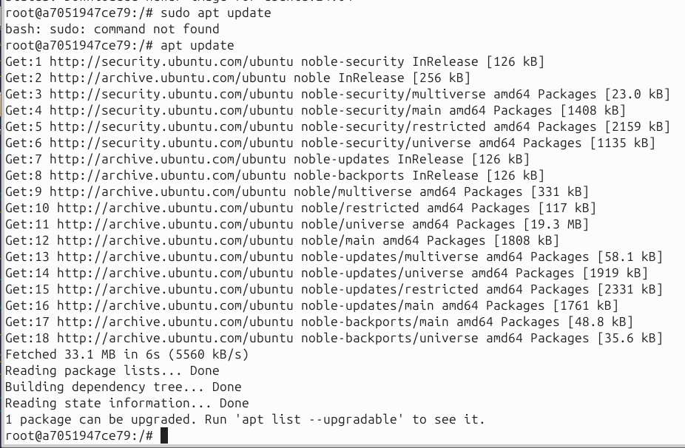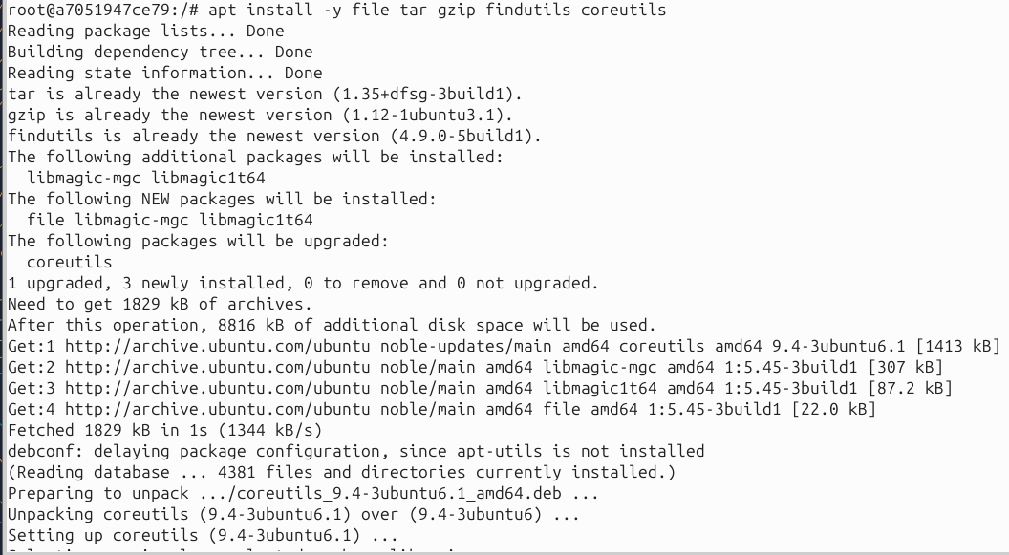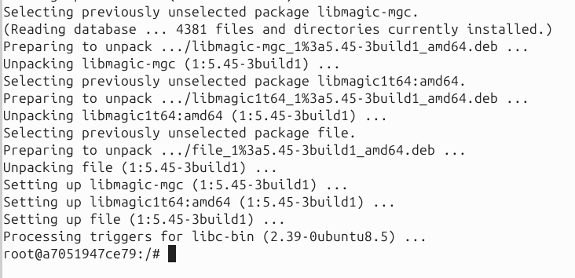

Part A: Basic Navigation and File System Exploration
This section focuses on core commands for navigating the file system and inspecting files.
Task 1: Navigate the File System
Check your current directory:
pwd
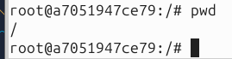

List the contents of the current directory:
ls

List the contents of the /usr/bin directory:
ls /usr/bin
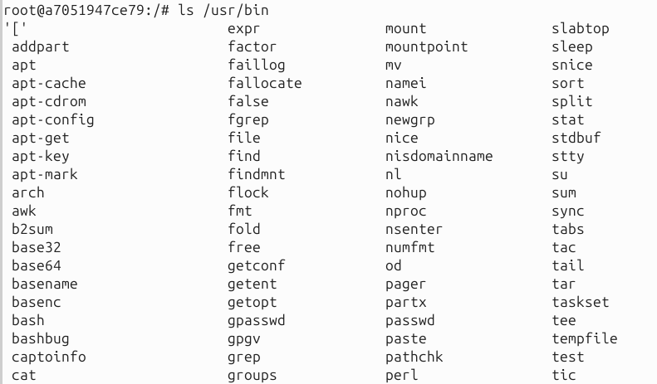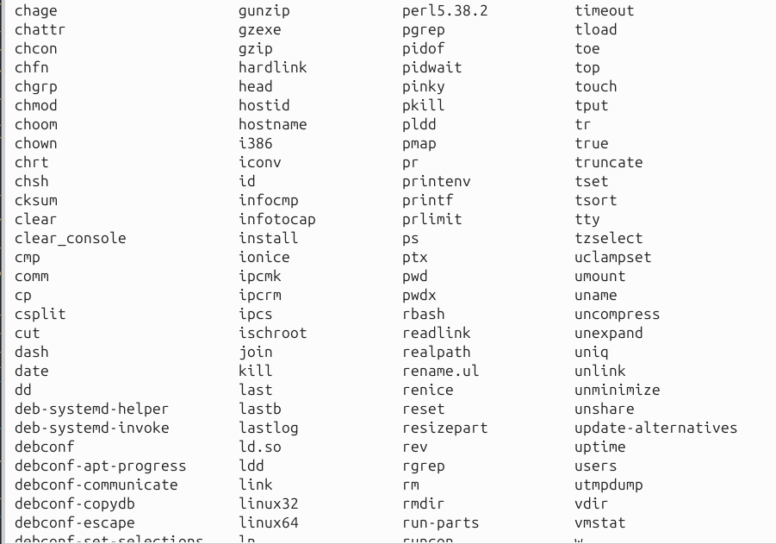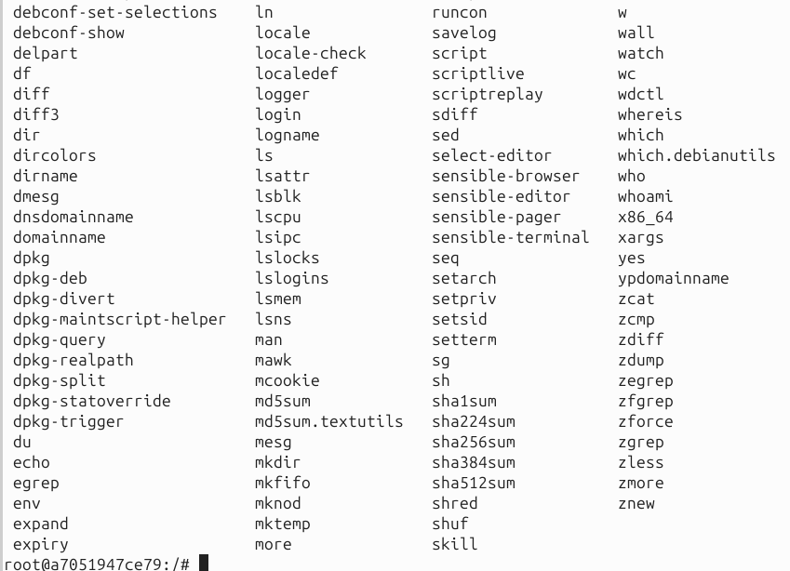

Change your directory to /usr/local:
cd /usr/local
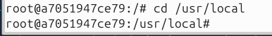

Go back to your home directory (/root):
cd
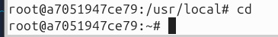

Task 2: Inspect Files
Find the full path of the sh binary:
which sh
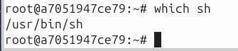

Check the type of the /bin/ls file. Note if it is a regular file or a symbolic link.
file /bin/ls
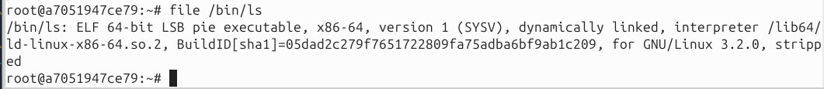

Check if the /bin/sh binary is executable:
test -x /bin/sh && echo "Executable" || echo "Not Executable"

Task 3: Permissions and Counting
Show the detailed permissions of the /bin/ls file. Save the output to a file named ls_perm.txt in your /root directory.
bash
ls -l /bin/ls > /root/ls_perm.txt

Add a brief explanation of the permission string to the file.
bash
printf "\nExplanation: The first character is the file type. The next nine characters represent permissions for the owner, group, and others (r=read, w=write, x=execute).\n" >> /root/ls_perm.txt

Count the total number of entries (files and directories) in the /bin folder and save the count to a file named bin_count.txt.
bash
ls -1 /bin | wc -l > /root/bin_count.txt

Part B: Scripting and Automation
This section applies what you've learned to a practical problem: identifying and archiving the largest files on the system.
Task 4: Find the Largest Files
Use a combination of find, sort, and head to locate the three largest files under the /usr directory. Save the file sizes and paths to a file named top3_usr.txt.
- find /usr: Searches for files under the /usr directory.
- -type f: Specifies that we are looking for regular files only.
- -printf '%s %p\n': Prints the file size in bytes (%s) and the file path (%p).
- 2>/dev/null: Discards any permission errors that find might generate.
- sort -nr: Sorts the output numerically (-n) in reverse (-r) order, from largest to smallest.
- head -n 3: Takes the first three lines of the sorted output.
bash
find /usr -type f -printf '%s %p\n' 2>/dev/null | sort -nr | head -n 3 > /root/top3_usr.txt

Task 5: Create a Shell Script to Archive Files
This is the main project of the lab. You will create a reusable shell script that can find and archive the largest files in any specified directory.
- Create a script file named top3_archive.sh using cat. The <<'SH' syntax allows you to paste the script block directly.
bash
cat > /root/top3_archive.sh <<'SH'
#!/usr/bin/env sh
# This script finds and archives the top N largest regular files in a directory.

# 1. Define variables with default values
TARGET=${1:-/usr}
OUT_DIR=${2:-/root}
N=${3:-3}
TMP=/tmp/top_files.list

# 2. Create the output directory if it doesn't exist
mkdir -p "$OUT_DIR"

# 3. Find top N files and save their paths to a temporary file
find "$TARGET" -type f -printf '%s %p\n' 2>/dev/null | sort -nr | head -n "$N" > "$TMP"

# 4. If files are found, use tar to create a gzipped archive
if [ -s "$TMP" ]; then
awk '{print $2}' "$TMP" | tar -czvf "$OUT_DIR/top_${N}_files.tar.gz" -T -
fi

# 5. Clean up the temporary file
rm -f "$TMP"
SH
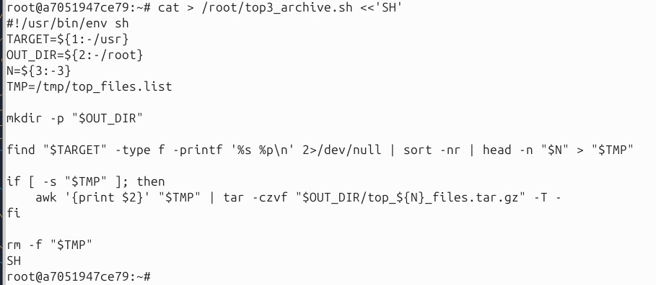

Make the script executable:
bash
chmod +x /root/top3_archive.sh
Run the script to create an archive of the top 3 largest files in /usr:
bash
/root/top3_archive.sh /usr /root 3
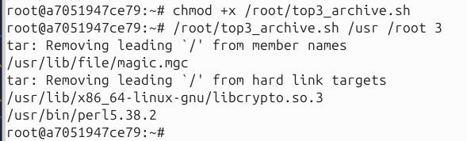

Exit and Verify Deliverables
Once you've completed all the tasks, exit the container. The files you created will be saved to the ~/lab_out directory on your host machine.
bash
exit
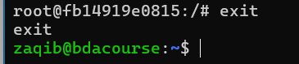

Now, on your host machine, you can check that all the files and the archive were created successfully.
bash
ls -la ~/lab_out
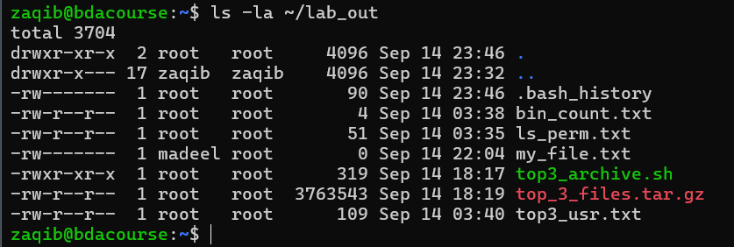
cat ~/lab_out/bin_count.txt
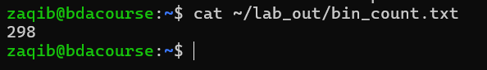
cat ~/lab_out/top3_usr.txt
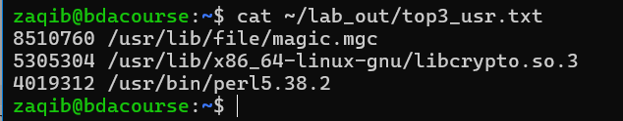
tar -tzvf ~/lab_out/top_3_files.tar.gz
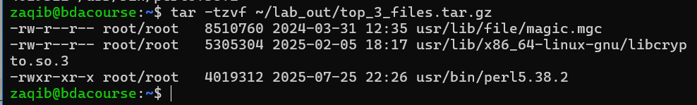
cat ~/lab_out/ls_perm.txt
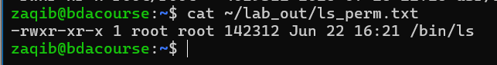

This final step reinforces the concept of persistent data in a containerized environment

File and Process Management
This section introduces concepts related to file ownership, user management, and process monitoring.
Task 6: Ownership and Permissions
Create a new file: In your home directory (/root), create a new empty file called my_file.txt.
touch my_file.txt
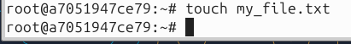

Check initial ownership: Use ls -l to see who the owner and group are for this new file. They should both be root.
ls -l my_file.txt
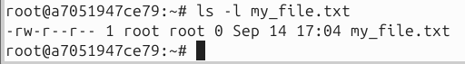

Create a new user: Add a new user named labuser without a password, as this is a temporary container.
useradd -m labuser
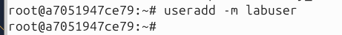

Change ownership: Change the owner of my_file.txt from root to labuser.
chown labuser my_file.txt

Verify ownership change: Check the ownership again to confirm the change.
ls -l my_file.txt
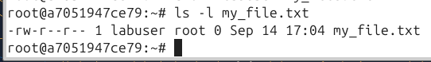

Change permissions: Give the owner (labuser) read and write permissions, but remove all permissions for the group and others. Use the octal notation 600.
chmod 600 my_file.txt

- Explain the permissions: Add a comment explaining what 600 means in terms of read/write/execute permissions for owner, group, and others.

Task 7: Simple Process Monitoring
View running processes: Use ps with the aux flags to view all processes currently running on the system.
ps aux
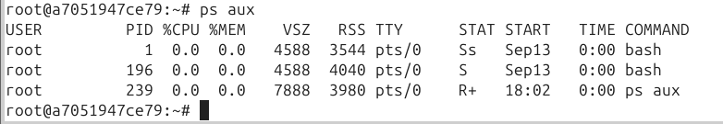

Identify parent-child processes: Run a command that spawns a child process and use pstree to visualize the relationship. sleep is a good example. Open a new terminal and run:
pstree -p
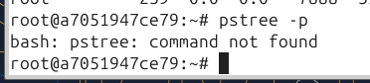
- You will see a tree-like structure showing the parent-child hierarchy, with process IDs in parentheses. The sleep command will be a child of your bash shell.
To resolve the command not found error, you must install the psmisc package inside your container.
Update the package list:
apt update:
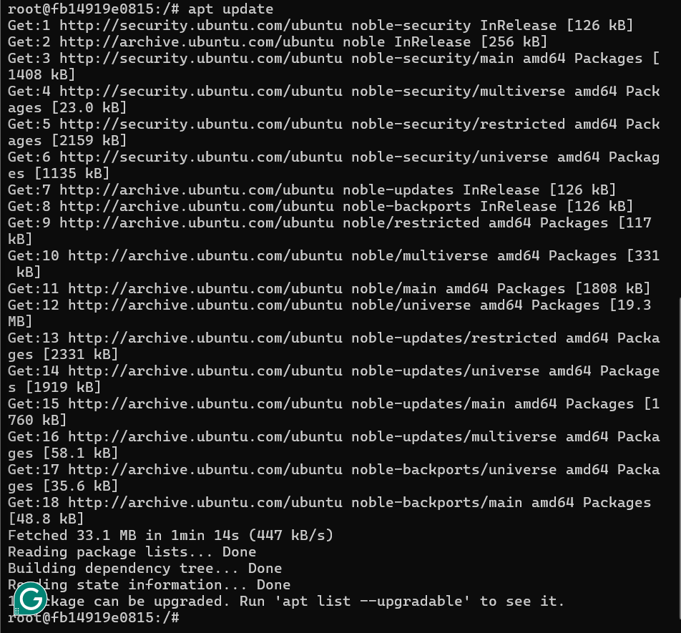
Install psmisc:
bash
apt install -y psmisc
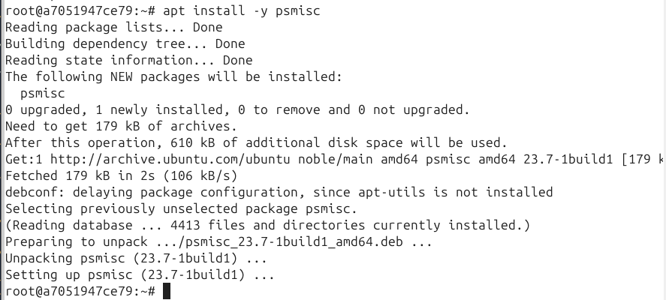

Send a signal: Use the kill command to terminate the sleep process. First, find its Process ID (PID) using ps aux | grep sleep. Then, use kill [PID].

Sleep 3600 & to find the sleeping process
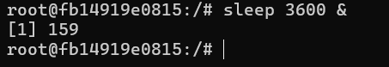
# Find the PID (it will be different each time)

ps aux | grep sleep
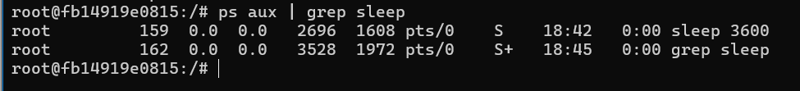

# Terminate the process
kill <PID_of_sleep>
