Installing Docker on Ubuntu typically involves using the official Docker APT repository to ensure the latest version and proper updates. Here are the general steps: Update your package list. Code
sudo apt update
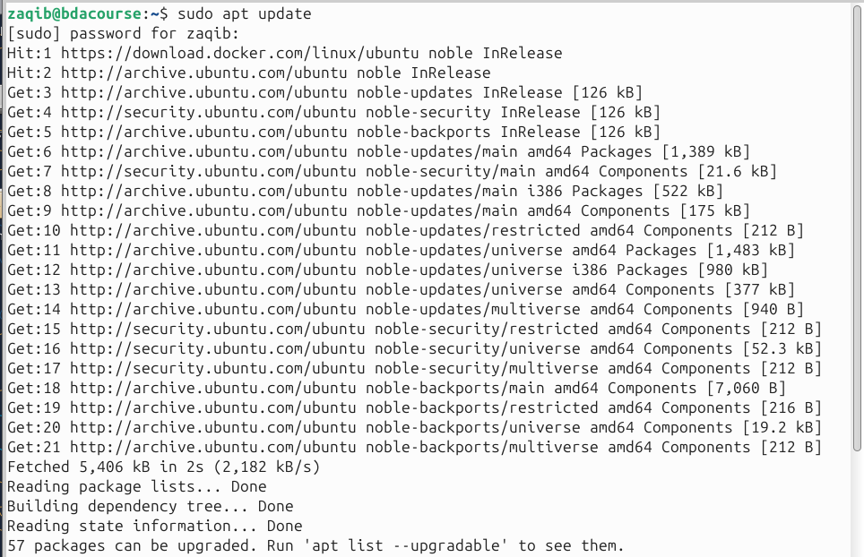
Install necessary packages for adding the Docker repository: Code
sudo apt install apt-transport-https ca-certificates curl software-properties-common
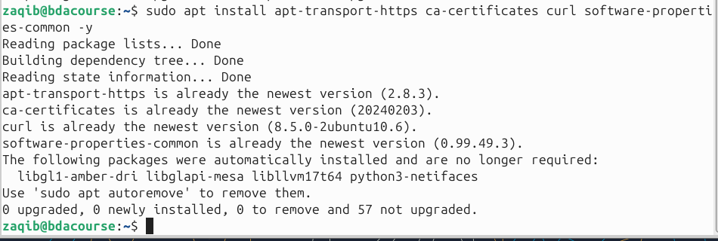
Add Docker’s official GPG key. Code
curl -fsSL https://download.docker.com/linux/ubuntu/gpg | sudo gpg --dearmor -o /usr/share/keyrings/docker-archive-keyring.gpg
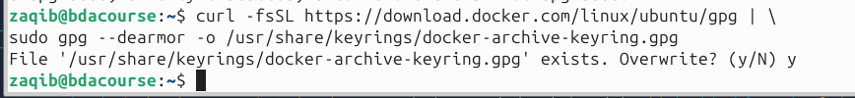
Add the Docker APT repository. Code
echo "deb [arch=$(dpkg --print-architecture) signed-by=/usr/share/keyrings/docker-archive-keyring.gpg] https://download.docker.com/linux/ubuntu $(lsb_release -cs) stable" | sudo tee /etc/apt/sources.list.d/docker.list > /dev/null
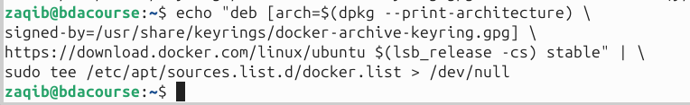
Update your package list again to include the new repository: Code
sudo apt update
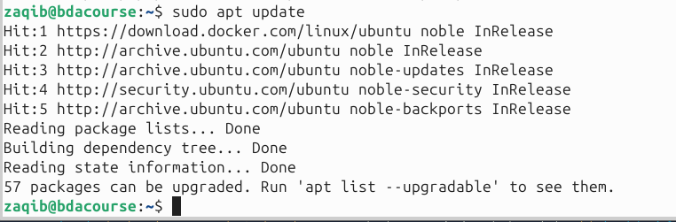
Install Docker Engine. Code
sudo apt install docker-ce docker-ce-cli containerd.io docker-buildx-plugin docker-compose-plugin
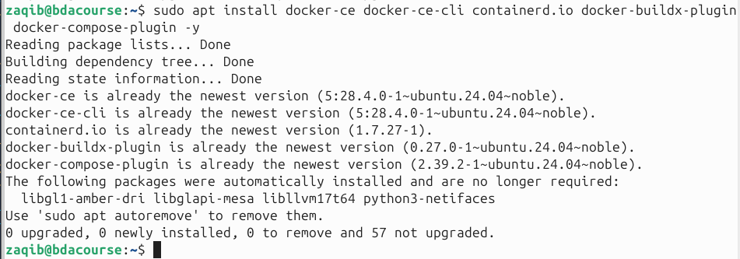
Verify the installation by running a test container: Code
sudo docker run hello-world
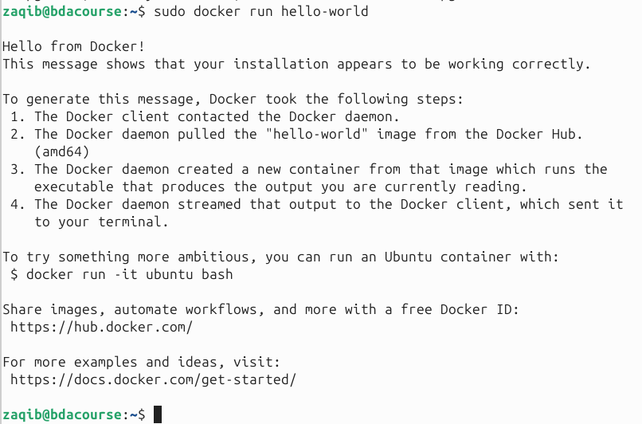
This command downloads a test image and runs a container, which should print a “Hello from Docker!” message.

